**AI-based Diabetes Prediction Project Design and Innovation**

|  |  |
| --- | --- |
| **Date** | **10-10-2023** |
| **Team ID** | **922** |
| **Project Name** | **6112-AI-Based Diabetes Prediction System** |

**Table of Contents**

|  |  |
| --- | --- |
| 1 | Introduction |
| 2 | Problem Statement |
| 3 | Design and Innovation Strategies |
| 3.1 | Data Collection |
| 3.2 | Data Pre-processing |
| 3.3 | Feature Engineering and Selection |
| 3.4 | Model Selection |
| 3.5 | Model Training |
| 3.6 | Hyperparameter Tuning |
| 3.7 | Model Evaluation and Validation |
| 3.8 | Incorporate Innovative Strategies |
| 3.9 | Interpretability and Explainability |
| 3.10 | Fine-Tuning and Iteration |
| 3.11 | Deployment |
| 3.12 | Monitoring and Maintenance |
| 4 | Conclusion |

**1. Introduction**

The objective of this document is to provide an in-depth analysis of the design and innovation strategies for the development of a AI-based Diabetes Prediction model using machine learning. Accurate diabetes prediction is a critical tool in the healthcare industry, and this project aims to utilize innovative approaches to enhance prediction accuracy and reliability.

**2. Problem Statement**

Predicting diabetes accurately is a complex task influenced by a multitude of factors, including Glucose, Blood Pressure, Insulin, BMI etc. The central problem of this project is to build a model that delivers precise diabetes predictions by incorporating these intricate factors.

**3. Design and Innovation Strategies**

**3.1. Data Collection**

Innovation: Comprehensive Data Gathering

Gather a diverse and representative dataset containing relevant features such as age, BMI, glucose levels, family history, etc.

Ensure the data is clean, handle missing values, remove duplicates, and perform any necessary preprocessing (e.g., normalization, standardization).



In this project , we use the above dataset for predicting diabetes precisely.

**3.2. Data Pre-processing**

Innovation Topic: Anomaly Detection and Outlier Analysis

Data preprocessing is a crucial step in building a robust Diabetes Prediction System using machine learning. It involves cleaning, transforming, and organizing the raw data to make it suitable for model training.

**Data Cleaning:**

Handle missing values: Impute missing values using techniques such as mean imputation, median imputation, or imputation based on correlated features.

Remove duplicates: Identify and remove duplicate records from the dataset to prevent bias in the model.

**Data Transformation:**

Feature scaling: Scale numerical features (e.g., age, BMI) to a similar range using techniques such as standardization (mean = 0, variance = 1) or normalization (values between 0 and 1).

One-hot encoding: Convert categorical features (e.g., gender, medication) into binary columns using one-hot encoding to make them suitable for machine learning models.

Encoding target variable: If the target variable is categorical (e.g., diabetes diagnosis: yes or no), encode it into numerical values (e.g., 1 for 'yes', 0 for 'no').

**Data Organizing:**

Organizing the data for data preprocessing involves structuring and formatting the dataset in a way that facilitates effective preprocessing steps. Here are the details on how to organize the data for preprocessing in the context of a Diabetes Prediction System:

Data Structure: Ensure the data is organized in a structured format, such as a tabular representation where each row corresponds to an individual record (sample) and each column represents a feature (attribute).

Data File Format: Store the data in a commonly used file format, such as CSV (Comma-Separated Values), Excel, or a database format, to allow easy access and compatibility with various tools and platforms.

Feature Identification: Clearly identify and label each feature (column) in the dataset, specifying its meaning, data type (numeric, categorical, etc.), and potential relevance to the prediction task (e.g., glucose levels, age, BMI).

Target Variable: Clearly designate the target variable (the variable to be predicted) and ensure it is separate from the features. For a diabetes prediction system, this would typically be a binary classification indicating the presence or absence of diabetes.

**3.3 Feature Engineering and Selection**

Innovation Topic: Genetic and Molecular Data Integration

Create new features or modify existing ones to improve the predictive power of the model.

Use feature selection techniques (e.g., recursive feature elimination, feature importance) to identify the most relevant features for prediction.

**3.4. Model Selection**

Innovation: Explainable AI for Model Selection

Choose appropriate machine learning models for diabetes prediction (e.g., logistic regression, decision trees, random forests, support vector machines, or neural networks).

Consider ensemble methods to combine multiple models for improved performance and robustness.

Develop a hybrid model that integrates the ensemble and deep learning approaches to leverage their respective advantages.

**3.5. Model Training**

Innovation: Online Learning and Adaptive Models

Split the dataset into training and testing sets for model training and evaluation (e.g., 80% training, 20% testing).

Train the chosen models using the training dataset and evaluate their performance using appropriate evaluation metrics (e.g., accuracy, precision, recall, F1-score, ROC-AUC).

**3.6. Hyperparameter Tunning**

Innovation: Automated Hyperparameter Optimization

Optimize model performance by tuning hyperparameters using techniques like grid search, random search, or Bayesian optimization.

**3.7. Model Evaluation and Validation**

Innovation: Real – world Evidence Integration

Validate the model using cross-validation to ensure its robustness and generalization across different data subsets.

Assess the model's performance on the testing set and compare it with baseline models to validate its effectiveness.

**3.8. Incorporate Innovative Strategies**

Innovation: Hybrid models and Rule – Based Systems

Consider incorporating innovative strategies such as transfer learning, ensemble methods, or advanced algorithms (e.g., deep learning) to enhance prediction accuracy.

**3.9. Interpretability and Explainability**

Innovation: Interactive and Visual Explanations

Develop interactive and visually intuitive tools to explain the model's predictions, fostering trust and facilitating better understanding by healthcare professionals and patients.

**3.10. Fine – Tuning and Iteration**

Innovation: Continuous Learning and Dynamic Methods

Based on evaluation results and stakeholder feedback, fine-tune the model or revisit earlier steps (e.g., data preprocessing, feature engineering) for further refinement and improvement.

**3.11. Deployment:**

Innovation: Edge Computing and On – device Inference

Deploy the finalized model as an API or application that can accept new input data and provide predictions in real-time.

Ensure proper integration with existing systems and compliance with relevant regulations (e.g., privacy, healthcare standards).

**3.12. Monitoring and Maintenance:**

Innovation: Automated Model Monitoring and Alerting

Monitor the deployed system's performance and retrain the model periodically to adapt to evolving patterns in the data.

Address any issues, incorporate feedback, and make necessary updates to maintain optimal system performance and accuracy.

Note: In the diagram below, we've depicted the key components and interactions described in sections 3.1 to 3.12, offering a clear and concise overview of our solution architecture. This visualization simplifies the complex concepts and relationships discussed in those sections, making it easier for the reader to grasp the overall design and innovation strategies at a glance.

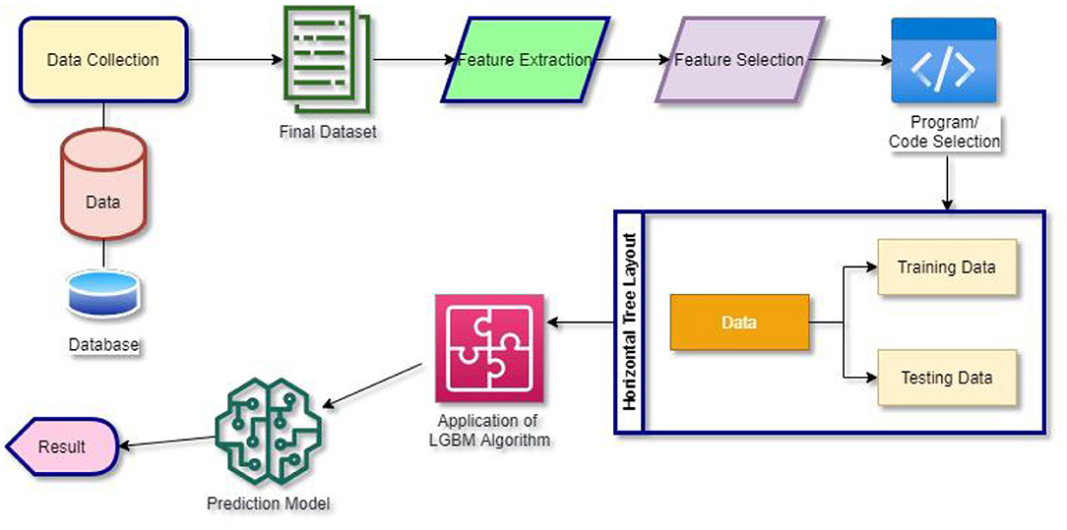

**4. Conclusion**

The diabetes prediction project employs a holistic approach to address the challenges of predicting diabetes accurately. By integrating innovative strategies such as Comprehensive Data Gathering, Anomaly Detection and Outlier Analysis, Genetic and Molecular Data Integration, Explainable AI for Model Selection, Online Learning and Adaptive Models, Automated Hyperparameter Optimization, Real – world Evidence Integration, Hybrid models and Rule – Based Systems, Interactive and Visual Explanations, Continuous Learning and Dynamic Methods, Edge Computing and On – device Inference, Automated Model Monitoring and Alerting.

This model will not only serve as a valuable tool for diabetes patients but also contribute to advancing the state of machine learning in the healthcare industry. Through a combination of cutting-edge technologies and techniques, we aspire to provide a comprehensive and insightful solution for diabetes prediction.