A Project Report

On

Library Management Program.



Submitted By

Name: Shrinibas Mahanta

Class: XII Sc.

Roll No.: ____________

Session: 2022-2023

Under The Guidance Of

Mr K. Jagannath Reddy

(Computer Science Teacher)

Department of Computer Science

Rabindra Vidya Niketan, Keonjhar

Odisha

**INDEX**

|  |  |  |
| --- | --- | --- |
| **SN** | **Details** | **Page No.** |
| 1. | Acknowledgment | 1 |
| 2. | Certificate from supervisor | 2 |
| 3. | System Requirements | 3 |
| 4. | Technology Stack Used | 4 |
| 5. | List of Database and Tables used | 5 |
| 6. | Source Code | 6 to 11 |
| 7. | Output | 12to17 |
| 8. | Objective of the Project | 18 |
| 9. | Bibliography / References | 19 |

**Acknowledgment**

I would like to Give my special thanks of gratitude to my Computer Science Teacher ,“MR K. Jagannath Reddy for his able Guidance and support during the completion of this Project

I would like to extend my gratitude to my Group members Without whose Contributions and Co-operation this project would not have been possible .

I would also like to thank my Parents and my friends for their Support and valuable suggestions regarding this Project.

At last I would thank each and everyone who has been helpful to me during the completion of this project

Student Sign.

**Certificate**

**This is To certify That The Project Work**

**Titled:**

**Library Management Program.**

**Is developed by**

**Shrinibas Mahanta**

**Prachurya Chandra jena**

**and**

**Sagnik Behera**

**in a group of 3 students.**

**This project work is carried out to fulfill the partial requirement of CBSE AISSCE Practical Exam 2023 for the subject Computer Science (083). This is a Original Work of Ours**

Student Sign. Teacher I/C Sign.

**System Requirements**

Hardware used:

* Operating System : Fedora Linux 37 x86_64
* Processor : Intel® Core™ i3-1115G4 Processor
* Ram : 8GB
* Graphics Processor: Intel® UHD Graphics G4
* Storage: 256 GB S.S.D

Software used:

* Linux OS
* Code Editor: VS Code
* Python : 3.11.0

**Technology Stack Used**

Front-End: -

Front-End refers to the interface which the user uses to communicate with the System underlying Programs and Databases. I have Used **Python 3.11.0** to develop the Front-End of the Project, Which is a Command Line Interface(CLI). I’ve used **VS Code** as my Code editor for writing the Program.

Back-End: -

Back-End refers to the database underlying in the system which is working with the front-end To store data. I have used MariaDB database for my back-end in this project.

Both The software used for developing this project are specified by C.B.S.E and are free and open source.

**List of Database and Tables Used**

Database: pathsala

Table(s): books and borrower

Structure of Table:books

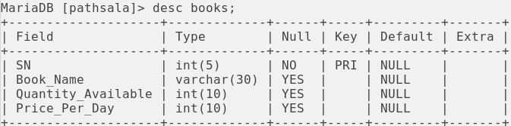

Structure of Table:borrower

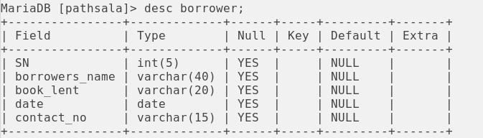

**Source Code**

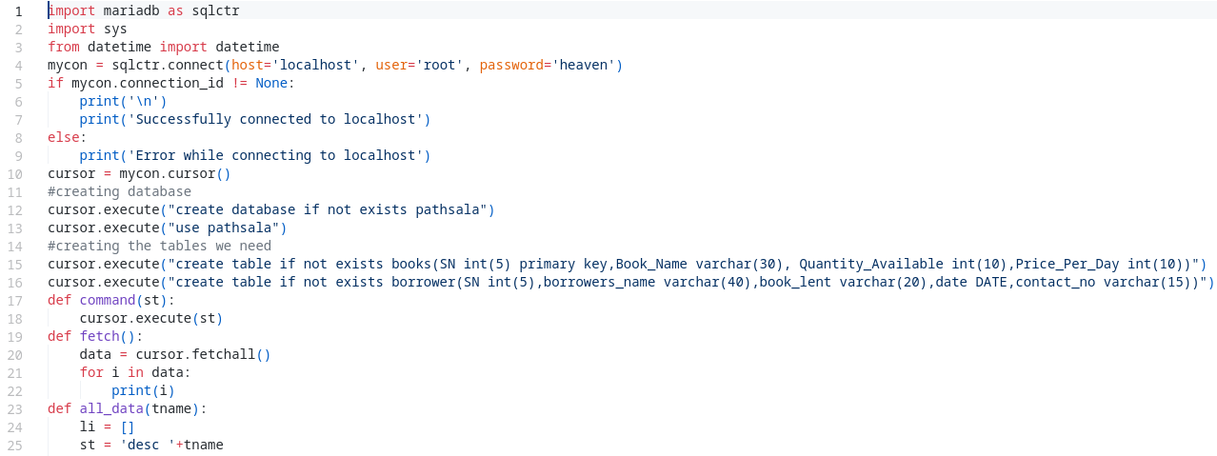

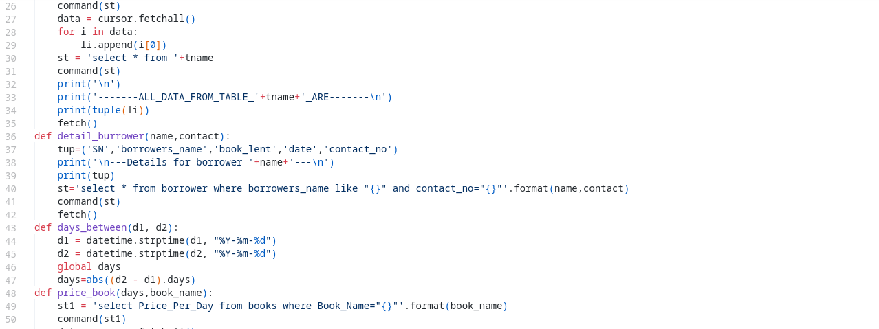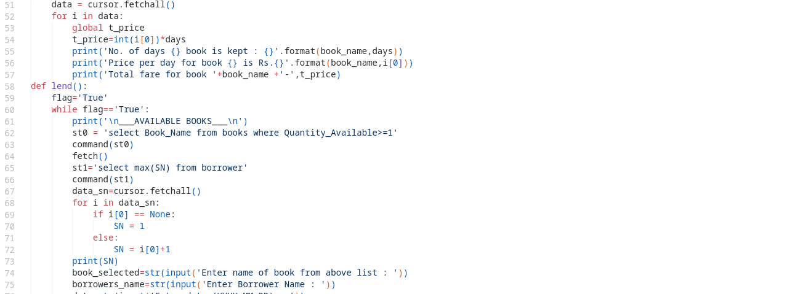

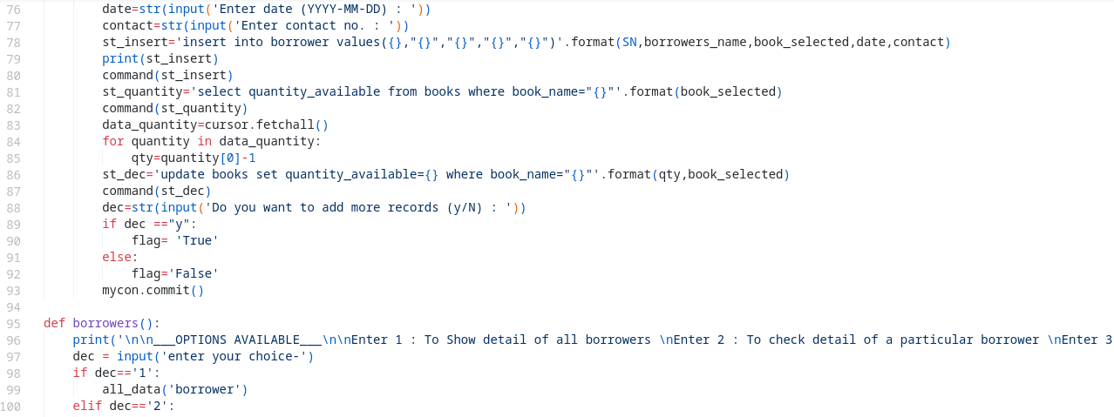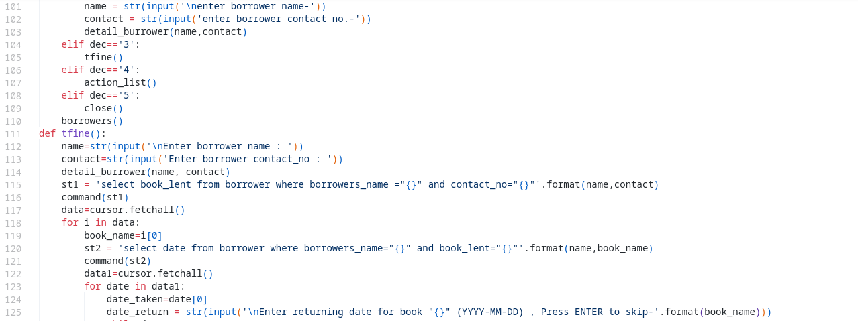

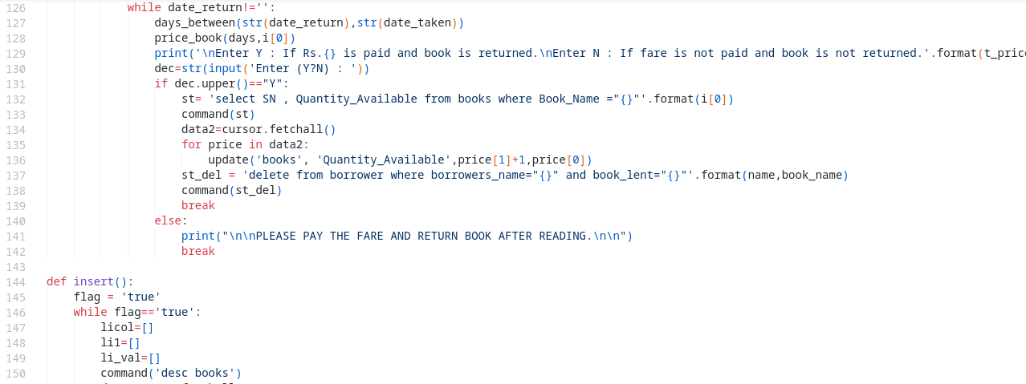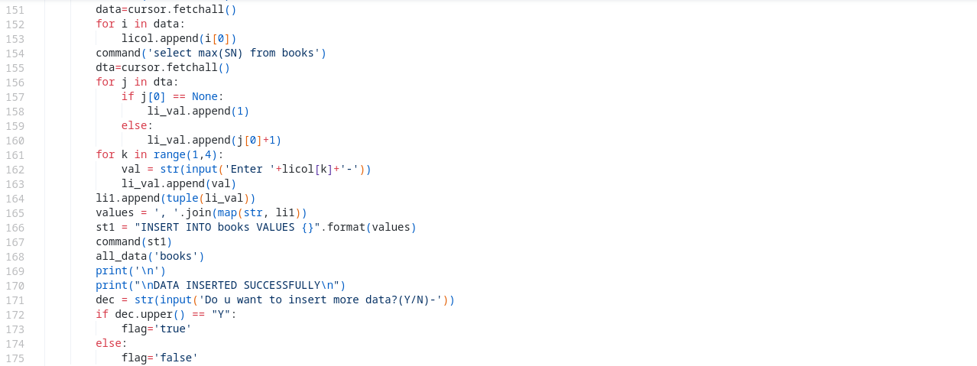

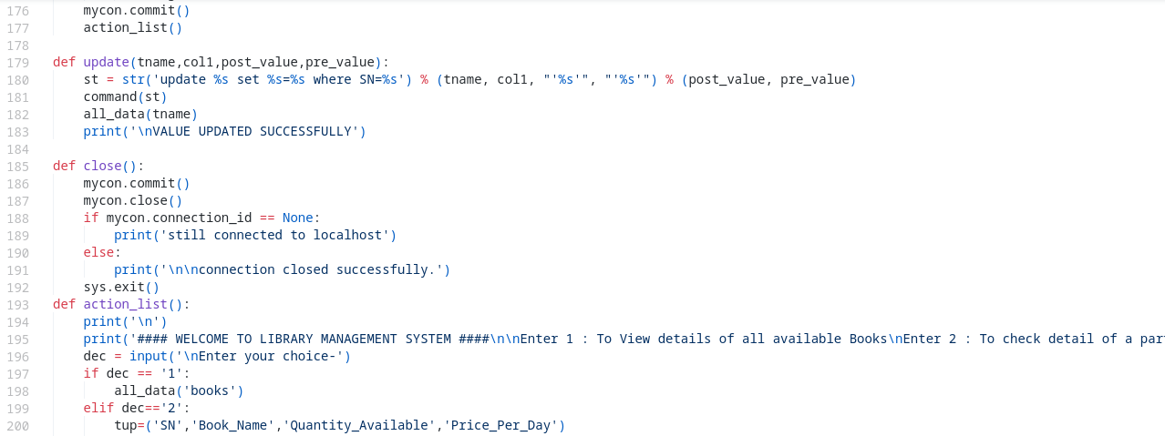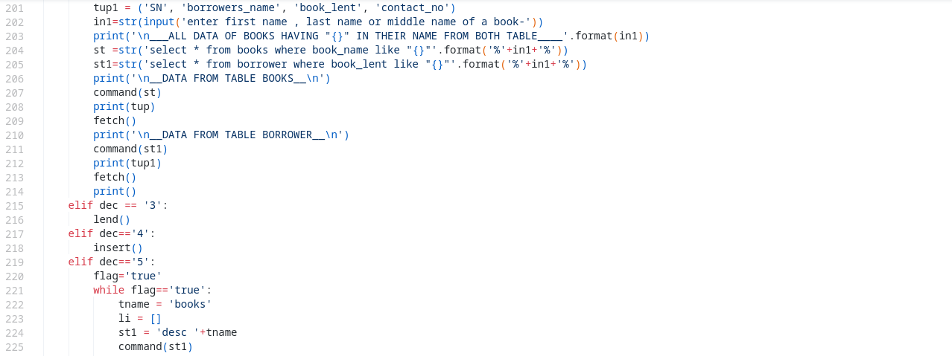

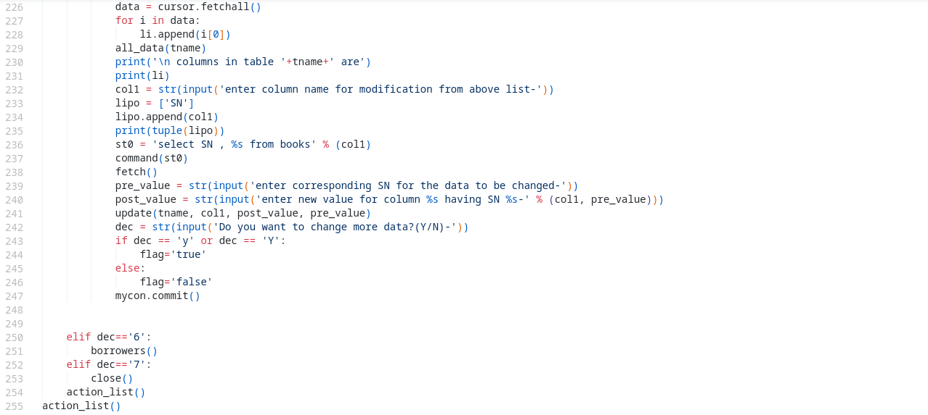

**Output**

**Welcome and Menu:-**

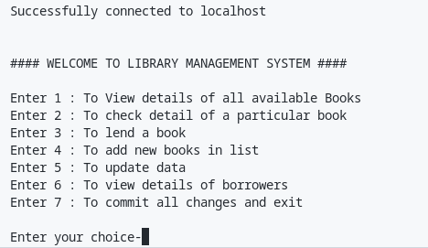

**Choice: 1 (To view details of all Books.):-**

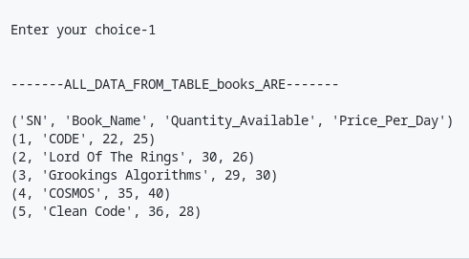

**Choice: 2 (To check details of a particular Book.):-**

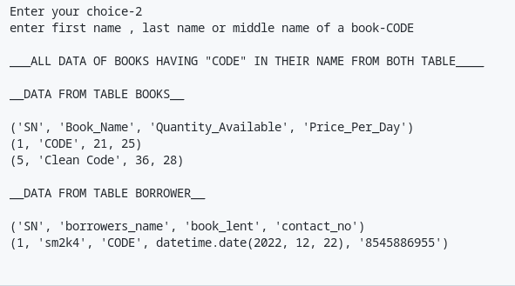

**Choice: 3 (To Lend a Book.):-**

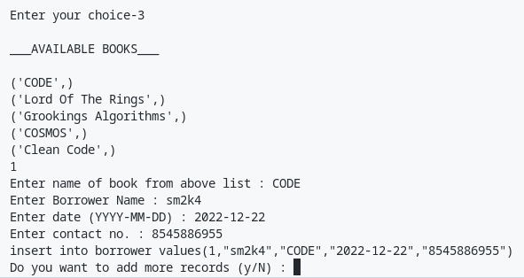

**Choice: 4 (To Add new Books in the list.):-**

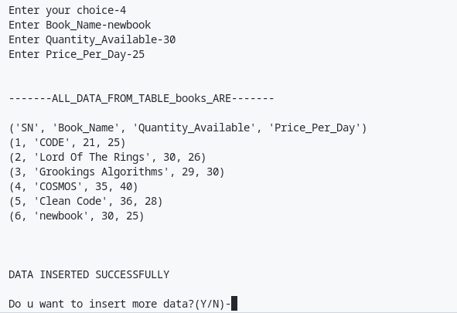

**Choice: 5 (To Update data.):-**

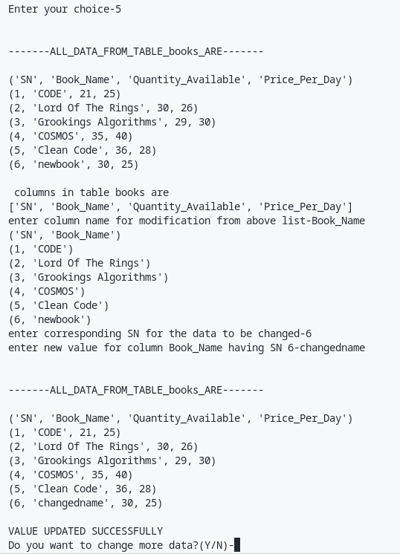

**Choice: 6 (To view details of Borrowers.):-**

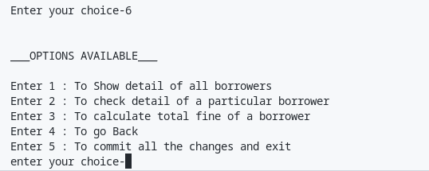

**Choice: 6(1) (To show details of all Borrowers.):-**

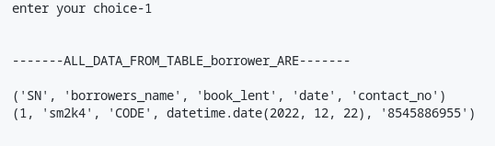

**Choice: 6(2) (To check details of particular Borrower.):-**

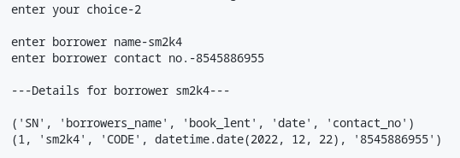

**Choice: 6(3) (To calculate total fine of a Borrower.):-**

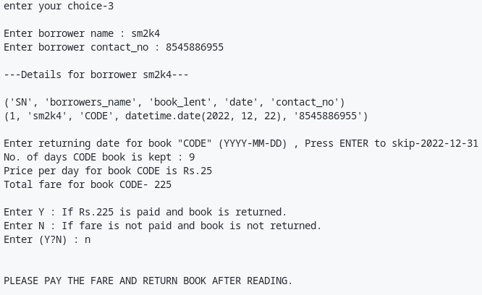

**Choice: 7 (To commit all changes and exit.):-**

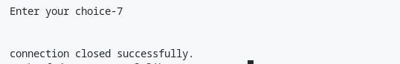

**Objective of The Project Work**

**This program is useful for any institution with a library And can make the process of library management easy.**

**Our program can streamline the whole process of library management And can make the process time efficient. It can help the library to become autonomous as this program does not need external human support to work properly and can be directly used by the customers.**

**The user Interface is easy enough for regular people to understand and at every part of the program there is pre written guide texts for helping the user to interact with the program.**

**Debugging the program is very easy as it uses Python and SQL language which are easy to understand,high level and simple programming languages.**

**Bibliography / References**

**The following resources and reference were helpful during the making of this project:-**

* **Offline classes by the teacher.**
* **Websites Refereed/Knowledge-base:-**
  + [**geeksforgeeks.org**](https://www.geeksforgeeks.org/)
  + [**freecodecamp.org**](https://www.freecodecamp.org/)
  + [**sqlcommands.com**](https://www.w3schools.com/sql/)
* **Books Referred:-**
  + **get programming with python.**