An operational algorithm for Evaluating Satellite Collision Consequence

(Preprint) AAS 19-669

Travis F. Lechtenberg[1]

Risk is properly considered as the combination of likelihood and consequence; but conjunction assessment has usually limited itself to the consideration of only collision likelihood. When considered from an orbital regime protection perspective, the focus shifts to the question of the amount of debris that a collision might produce (the “consequence”). The present paper presents an operational algorithm for determining the expected amount of debris production should a conjunction result in a collision, and an assessment of the algorithm’s fidelity against a database of characterized objects.

# Introduction

Collision risk management theory requires a thorough assessment of both the likelihood and consequence of potential collision events. Satellite conjunction risk assessment has produced a highly-developed theory for assessing the likelihood of collision but neglects to account for the consequences of a given collision. This approach has existed since the early 1980’s with collision likelihood methodology initially developed by Kaplan and Garrick[2]. Satellite operators tend to view all likely conjunctions as equally disastrous, with a single possible outcome: primary object inoperability. This approach may become untenable as conjunction events increase in rate as additional spacecraft tracking capabilities come online and additional debris creation events occur. The orbital debris population has significantly increased recently due to several events, including the Chinese ASAT test in 2007 that destroyed the FY-1C Fengyun satellite, and the Iridium-Cosmos collision in 2009. In addition, the satellite catalog population may also increase significantly due to the upcoming deployment of the U.S. Air Force’s S-Band Radar Space Fence.

While any collision may compromise the survival of an operational spacecraft, the amount of debris produced, and therefore the degree to which the orbital regime may be compromised, can vary greatly among satellite conjunctions. As spacecraft orbital regimes become more densely populated, consideration should be given to the potential consequences of a prospective collision. Potential collisions may be characterized as either catastrophic or non-catastrophic as determined by the relative velocities of two objects and their masses. A catastrophic collision is one in which the primary object and the secondary object are fully fragmented and hence contribute significantly to the spacecraft debris environment, while a non-catastrophic collision is one in which the primary object remains largely intact, with minimal generation of debris. As such, consideration of the potential debris generation as a measure of the “consequence” of a prospective collision is an important component to evaluating the risk a specific event poses to the orbital regime at which the potential collision may occur.

Considering the consequence of a prospective conjunction as it relates to the spacecraft orbital regime is critical to maintaining a safe environment for current and future missions. This means that the risk posed by a potential conjunction to the space environment is a combination of two factors, the likelihood, or probability of collision, and the possible additional debris production from a specific collision. Current practices in assessing collision risk are focused almost exclusively on the probability of collision aspect, whereas an approach incorporating the consequences of a prospective collision allows for more informed decisions to be made with regard to the risk posed to the orbital regime.

Taking into account the potential for debris generation as a consequence of a prospective collision will allow operators to tailor their collision risk management processes to preserve the space environment. If the potential for debris generation is not taken into consideration, future collisions may increase the debris density in favorable satellite orbits and render them unusable because operators, faced with multiple serious conjunctions and able to remediate only a subset of them, may unwittingly choose to prioritize and remediate only those with small debris production potential. Taking debris generation into account can also decelerate the onset of Kessler syndrome in the future[3]. This approach of considering debris production potential may be of considerable interest to satellite operators in geosynchronous orbit, where low velocity conjunctions (which are unlikely to produce large amounts of debris) are commonplace.

Previous work by Hejduk *et al.*[4] focused on developing methodologies to estimate debris generation for specific conjunctions and probability distribution functions of conjunction severity by orbit type based on historically observed conjunctions. Lechtenberg and Hejduk[5] further refined methods of estimating small secondary object masses using orbit determination values and radar cross sections. These methods were validated using a set of nanosatellites with known masses and cross-sectional areas and are revisited in this paper.

This analysis focuses on validating the secondary object size estimation process, proposing a conservative method of assessing secondary object mass, and presenting an intuitive method of interpreting collision consequence results using this methodology. For validation purposes, the same sets of both NaK RORSAT spheres from Hejduk *et al.*1 and nanosatellites from Lechtenberg and Hejduk4 were compared to the secondary object size estimation process outlined in this paper and assessed using a quantile estimation method. This study follows up on examination of the validity of the mass estimation process, and recommends conservative mass estimation quantiles for collision consequence assessment. This recommended mass estimation process can be used to approximate the consequences of a potential collision. This analysis applies this method to a large set of historical conjunctions to assess the frequency that future collisions may be catastrophic and significantly augment the orbital debris population, as well as how often non-catastrophic events may be triaged to lessen operational risk assessment workloads.

# Debris Generation Methodology

The NASA Orbital Debris Program Office (ODPO) has been studying the subject of collision and explosion fragmentation debris for several decades. Based on known satellite collisions and staged hyperkinetic collisions, the ODPO has developed methods to estimate the size and number of debris pieces generated by a hyperkinetic impact, as included in the EVOLVE 4 satellite break-up model[6].

The initial consequence-based assessment of a conjunction is whether the event could result in a “catastrophic” collision that produces widespread fragmentation of both the primary and secondary objects; or “non-catastrophic” in which only the secondary object is likely to fragment. This determination is made through a relationship based on the relative kinetic energy of the two objects as defined by the primary object mass (*Mp*), secondary object mass (*Ms*) and their relative velocity (*Vrel*); a collision may be considered “catastrophic” if the relative kinetic energy exceeds 40,000 J/kg.

$\frac{M_{s}V_{rel}^{2}}{2M_{p}}>40,000\frac{J}{kg}$ $\frac{M_{s}V_{rel}^{2}}{2M_{p}}>40,000\frac{J}{kg}$ (1)

Once the “catastrophic” or “non-catastrophic” nature of the event has been determined, an additional relation is used to estimate the possible number of debris objects that may be generated

$N\left(L_{c}\right)=\left\{\begin{aligned}0.1{\left(V_{rel}M_{s}\right)}^{0.75}L_{c}^{-1.71}, &\frac{M_{s}V_{rel}^{2}}{2M_{p}}≤40,000 \\ 0.1{\left(M_{s}+M_{p}\right)}^{0.75}L_{c}^{-1.71}, &\frac{M_{s}V_{rel}^{2}}{2M_{p}}>40,000\end{aligned}\right.$ (2)

In the equation (2), *Lc* refers to the characteristic length of the debris piece size threshold above which the operator is concerned*, i.e.,* how many pieces (N) will be generated with a characteristic length larger than *Lc*. A reasonable limiting value for this variable would be the minimum characteristic length for which an operator might expect tracking data, such as 5 cm for the published tracking fidelity of the Space Fence.

The previous equations are relatively straightforward to evaluate if all terms are known. However, for prospective conjunctions, the secondary mass values are often not known, predominantly because the secondary objects involved in conjunctions are often fragmentation debris, such as those from the Fengyun or Iridium-COSMOS events. There are also many other possible reasons why the secondary object characteristics may be unknown; this is simply the most dominant one. The relative velocity of the two objects is generally well known due to orbit determination processes for the two objects, as is the primary object’s mass which is known from the spacecraft’s operator, but the mass of the secondary object is still unknown.

# Unknown Satellite Mass Estimation Process

The mass of a secondary object orbiting at low altitudes can be estimated using parameters contained within the atmospheric drag equation which characterizes the acceleration due to drag (${\vec{a}}_{drag}$) based on atmospheric density (*ρ*), the object’s velocity vector ($\vec{v}$), and satellite dependent drag characteristics:

${\vec{a}}_{drag}= -0.5\frac{C_{d}A}{M}ρ\left\|\vec{v}\right\|\vec{v}$ (3)

Estimation of an object’s drag characteristics is of significant import in the orbit determination process, as this is the primary non-conservative force acting on objects in low earth orbit, where large numbers of spacecraft missions operate. As such, the collective terms for satellite drag can be determined as part of the orbit determination process and collected via a term known as the ballistic coefficient (*BC*) and is typically included in reported spacecraft states.

$BC=C_{d}A/M$ (4)

Knowledge of the ballistic coefficient allows for estimation of the object mass (*M*), but this requires that the drag coefficient (*Cd*) and frontal area (*A*) also be estimated or known. In this study, methods to estimate drag coefficients and frontal areas from known satellite quantities are validated by examining the characteristics of known nanosatellites and NaK RORSAT spheres, and as these objects are known, their drag coefficients can be estimated using either a spherical *Cd* of 2.1, or a cuboid drag model as proposed by Walker *et al*.[7] The cuboid drag model is broadly applicable regardless of nanosatellite configuration as they typically conform to the cuboid model, though there may be larger variation due to nanosatellite orientation. This allows for an examination of model accuracy when the object profile is relatively well known, though operationally, a greater estimation of *Cd* may be used as a conservative estimate for assessing the consequence of a collision. For this analysis the nanosatellite drag coefficients are generally presumed to be in line with the more oblong configurations, which show greater variation than strict cube-shaped approximations. Assuming an oblong cuboid satellite form, the drag values can be roughly approximated from Figure 8 of Walker *et al*.6 (Denoted in this paper as: Figure 1) as linearly varying based on exospheric temperature, which can be estimated by a given atmospheric model of choice.

$C_{d}=2.4+\frac{0.6}{800}\left(T_{inf}-200\right)$ (5)

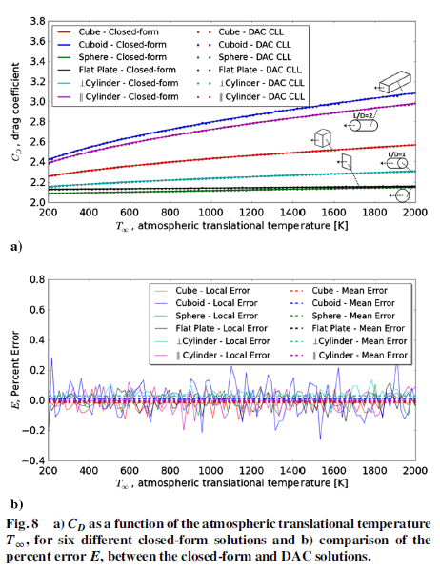

Figure : Recreation of Figure 8 from Walker et al.6 Denoting Drag Coefficient Dependence on Exospheric Temperature.

Variations in the drag coefficient estimates are often small compared to frontal area variations and atmospheric density variations, particularly for satellites orbiting at lower altitudes as shown in analysis by Pilinski *et al*.[8], which estimated that *Cd* variations are typically about 2% except in extremely low altitude cases. This analysis uses a sampling methodology to affect *Cd* uncertainty on the evaluation of collision consequence. Specifically, for each estimate of the drag coefficient, a number of samples are drawn from a normal distribution with a relative standard deviation of 5% (conservatively larger than Pilinski’s 2%) and a mean determined as described above. This larger uncertainty is used so that a larger spread of *Cd* values may be examined for their effect on collision consequence evaluation.

# Unknown Satellite Frontal Area Estimation Process

The frontal area of the secondary object may be estimated using a relationship between the projected area of the satellite and the object’s radar cross section (RCS). RCS characterizes the intensity of radar energy reflected during tracking observations and is a solved-for variable in the radar range equation if the signal-to-noise ratio and range are known. Typically, this is reported as the median RCS value, as the RCS distribution does not conform to a normal distribution.

Although the RCS value has units of area, it is not a direct estimate of a satellite’s cross sectional area, but can be used to estimate the distribution of an object’s characteristic size. This is accomplished using the ODPO’s size estimation model (SEM), which was developed by fragmenting a satellite in a vacuum, measuring the characteristic dimensions of the resulting fragments, and correlating those to radar returns when illuminated in all possible configurations.5 Radar theory allows a dimensionless relationship to be established between an object’s characteristic length (normalized by the radar wavelength) and the object’s RCS (normalized by the square of the radar wavelength).

If the wavelength of the observing radar is known, the characteristic length, *Lc*, of the object may be roughly estimated using the median RCS (a value that is made available from the 18th Space Control Squadron at the Combined Space Operations Center (CSpOC), for example). The uncertainty distribution for *Lc* can be characterized using the NASA ODPO size estimation model (SEM)[9], which uses a distribution of RCS values to produce a corresponding distribution of characteristic lengths. This study approximates the distribution of RCS values as a Swerling III, grounded by a single shape parameter that can be derived from the RCS median value. While this methodology is not an ideal characterization of RCS distributions, it outperforms most other choices, as presented by Hejduk and DePalma[10].This approach improves upon previous work, which used a less robust method of approximating the RCS distribution as a sum of two distributions. Using this Swerling III distribution, a large set of samples representing the secondary object RCS are generated for use in the mass estimation process.

This process provides a method by which the characteristic length may be determined if the RCS and the tracking radar’s wavelength or frequency is known; if not, a good approximation of a generic radar may be established using radar frequencies of either UHF (~430MHz) or L-Band (~1200MHz), depending on object RCS value. The characteristic length distribution of the secondary object is then used to approximate a distribution of estimates of the satellite frontal area:

$A=\frac{πL_{c}^{2}}{4}$ (6)

# Satellite Size Validation Method

NaK Spheres

As a follow-up to previous validation efforts by Hejduk *et. al.*3, 24 NaK liquid-droplet spheres were examined using this updated mass estimation methodology. Specific characteristics of the spheres used in prior analyses was obtained through direct contact with the author. These characteristics included:

* Object Designator
* Median RCS
* Calculated Diameter
* Error Estimate in Diameter

From this data, and the knowledge that the objects are spheres, the additional inputs to the mass estimation process could be retrieved. For the NaK spheres, a *Cd* of 2.1 was used as corresponds to spherical objects, along with a relative 5% uncertainty applied for sampling purposes. The ballistic coefficients for these objects and their associated uncertainties were retrieved from relevant Conjunction Data Messages (CDMs) pertaining to these objects. Finally, the mass of these droplets was calculated using the prescribed diameters of these objects in conjunction with the density given for NaK droplets at altitude as given in Krisko:[11] 0.9 g/cc. Estimated NaK sphere masses were then compared to the calculated masses.

Nanosatellites

To validate this mass estimation approach, a large set of nanosatellites spanning a range of operational altitudes was examined. The initial set included roughly 1000 nanosatellites. This set was then investigated to determine their prescribed masses, dimensions, satellite bus size, and Satellite ID numbers. The initial set of 1000 nanosatellites was reduced to 530 satellites based on satellite specification availability and launch successes. As all of these spacecraft are cuboid in nature based on standard satellite buses available at that size, the expected frontal area for each spacecraft was estimated as the mean area presented by the spacecraft assuming a random tumbling behavior. Using this approach, an independent data set of small object masses and frontal areas had been established. For an irregularly shaped object, a formula proposed in the NASA standard breakup model5 and expounded upon by Hanada[12] for the average cross-sectional area is:

$A_{total}=\frac{(A_{xy}+A_{yz}+A_{xz})}{3}$ (7)

Where the subscripts *x,y,* and *z* refer to the object’s dimensions. As the spacecraft in question are cuboid, the maximum triplet dimensions of *x, y,* and *z* can be determined in a relatively straightforward manner as the outer dimensions of the cuboid are known.

Next, orbit determination data was retrieved from relevant Conjunction Data Messages (CDMs) pertaining to these objects, including orbit regime, RCS, and ballistic coefficient. This exercise further reduced the available Nanosat population for validation to 371 based on CDM data availability. These 371 nanosatellites ranged in altitude from 323 to 1304 km.

# Validation Results

Combining the previous sections’ analyses and processes yields a distribution of object frontal areas and masses of previously examined NaK spheres and the prescribed nanosatellites. For each object, 10,000 samples were derived, taking random draws of ballistic coefficient, drag coefficient and frontal area as estimated from the RCS distribution. The mass estimates are given as quantile values as part of a cumulative distribution function of the object’s characteristics from this process. The estimated masses of these objects were then compared with the independently determined values from the spacecraft specifications as researched, and compared in a normalized ratio sense. Figures 2 and 3 summarize the distribution of these mass ratios.

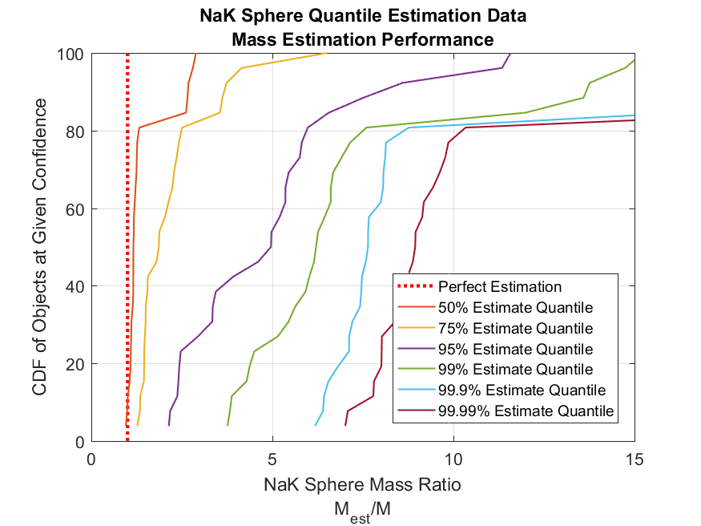

Figure 2: Cumulative Distribution Function of Quantile Mass Ratios to Researched   
Values for 24 NaK Spheres

Figure 2 demonstrates that for spherical objects such as the NaK liquid-droplet spheres, a mass estimation quantile of 75% would be sufficient. In this context, this would maintain a conservative mass estimate for the determination of collision nature. However, the actual shape of secondary satellites in conjunctions is rarely spherical, so additional analysis for more irregular objects is required.

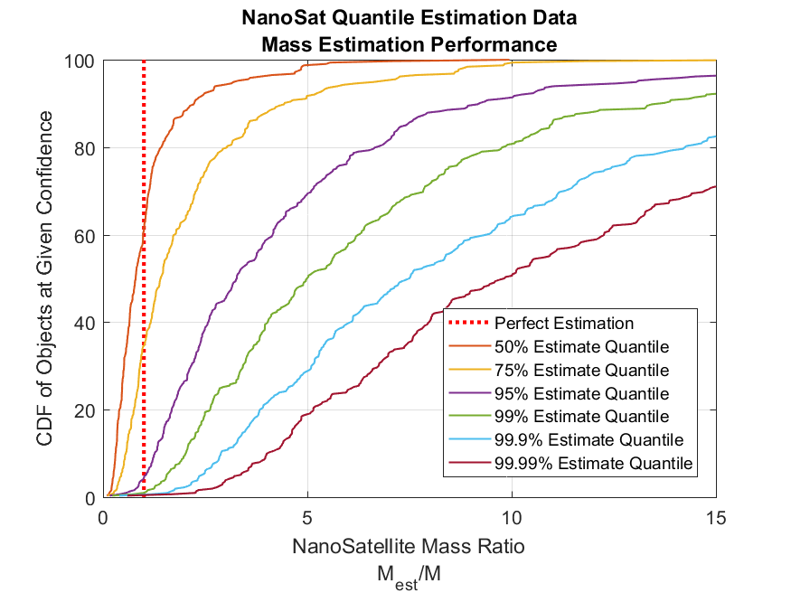

Figure 3: Cumulative Distribution Function of Quantile Mass Ratios to Researched   
Values for 371 Nanosatellites

Figure 3 shows the cumulative distribution of estimated mass quantile ratios for the 371 nanosatellites. For this group, the 75th percentile noted for the NaK spheres yields a mass underestimation rate of roughly 32% (see Table 1), this level of underestimation is deemed to be unacceptably high in this analysis to protect critical orbital regimes adequately. It is desired, that collision consequences, and by proxy: secondary masses, be estimated in a conservative manner so that the risk of debris production is minimized. For this reason, this analysis recommends that the more conservative 99.9th quantile of secondary mass estimation be used for both catastrophic collision determination as well as potential debris object generation. Table 1 lists specific thresholds at which the nanosatellite masses have been underestimated based on this mass quantile approach. There is a single outlier nanosatellite consistently underestimated by the mass estimation process which drives this recommendation up to the 99.9th percentile, but yet is still not included in the 99.99th percentile assessment.

Table 1: Mass Underestimation Thresholds for Given Mass Estimation Quantiles

|  |  |
| --- | --- |
| **Mass Estimation  Quantile** | **Percent of Nanosatellite Masses Underestimated** |
| 50% | 64.01% |
| 75% | 32.33% |
| 95% | 5.08% |
| 99% | 1.31% |
| 99.9% | 0.52% |
| 99.99% | 0.40% |

# Collision Consequence Assessment for Historic Events

Applying the quantile mass estimation method to a set of archived conjunctions provides a means to evaluate the frequency of catastrophic events. Specifically, this analysis applies the method to 9,652 conjunctions observed over 5 years involving three NASA “A-train” satellites, AQUA, AURA, and TERRA, which occupy a ~700 km altitude polar orbit in a leading/trailing configuration. The catastrophic nature of potential collisions was analyzed using a normalized mass of 2000 kg for each of these primary objects. This allowed the catastrophic event frequency and debris production potential for satellites in orbits similar to these primaries to be examined on a mass estimation quantile basis as seen in Figure 4.

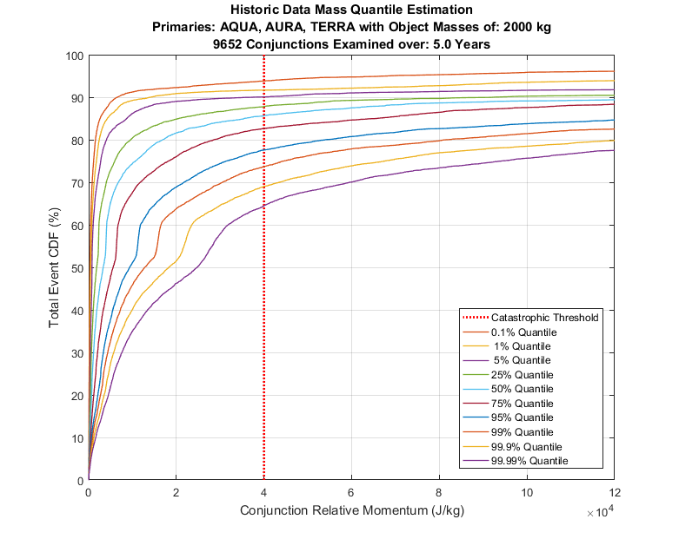

Figure 4: Historic Data, Catastrophic Collision Estimates by Mass Estimation Quantile

Figure 4 shows that the method indicates ~69% of the analyzed conjunctions to be likely non-catastrophic, using the recommended quantile of 99.9% for mass estimation. If an operator desires to invoke a more conservative approximation of a “lethal” relative kinetic energy at 20,000 J/kg (instead of 40,000 J/kg, to approximate the case wherein the primary object is rendered inoperable, but not fragmented), and treat all events below that threshold non-catastrophic, then this would be reduced to ~52%, as indicated in Figure 4. So, for this orbital regime and for this assumed primary mass, the analysis indicates that a majority of conjunctions may be considered non-catastrophic. This demonstrates that the method presented here provides a means of identifying the subset of events most consequential for orbital debris production, which will be increasingly useful as future satellite populations and conjunction rates continue to grow. While Figure 4 only examines the catastrophic nature of examined conjunctions, a trade space may be examined to understand the effect the primary object mass has on debris production potential.

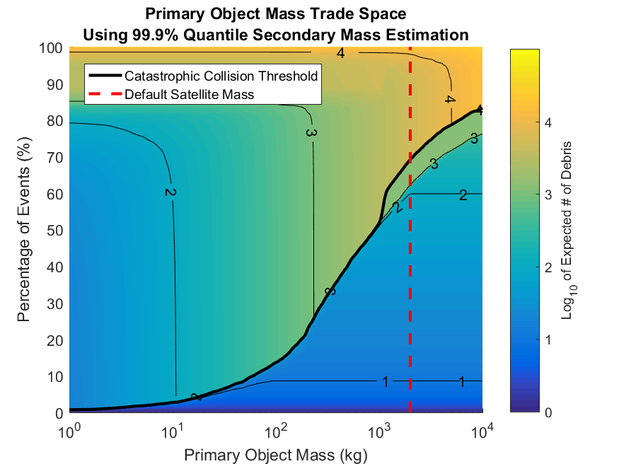

Figure 5: Primary Object Mass-Debris Production Trade Space

Figure 5 examines this trade space for the A-train conjunction data set, demonstrating that there is a significant, discontinuous increase in debris production potential across the catastrophic event threshold defined by equation (1). The bold black line in Figure 5 shows this discontinuity, which exceeds an order of magnitude over much of the examined trade space. This suggests another method to analyze collision consequence: by examining the potential for debris production for a conjunction given a primary object mass. For example, using the default 2,000 kg satellite mass, Figure 5 indicates that roughly 60% of all potential conjunctions produce less than 100 additional debris objects larger than 5 cm in characteristic length.

# Conclusions and Future Work

This study presents additional analysis in the estimation of the mass and size of secondary objects which pose a collision risk to operational spacecraft, but whose characteristics are not known. This study also presents analysis on how best to implement the secondary mass estimation process, and how primary object masses affect the potential for debris production. The estimation processes were validated against a set of known nanosatellites and NaK RORSAT spheres, and show acceptable agreement, but are far from perfect in the estimation of satellite masses. Updated methodologies for assessing secondary object mass may be used in a collision consequence assessment to provide operators with additional information regarding the potential for detrimental effects on specific orbital regimes through the severity of potential debris generation events.

Based on this analysis, in order to estimate secondary object masses conservatively, this analysis recommends using a quantile estimate of the secondary object mass at the 99.9th percentile level.

Conjunctions likely to be catastrophic, or likely to produce large amounts of debris, should be given higher priority in collision avoidance planning. Conjunctions likely to be non-catastrophic, or with a low debris production potential, may be allowed additional leniency in the collision avoidance processes and perhaps less stringent risk mitigation maneuver thresholds. Allowing satellite operators to triage maneuver planning activities based on either the catastrophic/non-catastrophic distinction, or the debris production potential of specific events, could significantly reduce maneuver planning and resource expenditures. For instance, in the example presented here of 2,000 kg satellites occupying ~700 km polar orbits, the analysis indicates that ~69% of all conjunctions likely produce non-catastrophic collisions.

In future work, better drag coefficient estimation methodologies may be explored, debris production potential analysis of operational events may be considered, and additional characteristics of the predicted debris pieces may be assessed. One such additional characteristic may be the orbital lifetime distribution and decay rate of the debris field based on drag modelling and atmospheric density predictions.

Acknowledgments

The author would like to thank Doyle Hall and Matthew Hejduk for several helpful discussions and analyses. As well as Matthew Hejduk’s supplying of NaK sphere characteristics.

NOTATION

|  |  |
| --- | --- |
| *A* | Satellite Frontal Area (m2) |
|  | Atmospheric Drag Acceleration (m/s2) |
| *BC* | Ballistic Coefficient (m2/kg) |
| *Cd* | Drag Coefficient (dimensionless) |
| *CDM* | Conjunction Data Message |
| *Lc* | Characteristic Length (m) |
| *Mp* | Mass of Primary Object (kg) |
| *Ms* | Mass of Secondary Object (kg) |
| *Pc* | Probability of Collision |
| *RCS* | Radar Cross Section (m) |
| *SEM* | Size Estimation Model |
| $$\vec{v}$$ | Satellite Velocity Vector (m/s) |
| *Vrel* | Relative Velocity (m/s) |
| *x* | Longest Dimension of Object (m) |
| *y* | Longest Dimension of Object in Plane Perpendicular to *x* (m) |
| *z* | Longest Dimension of Object Perpendicular to both *x* and *y* (m) |
| *ρ* | Atmospheric Density (kg/m3) |

1. Conjunction Assessment Research Scientist, Omitron Inc., 555 E. Pikes Peak Ave. #205 Colorado Springs, CO, USA
2. Kaplan, S. and Garrick, B.: “On the Quantitative Definition of Risk.” *Risk Analysis*, Vol. 1 No. 1 (1981), pp. 11-27.
3. Kessler, D.J. and Cour-Palais, B.C.: “Collision Frequency of Artificial Satellites: The Creation of a Debris Belt.” *Journal of Geophysical Research 83 (1978)*, pp. 2637–2646.
4. Hejduk, M., Laporte, F., Moury, M., Kelso, T.S., Newman, L., Shepperd, R. “Consideration of Collision “Consequence” in Satellite Conjunction Assessment and Risk Analysis”, International Symposium on Space Flight Dynamics, Matsuyama, Japan, 2017
5. Lechtenberg, T. F., and Hejduk, M. D., “Assessment and Validation of Collision “Consequence” Method of Assessing Orbital Regime Risk Posed by Potential Satellite Conjunctions,” Hypervelocity Impact Symposium, 2019, Destin FL, HVIS2019-061.
6. Johnson, N.L., Krisko, P.H., Liou, J.-C., and Anz-Meador, P.D.: “NASA’s New Breakup Model of EVOLVE 4.0.” *Advances in Space Research,* Vol. 28 No. 9 (2001), pp. 1377-1384.
7. Walker, A., Mehta, P., Koller, J., “Drag Coefficient Model Using Cercignani-Lampis-Lord Gas-Surface Interaction Model”, *Journal of Spacecraft and Rockets*, Vol. 51, No. 5 (2014), pp. 1544-1563.
8. Pilinski, M., Argrow, B., Palo, S., "Semi-Empirical Satellite Accommodation Model for Spherical and Randomly Tumbling Objects", *Journal of Spacecraft and Rockets*, Vol. 50, No. 3 (2013), pp. 556-571.
9. C. L. Stokely et al., "Haystack and HAX Radar Measurements of the Orbital Debris Environment; 2003", JSC-62815, Nov 2006.
10. Hejduk, M., DePalma, D., “Comprehensive Radar Cross-Section “Target Typing” Investigation for Spacecraft”, *Advances in the Astronautical Sciences*, Vol. 135, 2010, AAS 09-301.
11. Krisko, P. H., “The New NASA Orbital Debris Engineering Model ORDEM 3.0,” AIAA/AAS Astrodynamics Specialist Conference*,* San Diego, CA, August, 2014, AIAA 0214-4227, https://ntrs.nasa.gov/archive/nasa/casi.ntrs.nasa.gov/20140009932.pdf.
12. Hanada, T., Liou, J. C., Krisko, P., Nakajima, T., “For Better Calculation of the Average Cross-Sectional Area of Breakup Fragments”, *Transactions of Space Technology Japan*, Vol. 7, Iss. 26, 2009, pp. 25-30.