Free Modelica Library of Chemical and Electrochemical Processes

Marek Mateják1, Martin Tribula1, Filip Ježek2, Jiří Kofránek1,2

11st Faculty of Medicine, Charles University, Czech Republic

2Faculty of Electrical Engineering, Czech Technical University, Czech Republic

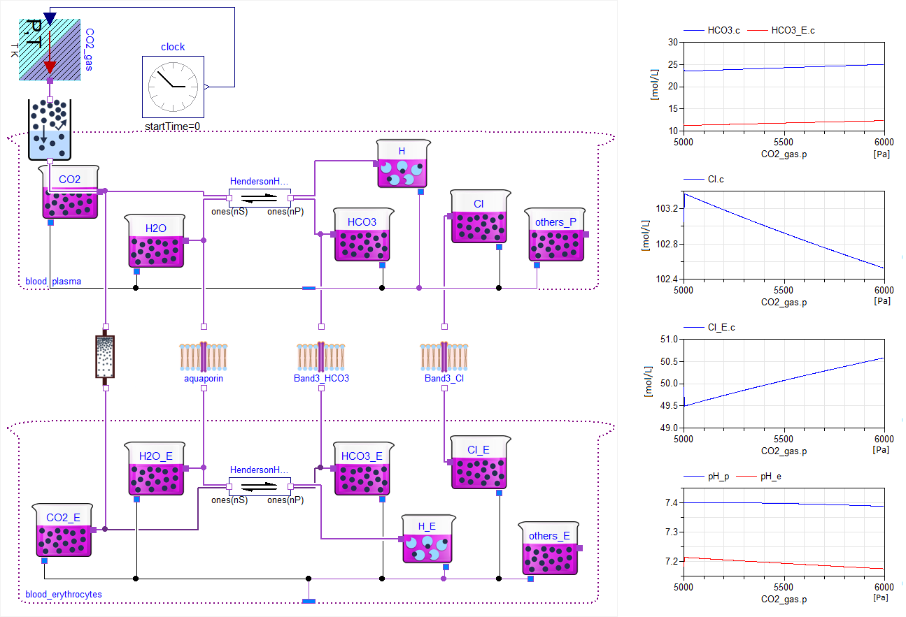A new, free Modelica library for electrochemical processes has been released - accessible as “Chemical” at <https://www.modelica.org/libraries>. It is based on equilibrating the electrochemical potentials of the substances involved, following the modern theories of physical chemistry. It dynamically solves the chemical equilibration of homogeneous chemical solutions with fully thermodynamic states, supported also through thermal, mechanical, electrical and fluid components of Modelica Standard Library 3.2.1. Even the complex processes can be composed from only a few base components, such as a component for the chemical solution, a component for the chemical substance or a component for the chemical reaction. Behind these components are fundamental laws of thermodynamics and physical chemistry. The library was designed to be very intuitive and easy to use. This paper shows how the library can be used to implement the examples of a lead-acid battery, a hydrogen burning and a chloride shift of human red blood cells.

**Figure 1**. Chloride shift with carbon dioxide hydration with assumption of non-bicarbonate linear acid-base buffering properties of plasma and erythrocytes.

In this way, it is possible to model more complex processes of a membrane where chemical reactions of active membrane channels or membrane receptors can also be used.

The library is usable for any chemical or electrochemical process. However, chemical kinetics are not yet seriously validated, so the only assumption is, that the equilibrating time of chemical processes is by orders of magnitude shorter than of other connected domains.