**Portfolio U – An Algorithmic Trading Systems**

CA1 for KE5207 (Computational Intelligence 2)

2018

Tan Chee Wei (A0179723U, email: )

Ramasamy Muthuraman (A0179756H, email: e0269775@u.nus.edu)

Laxman Singh (A0178223E, email: )

Varoon (AXXXXXXXX, email: )

Abstract

Summary of system design & modelling

* To design and develop a real quantitative algorithmic trading system (ATS) using (Genetic Algorithms (GA) and Fuzzy Logic/Set) to trade Crude Palm Oil (FCPO) Futures on Bursa Malaysia Derivatives Exchange.
* With an initial investment fund of $1million was allocated, using new ATS to obtain highest profit by running for few years.
* Our system’s trading strategy was based on real historical market data, through simulation. Hence to calculate the actual market value (MKV) of position at end a few years are evaluated.
* The trading strategy is modelled/optimized/learnt based on known historical market data, using computational intelligence techniques such as GA and fuzzy logic methods.

Results from simulation (e.g. simulated total asset value)

* Simulated total asset value at end of year 1, 2 and 3
* Total Profit and Loss (P&L)
  + Short sell P&L
  + Commission and fees
  + Net asset value (NAV)
  + Interest rate
  + Rate of return

1. **Introduction**
2. **Materials & Methods** 
   * **System Design and Architecture**
   * **Overview**
   * **Moving Average method**
   * **GA Strategy**
   1. Generate the initial population. Randomly generate 20 individuals. Each individual contains 10 rules in accordance with the rules set.
   2. Calculate the fuzzy moving averages in the training period. Calculate the differences between two moving averages in the training period and the previous training period using the moving average method and the length of two moving averages that the rule provides.
   3. Next, obtain the membership function according to the moving average differences of the previous training period.
   4. Calculate the rating level according to the moving average differences of this training period, the membership function, and the recommend values that the individual provides. Because every individual provides a set of recommend values, there are ultimately 20 sets of rating levels.
   5. Select the best individual in the training period. Calculate the trading volume using the initial capital and the rating degree. Then, calculate the rate of return according to the rate of return calculation method provided above. Every individual has a rate of return. The one that has the highest rate of return is the best individual in the training period.
   6. Calculate the rate of return in the selection period using the best individual in the training period. Calculate the differences between the two moving averages of this selection period and the previous selection period. Then, obtain the membership function and calculate the rating level and the rate of return.
   7. Mark the best individual. In the first cycle, mark the rate of return as the best rate of return and the best individual in the training period as the overall best individual. From the second cycle, compare the rate of return in this loop and the best rate of return. If the rate of return from this loop is higher than the best individual in the last loop, and the gap is over 0.05, replace the best rate of return and the overall best individual.

**Rate of return calculation for each individual**

1. Conduct a population evolution. Use genetic algorithms to choose 10% of the individuals from the old population in terms of their rate of return. Next, choose 80% of the individuals from the old population together with 10% randomly generated new individuals to experience the crossover and mutation. Finally, these two parts combined to form the new population.
2. Repeat Steps (4)–(6) for 50 repetitions.
3. Calculate the rate of return of the best individual in the test period using the overall best individual selected in the previous steps. Calculate the two moving averages in this test period and the previous test period. Then, obtain the membership function and calculate the rating level and the rate of return.
4. Move forward to the next experiment period and return to step (1).

**Chromosome Selection strategy:**

1. After one experiment of one generation, the population needs to evolve. We take the rate of return as the fitness value and use Roulette Wheel Selection (RWS) to choose 10% of the 20 individuals from the old population.
2. They are most likely the two best individuals. We retain the two individuals as the first part of the new population. The second part of the new population is two individuals that are randomly generated. Then we continue use RWS to select 80% of the 20 individuals from the old population which is mostly like the 16 best individuals. These 16 individuals need to go through crossover and mutation to become the third part of the new population.
   * **Fuzzy Logic**

Seven level of membership defined.

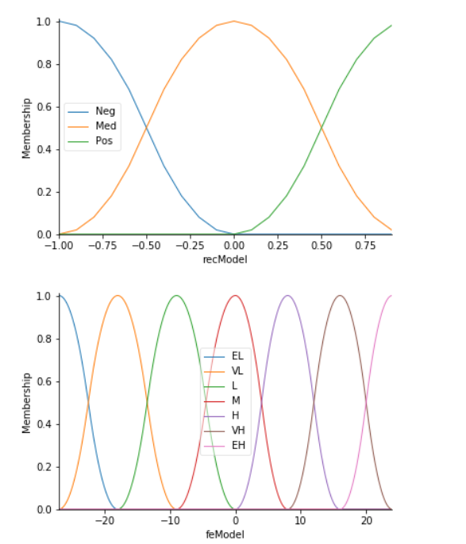

* + **Process flow**
  + **Modelling and Simulation**
    1. **Training Data set**
    2. **Testing Data set**

1. **Results & Discussion**
   * **Final total asset value calculation details**
     + - NAV (Total unrealized market value + cash balance) at end of 2016 DEC 30 17:59.
   * **Short Sell P&L calculation details**
2. **Conclusions**
3. **List of abbreviations**
4. **Acknowledgements**
5. **Appendix A.**
6. **References**