**How to Deploy IronDB as a DigitalOcean Droplet**

*(Developer Edition)*

In order to test deployment of IronDB on a DigitalOcean droplet, you will first need to sign up for an account at [Digital Ocean](https://www.digitalocean.com/). If you would like $50 of free credits, sign up for the [Github Student Pack](https://education.github.com/pack).

Create a new droplet based on the Docker Ubuntu 18.04. When making the droplet, tell it you will be using Docker and it will populate the option on the next screen. This will have all the tools installed that are needed for a deployment.

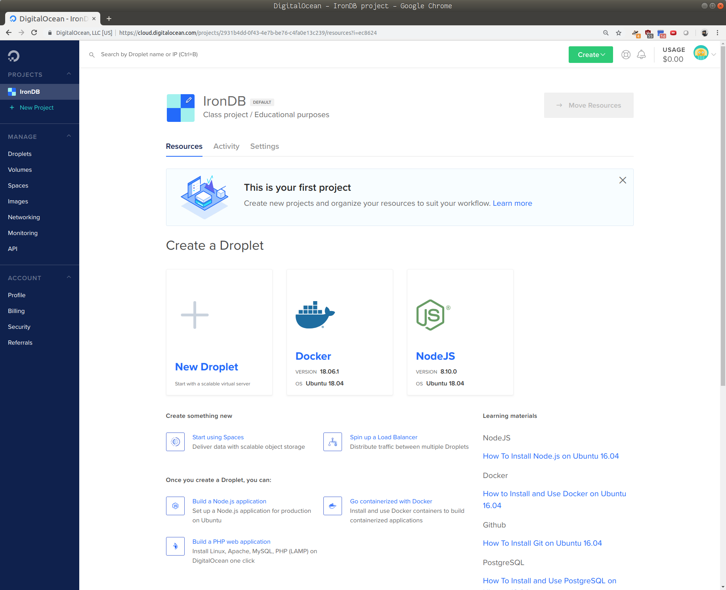

Select the appropriate droplet size. The $10 droplet is fine, although you may choose a cheaper option. If you find yourself lost at any point, head over to [the documentation](https://www.digitalocean.com/docs/droplets/how-to/create/).

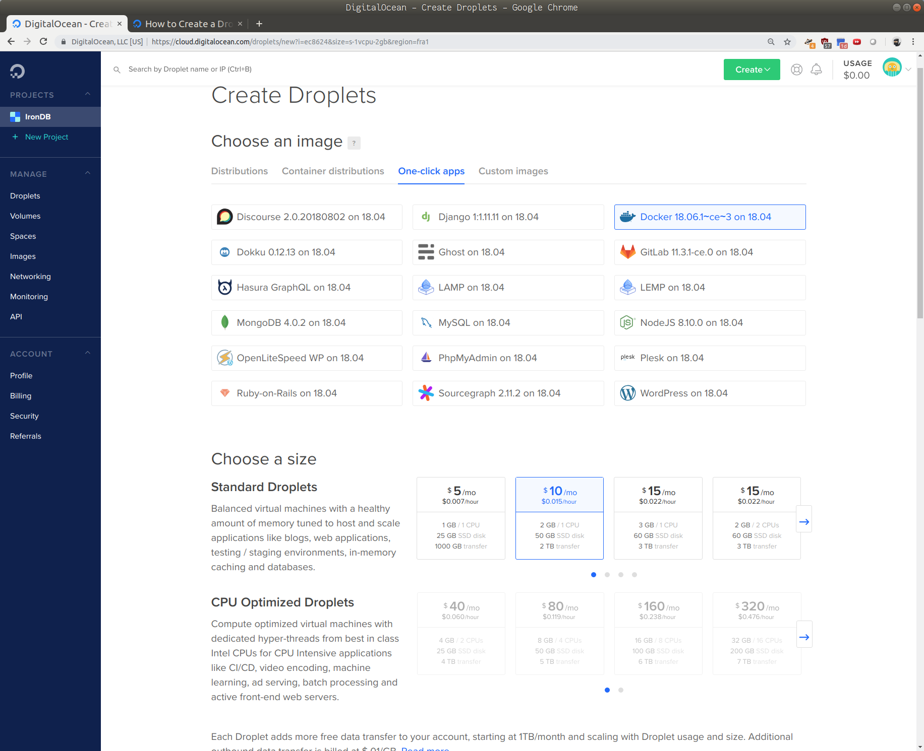

Add a SSH key. If you are using a proper OS, you can make a SSH key with the command

ssh-keygen or use one that you have previously generated, which should be at ~/.ssh/id_rsa.pub

When you create your droplet it will give you an IP address, copy that.

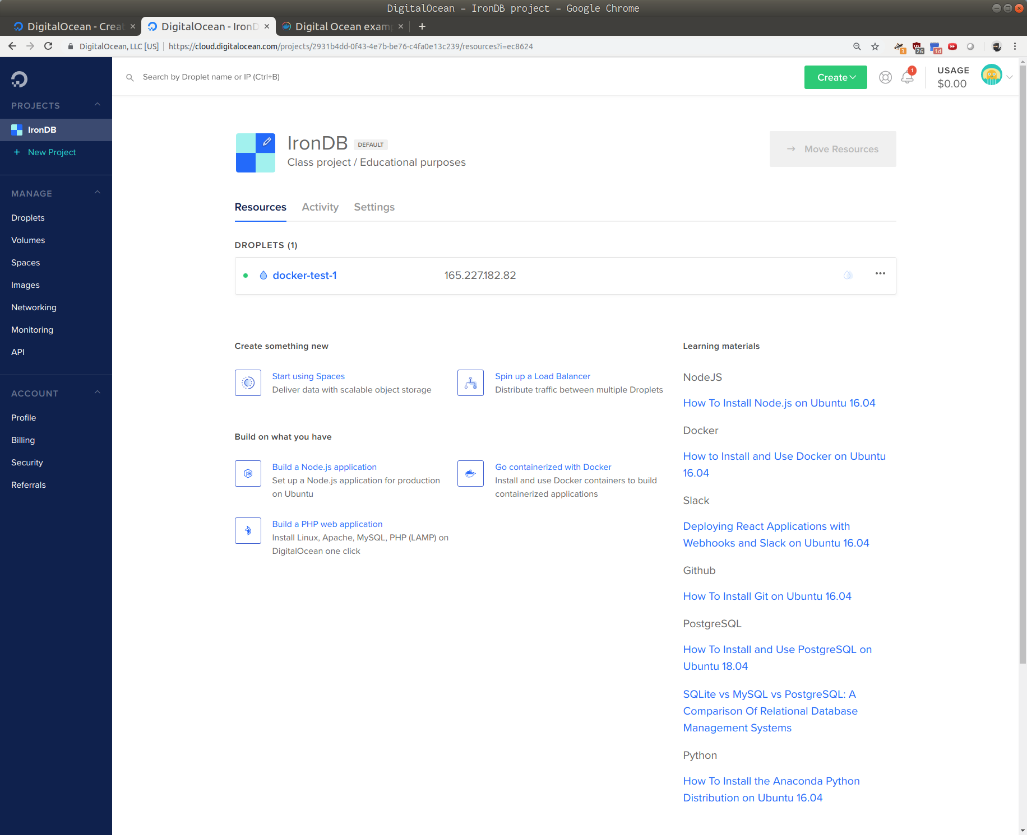

From there, open your terminal and enter ssh@your.ip.addr

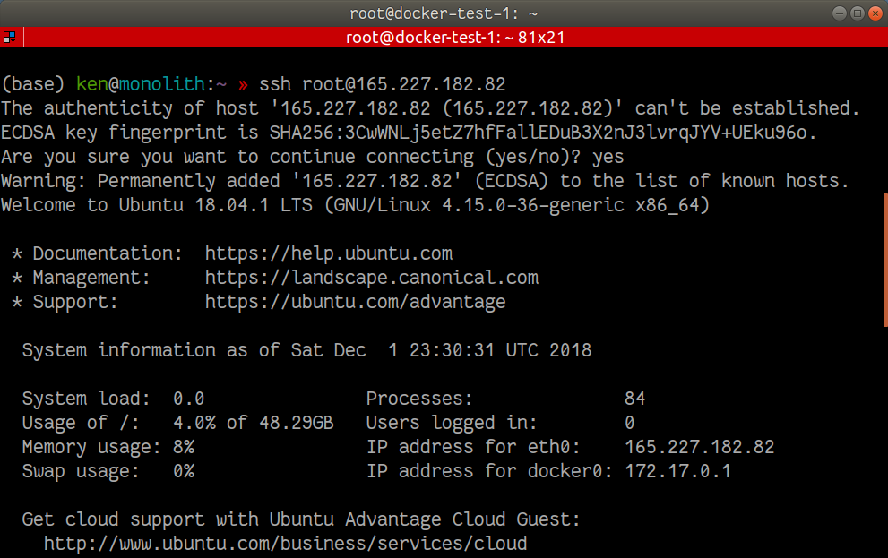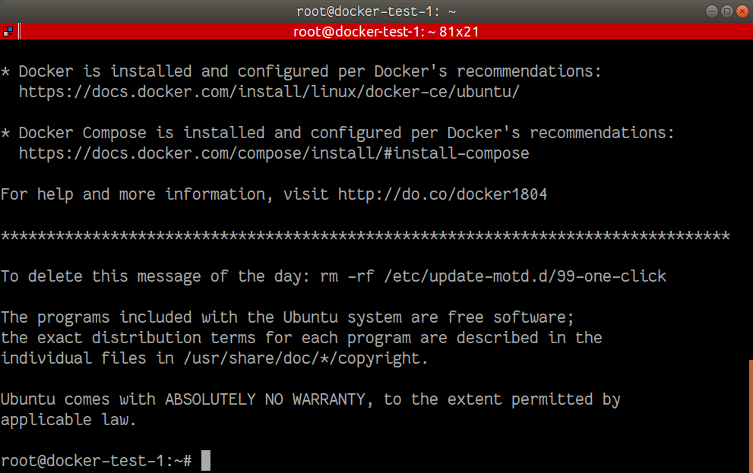

Then do the following:

git clone https://github.com/kenbonilla/irondb.git

cd irondb

git checkout nosudo

./iron.sh

1

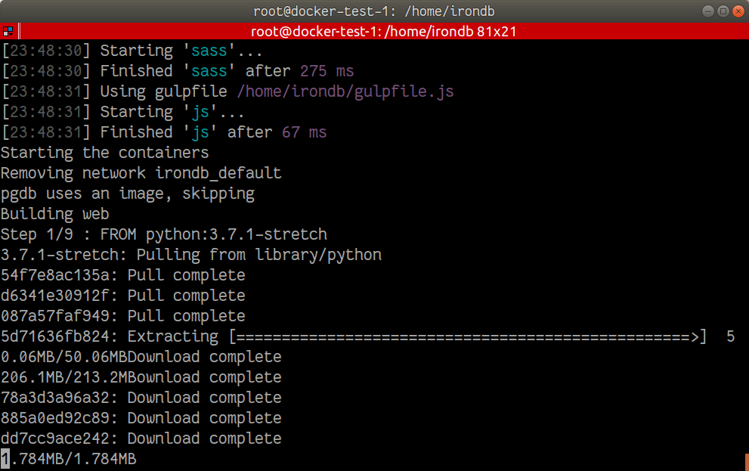

Basically you will see a lot of this, and this will take about 10 minutes. Once it completes, wait a couple minutes for Postgresql to finish standing up. Then open your browser to your.ip.addr:3001 and behold the glory.

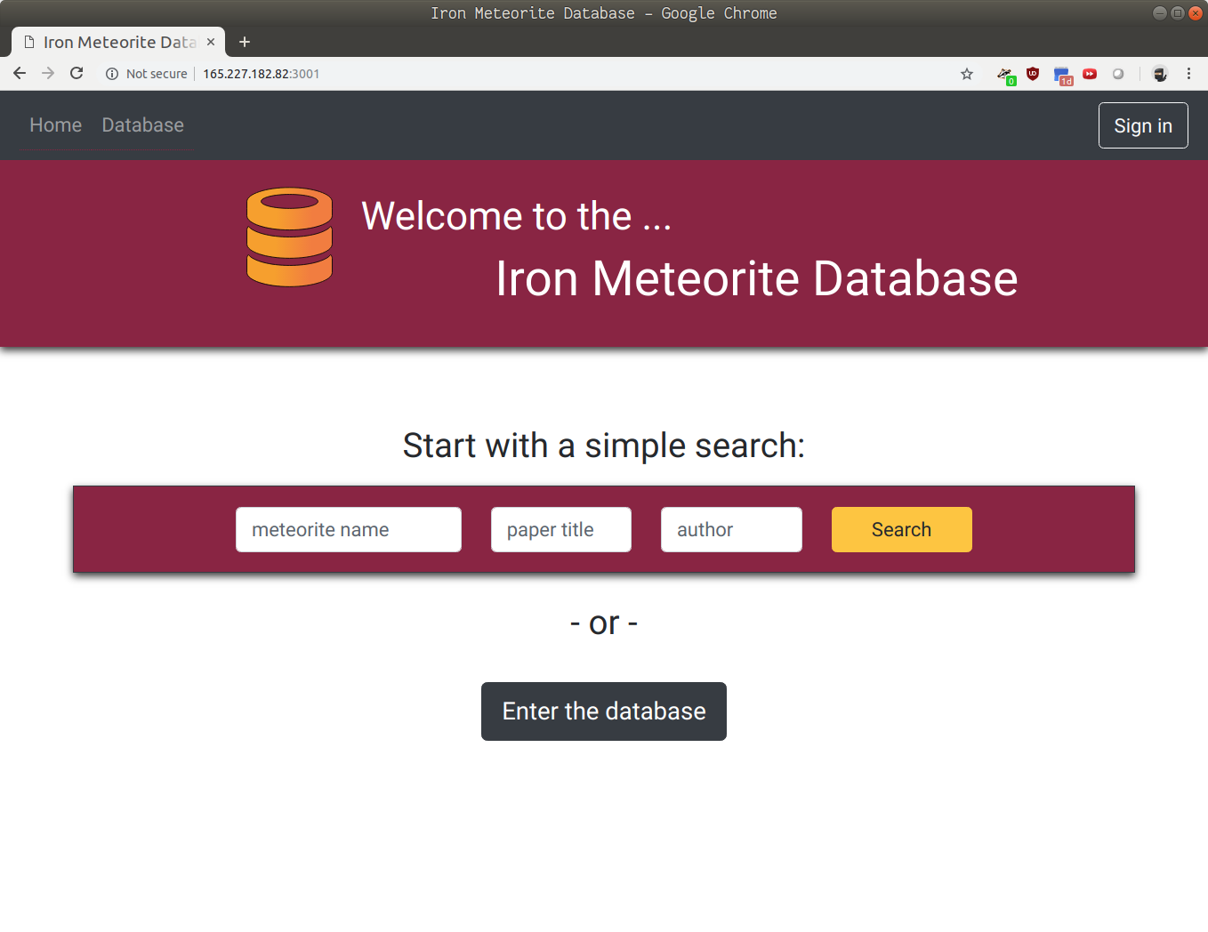

That’s it, crack open a cold one! We are done with devops hell.