Simple Raytracing Triangle PC (DXR)

*This sample is compatible with the Windows 10 October 2018 Update SDK (17763)*

# Description

This sample demonstrates how set up [DirectX Raytracing (DXR)](https://docs.microsoft.com/en-us/windows/desktop/direct3d12/direct3d-12-raytracing) and render a screen space triangle.

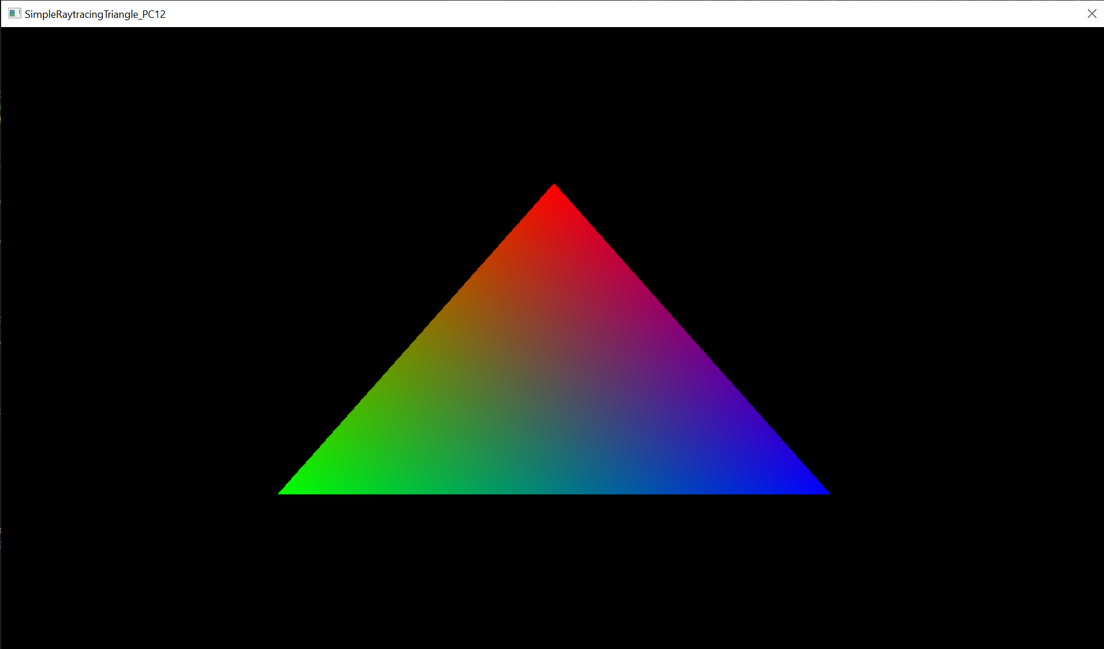

# Setup notes

DirectX Raytracing requires:

* Windows 10 October 2018 Update SDK 17763 or higher
* DirectX 12 compatible video card
* For hardware accelerate Ray Tracing
  + Nvidia: Volta card
  + Nvidia: Turing card

# Using the sample

The sample has no controls other than exiting.

# Implementation notes

DXR support is only available in the DirectX 12 API. If you do not have a Volta or Turing card you can still run the sample as it will drop back to using the DirectX Raytracing Fallback layer. Performance is roughly 2x slower than when hardware supported.

# Update history

Initial release November 2018.