Simple Play Sound Sample

# *This sample is compatible with the Windows 10 Anniversary Update SDK (14393)*

# Description

This sample demonstrates how to play a wav file using XAudio2 (version 2.9) in a Universal Windows Platform (UWP) app.

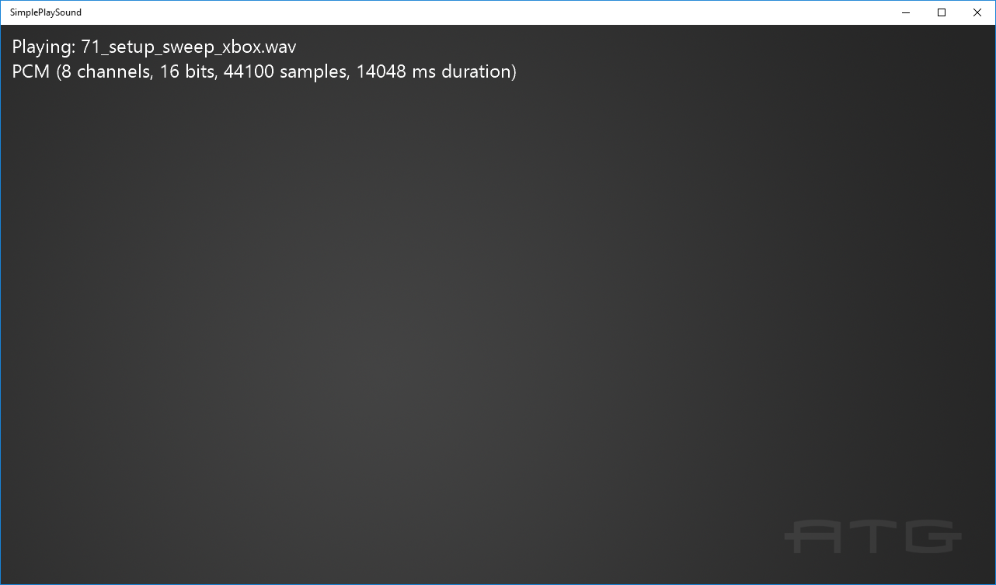

# Using the sample

The sample has no controls other than exiting. It automatically advances through the sample wav files as each completes.

# Implementation notes

This sample demonstrates how to play PCM, ADPCM, and xWMA format wav files. It uses helper code in the *ATG Tool Kit* files WAVFileReader.h/.cpp. This implements a simple wav file parser, along with code for computing the play time of the supported sound formats.

For more information on XAudio2, see [MSDN](https://msdn.microsoft.com/en-us/library/windows/desktop/hh405049.aspx).

# Update history

Initial release March 2016