DirectX Tool Kit Simple Sample

# *This sample is compatible with the Windows 10 Anniversary Update SDK (14393)*

# Description

The SimpleSample demo shows how to link to the DirectXTK library and demonstrates the use of several DirectXTK components:

* SpriteBatch is used to render a Windows logo
* SpriteFont and SpriteBatch are used to render text
* GeometricPrimitive is used to render a teapot
* PrimitiveBatch is used to render the grid
* Model is used to render a mesh loaded from the legacy DirectX SDK .SDKMESH file "Tiny.SDKMESH"
* Several textures are loaded using DDSTextureLoader
* Plays a looping sound and timed 'one-shot' audio
* Demonstrates a simple handling of audio device scenarios for DirectX for Audio

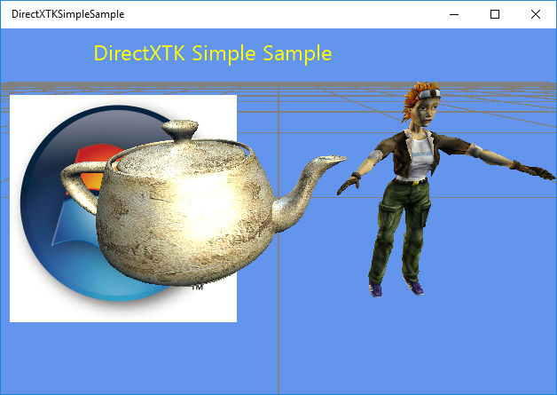

# Using the sample

The sample has no controls other than exiting via the View button or Esc key.

# Implementation notes

This sample includes the DirectX Tool Kit library which is available on [GitHub](https://github.com/Microsoft/DirectXTK/).

# Update history

Initial release March 2016

# Privacy statement

When compiling and running a sample, the file name of the sample executable will be sent to Microsoft to help track sample usage. To opt-out of this data collection, you can remove the block of code in Main.cpp labeled “Sample Usage Telemetry”.

For more information about Microsoft’s privacy policies in general, see the [Microsoft Privacy Statement](https://privacy.microsoft.com/en-us/privacystatement/).