Simple Triangle Sample

*This sample is compatible with the Windows 10 Anniversary Update SDK (14393)*

# Description

This sample demonstrates how to create a static Direct3D vertex buffer to render a triangle on screen.

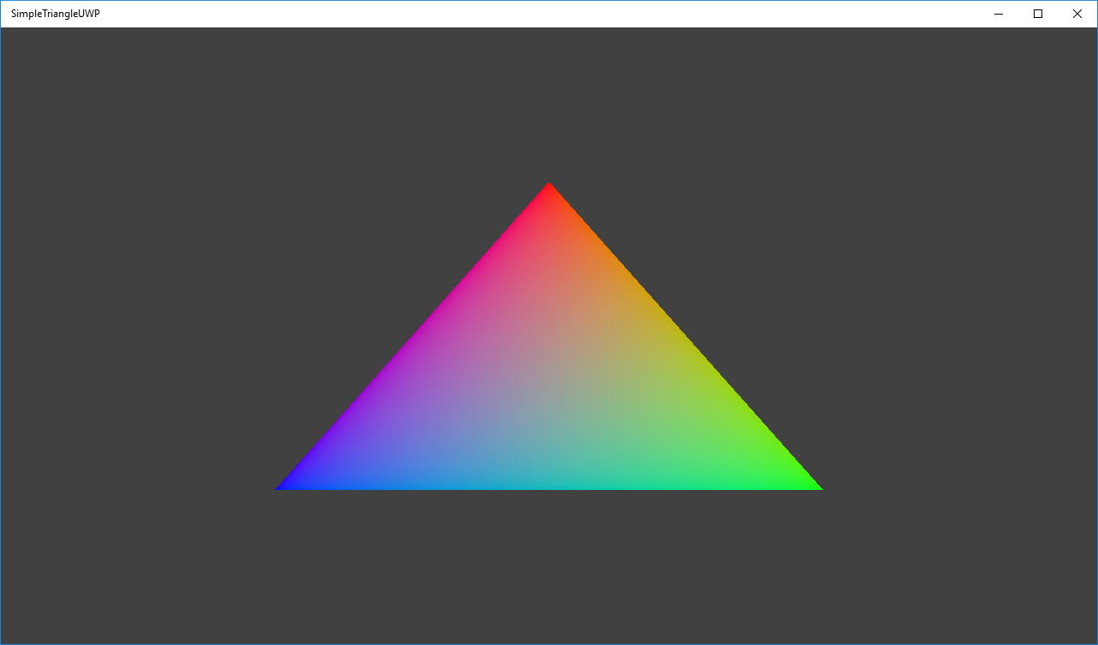

# Using the sample

The sample has no controls other than exiting.

# Implementation notes

The primary purpose of this sample is to familiarize the reader with the ATG samples template structure, as well as provide a simple demonstration of using Direct3D 11 APIs.

**CreateDeviceDependentResources**: This is where the compiled vertex and pixel shaders blobs are loaded and the various Direct3D rendering resources are created. *The shaders are compiled by Visual Studio.*

**Render:** This is where the triangle is rendered and presented to the screen.

For details on device creation and presentation handling, see [DeviceResources](https://github.com/Microsoft/DirectXTK/wiki/DeviceResources).

For details on the use of the loop timer, see [StepTimer](https://github.com/Microsoft/DirectXTK/wiki/StepTimer).

# Update history

Initial release March 2016