Gamepad Sample

# *This sample is compatible with the Windows 10 Anniversary Update SDK (14393)*

# Description

This sample demonstrates how to read inputs from a gamepad in a Universal Windows Platform (UWP) app implemented using the C++/WinRT projections

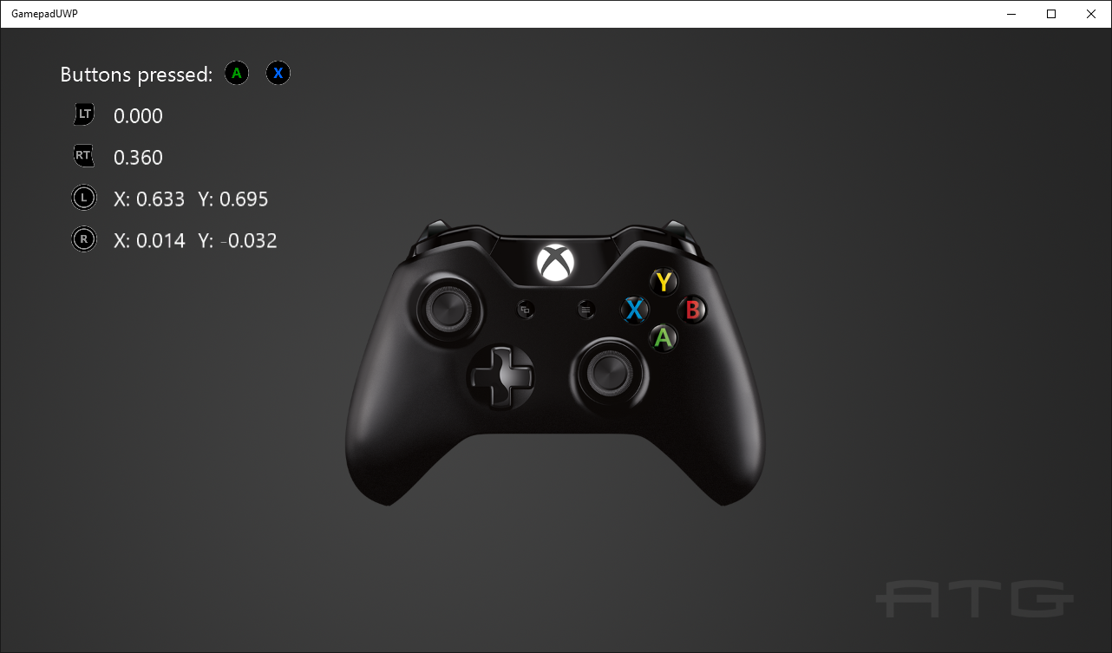

# Building the Sample

The C++/WinRT projection headers require Visual Studio 2015 Update 3 or later to build properly.

# Using the sample

Press buttons to see them displayed and move the thumbsticks and triggers to see their readings.

# Implementation notes

This sample demonstrates how to use winrt.Windows.Gaming.Input to read input from a gamepad, including thumbsticks and triggers. Libraries in the winrt namespace mirror those with the same name outside of the winrt namespace very closely.

For more information on Windows.Gaming.Input, see [MSDN](https://msdn.microsoft.com/en-us/library/windows/apps/windows.gaming.input.aspx). Documents about, and header for, C++/WinRT development are available on [GitHub](https://github.com/Microsoft/cppwinrt). The headers may also be downloaded as a Nuget package under the name “cppwinrt”.

# Update history

Initial release December 2016

# Privacy statement

When compiling and running a sample, the file name of the sample executable will be sent to Microsoft to help track sample usage. To opt-out of this data collection, you can remove the block of code in Main.cpp labeled “Sample Usage Telemetry”.

For more information about Microsoft’s privacy policies in general, see the [Microsoft Privacy Statement](https://privacy.microsoft.com/en-us/privacystatement/).