

SimplePLM_UWP Sample

*This sample is compatible with the Windows 10 SDK November 2015 (10586).*

# Description

This sample shows the behavior of the PLM events and the events that are related to PLM. The sample will print to the screen and to debug output a timestamp, thread ID, function name, and any additional data relevant to that function for events related to PLM. This sample can be used to understand the behavior of PLM events.

The user also has the ability to toggle whether or not output is also displayed in the Windows Notification Center using the N key, which can be useful for watching events occur when the screen is not visible and there is no debugger attached.

The user can also toggle whether or not the sample uses a suspend deferral using the ‘D’ key. This will not change any PLM behavior but will demonstrate how the suspend can be completed off of the core window thread.

# Building the Sample

There are no additional steps necessary for building this sample. Simply open the solution in Visual Studio and then compile and run it.

# Using the sample

## Main Screen

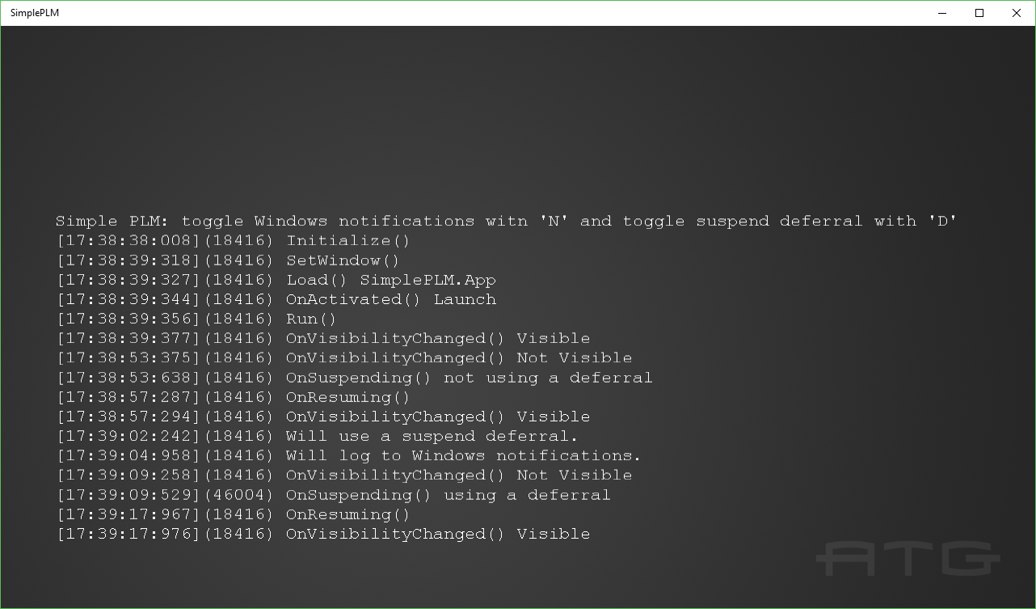

|  |  |  |
| --- | --- | --- |
| Action | Keyboard | Xbox One Controller |
| Toggle Windows Notifications | N | A |
| Toggle suspend deferral | D | B |
| Exit | Esc | View |

When running in Visual Studio to test suspend and resume operations, the user can use the Lifecycle Events menu to cause the app to suspend and resume shown below.

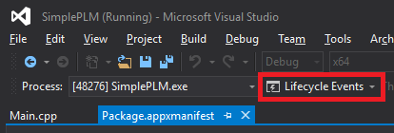

When not running in Visual Studio the user can cause an application to suspend by minimizing the app, it will begin suspending almost immediately. To resume a suspended application, the user simply needs to make the application visible again.

Another option is to use the PLMDebug.exe tool that is installed with the Windows SDK here:

C:\Program Files (x86)\Windows Kits\10\Debuggers\x64\plmdebug.exe

Which will allow you to suspend and resume an app with the following commands:

plmdebug.exe /suspend SimplePLM_1.0.0.0_x64__g2vy7yb2fz2ne

plmdebug.exe /resume SimplePLM_1.0.0.0_x64__g2vy7yb2fz2ne

# Implementation notes

This sample currently logs events for the following functions:

IFrameworkView::Initialize

IFrameworkView::SetWindow

IFrameworkView::Load

CoreApplicationView::Activated

IFrameworkView::Run

CoreApplication::Suspending

CoreApplication::Resuming

CoreWindow::VisibilityChanged

Logging of these events occurs in Main.cpp in the associated functions and event handlers, not in SimplePLM.cpp. There are also logs for when notifications or suspend deferral are toggled and an initial log to remind the user of the controls.

# Update history

Initial release April 2016