SystemInfo Sample

*This sample is compatible with Windows 10 SDK November 2015 (10586).*

# Description

This sample demonstrates a number of Universal Windows Platform (UWP) APIs for querying system information, statistics, and hardware capabilities.

# Using the sample

This sample displays a series of text pages with technical information.

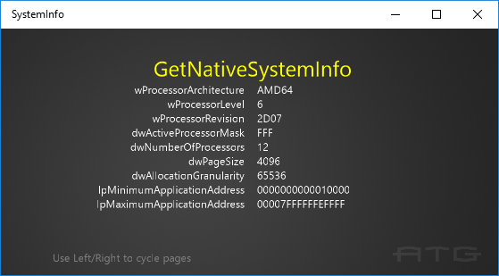

To switch between pages with the keyboard, use the left & right arrow keys.

To switch between pages with the keyboard, use A or DPad Right / B or DPad Left.

# Implementation notes

The important code is in the switch case within the **Render** function.

# Update history

Initial release March 2016