Error Lookup Sample

*\* This sample is compatible with the Windows 10 SDK*

# Description

This sample demonstrates the Cloud Error Message (CEM) service. The service allows a game or app to query the system for a user friendly messages for a given error code. Error code messages are cached on the system which is updated regularly. If a message is not available in the system cache, then an online service is queried so the local cache can be updated with new data. This service is available for UWP games and apps only.

# Building the Sample

Requirements:

* Visual Studio 2015 with Windows 10 SDK

# Using the sample

This utility utilizes the Cloud Error Message (CEM) service to quickly look up the meaning of the common error codes. Type the code you’d like to query into the text box at the top of the utility, then hit the “Lookup” button. Results will be displayed in the larger text box below the “Lookup” button.

The text entered is converted to a 32-bit signed integer at runtime. This means its value must be within the range of [-2147483648, 2147483647]. A number that begins with “0x” will be converted as a hexadecimal number. All other input will fail to be converted at runtime.

## User Interface

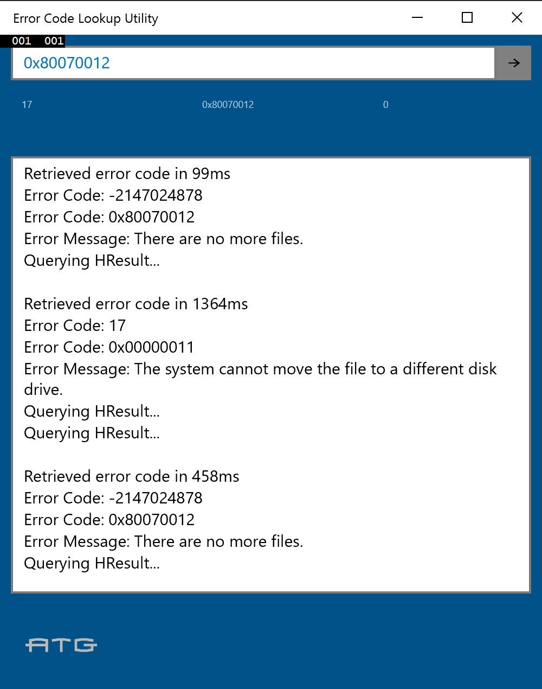

|  |  |
| --- | --- |
| Action | Button |
| Execute error lookup | Click the arrow button to the right of the input text box, or hit the ‘Enter’ key |
| Lookup recent error codes | Click on one of the recent error codes displayed beneath the input text box |

# Implementation notes

This sample is a small utility mainly focused on demonstrating one implementation of the **ErrorDetails** class in the **Windows::Foundation::Diagnostics** namespace. The **ErrorDetails** class contains one static method, **CreateFromHResultAsync**. This method takes a single parameter, a signed integer, and asynchronously checks it against a locally cached list of available error codes and error messages. If the message is not available locally, then it will check the CEM for any updated data for the provided code. If it is available on the service, it will be added to the local cache for faster retrieval the next time it is queried. Due to the divergent branches of the function, it may return quickly, on the order or a few milliseconds, or take as long as is required for a network request. The information returned includes a user friendly error message that can be displayed to the user along with other, optional information.

# 

# Known issues

* This utility does not support gamepad input

# Update history

3/25/2016 – Initial release