

Simple Mesh Shader Sample

*This sample is compatible with the Microsoft Game Development Kit (June 2020) and Windows 10 (Version 2004) May 2020 Update*

# Description

This sample is a companion to the well-aged sample SimpleTriangle with the exception being that it uses mesh shaders. Its purpose is to simply demonstrate all the pieces necessary to get a mesh shader pipeline initialized and running on both PC & the Scarlett GXDK.

Note: There is no mesh shader support on the Xbox One console family, and as such no build configuration is available for that platform.

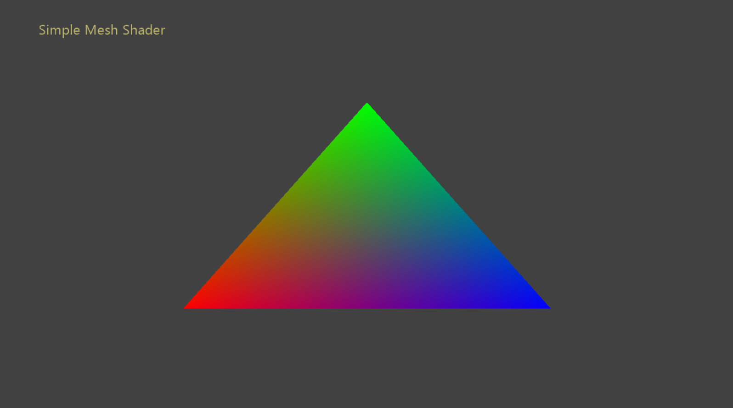

# Building the sample

If using Project Scarlett, set the active solution platform to Gaming.Xbox.Scarlett.x64.

If using PC with appropriate hardware and Windows 10 release, set the active solution platform to Gaming.Desktop.x64.

This sample does not support Xbox One.

*For more information, see* Running samples*, in the GDK documentation.*

# Using the sample

|  |  |
| --- | --- |
| Action | Gamepad |
| Exit | View Button |

# Implementation notes

The steps demonstrated by this sample are as follows:

1. Initialize the ID3D12Device & request API objects for rendering with DirectX12.
2. Check for mesh shader feature support using the ID3D12Device::CheckFeatureSupport() function.
3. Create a mesh shader pipeline using the ID3D12Device2::CreatePipelineState() function.
4. Bind the root signature, pipeline state, and resources to a command list. Dispatch the mesh bound pipeline using the ID3D12GraphicsCommandList6::DispatchMesh() function with the requisite parameters.

# Update history

10/31/2019 – Sample creation.

4/28/2020 - Updated to use the D3DX12 helpers for mesh shader pipeline creation

# Privacy Statement

When compiling and running a sample, the file name of the sample executable will be sent to Microsoft to help track sample usage. To opt-out of this data collection, you can remove the block of code in Main.cpp labeled “Sample Usage Telemetry”.

For more information about Microsoft’s privacy policies in general, see the [Microsoft Privacy Statement](https://privacy.microsoft.com/en-us/privacystatement/).