

In-Game Store Sample

*Windows PC: This sample is compatible with the Microsoft Game Development Kit (June 2020 QFE6)*

*Xbox One/Xbox Series X|S: This sample is compatible with the Microsoft GDKX (June 2020 QFE6)*

# Description

This sample demonstrates the client-based operations used in presenting and operating an in-game storefront. This also shows how to examine game license information, including how to enable and check for trial status.

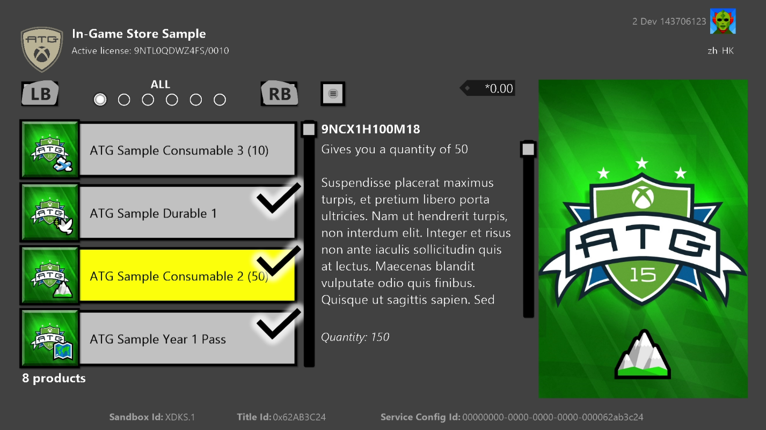

# Building the sample

This sample supports Xbox One, Scarlett as well as Desktop. Select the config in the dropdown to build.

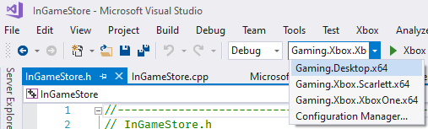

*For more information, see* Running samples*, in the GDK documentation.*

# Running the sample

The example exercises several API that are either specific to an item (purchase, license, etc.) or universally (show associated products, query entitled products, etc.). Select an item in the product list to bring up the item-specific menu; select the menu button (menu button on controller) for the universal menu.

A key characteristic of using the XStore API’s is that they require a valid license in order to function. Refer to the GDK documentation section titled “Setting up your product to test the XStore API” for full details.

A license is verified with a call to the licensing service when the game is launched. Without this available, XStore APIs will typically return 0x803f6107 (IAP_E_UNEXPECTED) indicating that a valid license was not found.

To obtain a valid license for the sample for your test account, ensure you are in sandbox **XDKS.1** (any developer account can use this sandbox), then go the store page for the sample product to acquire a license:

**Xbox:**

In Gaming command prompt: xbapp launch ms-windows-store://pdp/?productid=9NTL0QDWZ4FS

**PC:**

Run box (Win+R):

ms-windows-store://pdp/?productid=9NTL0QDWZ4FS

or

msxbox://game/?productId=9NTL0QDWZ4FS

Select “Get” to obtain a product license for the account. It is not necessary to wait for the download to complete:

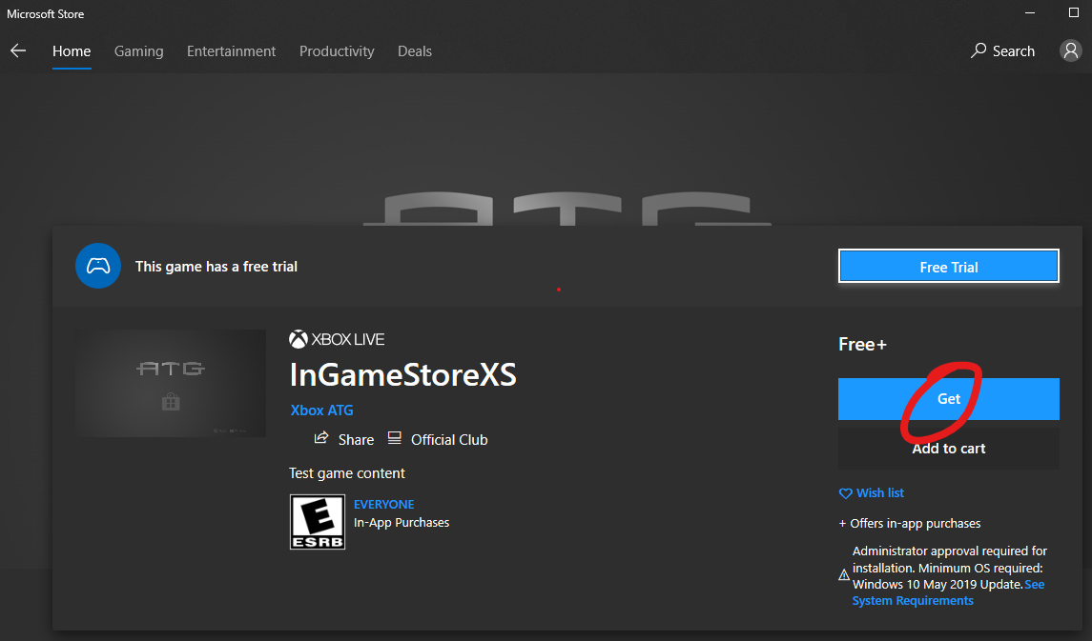

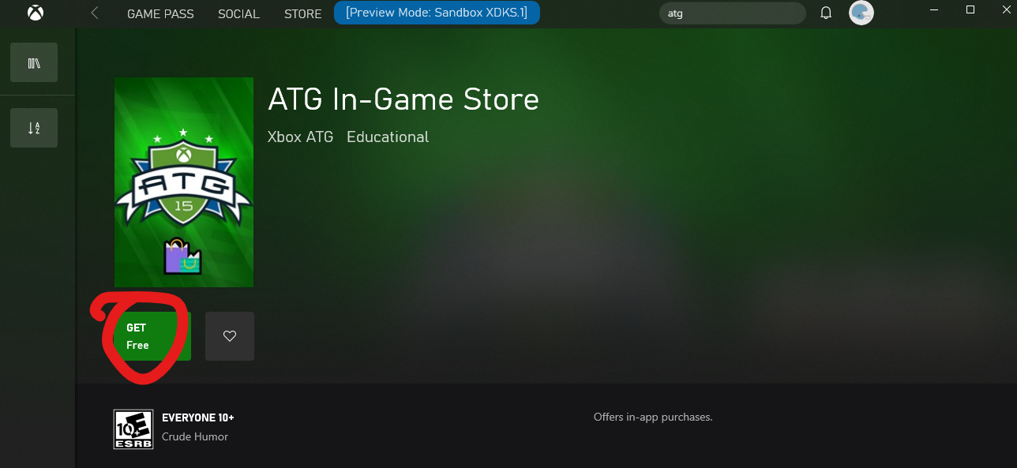

The sample as installed from the store will be properly licensed and function properly, but may represent an older version of the sample.

**Xbox only:** A **locally deployed build** (i.e. push or run from PC) will not be licensable by default, but if the microsoftgame.config contains development only override values for content ID and EKBID, it will be able to license properly and allow XStore API to work. Note this section in the microsoftgame.config in this sample:

<DevelopmentOnly>

<ContentIdOverride>2797FA46-A93B-494C-AD80-B67C9FCA939F</ContentIdOverride>

<EKBIDOverride>00000000-0000-0000-0000-000000000001</EKBIDOverride>

</DevelopmentOnly>

Content ID must match that assigned to the package submitted the sandbox in Partner Center.

EKBID can be anything other than all zeroes or the default 33EC8436-5A0E-4F0D-B1CE-3F29C3955039.

Once this is in place, and in combination with an account licensed to the product, the sample will run in licensed state.

A **locally built packaged build** (i.e. not installed from store) will also not be licensable, and the overrides present in the microsoftgame.config will also not apply. Licensing will require four things:

1. **Identity name** and **publisher** that matches the one assigned to your title in Partner Center
2. **Store ID** that matches your title’s
3. Package built with **content ID** that matches the one assigned to the ingested package in sandbox
4. **EKBID** set to a GUID that is not all zeroes or the default value:

xbapp setekbid *<pfn>* {*<EKBIDOverride value>*}

<pfn> is the installed package full name or package family name

Ensure you have the braces around the EKBID, e.g.

xbapp setekbid 41336MicrosoftATG.InGameStoreXS_1.0.0.0_neutral__dspnxghe87tn0 {00000000-0000-0000-0000-000000000001}

or

xbapp setekbid 41336MicrosoftATG.InGameStoreXS_dspnxghe87tn0!Game {00000000-0000-0000-0000-000000000001}

The best way to obtain the content ID, the proper EKBID (not required), and PFN is to install the ingested and published package from sandbox and then running xbapp list /d

Registered Applications by Package Full Name:

41336MicrosoftATG.InGameStoreXS_1.0.0.0_neutral__dspnxghe87tn0

Install

Drive: Retail

Size: 0.28 GB.

ContentId: {2797FA46-A93B-494C-AD80-B67C9FCA939F}

ProductId: {4C544E39-5130-3044-C057-5A3446536A00}

EKBID: {37E80840-6BEE-46F8-8EDB-92F877056087}

DisplayName: ATG In-Game Store Sample

41336MicrosoftATG.InGameStoreXS_dspnxghe87tn0!Game

These values can also be seen onscreen by selecting Menu on the installed title’s tile in My Games and looking at File Info.

In the case of EKBID, this is visible upon package registration, i.e. Ready to Launch, so if your title’s package is large, this can be cancelled at this time once you have the EKBID and intend to deploy or sideload your development build instead. This is not strictly needed unless you wish to test trial scenarios (see below).

## Explanation

On Xbox, a license is obtained using a combination of the content ID, product ID and the EKBID. For builds not obtained through consumer channels (i.e. from the Microsoft Store or from retail), these attributes must be manually applied to match that of that title’s package submission to a sandbox.

Loose file deploys are unlicensed and are not associated with a real content ID. The override values in the microsoftgame.config is how to apply the real IDs to local builds.

Locally built packages can be created with the correct content ID and applying a non-test EKBID to this installed package will allow the proper combination to mimic a package obtained from store.

Product ID is derived from the Store ID so this never needs to be manually set, only that you use the correct Store ID.

All these steps still require a product be configured and published to the sandbox. Contact your account representative to find out where to look for the content ID after submission. The content ID may be different per sandbox.

On PC, the license is generated from the combination of app identity and the content ID, having these match the canonical values of a published product available in the same sandbox will suffice to allow the sample to run in licensed state.

# Testing trials

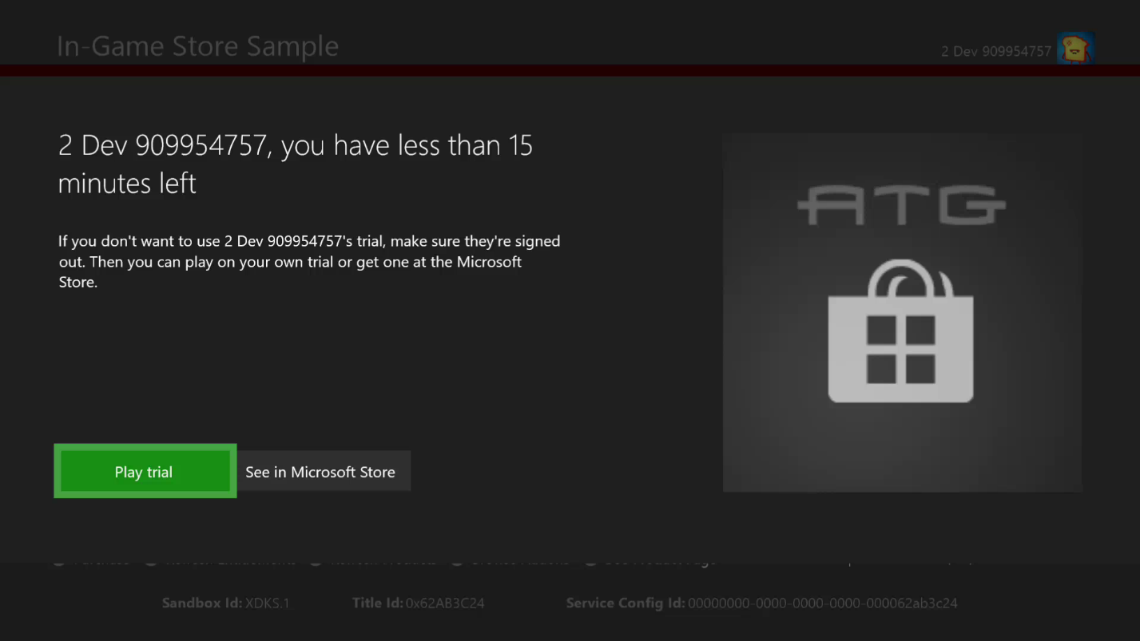

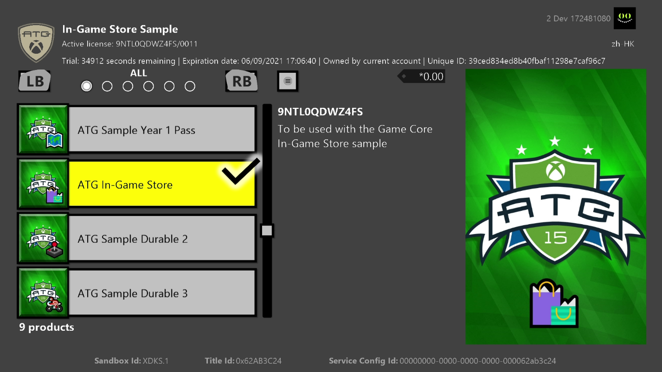

This sample can also be run in trial mode. The product this sample points to be default is configured with a usage-based trial, that is, once obtained, the licensee will have 10 hours of title uptime. This uptime is configured in Partner Center, and requires the title to use the Restrictive Licensing policy. Contact your Microsoft Account Representative for more details.

In order to execute in trial mode:

1. Ensure no other account with any license to the sample product is signed in, or present in the case the console is set as Home Xbox for any owner account
2. Obtain a trial license with a test account

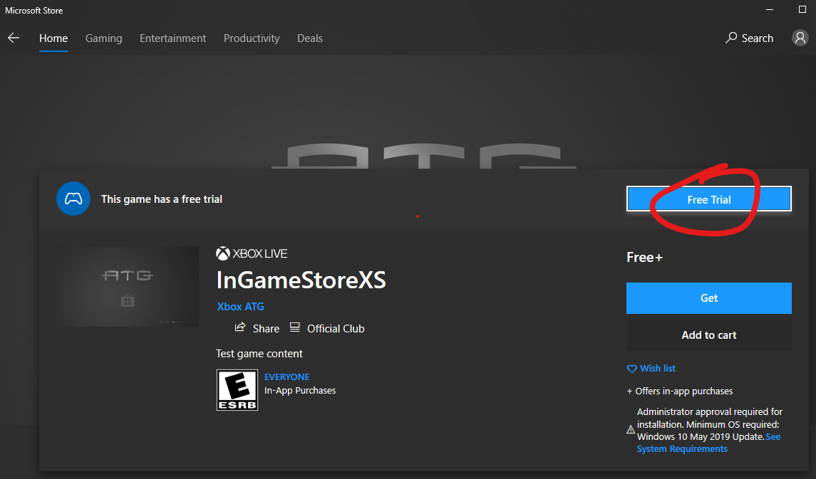

1. **Xbox only:** Download store package fully
2. **Xbox only:** Launch the store package, a TCUI should show up stating the approximate gameplay time remaining

In order to sideload development build that runs in trial mode:

1. **Xbox only:** With the package installed in step 3 above, obtain content ID and EKBID
   1. **IMPORTANT:** In this scenario it is necessary to use the **actual** EKBID from a package downloaded by a trial license owner
2. **Xbox only:** Update development build’s microsoftgame.config’s override values to match
3. Uninstall store package, build and deploy
4. Launch (F5 or from Start menu), observe trial attributes should show in debug and UI

**Xbox only:** In order to see the TCUI trial notification, you need to additionally create a packaged build using makepkg and install using xbapp install

When in trial mode, an additional item will show in the catalog that represents the sample product itself, in order to facilitate an upsell to the full game.

There are two important attributes to check when in trial mode, depending on platform and scenario:

* **Xbox only:** isTrialOwnedByThisUser: for usage-based trials, check this to ensure that the game was launched by the user whose account acquired the trial. If this is not checked, then users can obtain the trial with new accounts and continue playing indefinitely with the first account.
  + **Note this does not work on PC**
* trialUniqueId: this is specific to each trial instance, i.e. for an account. Use this to persist in save game data to ensure that no other account’s trial (which will have a different trialUniqueId) can read from the save and continue it.

# Pointing sample to your title

You can redirect the sample to use your title configuration in order to test and troubleshoot product enumeration and purchase functionality related to your addons. Note that this take the place of any installed build, so be aware as installing the sample as your title may incur subsequent reinstallation cost.

1. Use a test account that is provisioned for sandbox and owns the title
2. From your title’s microsoftgame.config. copy over
   1. Identity node; version doesn’t matter
   2. Title ID
   3. Store ID
   4. **Xbox only:** ContentIdOverride and EKBIDOverride
3. Rebuild and deploy
4. Launch (in your developer sandbox)

It is recommended you do a clean rebuild and uninstall all previous installations of the sample that points to any other title.

If you encounter issues on Xbox, do an xbapp list /d on the deployment and ensure that all values match the expected values of your title’s, aside from the names and version numbers you hadn’t changed. For both platforms, ensure the PFN matches in terms of the app identity as well as the suffix which is a function of your publisher.

41336MicrosoftATG.InGameStoreXS_1.0.0.0_neutral__dspnxghe87tn0

Folder: xD:\Drives\Retail\41336MicrosoftATG.InGameStoreXS_dspnxghe87tn0

Drive: Retail

ContentId: {2797FA46-A93B-494C-AD80-B67C9FCA939F}

ProductId: {4C544E39-5130-3044-C057-5A3446536A00}

EKBID: {37E80840-6BEE-46F8-8EDB-92F877056087}

DisplayName: ATG In-Game Store Sample

41336MicrosoftATG.InGameStoreXS_dspnxghe87tn0!Game

xD:\Drives\Retail\41336MicrosoftATG.InGameStoreXS_dspnxghe87tn0\InGameStore.exe

On PC, you can check the installed app details with get-appxpackage in powershell, e.g.

Name : 41336MicrosoftATG.InGameStoreXS

Publisher : CN=A4954634-DF4B-47C7-AB70-D3215D246AF1

Architecture : X64

ResourceId :

Version : 1.0.0.0

PackageFullName : 41336MicrosoftATG.InGameStoreXS_1.0.0.0_x64__dspnxghe87tn0

InstallLocation : E:\Repos\ATGgit\gx_dev\Samples\Live\InGameStore\Gaming.Desktop.x64\Debug

IsFramework : False

PackageFamilyName : 41336MicrosoftATG.InGameStoreXS_dspnxghe87tn0

PublisherId : dspnxghe87tn0

IsResourcePackage : False

IsBundle : False

IsDevelopmentMode : True

NonRemovable : False

IsPartiallyStaged : False

SignatureKind : None

Status : Ok

# Implementation notes

If multiple users are signed in, the account picker will show and the StoreContext will be assigned to selected user.

**XStoreShowAssociatedProductsUI** and **XStoreShowProductPageUI** are newer API available since June 2020 QFE6 GDK. For PC, it will require at least Microsoft.GamingServices version 2.43.30001.0 or newer.

## Paging

Any of the API that returns XStoreProducts to enumerate can be called with a page size parameter. This sample executes the paging handling code by artificially setting the page size low. A more reasonable page size is 25. Note that this does not correspond to the number of service requests the title makes (this is handled automatically). This is useful for segmenting your results so you the enumeration callback can execute at a more regular interval for large catalogs.

## Consumables

This sample in CopyToUIProduct assigns a quantity value from the XStoreProduct. Consumables theoretically can be configured for multiple SKUs, each of which can be individually purchased and have a separate quantity assigned to it. The code will simply add them up to present a single quantity. In practice, consumables will only have a single SKU and the quantity will simply correspond to the product.

Even though the quantity value is obtained and displayed from the queried product results, it is recommended to obtain the consumable quantity using a b2b call from a title service. The collections service and the b2blicensepreview endpoint is the recommended way to do this. Please refer to the documentation on collections for more details.

# Known issues

isTrialOwnedByThisUser does not return true for PC, even if trial owner is the only account signed in. This will be addressed in a future OS update, but in the meantime, usage-based trials are not typical for the PC platform, so this should be irrelevant. Contact your Microsoft Account Manager and ATG if you think this is important.

XStoreRegisterPackageLicenseLost may give an exception for PC when called on an XStoreLicenseHandle for a Durable (without package) type. This is known issue at least with Microsoft.GamingServices version 2.53.17003.0 and is being investigated. Comment it out to bypass.

If the number products approaches 200, there may not be sufficient resources to support texture allocation and an exception will occur. This also happens if navigating between tabs as new textures are assigned to the list items. If this is a problem, adjust the below line to increase the limit:

auto styleRenderer = std::make_unique<UIStyleRendererD3D>(*this, 200);

# Privacy statement

When compiling and running a sample, the file name of the sample executable will be sent to Microsoft to help track sample usage. To opt-out of this data collection, you can remove the block of code in Main.cpp labeled “Sample Usage Telemetry”.

For more information about Microsoft’s privacy policies in general, see the [Microsoft Privacy Statement](https://privacy.microsoft.com/en-us/privacystatement/).

# Update history

**Initial Release:** April 2019

**Update:** April 2020

**Update:** May 2020

**Update:** September 2020

**Update:** June 2021