

Leaderboards Sample

*This sample is compatible with the Microsoft Game Development Kit with Xbox Extensions (November 2020)*

# Description

The leaderboards sample demonstrates the usage of Xbox Live Leaderboards with Title-Managed stats (previously referred to as Stats 2017).

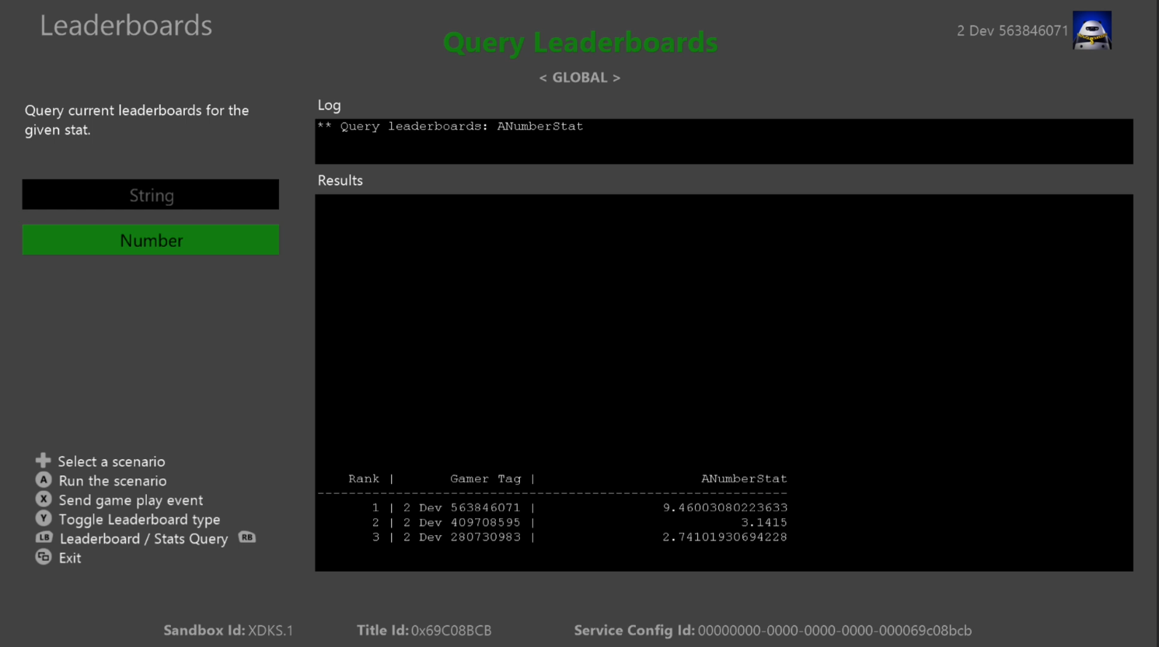

# Building the sample

If using an Xbox One devkit, set the active solution platform to Gaming.Xbox.XboxOne.x64.

If using Project Scarlett, set the active solution platform to Gaming.Xbox.Scarlett.x64.

*For more information, see* Running samples*, in the GDK documentation.*

# Running the sample

* You will need an Xbox Live test account signed in to send player stats and view *Social Leaderboards*
* Xbox One devkit: set the console’s sandbox to XDKS.1

*NOTE: You will need more than one test account, friended with each other both having sent stats from the sample to see more than one user listed in Social Leaderboards queries*

# Sample Setup in Partner Center

Unlike Leaderboards based on Event-Based stats, Title-Managed Featured Stats and Leaderboards are defined at the same time.

1. Create a new leaderboard for the stat
2. Fill out the information for the stat

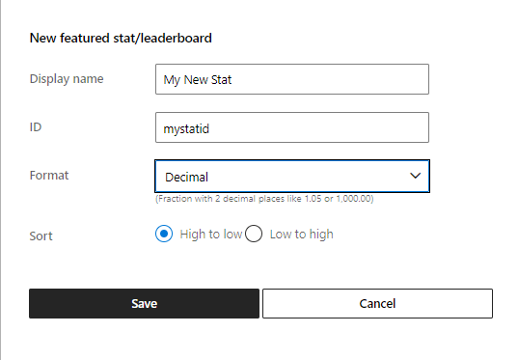

The ID field is what you will use to refer to your stat when uploading from the client.

NOTE: When selecting the String type for a stat, the sorting mode doesn’t matter as they can’t be used in leaderboards. Instead, they are just queried from the server.

Below are the stats defined for this sample.

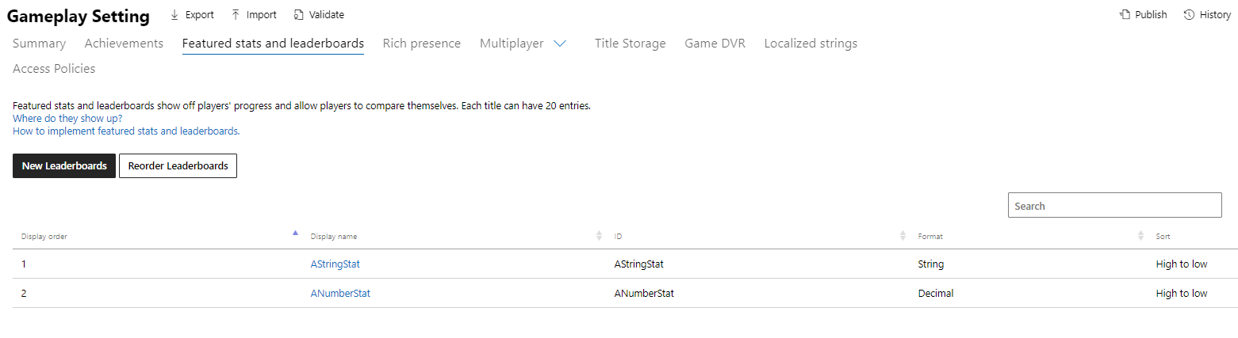

*NOTE: These images reflect the layout of Partner Center at the time this sample was written.*

# Privacy statement

When compiling and running a sample, the file name of the sample executable will be sent to Microsoft to help track sample usage. To opt-out of this data collection, you can remove the block of code in Main.cpp labeled “Sample Usage Telemetry”.

For more information about Microsoft’s privacy policies in general, see the [Microsoft Privacy Statement](https://privacy.microsoft.com/en-us/privacystatement/).

# Update history

**Initial Release:** January 2021