

FrontPanelLogo Sample

*This sample is compatible with the Microsoft Game Development Kit (June 2020)*

# Description

This sample provides some starting code to help you render an image the Xbox One X Devkit and Project Scarlett devkit front panel displays using a standard image format. For example, if you are demonstrating your game at a tradeshow or a conference, you may want to have some graphics on the front panel that are consistent with the art and style of your game. The sample also displays an image on the main display and so will run on an Xbox One S or Xbox One devkit as well, however there is limited utility in using the sample this way.

# Building the sample

If using an Xbox One devkit, set the active solution platform to Gaming.Xbox.XboxOne.x64.

If using Project Scarlett, set the active solution platform to Gaming.Xbox.Scarlett.x64.

*For more information, see* Running samples*, in the GDK documentation.*

By default, the sample uses two images to display on the Front Panel and main display during execution. FrontPanelLogo.png is displayed on the FrontPanel while FullScreenLogo.png is displayed on the main display. For a quick and simple customization, you can simply replace FrontPanelLogo.png and FullScreenLogo.png with your own artwork and rebuild.

# Using the sample

## Main Display Logo

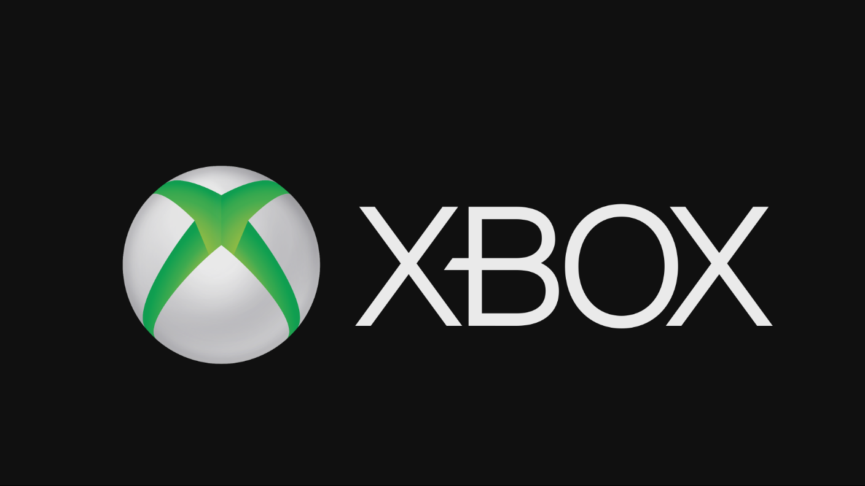

## Front Panel Display Logo



|  |  |
| --- | --- |
| Action | Gamepad |
| Exit | View Button |

# Implementation notes

The sample uses a helper class, FrontPanelDisplay, which manages a buffer for the FrontPanel and provides methods for simplifying display operations. In particular, the sample uses FrontPanelDisplay::LoadWICFromFile to load a standard .png image file. The method supports many standard image formats including PNG, JPG, and BMP. The method will also automatically scale and convert the image to the required size and pixel format for the front panel. If you are concerned about image quality on the front panel, you will get the best results by editing the image beforehand to best fit the size and pixel format of the panel. (The panel has 256x64 pixels with 16 shades of gray per pixel.)

To quickly add a custom front panel image to your own game, add the FrontPanelDisplay class (and supporting code) to your codebase and then copy only a few lines of code from the sample to initialize the display and load the image:

if (XFrontPanelIsAvailable())

{

// Initialize the FrontPanelDisplay object

m_frontPanelDisplay = std::make_unique<FrontPanelDisplay>();

// Load the logo image

m_frontPanelDisplay->LoadWICFromFile(L"Assets\\FrontPanelLogo.png");

}

Somewhere in your initialization/update code path you will need to make at least one call to FrontPanelDisplay::Present():

if (XFrontPanelIsAvailable())

{

// wait a few frames and then this only needs to be called once

if (m_timer.GetFrameCount() == 10)

{

m_frontPanelDisplay->Present();

}

}

# Update history

First released in April 2019.

Support for the Project Scarlett Devkit in November 2019.

# Privacy Statement

When compiling and running a sample, the file name of the sample executable will be sent to Microsoft to help track sample usage. To opt-out of this data collection, you can remove the block of code in Main.cpp labeled “Sample Usage Telemetry”.

For more information about Microsoft’s privacy policies in general, see the [Microsoft Privacy Statement](https://privacy.microsoft.com/en-us/privacystatement/).