

Gamepad Sample

*This sample is compatible with the Microsoft Game Development Kit (August 2020)*

# Description

This sample demonstrates how to read inputs sequentially from a gamepad

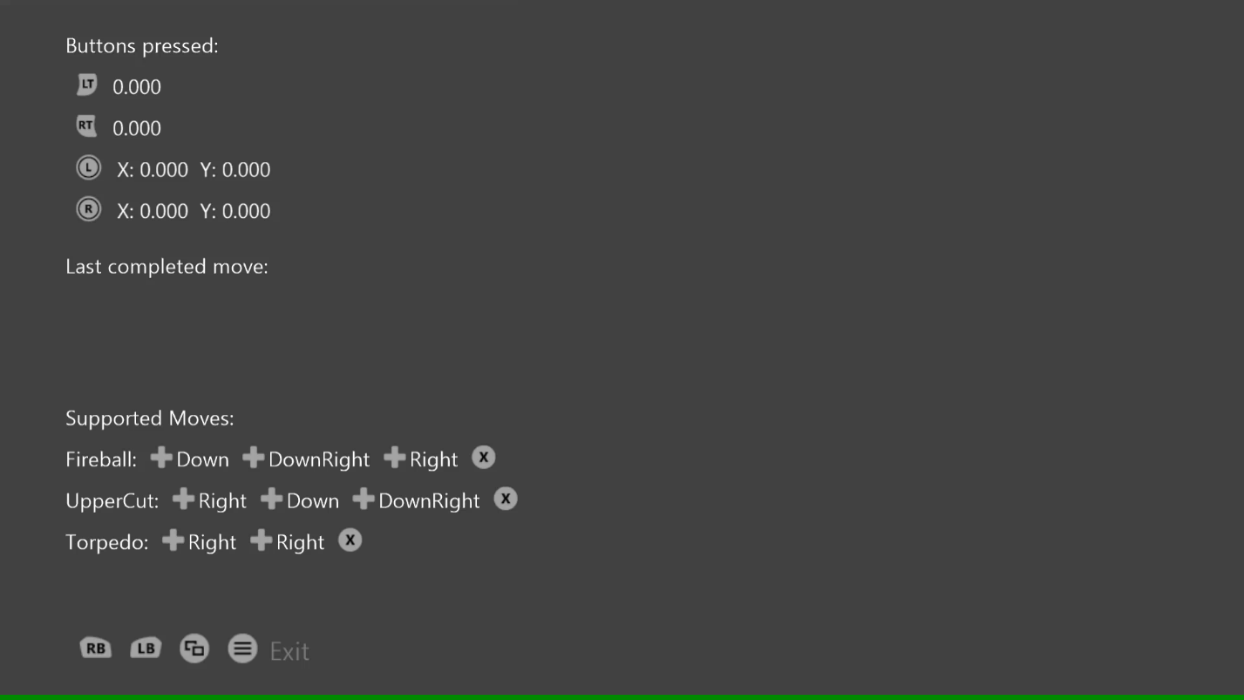

# Using the sample

Press buttons to see them displayed and move the thumbsticks and triggers to see their readings. Use the sequences of inputs listed at the bottom to see the complete “moves”.

# Implementation notes

This sample demonstrates how to use the GameInput API to read input from a gamepad sequentially. While GetCurrentReading can be used to get the current state of input, this sample then uses the GetNextReading call to walk through the sequential recent history of input events to read them in order.

# Privacy statement

When compiling and running a sample, the file name of the sample executable will be sent to Microsoft to help track sample usage. To opt-out of this data collection, you can remove the block of code in Main.cpp labeled “Sample Usage Telemetry”.

For more information about Microsoft’s privacy policies in general, see the [Microsoft Privacy Statement](https://privacy.microsoft.com/en-us/privacystatement/).