

Gamepad Vibration Sample

*This sample is compatible with the Microsoft Game Development Kit (June 2020)*

# Description

This sample demonstrates how to use vibration with a gamepad on an Xbox One.

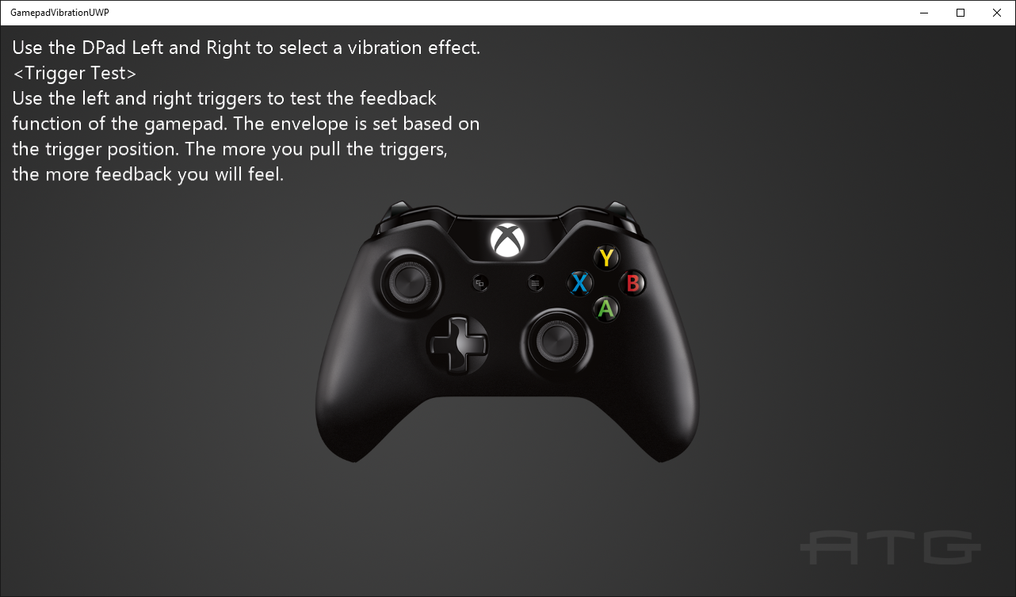

# Building the sample

If using an Xbox One devkit, set the active solution platform to Gaming.Xbox.XboxOne.x64.

If using Project Scarlett, set the active solution platform to Gaming.Xbox.Scarlett.x64.

*For more information, see* Running samples*, in the GDK documentation.*

# Using the sample

Use left and right on the DPad to cycle between different vibration examples. Use the triggers in most of these examples to increase the amount of vibration.

# Implementation notes

This sample demonstrates how to use the GameInput API to set vibration levels on an Xbox One gamepad.

# Update history

Initial release April 2019

Updated in June 2019 for minor breaking change to **SetRumbleState**.

February 2020: Updated for changes to GameInput API.

# Privacy statement

When compiling and running a sample, the file name of the sample executable will be sent to Microsoft to help track sample usage. To opt-out of this data collection, you can remove the block of code in Main.cpp labeled “Sample Usage Telemetry”.

For more information about Microsoft’s privacy policies in general, see the [Microsoft Privacy Statement](https://privacy.microsoft.com/en-us/privacystatement/).