

SystemInfo Sample

*This sample is compatible with the Microsoft Game Development Kit Preview (June 2020)*

# Description

This sample demonstrates a number of APIs for querying system information and hardware capabilities.

# Building the sample

If using an Xbox One devkit, set the active solution platform to Gaming.Xbox.XboxOne.x64.

If using Project Scarlett, set the active solution platform to Gaming.Xbox.Scarlett.x64.

If using PC with Windows 10 May 2019 Update (Version 1903; Build 18362) release or later, set the active solution platform to Gaming.Deskop.x64.

*For more information, see* Running samples*, in the GDK documentation.*

# Using the sample

This sample displays a series of text pages with technical information.

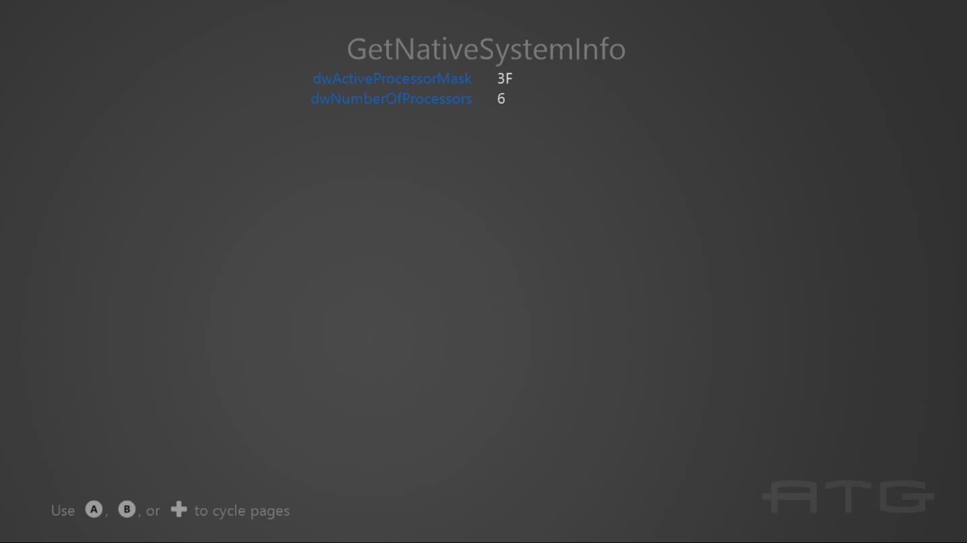

To switch between pages with the gamepad controller, use A or DPad Right / B or DPad Left.

For keyboard, use Left or Enter / Right or BackSpace.

# Implementation notes

The important code is in the switch case within the **Render** function.

# Update history

October 2018: Initial GDK release

April 2020 – Updated to support Gaming.Desktop.x64

June 2020 – Added use of GetLogicalProcessorInformation / Get LogicalProcessorInformationEx

# Privacy statement

When compiling and running a sample, the file name of the sample executable will be sent to Microsoft to help track sample usage. To opt-out of this data collection, you can remove the block of code in Main.cpp labeled “Sample Usage Telemetry”.

For more information about Microsoft’s privacy policies in general, see the [Microsoft Privacy Statement](https://privacy.microsoft.com/en-us/privacystatement/).