

*Geophysical Research Letters*

Supporting Information for

**Stratigraphy of ice and ejecta deposits at the lunar poles**

Kevin M. Cannon1,2, Ariel N. Deutsch3,4, James W. Head III4, and Daniel T. Britt5

1Colorado School of Mines, Department of Geology and Geological Engineering, Golden CO 80401

2Colorado School of Mines, Space Resources Program, Golden CO 80401

3Now at: NASA Ames Research Center, Mountain View CA 94035

4Brown University, Department of Earth, Environmental and Planetary Sciences, Providence RI 02906

5University of Central Florida, Department of Physics, Orlando FL 32816

**Contents of this file**

Figure S1 to S4

Text S1 to S5

Tables S1 to S3

Data Set S1 to S2

**Introduction**

This supporting information provides a map of cold traps (Figure S1), ice deposition vectors from the Monte Carlo model runs (Figures S2-S4), a description of the ice migration modeling (Text S1), crater counting methods (Text S2), the resulting model ages for the large polar craters (Tables S1 and S2), a description of ice sources from impact and volcanism (Text S3 and S4; Table S3), a description of the metric for gardening shown in Figure 1 (Text S5), and MATLAB code for the main functions used in the ice deposition model (Data Set S1 and S2).

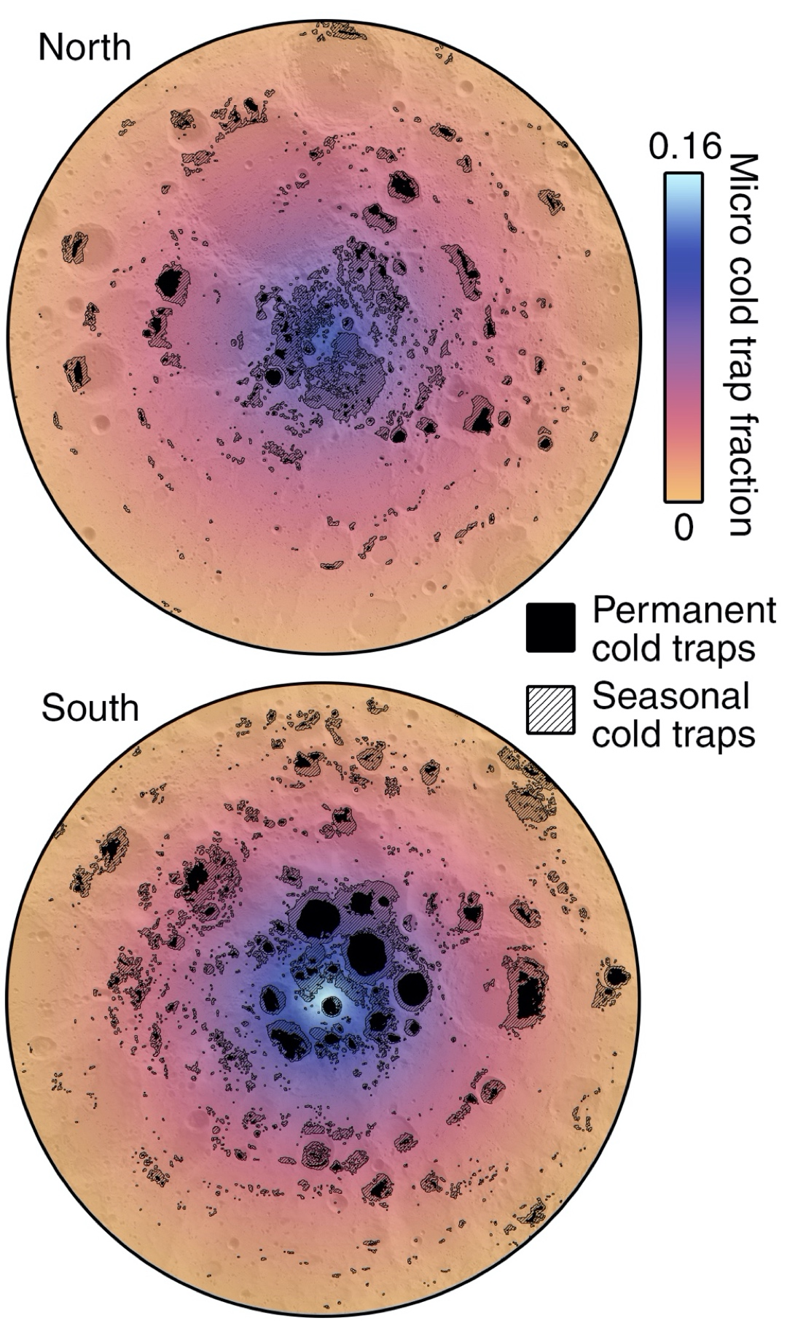

**Figure S1.** Maps from 80–90° showing large permanent cold traps (many of them hosted within the age-dated craters in this study) seasonal cold traps (modified from Williams et al., 2019), and micro cold trap areal fractions derived from Hayne et al. (2020).

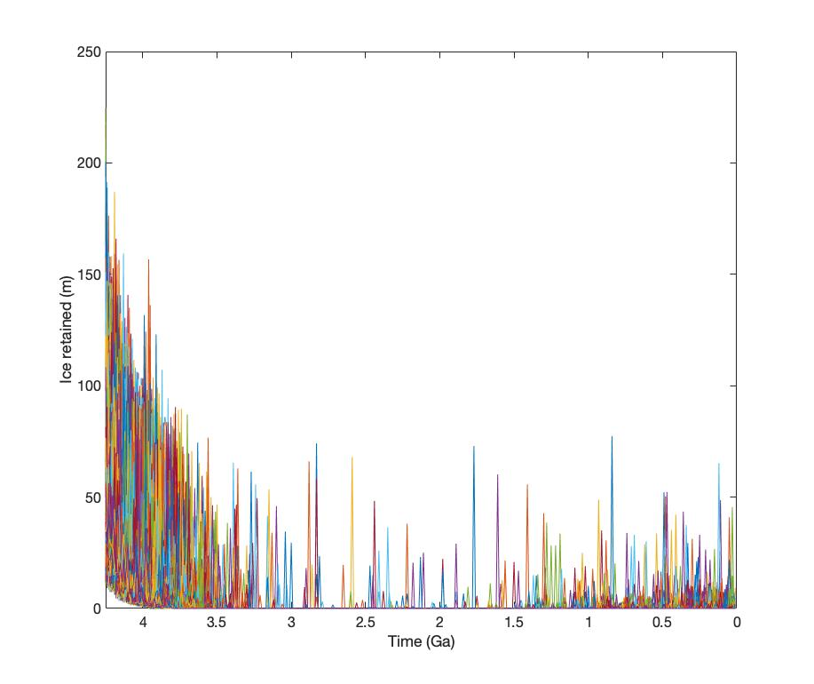

**Figure S2.** Model ensemble showing the thickness of ice retained (north pole) for all 10,000 runs.

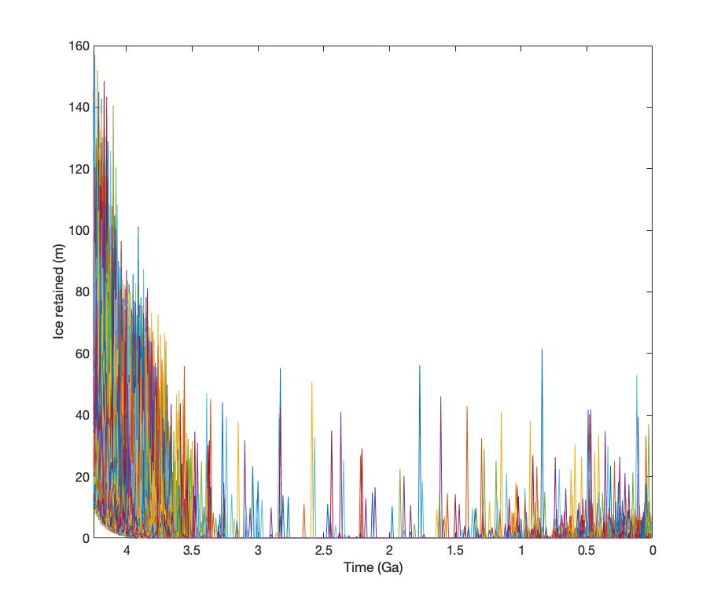

**Figure S3.** Model ensemble showing the thickness of ice retained (south pole) for all 10,000 runs.

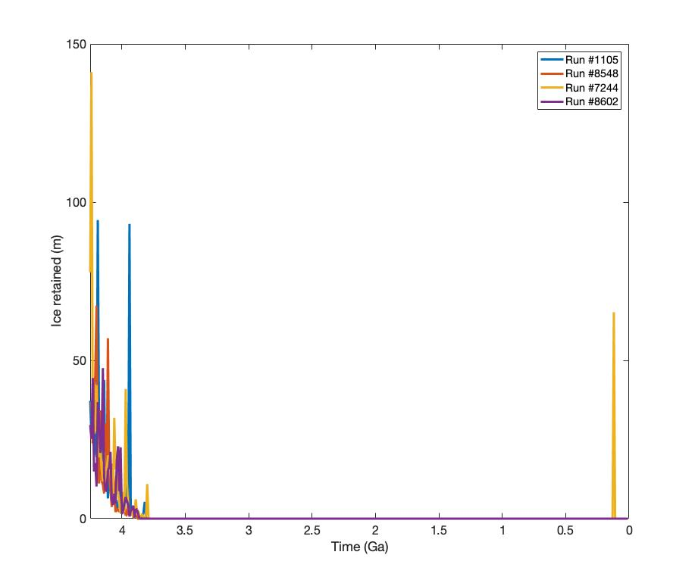

**Figure S4.** Thickness of ice deposited as a function of time for the four selected model runs shown in Figure 1.

Text S1. Ice migration modeling

Kloos et al. (2019) built on the work by Moores (2016) to construct a migration model that considers H2O molecules migrating ballistically to the poles. In Kloos et al. (2019), permanent and seasonal shadowed regions were used, with a combination of data from Mazarico et al. (2011) and newly calculated shadowing. The code for this model is available from the supplemental material in Kloos et al. (2019).

We used this code, but replaced the PSR locations with cold trap locations from Williams et al. (2019), and included the effects of micro cold traps. Replacing the PSRs was a simple change that involved swapping the PSR maps for cold trap maps. To incorporate micro cold traps, we used data from Hayne et al. (2020) which give fractional cold trap areas (all length scales) as a function of latitude for both the north and south pole. However, because these include length scales >250 m, we need to make sure we are not double counting the large cold traps that are actually resolved in the Diviner cold trap maps we fed into the model. To account for this, we fit the data from Hayne et al. (2020, their Figure 3) with an exponential function:

$$CTnorth=3.337E-10×exp⁡(0.2213×lat)$$

$$CTsouth=6.263E-13×exp⁡(0.2999×lat)$$

Where *CTnorth* and *CTsouth* are the areal fractions covered by cold traps. Then we multiplied by a constant such that these functions maintained the same form, but gave integrated cold trap areas equal to the total cold trap areas (17,000 km2 north, 23,000 km2 south) less the Williams et al. (2019) macro cold trap areas (5,300 km2 north, 13,000 km2 south):

To include micro cold traps in the model, we used these functions as probabilities that molecules landing at a given latitude are trapped by micro cold traps and removed from circulation.

We first ran the Kloos et al. (2019) code as-is to verify the same results from the paper (10.7% particles captured in the north PSRs and 11.0% captured in the south PSRs). Then, implementing our changes, we calculated the fraction of particles captured in the large permanent cold traps. This gave 5.4% in the north and 2.7% in the south, based on 12 lunations with 500,000 particles simulated in each.

Text S2. Crater counting.

Crater counting was performed using artificially illuminated hillshade maps generated from 20-m resolution gridded LOLA digital elevation models available from the NASA PDS and from <http://imbrium.mit.edu/BROWSE/LOLA_GDR/>. Counting was performed in ArcGIS, with count areas defined on crater floors where >100 km2 of terrain with low topographic slope (<10°) was available. Model ages were calculated using the CraterStats II program (Michael & Neukum, 2010) with the Neukum et al. (2001) chronology system, and 200 m minimum crater diameters.

For the south pole, we used model ages from Deutsch et al. (2020), but updated the counts for Cabeus crater which resulted in a model age of 3.9 Ga rather than 3.5 Ga. For the north pole, we dated 43 new crater floors for craters >20 km diameter located >80° N that had the requisite floor area for counting. Derived model ages and errors are listed in Tables S1 and S2.

We estimated the absolute model ages and report the 1-sigma uncertainties, which are calculated as $\frac{1}{n^{0.5}}$ where *n* is the number of craters in the range used for the fit. This was then translated in CraterStats into an error in the age with respect to the chronology function (here, Neukum et al. 2001). Note that these reported uncertainties are derived from counting statistics alone, and thus do not incorporate systematic errors associated with the chronology function. This is consistent with the statistical uncertainties reported by Tye et al. (2015) and Deutsch et al. (2020).

**Text S3. Ice from impact sources**

We divided impactors responsible for delivering water into five size regimes (Table S3). This was done because there are four natural breaks in the data sources, crater production function slopes, or scaling laws: (1) micrometeoroid data come from different observations and literature sources than data for larger impactors; (2) small impactor statistics are estimated from e.g., fireball observations instead of from the cratering record; (3) there is a kink in the slope of the crater production function, which changes from approximately -4 to -2; (4) different scaling laws are used to back out impactor sizes for the largest impactors compared to smaller ones.

For hydrated asteroid and cometary micrometeoroids, we used present-day mass fluxes from Grün et al. (2011), assumed 10% hydration by mass, 16.5% water retention (Ong et al., 2010) and scaled the rates back in time using the Neukum et al. (2001) chronology function.

For small impactors, we used the present-day terrestrial fluxes from Brown et al. (2002), scaled these back in time, and used a conversion factor for the difference between terrestrial and lunar impact rates (Mazrouei et al., 2019). We assumed 36% of the NEO population are C-type asteroids (Jedicke et al., 2018), that 2/3 of these are hydrated (Rivkin, 2012), with 10% hydration, and 16.5% water retention.

For larger impactors, we converted production functions based on crater diameters (Neukum et al., 2001) into impactor diameters using standard crater scaling relations (Table S3). Three different relations were used: (1) strength-controlled cratering regime, (2) gravity-controlled cratering regime (simple craters), and (3) gravity-controlled cratering regime (complex craters). For (1), we applied the same hydration averages as above, but for (2) and (3) we created synthetic impactor populations where each asteroid was assigned a size, hydration status (24% chance of being a hydrated C-type), and impact velocity. Impact velocities were drawn from a normal distribution with a mean of 20 km/s and a standard deviation of 6 km/s. For velocities below 10 km/s, we assumed 50% volatile retention due to incomplete clay mineral heating (Svetsov & Shuvalov, 2015). For velocities >10 km/s, we used velocity-dependent retention amounts from Ong et al. (2010).

**Text S4. Ice from volcanic sources**

Originally, we developed a stochastic model for volcanic outgassing, but found the water masses were so low compared to impact delivery that it made no difference in the model. Instead, we used a constant amount of volcanic water delivery per timestep in order to increase computational performance which let us run a larger ensemble of model runs.

We followed the assumptions from Head et al. (2020). 107 km3 of total effusive mare basalts were divided between 2–4 Ga, with 75% erupted from 3–4 Ga and 25% erupted from 2–3 Ga. We assumed 3000 kg/m3 magma ­densities, and 10 ppm outgassed H2O.

**Text S5. A proxy for small-scale gardening**

We calculated a semi-quantitative metric as a proxy for the degree to which individual ice layers are subjected to impact gardening. To do this, in a post-model analysis we determined how many timesteps each ice packet spent within 1 m of the surface before they were buried by subsequent ice and ejecta. This exposure time was multiplied by the impact rate at each timestep calculated using the Neukum et al. (2001) chronology function. The gardening proxy is the sum of these for all timesteps (*i*):

$$Gardening/destruction= \sum_{i}^{n}{(\# timesteps within 1 m × impact rate(i))}$$

The proxy was used *only* for the color scale in Figure 1 to show where in the columns ice would have been most subject to gardening.

|  |  |  |  |  |  |  |
| --- | --- | --- | --- | --- | --- | --- |
| **Crater Name** | **Lat (°)** | **Lon (°)** | **Diam (km)** | **Age (Ga)** | **Error (- Ga)** | **Error (+ Ga)** |
| Haworth | -87.5 | 354.8 | 51.4 | 4.18 | 0.02 | 0.02 |
| Shoemaker | -88.1 | 45.9 | 51.8 | 4.15 | 0.02 | 0.02 |
| Faustini | -87.2 | 84.3 | 42.5 | 4.1 | 0.03 | 0.03 |
| Amundsen | -84.4 | 83.1 | 103.4 | 3.9 | 0.1 | 0.1 |
| ***Cabeus*** | ***-85.3*** | ***317.9*** | ***100.6*** | ***3.88*** | ***0.1*** | ***0.1*** |
| Cabeus B | -82.3 | 305.4 | 59.6 | 3.9 | 0.1 | 0.1 |
| de Gerlache | -88.5 | 271.7 | 32.7 | 3.9 | 0.1 | 0.1 |
| Hedervari | -81.9 | 85.6 | 74.1 | 3.9 | 0.1 | 0.1 |
| Idel'son L | -84.0 | 118.6 | 28.0 | 3.9 | 0.1 | 0.1 |
| Unnamed 1 | -83.7 | 69.2 | 57.7 | 3.9 | 0.1 | 0.1 |
| Nobile | -85.3 | 53.3 | 79.3 | 3.8 | 0.1 | 0.1 |
| Scott | -82.4 | 48.5 | 107.8 | 3.8 | 0.1 | 0.1 |
| Scott E | -81.2 | 35.7 | 29.2 | 3.8 | 0.1 | 0.1 |
| Slater | -88.1 | 111.3 | 25.1 | 3.8 | 0.1 | 0.1 |
| Sverdrup | -88.3 | 206.6 | 32.8 | 3.8 | 0.1 | 0.1 |
| Wiechert P | -85.1 | 151.8 | 38.6 | 3.8 | 0.1 | 0.1 |
| Unnamed 2 | -82.2 | 10.6 | 26.8 | 3.7 | 0.1 | 0.1 |
| Wiechert | -84.0 | 164.7 | 40.8 | 3.7 | 0.2 | 0.1 |
| Idel'son | -81.3 | 112.7 | 59.8 | 3.5 | 0.5 | 0.1 |
| Unnamed 3 | -83.9 | 338.3 | 22.3 | 3.4 | 0.5 | 0.1 |
| Wiechert U | -83.4 | 149 | 30.0 | 3.4 | 0.7 | 0.1 |
| Wiechert J | -85.2 | 182.4 | 34.9 | 3.2 | 0.1 | 0.3 |
| Shackleton | -89.7 | 129.8 | 20.9 | 3.15 | 0.08 | 0.05 |
| Amundsen C | -80.8 | 85.2 | 24.2 | 1.8 | 0.2 | 0.2 |

Table S1. Model ages of large south polar craters used in this work from crater counting (Text S1), reproduced from Deutsch et al. (2020). Note the revised age of Cabeus crater based on new counting.

|  |  |  |  |  |  |  |
| --- | --- | --- | --- | --- | --- | --- |
| **Crater** | **Lat (°)** | **Lon (°)** | **Diam (km)** | **Age (Ga)** | **Error (- Ga)** | **Error (+ Ga)** |
| Unnamed 21 | 86.7 | 70.8 | 32.9 | 4.24 | 0.04 | 0.03 |
| Unnamed 3 | 81.7 | 146.1 | 21.6 | 4.23 | 0.1 | 0.06 |
| Unnamed 2 | 81.1 | 160.1 | 67.8 | 4.22 | 0.07 | 0.05 |
| Haber | 83.6 | -93.8 | 69.8 | 4.18 | 0.06 | 0.04 |
| Florey | 86.97 | -20.23 | 66.6 | 4.14 | 0.04 | 0.03 |
| Plaskett V | 82.1 | 120.7 | 45.9 | 4.14 | 0.06 | 0.04 |
| Nansen F | 85 | 62.6 | 55.7 | 4.12 | 0.04 | 0.03 |
| Rozhdestvenskiy | 85.17 | -159.5 | 168.7 | 4.12 | 0.1 | 0.04 |
| Unnamed 10 | 86 | 155.2 | 44.8 | 4.11 | 0.05 | 0.04 |
| Unnamed 14 | 84.4 | -53.9 | 22.5 | 4.11 | 0.1 | 0.06 |
| Unnamed 11 | 84.2 | 160.8 | 27.8 | 4.1 | 0.08 | 0.05 |
| Unnamed 13 | 84 | -66.1 | 23.4 | 4.1 | 0.04 | 0.03 |
| Unnamed 16 | 84.9 | -26.5 | 36.6 | 4.1 | 0.04 | 0.03 |
| Unnamed 19 | 83.1 | -41 | 30.8 | 4.1 | 0.04 | 0.03 |
| Unnamed 6 | 83.2 | 82.3 | 23.8 | 4.1 | 0.05 | 0.04 |
| Nansen | 81.2 | 96.5 | 113.5 | 4.09 | 0.04 | 0.03 |
| Unnamed 12 | 81.7 | -72.9 | 38.7 | 4.09 | 0.04 | 0.03 |
| Unnamed 4 | 83.4 | 141.8 | 42.9 | 4.09 | 0.07 | 0.04 |
| Unnamed 5 | 85 | 92.6 | 24.0 | 4.09 | 0.05 | 0.04 |
| Unnamed 15 | 86.3 | -41.7 | 32.6 | 4.07 | 0.04 | 0.03 |
| Byrd | 85.4 | 12.1 | 93.4 | 4.06 | 0.02 | 0.02 |
| Mouchez A | 80.9 | -30 | 47.0 | 4.06 | 0.04 | 0.03 |
| Hermite | 86.2 | -92.4 | 104.9 | 4.05 | 0.04 | 0.03 |
| Peary | 88.7 | 24.5 | 78.6 | 4.05 | 0.04 | 0.03 |
| Unnamed 20 | 82 | -49.3 | 22.0 | 4.05 | 0.03 | 0.03 |
| Haskin | 81.5 | 133.2 | 60.2 | 4.04 | 0.05 | 0.04 |
| Rozhdestvenskiy K | 82 | -139.4 | 88.9 | 4.04 | 0.05 | 0.04 |
| Unnamed 18 | 83.7 | -44.3 | 33.4 | 4.04 | 0.04 | 0.03 |
| Rozhdestvenskiy W | 85.9 | 115.3 | 72.1 | 4.03 | 0.04 | 0.03 |
| Nansen A | 82.9 | 65.1 | 43.3 | 4.02 | 0.05 | 0.03 |
| Unnamed 9 | 82.9 | 15.5 | 24.9 | 4.01 | 0.03 | 0.02 |
| Main | 80.8 | 9.9 | 50.4 | 4.00 | 0.04 | 0.03 |
| Nansen C | 83.6 | 55.7 | 27.1 | 4.00 | 0.03 | 0.02 |
| Sylvester | 82.7 | -81.7 | 59.5 | 3.99 | 0.04 | 0.03 |
| Unnamed 17 | 84.6 | -38.9 | 26.5 | 3.99 | 0.02 | 0.02 |
| Plaskett | 81.7 | 176.5 | 109 | 3.97 | 0.04 | 0.03 |
| Hevesy | 83.1 | 149.8 | 48.4 | 3.92 | 0.07 | 0.05 |
| Rozhdestvenskiy U | 84.9 | 151.9 | 41.6 | 3.92 | 0.08 | 0.05 |
| Gioja | 83.3 | 2.0 | 43.6 | 3.91 | 0.03 | 0.03 |
| Unnamed 7 | 81.7 | 49.2 | 35.0 | 3.90 | 0.07 | 0.05 |
| Unnamed 8 | 82.1 | 17.2 | 30.3 | 3.86 | 0.03 | 0.03 |
| Lovelace | 82.1 | -110 | 57.6 | 3.77 | 0.03 | 0.02 |
| De Sitter M | 81.1 | 37.1 | 73.8 | 3.71 | 0.06 | 0.04 |

Table S2. Model ages of large north polar craters used in this work from crater counting (Text S1).

|  |  |  |  |  |  |
| --- | --- | --- | --- | --- | --- |
| **Regime** | **A** | **B** | **C** | **D** | **E** |
| Source for number of impacts | Grün et al. (2011) | Brown et al. (2002) | Neukum et al. (2001) | Neukum et al. (2001) | Neukum et al. (2001) |
| Model treatment | Averaged | Averaged | Averaged | Stochastic | Stochastic |
| Size-frequency distribution slope (differential) | N/A | -3.82 | -3.82 | -1.8 | -1.8 |
| Crater regime | N/A | N/A | Strength | Gravity | Gravity |
| Scaling law reference | N/A | N/A | Prieur et al. (2017) | Collins et al. (2005) | Johnson et al. (2016) |
| Impactor diameter (L) or crater diameter (D), lower bound | L = 10 nm | L = 10 mm | D = 0.1 km | D = 1.5 km | D = 15 km |
| Impactor diameter (L) or crater diameter (D), upper bound | L = ~1 mm | L = 3 m | D = 1.5 km | D = 15 km | D = 500 km |

**Table S3.** Details of five size regimes used to calculate water delivery from hydrated impactors.

Data Set S1. MATLAB function for the main file used in the ice deposition model.

Data Set S2. MATLAB subfunction for calculating the amount of water delivered by impactors per timestep in the model.