

Software Development Kit: Maximum 2D Probability of Collision

CONJUNCTION ASSESSMENT AND RISK ANALYSIS (CARA) PROGRAM

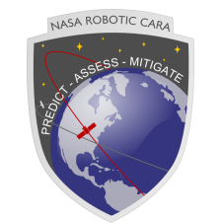

*Matthew Hejduk*

*Astrorum, Inc*

*Waco, Tx*

*Travis Lechtenberg*

*Doyle Hall*

*Luis Baars*

*Omitron, Inc*

*Colorado Springs, CO*

|  |
| --- |
|  |

National Aeronautics and

Space Administration

Goddard Space Flight Center,

Greenbelt, MD 20771

**December 2019Preface**

This document outlines the Maximum 2D Probability of Collision Calculation submitted as part of the Software Development Kit (SDK). The SDK is intended to provide both industry and government customers with a code base with which to perform standard calculations inherent to the Collision Avoidance (CA) problem and as outlined in the CA Standard.

# Table of Contents

Table of Contents iii

List of Figures iii

1.0 Maximum 2D Probability of Collision Calculation 4

1.1 Dilution Region Assessment of Maximum Probability of Collision – Mathematical Formulas 4

1.2 Dilution Region Assessment of Maximum Probability of Collision – Source Code Description 6

1.3 Frisbee’s Method of Determining Maximum 2D Probability of Collision – Mathematical Formulas 8

1.4 Frisbee’s Method of Determining Maximum 2D Probability of Collision – Source Code Description 13

2.0 Acronyms 17

3.0 References 18

# List of Figures

Figure 1: Conjunction-Plane rendering of 2-D Pc Calculation 5

Figure 2: Pc vs the Ratio of Covariance Size to Miss Distance 6

Figure 3: Graphic Representation on Maximum Pc Covariance in the Conjunction Planeii 9

Figure 4: Comparison of Frisbee’s Approximation to the Integrated Maximum Probability of Collision for Frisbee’s Example. 11

Figure 5: Comparison of Frisbee’s Approximation to the Integrated Maximum Probability of Collision for Collision with a Pc = 4.20E-01. 12

**List of Tables**

Table 1: Dilution Region Maximum Probability of Collision Routine Input Parameters 6

Table 2: Dilution Region Maximum Probability of Collision Routine Output Parameters 7

Table 3: 2D Probability of Collision Foster Function Unit Test Cases 8

Table 4: Maximum 2D Probability of Collision Routine Input Parameters 13

Table 5: Maximum 2D Probability of Collision Routine Output Parameters 14

Table 6: Maximum 2D Probability of Collision UnIt Test Cases 14

# Maximum 2D Probability of Collision Calculation

In the conjunction assessment community, there is sustained interest in determining not only the current probability of collision, but also the maximum probability of collision. This is due to the probability of collision having a possibility of producing a false sense of security for occasions when the conjunction is not truly well characterized. In this section two methods are examined for determining the maximum probability of collision:

First, when the orbital position uncertainties are high, the reported probability of collision may be low due to the sheer dilution of the combined covariance matrices. In this case the Pc is referred to as diluted and may understate the collision risk.

Second, if covariance data is unavailable for a specific object, no assumptions may be made about the object’s covariance, so there is an alternative measure of maximum probability of collision based on having no knowledge of one of the object’s covariance matrix.

## Dilution Region Assessment of Maximum Probability of Collision – Mathematical Formulas

Hejduk[1] outlines the method used to determine the dilution status and relevant maximum Pc when a conjunction is in the dilution region and builds on earlier bodies of work. The dilution effect can be inferred from Figure 1 where for a given HBR, there will be a particular joint covariance size that will maximize the amount of covariance probability density that falls within that HBR and thus will similarly maximize the calculated Pc. Because such a Pc maximum exists, growing or shrinking the covariance from this value will produce smaller Pc values.

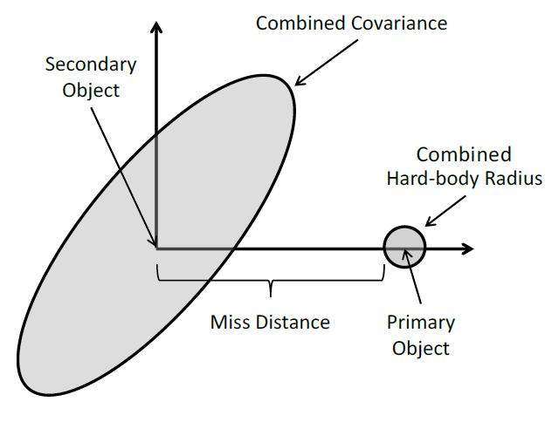

Figure 1: Conjunction-Plane rendering of 2-D Pc Calculation

This can also be observed in Figure 2, which demonstrates that as a covariance matrix expands, the Pc either grows in the robust region, or decreases in the dilution region. To assess for a given CDM whether a conjunction is in the dilution region or not, either the primary covariance, the secondary covariance, or the combined covariance matrix is scaled and assessed vs the initial Pc estimate. By scaling the covariance matrices individually, each object can be assessed for whether or not it is in the dilution region by examining the first derivative of Pc with respect to a linear scaling factor of one of the input covariance matrices.

$$\frac{∂Pc}{∂C_{pri}}>1 \underset{→}{yields} Primary Object in Robust Region \\ \frac{∂Pc}{∂C_{pri}}<1\underset{→}{yields} Primary Object in Dilution Region \\ \frac{∂Pc}{∂C_{sec}}>1\underset{→}{yields}Secondary Object in Robust Region \\ \frac{∂Pc}{∂C_{sec}}<1\underset{→}{yields} Secondary Object in Dilution Region$$

When these first derivatives are equal to 0, the maximum Pc with regards to the input object dilution has been reached. This is determined via an iterative process until convergence is attained by examining a span of scaled covariance matrices and refining this span until the maximum Pc is determined. As covariance matrices do not generally grow with data updates, if an object is in the robust region, the maximum Pc is reported as the Pc for the input CDM.

$$Pc_{max}=max\left(\begin{matrix}Pc_{input} \\ {Pc}_{max}(Primary Dilution) \\ {Pc}_{max}(Secondary Dilution)\end{matrix}\right)$$

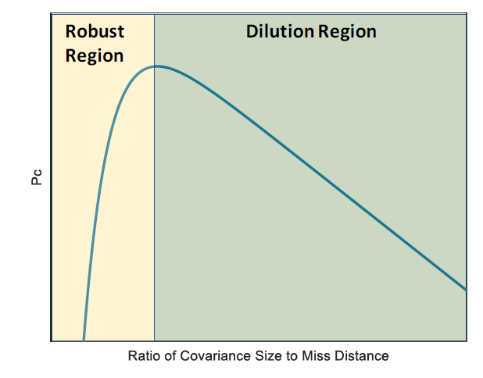

Figure 2: Pc vs the Ratio of Covariance Size to Miss Distance

## Dilution Region Assessment of Maximum Probability of Collision – Source Code Description

The primary function contained within the SDK used for estimating the maximum 2D Probability of Collision of a close approach event with regards to dilution region assessment is the:

DilutionMaxPc.m

routine, which estimates the maximum probability of collision using the process above.

As inputs, the routine accepts the following:

Table 1: Dilution Region Maximum Probability of Collision Routine Input Parameters

|  |  |
| --- | --- |
| Input Variable | Definition |
| r1 | [3X1] ECI Position Vector of the Primary Object (meters) |
| v1 | [3X1] ECI Velocity Vector of the Primary Object (meters/second) |
| cov1 | [6X6] Primary State covariance matrix corresponding to input primary object reference frame |
| r2 | [3X1] ECI Position Vector of the Secondary Object (meters) |
| v2 | [3X1] ECI Velocity Vector of the Secondary Object (meters/second) |
| cov2 | [6X6] Secondary State covariance matrix corresponding to input primary object reference frame |
| HBR | Combined hard body radius or exclusion zone of the two objects (m) |
| params | Run parameters for subfunction “PcDilution.m” (optional) |

The maximum 2D Probability of Collision routine outputs the following:

Table 2: Dilution Region Maximum Probability of Collision Routine Output Parameters

|  |  |
| --- | --- |
| Output Variable | Definition |
| PcMax | Maximum probability of collision value from combined primary and secondary object covariance scaling Pc-dilution analysis |
| Diluted | Integer indicating if the either the primary or secondary object is in the dilution region:  Diluted = 0 => No dilution for either case Diluted = 1 => Secondary dilution but no primary dilution Diluted = 10 => Primary dilution but no secondary dilution Diluted = 11 => Primary dilution and secondary dilution |
| Pri | Structure holding the primary Pc-dilution analysis results |
| Sec | Structure holding the secondary Pc-dilution analysis results |

Validation cases for this algorithm are contained within the unit test suite for the SDK at:

..\SDK\UnitTest\ProbabilityOfCollisionCode\DilutionMaxPc_UnitTest.m

These test cases were developed using previously existing test cases developed by Omitron to test specific stressing cases observed operationally.

Table 3: 2D Probability of Collision Foster Function Unit Test Cases

|  |  |
| --- | --- |
| Test ID | Description |
| test01 | Operational close approach event with maximum estimated probability of collision from selected subset of events using original hard body radius of 20 meters. |
| test02 | Operational close approach event with maximum secondary object radial position uncertainty from selected subset of events using a modified hard body radius of 100 meters for more rapid testing. |
| test03 | Operational close approach event with maximum secondary object intrack position uncertainty from selected subset of events using a modified hard body radius of 100 meters for more rapid testing. |
| test04 | Operational close approach event with maximum secondary object crosstrack position uncertainty from selected subset of events using a modified hard body radius of 100 meters for more rapid testing. |
| test05 | Operational close approach event with minimum miss distance from selected subset of events using a modified hard body radius of 20 meters for more rapid testing. |
| test06 | Operational close approach event with minimum relative velocity from selected subset of events using original hard body radius of 20 meters. |

## Frisbee’s Method of Determining Maximum 2D Probability of Collision – Mathematical Formulas

Frisbee 2015[2] proposed a method by which the maximum possible probability of collision could be determined for a close approach event for which only one object has position uncertainty information. This is of particular use in determining whether an encounter may be of risk to an asset, as the maximum probability of collision may be below an actionable threshold. To determine the maximum probability of collision, the covariance ellipsoid of the object possessing a covariance matrix is mapped to the conjunction plane and distended so that the Mahalanobis distance between the two objects is equal to one. To do this, the covariance of the secondary object is oriented along a one dimensional position uncertainty along the miss vector between the two objects. Graphically, this can be seen in Figure 3:

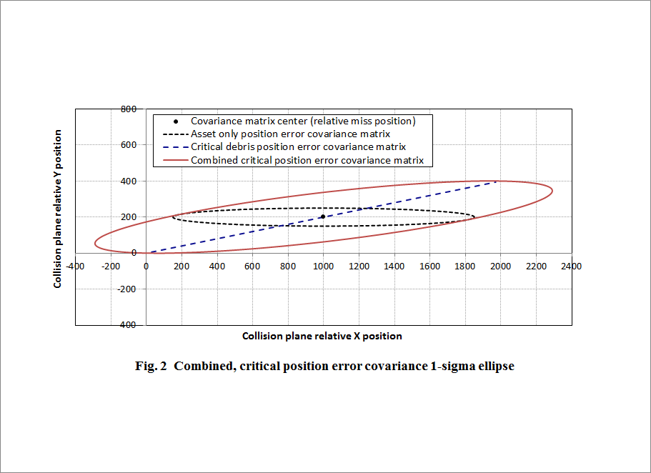

Figure 3: Graphic Representation on Maximum Pc Covariance in the Conjunction Planeii

Since this unknown uncertainty resulting in maximum probability of collision is oriented along the miss vector, it may be characterized using a constant in conjunction with the relative miss vector, $u_{rel}$**,** which is the unit vector of the miss geometry in the conjunction plane.

$$C_{unknown}=V_{r}u_{rel}u_{rel}^{T}$$

From Section **Error! Reference source not found.**, we know that the probability of collision may be characterized as:

$$P_{C}=\frac{1}{2π\sqrt{\left|C\right|}}\int_{⊕}{e^{-\frac{1}{2}{\left(\overset{⃑}{r}-{\overset{⃑}{r}}_{d}\right)}^{T}C^{-1}\left(\overset{⃑}{r}-{\overset{⃑}{r}}_{d}\right)}}d\vec{r}$$

Where ***C*** is the combined position uncertainty of the two objects for probability of collision calculation, and is characterized as the sum of the two position covariances in a common frame.

$$C=C_{known}+C_{unknown}$$

Frisbee 2015ii, makes an argument for an approximation of the probability of collision calculation assuming that the spatial debris density does not vary over the exclusion zone reducing the two dimensional probability of collision equation to:

$$P_{C}≈A\frac{e^{-0.5r_{rel}^{T}C^{-1}r_{rel}}}{2π\sqrt{C}}$$

By differentiating this equation with respect to $V_{r}$, it is possible to determine the value of $V_{r}$ which maximizes the probability of collision with respect to the known object position uncertainty and miss vector.

$$V_{r}={\left|r_{rel}\right|}^{2}\left(\frac{K_{A}^{2}-1}{K_{A}^{2}}\right)$$

Where:

$$K_{A}^{2}=r_{rel}^{T}C_{known}^{-1}r_{rel}$$

As stated before, the Mahalanobis distance of the miss geometry becomes a value of 1, this causes Frisbee’s approximation to reduce to:

$$P_{C}≈A\frac{e^{-0.5}}{2π\sqrt{C}}$$

Frisbee’s approximation functions simplify the calculation of the maximum probability of collision by removing the integration of the debris spatial density from the probability of collision equation instead opting to multiply the debris spatial density at the time of closest approach by the area of the exclusion zone. This is effectively making the assumption that the debris spatial density is constant over the entire cross-sectional area of the exclusion zone. This causes the approximation to tend to overestimate the actual probability of collision, and can be seen in Figure 4 where the example event from Frisbee’s paper is analyzed for a varying array of hard body radii.

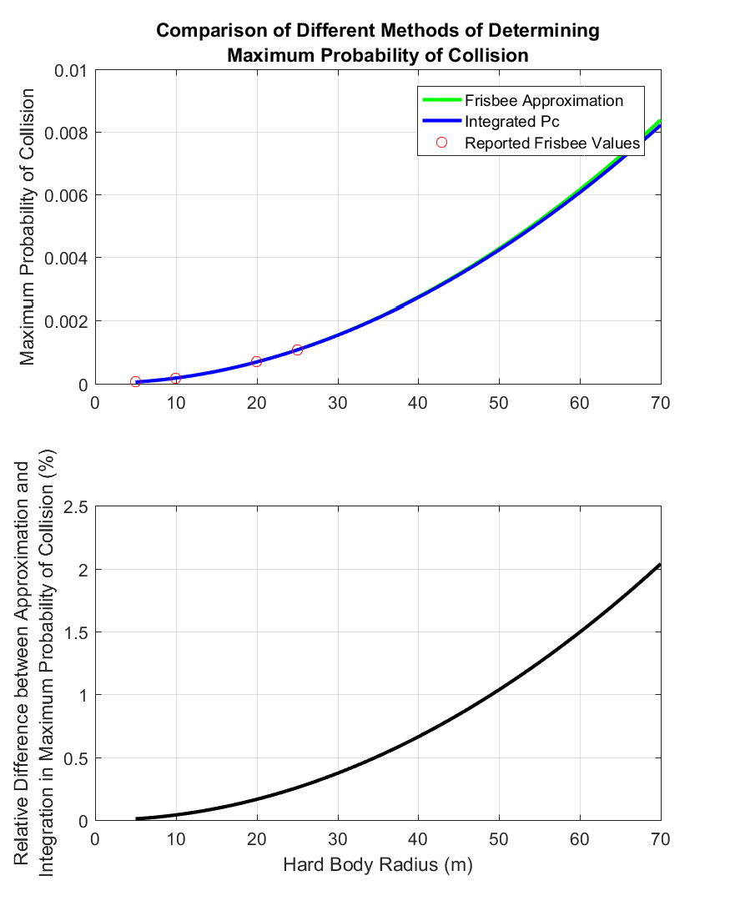

Figure 4: Comparison of Frisbee’s Approximation to the Integrated Maximum Probability of Collision for Frisbee’s Example.

In Frisbee’s manufactured example close approach, the difference between the maximum probability of collision approximation and the full integration differs by only a few percent even as the input hard body radius approaches an upper limit defined by the ISS station size.

While the assumption that the debris spatial density is invariant over the exclusion zone is a valid one that causes only minor variations when the exclusion radius is small in respect to the combined position uncertainty bounds of the event, this assumption becomes less valid as the exclusion zone increases in size. Particularly with respect to the combined position uncertainty bounds. In Figure 5, an extreme operational example is analyzed with varying hard body radii, and Frisbee’s approximation begins to give answers that no longer make physical sense as the approximated probability of collision exceeds a value of unity. For this reason, Omitron has coded its output probability of collision to reflect the debris spatial density as integrated over the entire exclusion zone instead of using the approximation.

This will give operators a better measure of the maximum probability of collision and the outputs will be more robust in that they will not give non-sensical results under specific conditions.

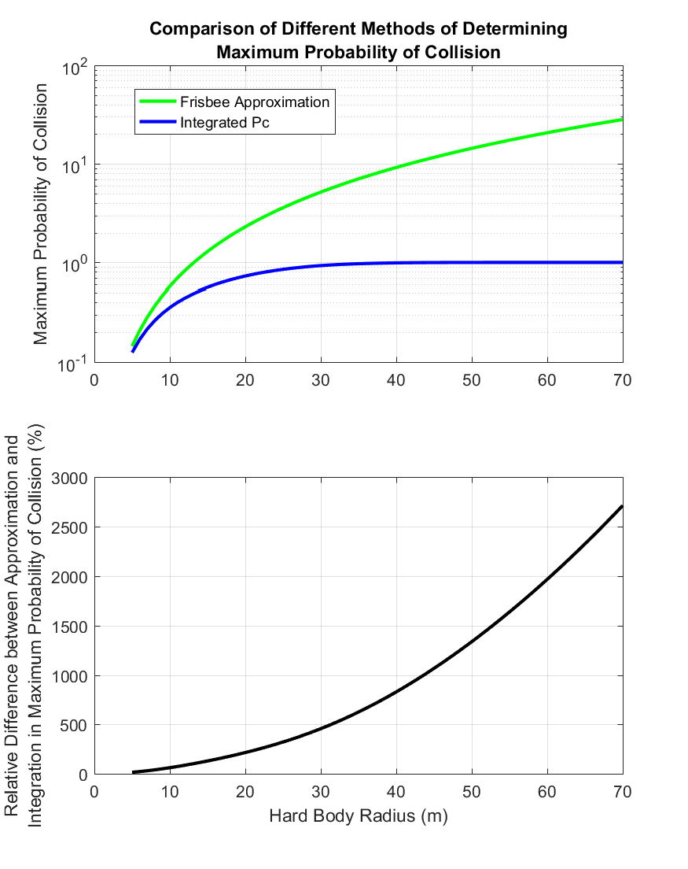

Figure 5: Comparison of Frisbee’s Approximation to the Integrated Maximum Probability of Collision for Collision with a Pc = 4.20E-01.

## Frisbee’s Method of Determining Maximum 2D Probability of Collision – Source Code Description

The primary function contained within the SDK used for estimating the maximum 2D Probability of Collision of a close approach event is the:

FrisbeeMaxPc.m

routine, which estimates the probability of collision using the formula above.

As inputs, the routine accepts the following:

Table 4: Maximum 2D Probability of Collision Routine Input Parameters

|  |  |
| --- | --- |
| Input Variable | Definition |
| r1 | [3X1] ECI Position Vector of the Primary Object (meters) |
| v1 | [3X1] ECI Velocity Vector of the Primary Object (meters/second) |
| cov1 | [6X6] Primary State covariance matrix corresponding to input primary object reference frame |
| r2 | [3X1] ECI Position Vector of the Secondary Object (meters) |
| v2 | [3X1] ECI Velocity Vector of the Secondary Object (meters/second) |
| cov2 | [6X6] Secondary State covariance matrix corresponding to input primary object reference frame |
| HBR | Combined hard body radius or exclusion zone of the two objects (m) |
| RelTol | Relative Tolerance used for double integration convergence (1E-08 is recommended) |
| HBRType | Definition of hard body region, typically “circle”. Allowable inputs:   * “circle” – Hard body region defined as a sphere or circle * “square” – Hard body region defined as a cube or square * “squareEquArea” – Hard body region defined as a square with equivalent area to a circle with radius as defined y HBR |

The Maximum 2D Probability of Collision routine outputs the following:

Table 5: Maximum 2D Probability of Collision Routine Output Parameters

|  |  |
| --- | --- |
| Output Variable | Definition |
| Pc | Maximum Probability of Collision calculated using Frisbee’s Method |

Validation cases for this algorithm are contained within the unit test suite for the SDK at:

..\SDK\UnitTest\ProbabilityOfCollisionCode\FrisbeeMaxPc_UnitTest.m

These test cases were developed using previously defined stressing cases developed by Alfano 2009**Error! Bookmark not defined.**, manufactured test cases corresponding to Frisbee’s examples provided within his paper, and previously validated test cases from initial examination of this work.

Table 6: Maximum 2D Probability of Collision UnIt Test Cases

|  |  |
| --- | --- |
| Test ID | Description |
| test01 | Alfano test case 1 |
| test02 | Alfano test case 2 |
| test03 | Alfano test case 3 |
| test04 | Alfano test case 4 |
| test05 | Alfano test case 5 |
| test06 | Alfano test case 6 |
| test07 | Alfano test case 7 |
| test08 | Alfano test case 8 |
| test09 | Alfano test case 9 |
| test10 | Alfano test case 10 |
| test11 | Alfano test case 11 |
| test12 | Manufactured Test Case Corresponding To Frisbee's Example (HBR=5) |
| test13 | Manufactured Test Case Corresponding To Frisbee's Example (HBR=10) |
| test14 | Validation Test Case 1-1 from original development (FDSS-II-28-XXXX Single Cov Maximum Pc Validation) validated against independent code base of Joseph Frisbee |
| test15 | Validation Test Case 1-3 from original development (FDSS-II-28-XXXX Single Cov Maximum Pc Validation) validated against independent code base of Joseph Frisbee |
| test16 | Validation Test Case 1-4 from original development (FDSS-II-28-XXXX Single Cov Maximum Pc Validation) validated against independent code base of Joseph Frisbee |
| test17 | Validation Test Case 1-5 from original development (FDSS-II-28-XXXX Single Cov Maximum Pc Validation) validated against independent code base of Joseph Frisbee |
| test18 | Validation Test Case 1-6 from original development (FDSS-II-28-XXXX Single Cov Maximum Pc Validation) validated against independent code base of Joseph Frisbee |
| test19 | Validation Test Case 1-7 from original development (FDSS-II-28-XXXX Single Cov Maximum Pc Validation) validated against independent code base of Joseph Frisbee |
| test20 | Validation Test Case 1-8 from original development (FDSS-II-28-XXXX Single Cov Maximum Pc Validation) validated against independent code base of Joseph Frisbee |
| test21 | Validation Test Case 1-9 from original development (FDSS-II-28-XXXX Single Cov Maximum Pc Validation) validated against independent code base of Joseph Frisbee |
| test22 | Validation Test Case 1-10 from original development (FDSS-II-28-XXXX Single Cov Maximum Pc Validation) validated against independent code base of Joseph Frisbee |
| test23 | Validation Test Case 1-11 from original development (FDSS-II-28-XXXX Single Cov Maximum Pc Validation) validated against independent code base of Joseph Frisbee |
| test24 | Validation Test Case 1-12 from original development (FDSS-II-28-XXXX Single Cov Maximum Pc Validation) validated against independent code base of Joseph Frisbee |
| test25 | Validation Test Case 1-13 from original development (FDSS-II-28-XXXX Single Cov Maximum Pc Validation) validated against independent code base of Joseph Frisbee |
| test26 | Validation Test Case 1-14 from original development (FDSS-II-28-XXXX Single Cov Maximum Pc Validation) validated against independent code base of Joseph Frisbee |
| test27 | Validation Test Case 1-15 from original development (FDSS-II-28-XXXX Single Cov Maximum Pc Validation) validated against independent code base of Joseph Frisbee |

# Acronyms

|  |  |
| --- | --- |
| CARA | Conjunction Assessment Risk Analysis |
| CDM | Conjunction Data Message |
| ECI | Earth Centered Inertial |
| HBR | Hard Body Radius |
| Pc | Probability of Collision |
| SDK | Software Development Kit |

# References

1. Hejduk, Matthew D., "Satellite Conjunction Assessment Risk Analysis for “Dilution Region” Events: Issues and Operational Approaches" (2019). Space Traffic Management Conference. 28.
2. Frisbee, J. H. *An upper Bound on High Speed Satellite Collision Probability when Only One Object has Position Uncertainty Information.* AAS 15-717. 2015