**Comparison between** **Time Series Analysis Vs Fundamental Analysis for Apple Inc**.

**Part-A-Time Series Analysis**

(Seasonal Auto-Regressive Moving Average (SARIMA) & Facebook Prophet)

**Data**

We start with exploring the data we collected.

We collected our data from Yahoo Finance ranging from April 2012 to Dec 2019 roughly counting to 2011 instances of data.

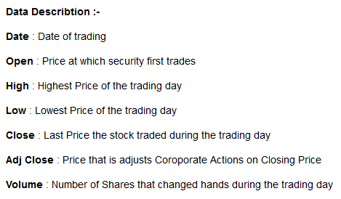

Data Snapshot: -

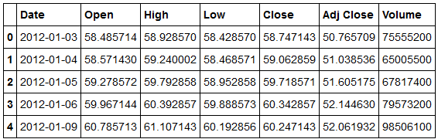

Summary Statistics: -

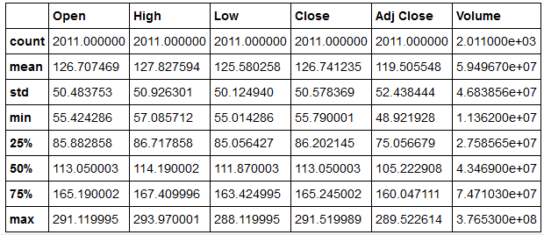

**Data Pre-Processing: -**

We did the following Steps: -

1. Convert Date into Date Time Index
2. Checked if there were any missing values
3. Eliminated Features like “Open”,”High”,”Close” as they were Multicollinear with “Adj Close”.

We consider “Adj Close” as our target variables as it accounts for all corporate decisions like stock split and dividends. Volume filtered out as it was less correlated to target variable.

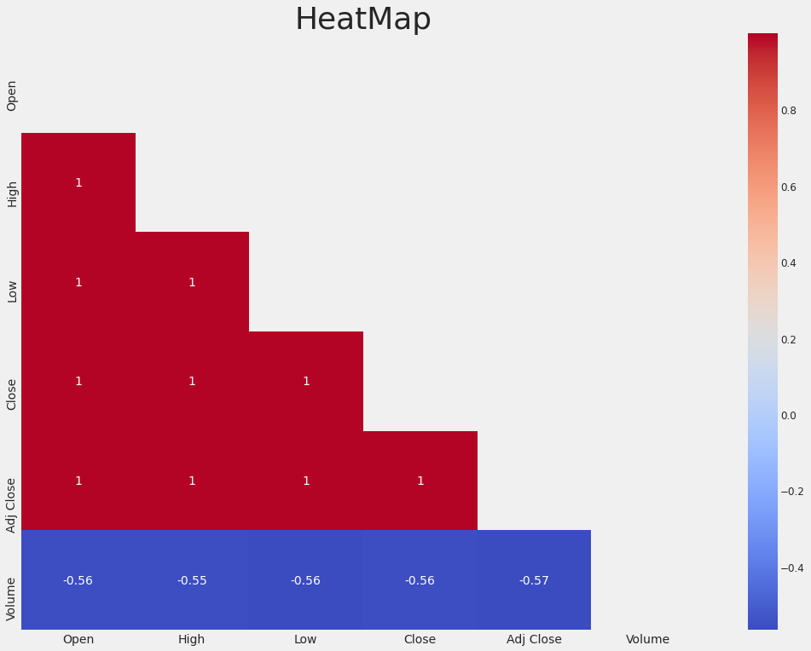

Inference: We detected multicollinearity by checking the Heatmap.

1. Resampled Data into Monthly Frequency

**Exploratory Data Analysis**

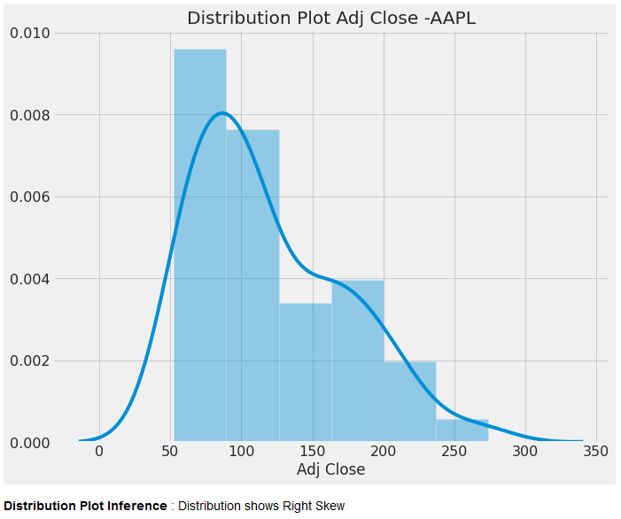

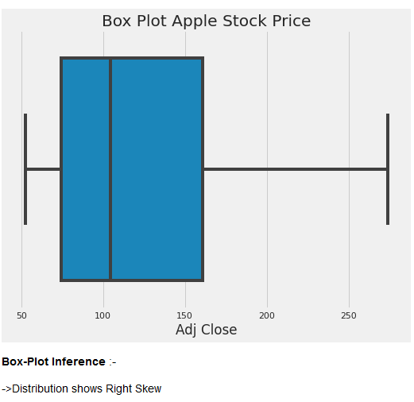

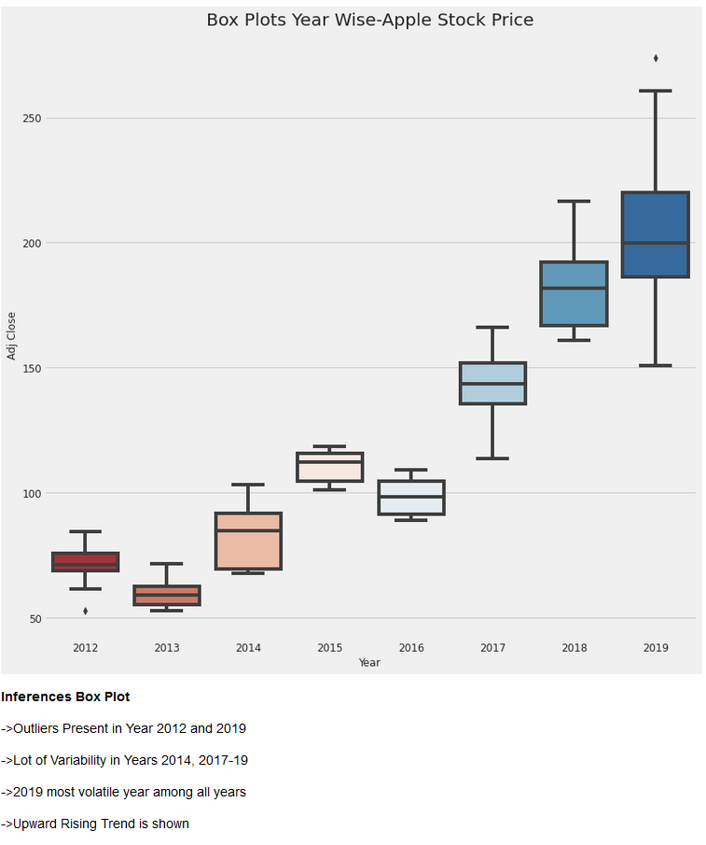

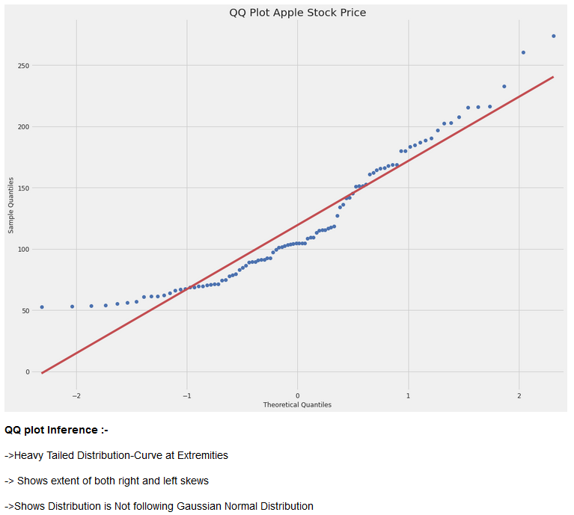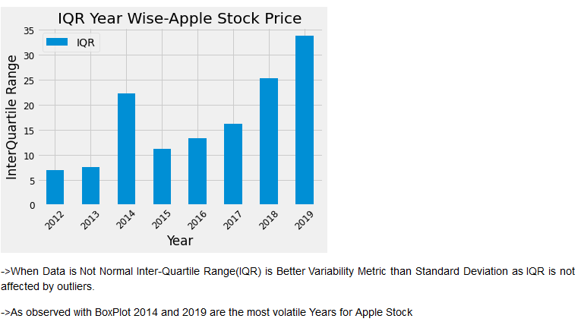

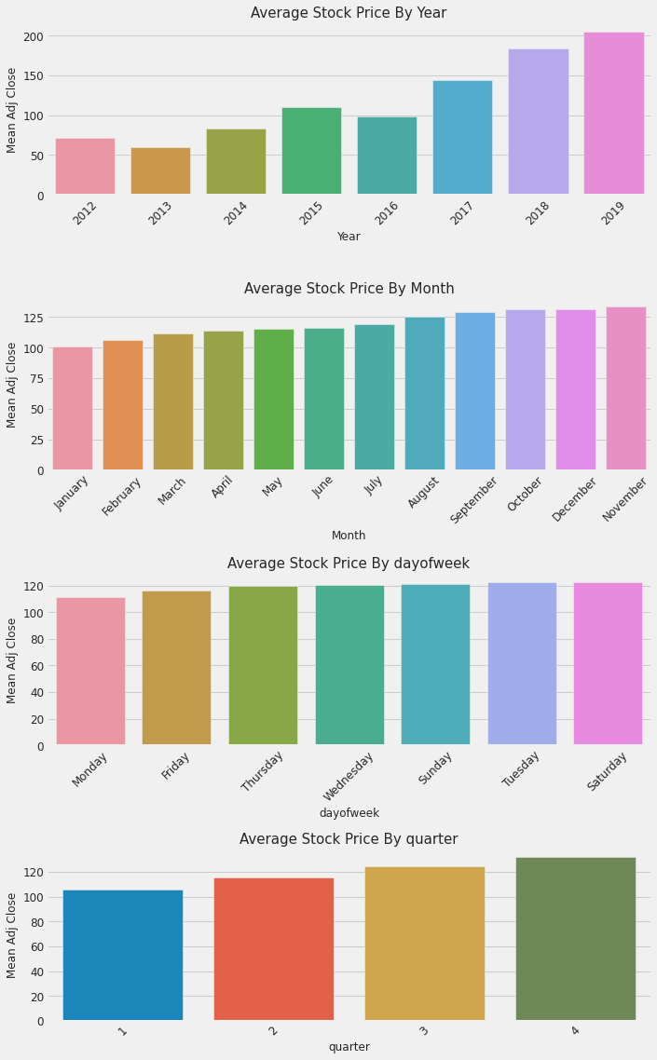

Inferences: -

* According to Mean price by Years, 2013 and 2016 are the only years where Mean price is lower than previous Year.
* Average Stock Price is lower at start of the week in comparison to the end of the week.
* The Average Price is Highest in the Month of November.
* Q4 is the best for Apple according to average stock price. By sales figures Q4 has always been strong for Apple since the new product cycle takes place and it’s the Holiday period. We also observe this as a seasonal effect for Apple.

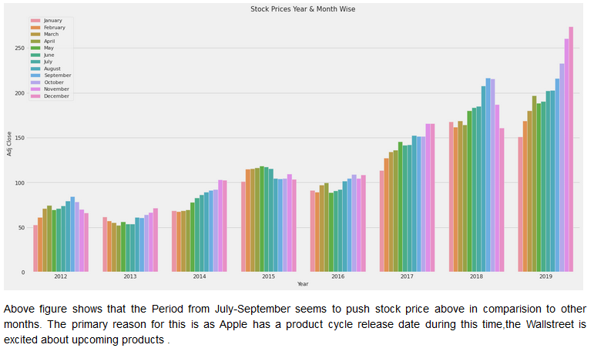

**Decomposition of Time Series: -**

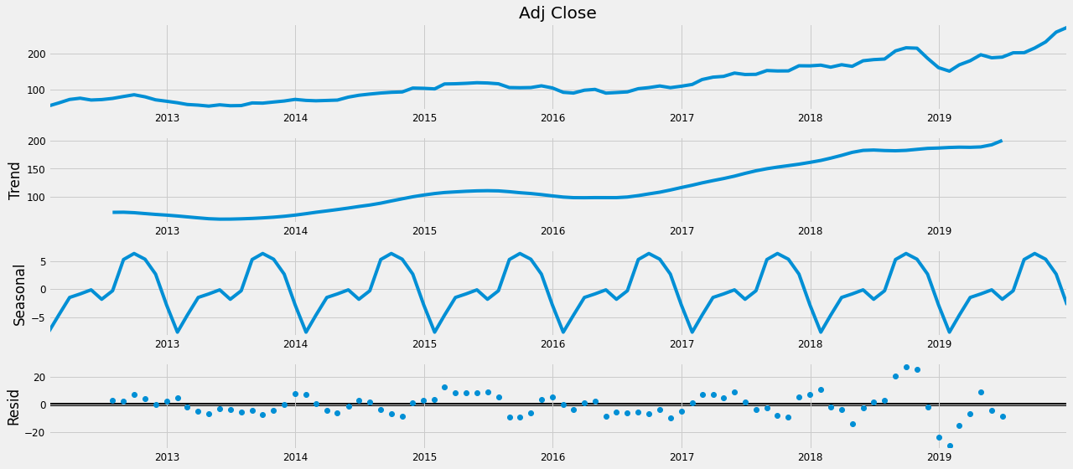

**Inferences by Decomposition: -**

* Trend: Overall an Upward Trend
* Seasonality: There appears to be seasonality, Apple has rallied during the Holiday season as expected. Since Holiday period has good sales for Apple Over the Years.

**Checking Stationarity of Time Series: -**

**We can check stationarity of Time Series** using Augmented Dickey-Fuller (ADF) Test, a statistical test.

**ADF Test: -**

**Null Hypothesis**: Time series has a unit root -It is non-stationary

**Alternate Hypothesis**: Time series does not have a unit root -It is stationary

Time Series is Stationary if we have constant mean, constant variance and No Trend and Seasonality.

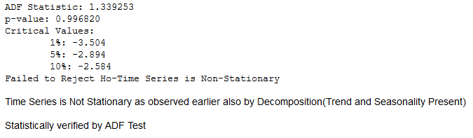

**Autocorrelation (ACF) & Partial Auto-Correlation Plot (PACF)**

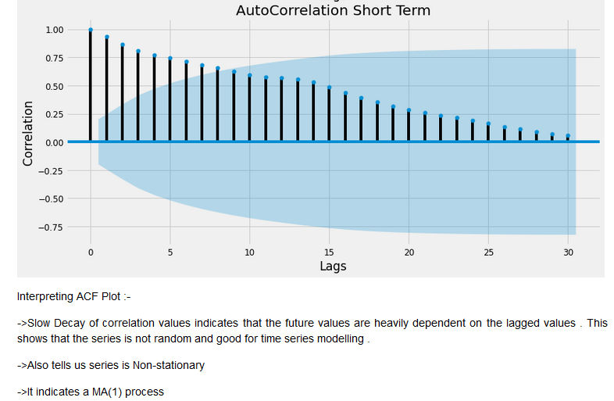

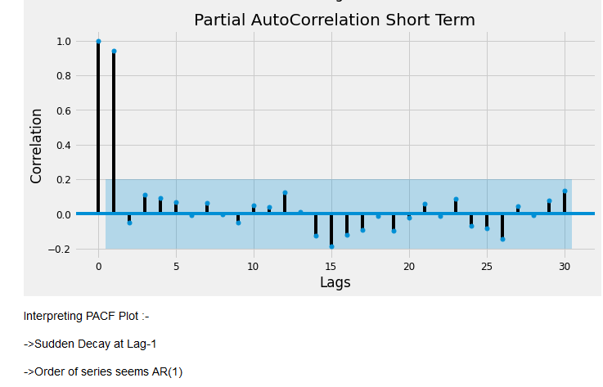

**Transforming Series for Stationarity**

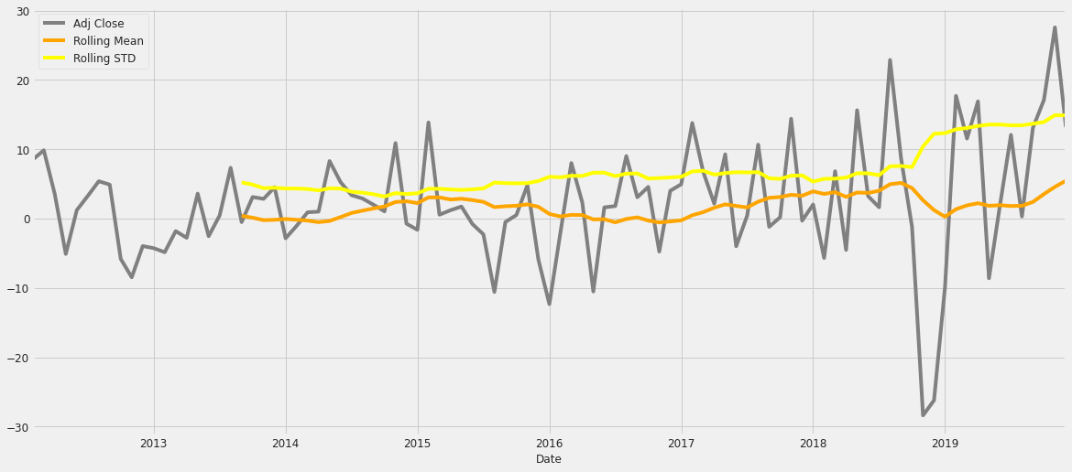

After Differencing by Lag 1

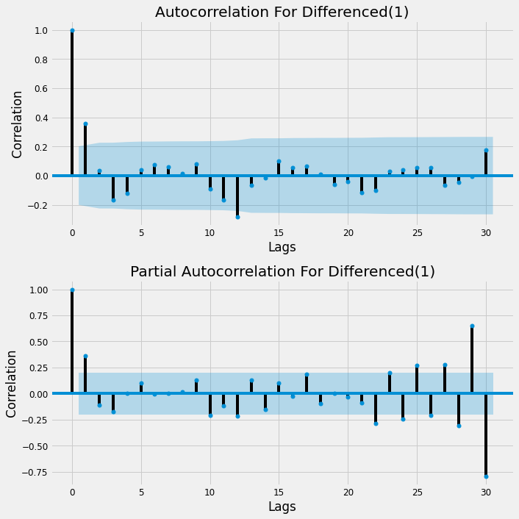

From ACF and PACF we can observe that series has become kind of stationary.

To statistically verify we conduct ADF Test.

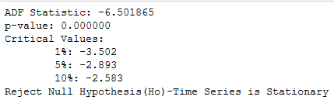

Carrying out Grid Search to Select Parameters especially for Seasonal Component of the Time Series.

Parameters for Series already indicate Non-Seasonality Part with Order (1,1,1).

* (p)-Auto-Regressive (1) derived by the PACF plot
* (q)-Moving Average (1) derived by the ACF Plot
* (d)-Differencing (1) derived by differencing and observing stationarity.

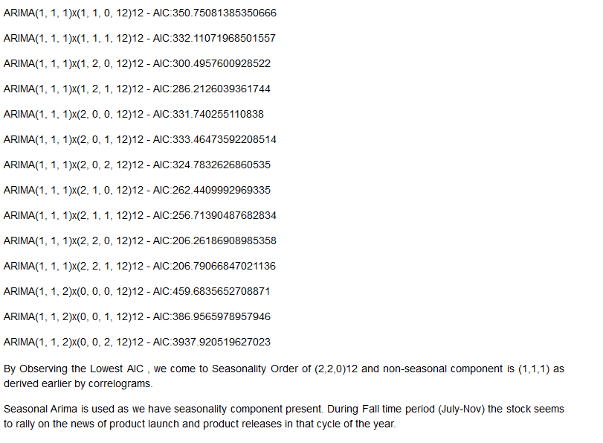

**Forecasting Seasonal ARIMA**

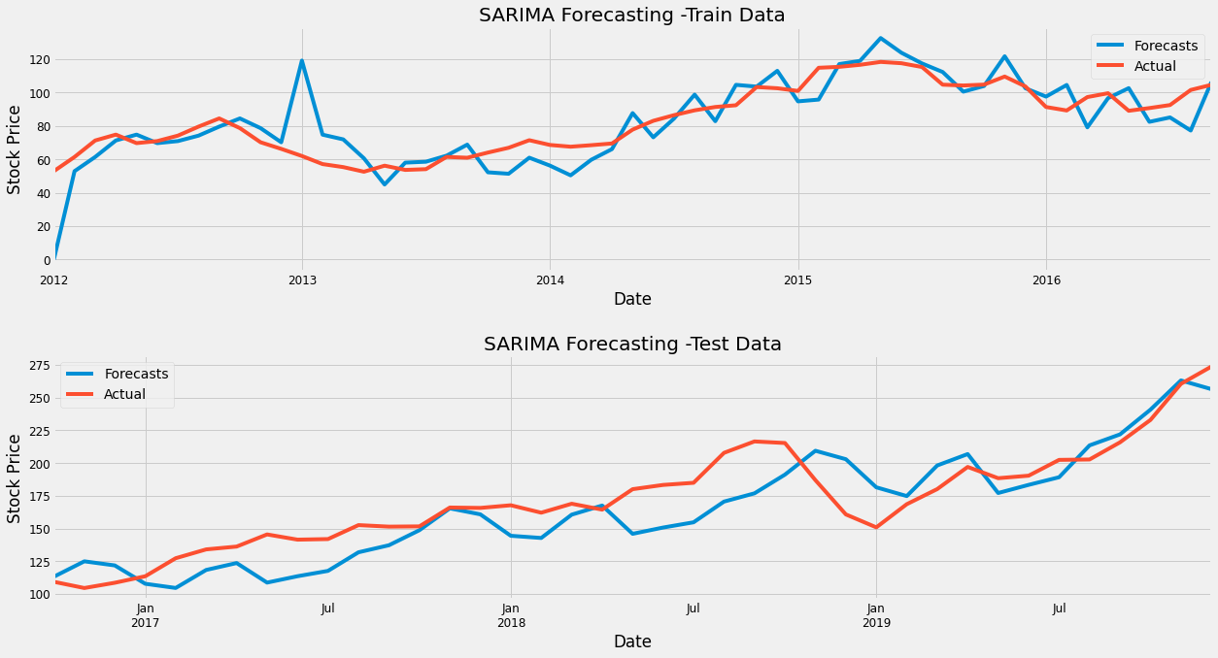

We check Overfitting and Underfitting by observing the In and Out samples fitting. Seems that our model has a balance fit.

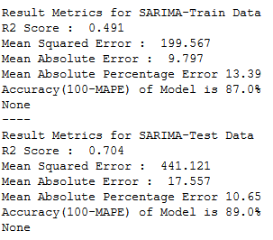

**Model Summary**

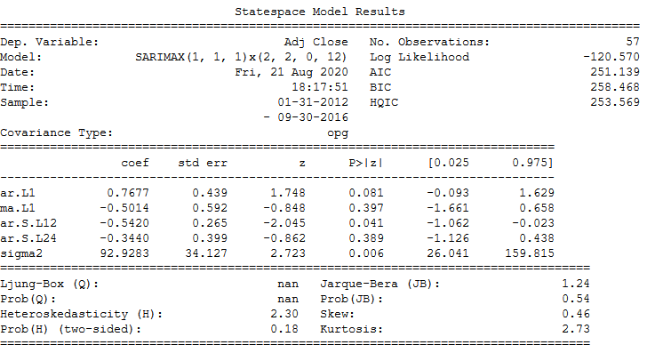

**Residual Analysis**

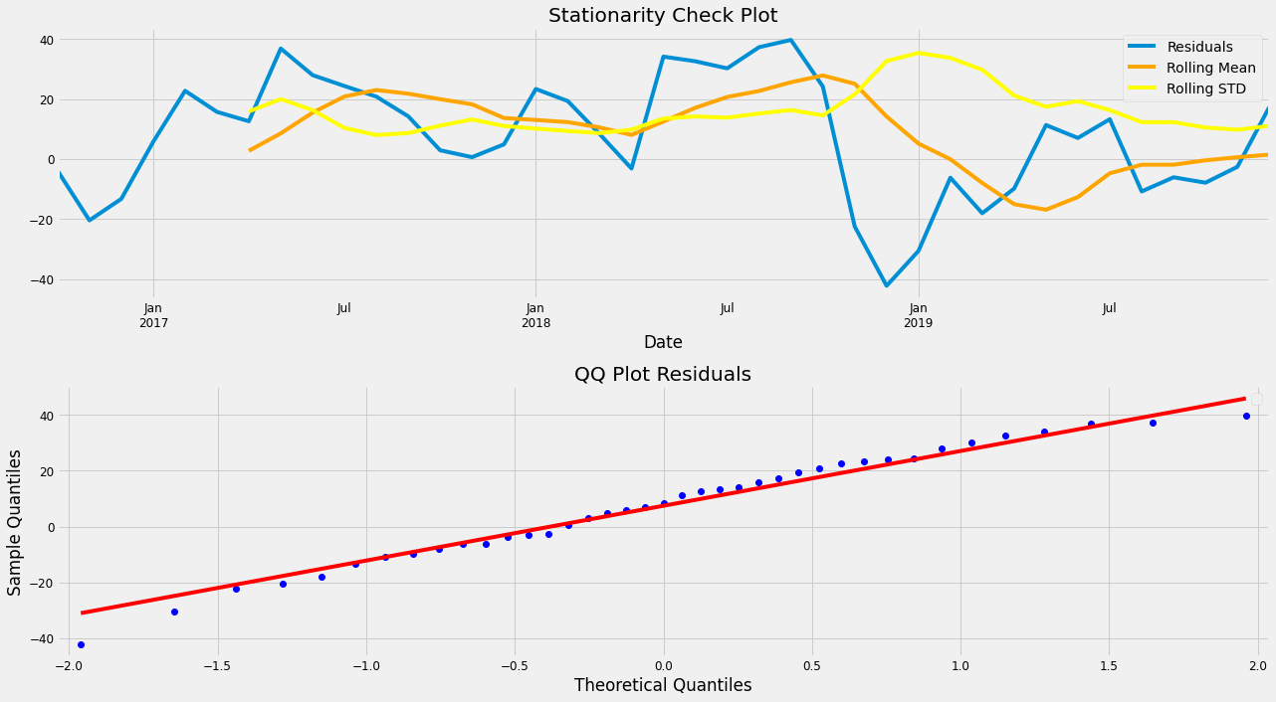

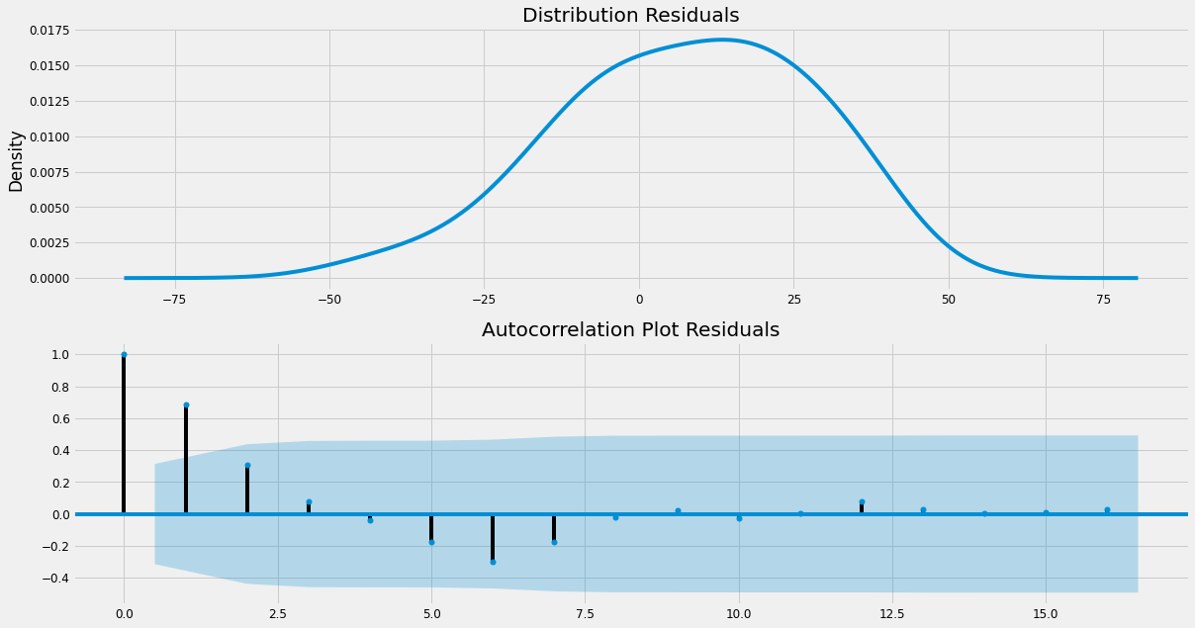

Residuals show us that model approximately follows Normal Distribution, and it also indicates randomness when we look at the ACF plot. This indicates that the model has random residuals and the model has captured the series in a good way. There is little bias in the model.

**Prophet Model Facebook**

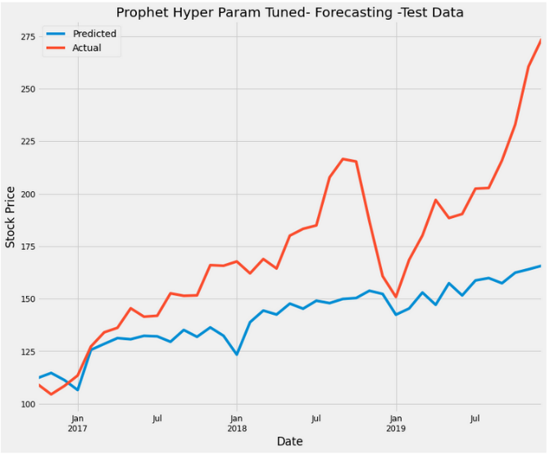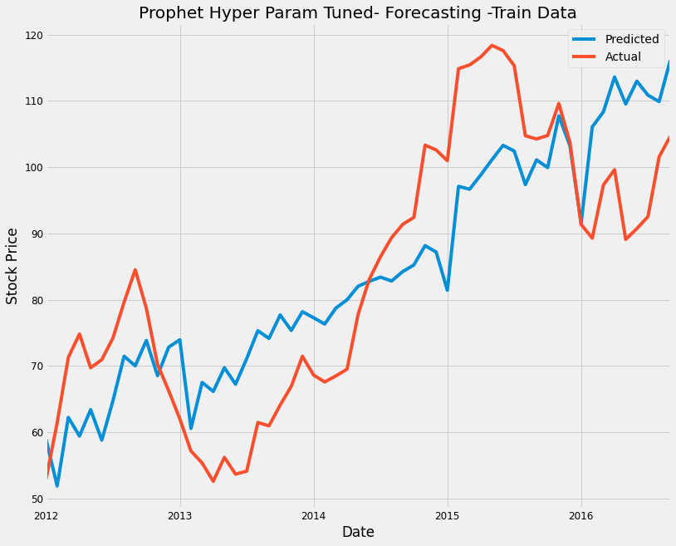

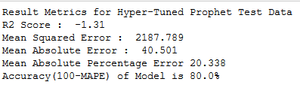

The model is not able to capture the seasonality and sudden jump in time series in the Year 2017 onwards as effectively as the Seasonal ARIMA model.

**Seasonal ARIMA Vs Facebook's Prophet**

* Advantages of Prophet includes very easy to implement, fast, and less statistical/mathematical know-how model. In Seasonal ARIMA we had to follow lot of tests in order to generate predictions.
* Seasonal ARIMA is better at capturing the seasonality part.
* Overall Both models are robust.
* Prophet is easily overfitted.
* Seasonal ARIMA is superior to Prophet
* Prophet is good at capturing the trend.
* By creating Extra Regressors we can maybe improve the Results in future projects.
* Prophet is better at dealing with outliers.
* We have found Seasonal ARIMA is much better at prediction problem. More confidence when predicting with Seasonal-ARIMA since its backed by Mathematical and Statistical tests.
* Accuracy of SARIMA is 89% and 80% for Prophet (Both on Out of Sample Data)

# Actionable Insight

Observing the Trend given by Both Models.

**Apple IS A BUY.**

---------------------------------------------------------------------------------------------------------

**Part-B-Fundamental Analysis**

(Business Valuation – (Discounted Cash Flow)-Intrinsic Valuation Technique)

**Kindly Note this Valuation has taken place at the time between Feb-April 2018-all insights and analysis are subject to that time.**

**Some Insights from Company Study: -**

* The main cash cow for Apple is the iPhone. It roughly generates 60% of total revenues for Apple.
* This company is very fortunate that it was able to release products that changed some industries.
* The reason for Apple’s success is because it offers you quality hardware with easy to use software and the lifetime of its products is very good when compared to competitors.
* The Apple ecosystem is a competitive advantage as they make it difficult for you to change to another ecosystem.

**Operating Margins**

Since Apple is a company which has been known for its premium products its operating margins are also premium. Let us compare the operating margins with Apple’s biggest competitor in terms of

smartphone which is Samsung.

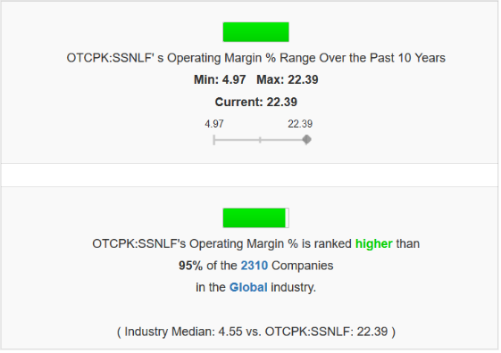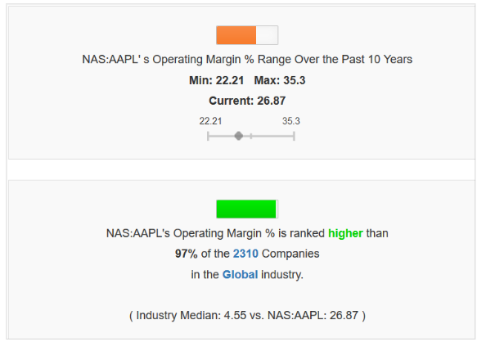

**Operating Margins -Apple & Samsung**

**Brand Value**

The reason was Apple’s high operating margin is because of impact on **Brand value**. Apple’s brand

value is one of its most valued competitive advantage.

But there a different side to this argument. When we talk about Samsung and Apple it’s not only

about the brand value difference.

This can be justified by saying that there’s a different software experience and hardware.

To some extend brand value plays a big role. But the brand value is not the only reason.

**Competitive Advantages**

* Company has a history of releasing new technology, by focusing on less R&D they have less

things to concentrate on and that’s why there’s a saying

“Apple makes the best, not the first”. Doing something First is a big competitive advantage.

• Giving better customer service is also a part of it.

• Giving software update to older smartphones, for a time of 4 yrs on an average whereas Samsung and other Chinese manufacturers give only 2 yrs. of software updates. Including updates to

security and new features whereas android updates are rolled out late as there is problem in

software integration by manufacturers. Helps in more customer satisfaction levels thereby

decreasing rate of switching to another platform such as android. This also helps maintaining a

active user base.

**Estimating Growth Rates :-**

To estimate the growth rates for coming years we need to do a product breakdown to get an idea of

Apple’s business composition.

Data has been collected from SEC filings of 10-k Report.

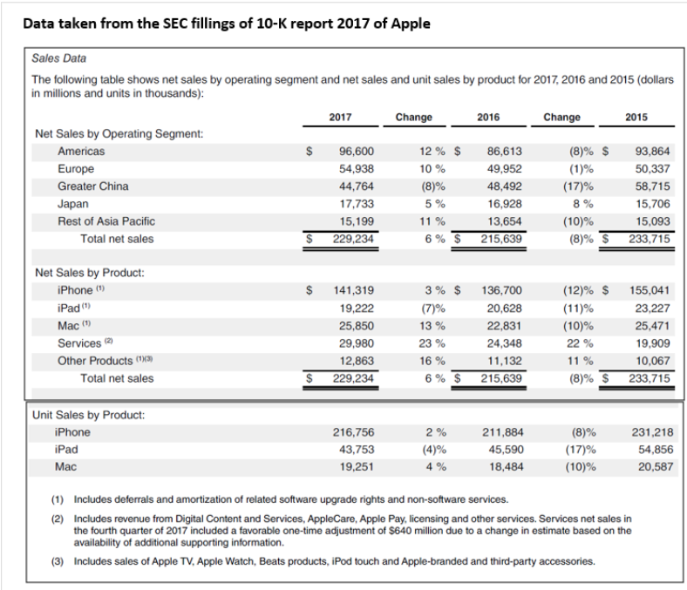

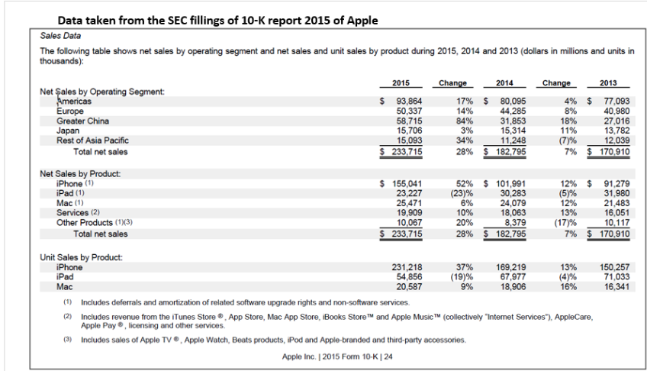

**Thought Process -Growth Across Products: -**

* Our valuation is based on Supply chain rumours and products in the pipeline.
* Using the SEC annual fillings by Apple Inc. we will calculate the growth rate of year 2018.
* First, we would estimate the number of iPhone’s Apple will ship in 2018.

iPhone Growth

We estimate that since Apple’s iPhone will cause super-cycle in 2018 we will consider that iPhone

model of $700 with iPhone X like design will sell 100 million smartphones in its life cycle.

So, by the end of Q4 2018 it should sell 60% of its cycle.

So, we estimate 60 million more than it did in this year of 2017.

Assuming Apple sells the other iPhone’s in the previous year ratio.

Therefore, we get 267 million iPhones for year of 2018.

iPad Growth

For iPad we expect an increase of 10% yoy according as Apple released a student friendly iPad at an

attractive price on $349.

Mac Growth

For Mac as supply chain rumours point we expect sales increase by 15% as Apple will be releasing a

student friendly Mac priced at around $850-$1050.

Services Growth

Services we expect to grow by 13% as observed historically.

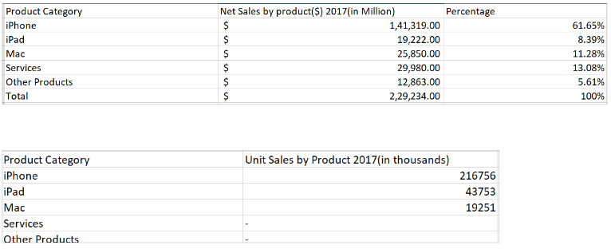

**Historic Average Selling Price (ASP) of Products: -**

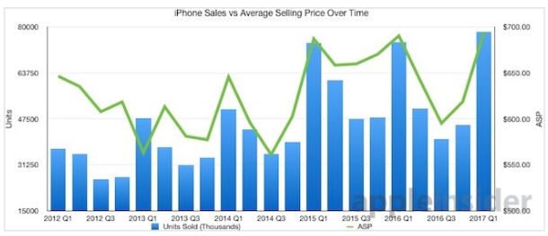

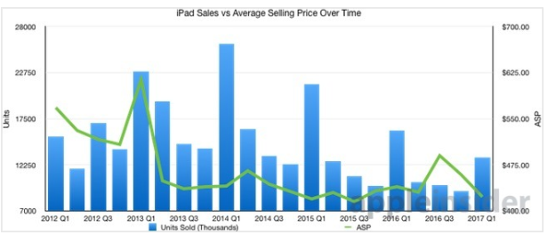

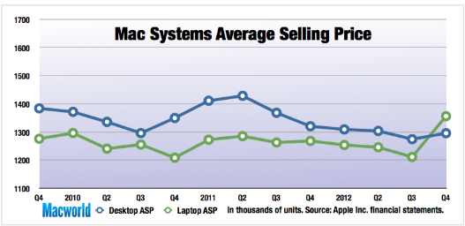

iPad’s becoming cheaper and also in March Apple launched a cheaper iPad at $350. This year iPad

ASP will come down.

iPhone ASP will also come down as Apple will be releasing iPhone will cheaper price.

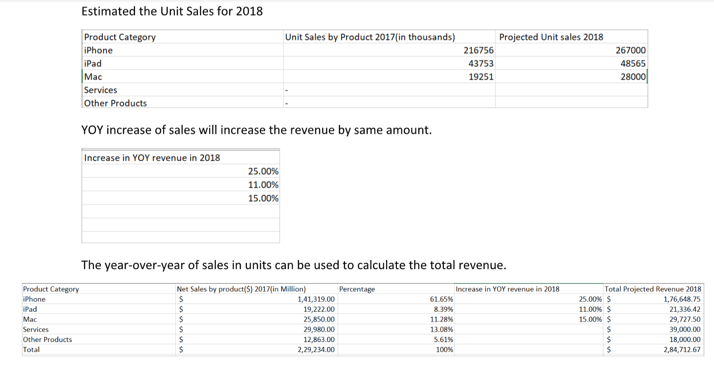Apple will be launch cheaper MacBook this year. ASP should come down significantly.



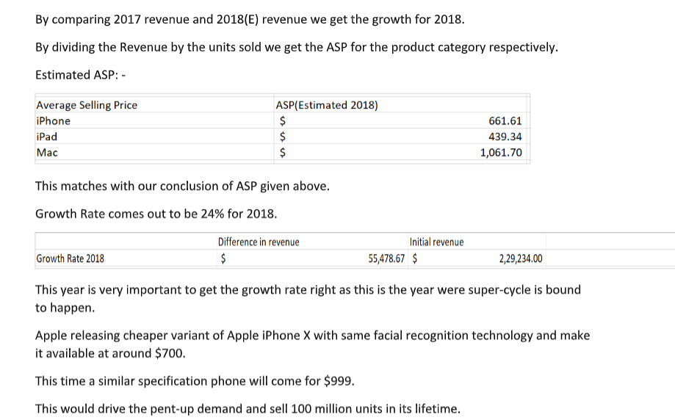

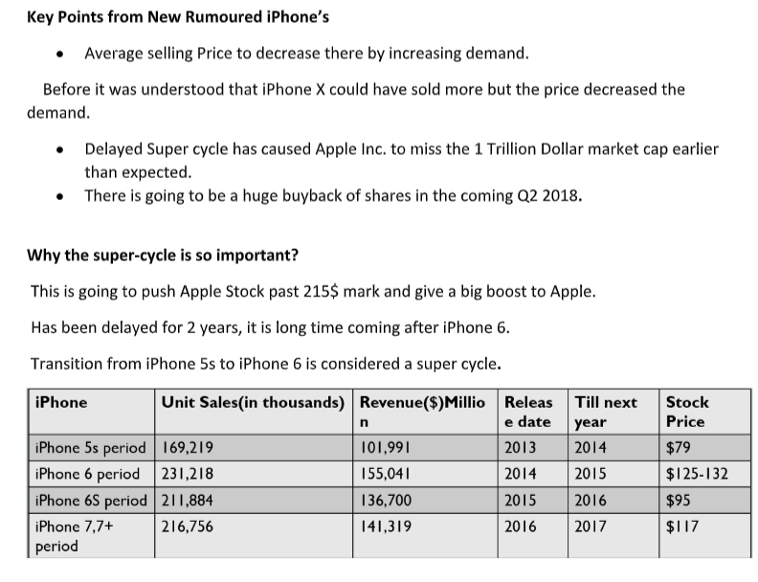

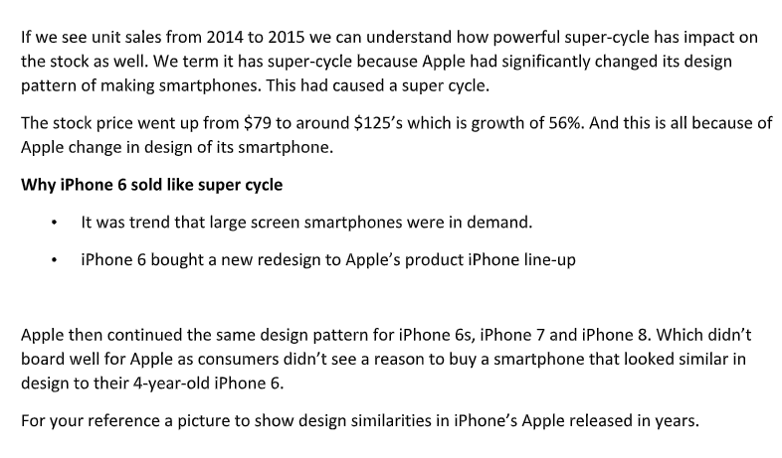

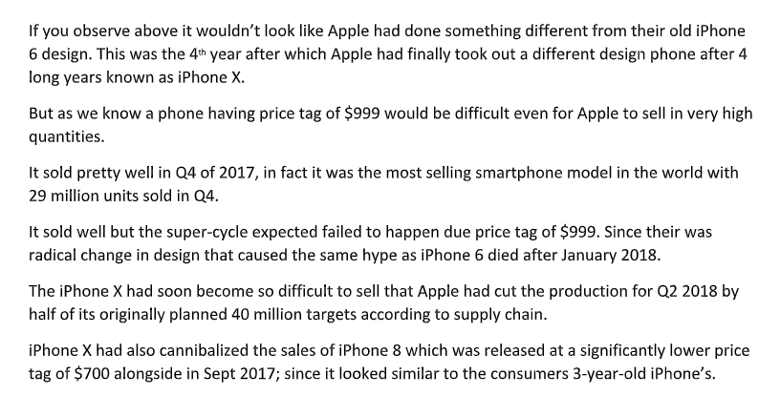

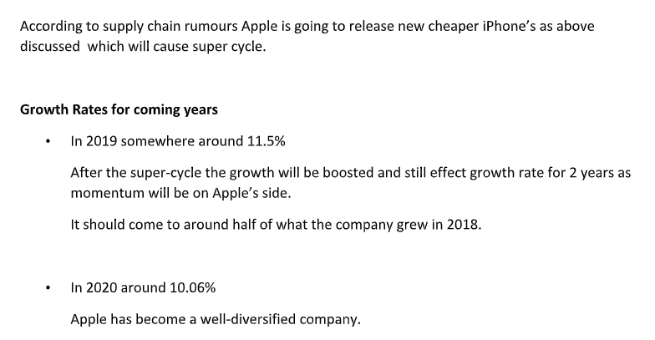

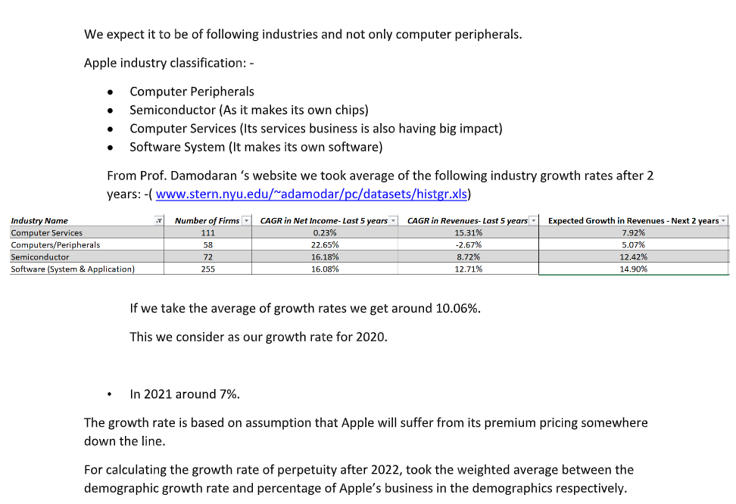

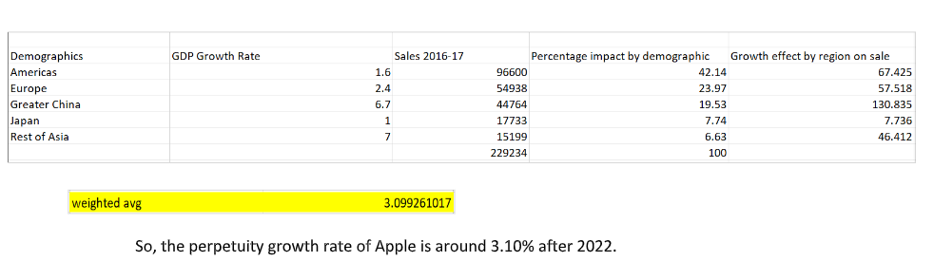

**Discounted Cash Flow Sheet**

The valuation method we are using is intrinsic valuation in which value of company is based on its cash flows, growth potential and risk. We use the discounted cash flow approach to estimate intrinsic value, and the present value of the expected cashflows on the asset, discounted back at a rate that reflects the riskiness of these cashflows.

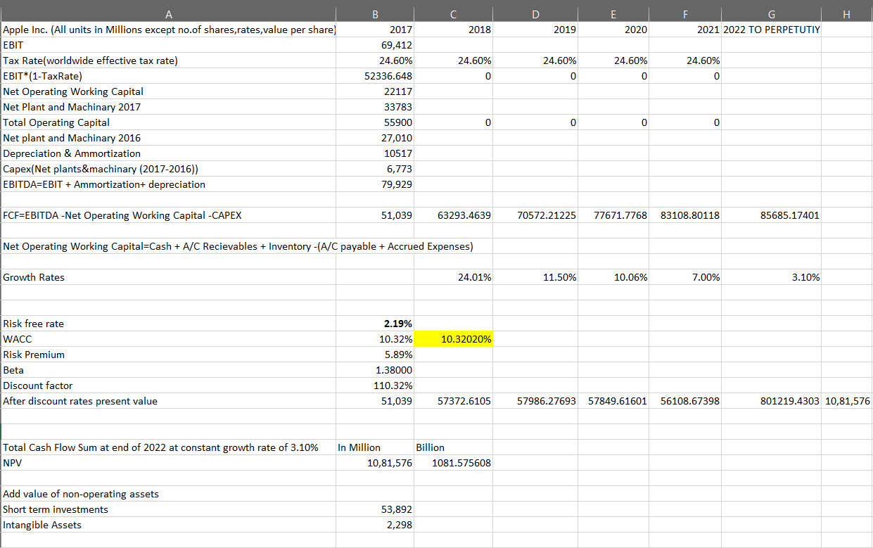

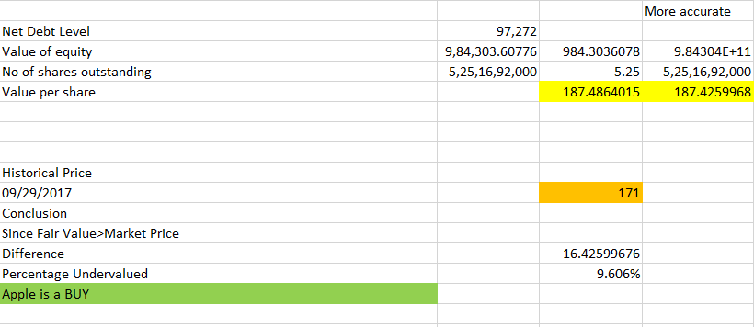

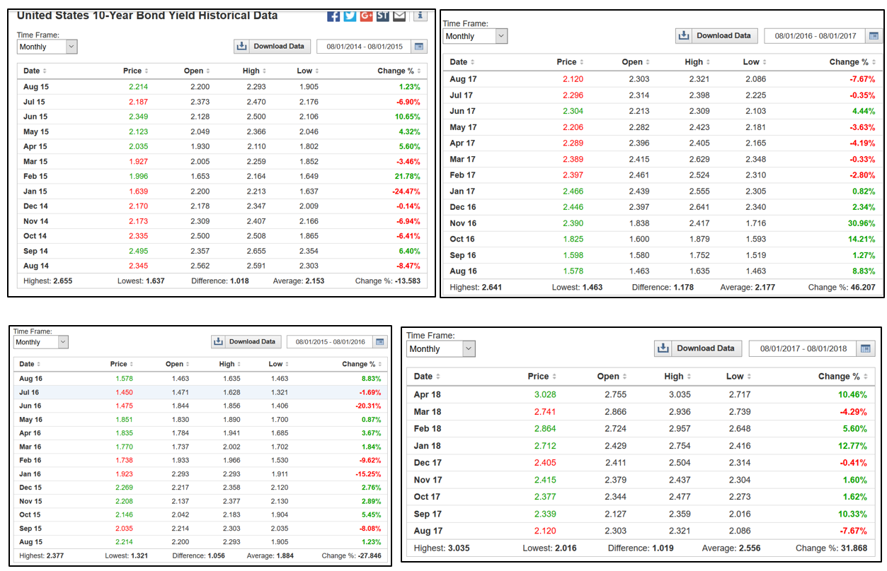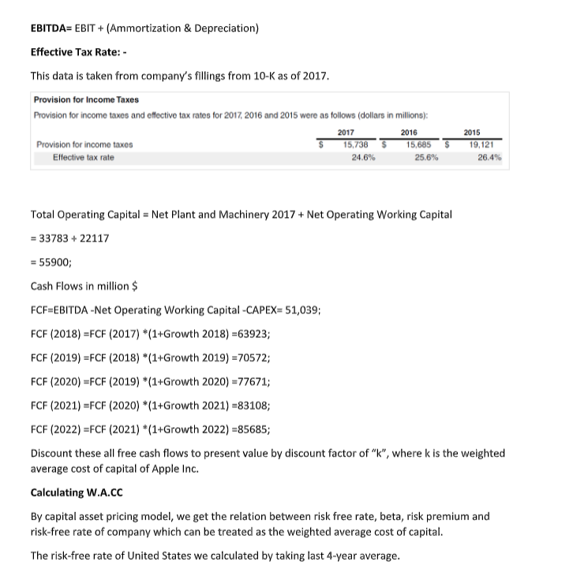

**We get the risk-free rate as 2.192 %**

**Calculating Apple Beta Value**

1.) From Yahoo finance got the monthly adjusted price closing of the index NYSE DJ composite and the Apple Inc. accordingly.

2.) Calculated the monthly return percentage accordingly.

3.) Slope of return % company to return % of index gave the Beta for the following year.

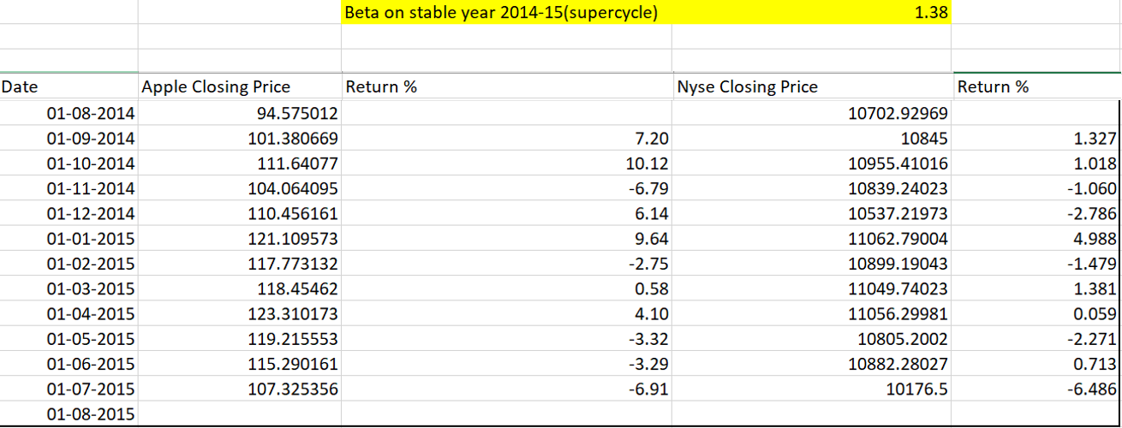

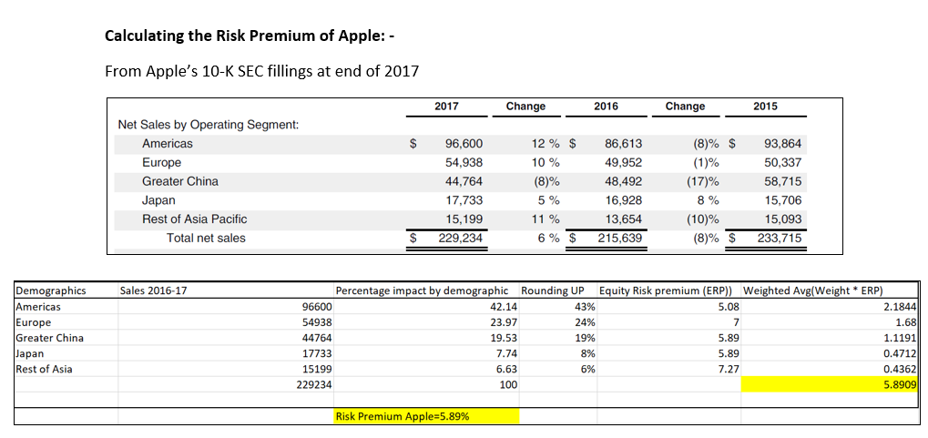

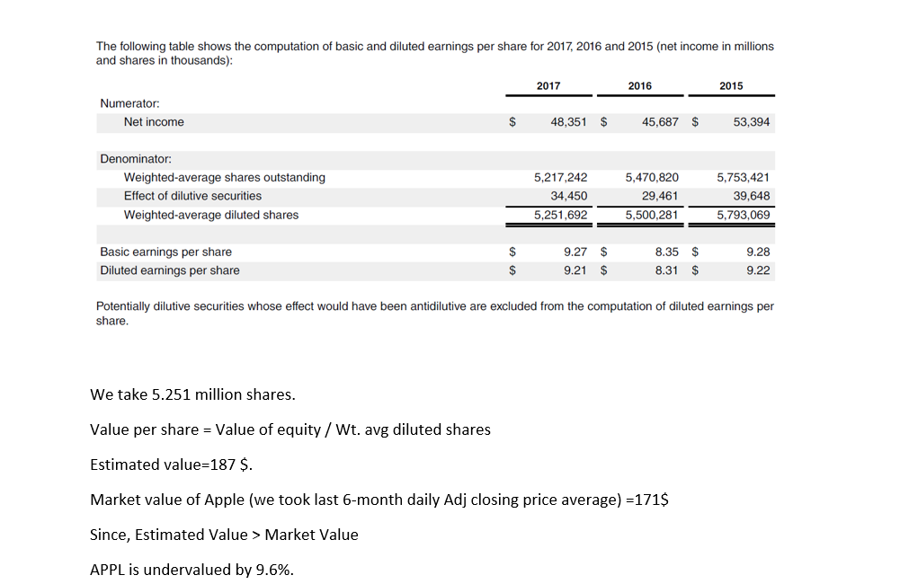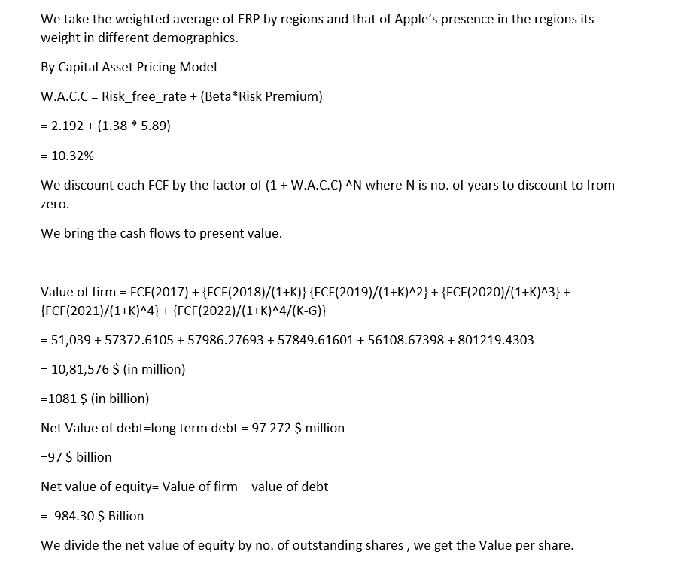

**Our valuation was completed before April 30th 2018**

**Conclusion**

On 1st May 2018 Apple Inc. declared its earnings of Q2 2018.

Analysts were bear about the stock. As iPhone X wasn’t selling that well.

Everyone though the stock be in the red after the earnings.

According to my valuation I had quoted optimism about Apple.

And so, it happened that Apple beats Wall Street expectation and we were right.

The stock picked up and reached 178 on the day after earnings call.

We were also expected a huge buyback as Apple’s plan is to get net neutral of its 267 $ billion overseas cash.

Apple announced 100 billion of buyback which we had right on our prediction.

Apple is going to perform well in long term and investors shouldn’t worry of any downs as end of the day I don’t think we can live without an iPhone.

**End Notes**

**I would like to express my gratitude to Dr. Natesa Prasad, who has guided me as the Project Supervisor.**

**Some Links: -**

**This was a brief report to summarize my project.**

**You can also visit the detailed files as given below: -**

**1.) Detailed Full Report**

[**https://drive.google.com/file/d/14RQdLYkBWvWVceD0L3907620Jf-c9tdN/view?usp=sharing**](https://drive.google.com/file/d/14RQdLYkBWvWVceD0L3907620Jf-c9tdN/view?usp=sharing)

**2.) Valuation Excel Sheet**

[**https://drive.google.com/file/d/1EPU_JsF5EnPc9fhBniFpKeXH9J9GkFDt/view?usp=sharing**](https://drive.google.com/file/d/1EPU_JsF5EnPc9fhBniFpKeXH9J9GkFDt/view?usp=sharing)

**3.) Entire Project Files**

[**https://docs.google.com/document/d/1zNf9gxoUwTUocQpKLseXJqHEit162CRx1bI5srsSMTE/edit?usp=sharing**](https://docs.google.com/document/d/1zNf9gxoUwTUocQpKLseXJqHEit162CRx1bI5srsSMTE/edit?usp=sharing)

**--------------------------------------------------------------------------------------------------------------------------------------**

**Part-C-Comparisons Between Fundamental Analysis & Time Series Analysis**

Time series analysis is based on forecasting the future trends based on previous patterns.

The problem is divided by observing the trend, seasonality effects and by determining the order of the series using statistical methods we fit a line which then forecasts values into the future.

In many cases, as far as univariate analysis is concerned we ignore external factors like competitive advantages, business study, economic factors and focus on the series of historic prices itself.

In multivariate analysis we are able to counter this and we can account for some economic factors. But there are limitations to what we can quantify and what we cannot.

We cannot completely ignore the balance sheet essentials and say that this is the right way to forecast.

During our problem of stock price prediction, we had focused on the series and then we applied Seasonal ARIMA. We didn’t focus much on external factors/variables.

In fundamental analysis, we ignore most charts and trends and focus more on the financial reports like balance sheets. We look into competitive advantages, economic factors, growth story of the company, etc. At the end we value the company and see whether it is overvalued or undervalued according to our prediction.

Neural networks and new machine learning techniques have given forecasting models unimaginable accuracy. But the challenge is no model is perfect.

Fundamental analysis in its own way is unique and powerful and is a more traditional way for valuing companies.

Apart from difference methodologies, time series forecasting is much quicker at deployment than valuing a company. Valuation can take much longer time in comparison.

The best way to make forecasting decisions I believe is by deploying both types of methods.

By using both of the techniques to give us more intuition towards the problem and make sure that we invest in the right place.

Using many techniques in harmony can create a more complete picture and give better forecasting powers.