**Heuristic Analysis**

|  |  |  |  |  |  |  |  |  |  |  |
| --- | --- | --- | --- | --- | --- | --- | --- | --- | --- | --- |
|  |  |  | *AB_Improved* | | *AB_Custom* | | *AB_Custom_2* | | *AB_Custom_3* | |
| # |  | **Opponent** | **Won** | **Lost** | **Won** | **Lost** | **Won** | **Lost** | **Won** | **Lost** |
| 1 |  | Random | 8 | 2 | 10 | 0 | 8 | 2 | 8 | 2 |
| 2 |  | MM_Open | 10 | 0 | 10 | 0 | 10 | 0 | 10 | 0 |
| 3 |  | MM_Center | 10 | 0 | 8 | 2 | 9 | 1 | 9 | 1 |
| 4 |  | MM_Improved | 10 | 0 | 9 | 1 | 10 | 0 | 10 | 0 |
| 5 |  | AB_Open | 6 | 4 | 6 | 4 | 5 | 5 | 6 | 4 |
| 6 |  | AB_Center | 10 | 0 | 8 | 2 | 5 | 5 | 7 | 3 |
| 7 |  | AB_Improved | 4 | 6 | 6 | 4 | 4 | 6 | 5 | 5 |
|  |  | ***Win Rate*** | **82.9%** | | **81.4%** | | **72.9%** | | **78.6%** | |

Those are the 3 methods I attempted:

**Custom 1**

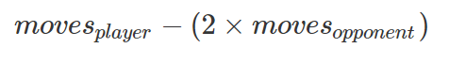

The fist method is a scorer that rewards a more “aggressive” stance as hinted during the lectures, by simply multiplying the amount of opponent moves available by 2. But results were slightly worse than before. It seems aggressiveness is not necessarily a good overall strategy.

**Custom 2**

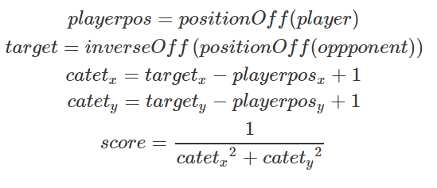In one of the lectures, the student hinted that player 2 could win by mirroring the movements from another player. This scorer is an attempt to stimulate this behavior through a formula, by picking the mirrored position of the opponent and calculating a score with a simple Euclidean distance.

But results were the worse. Probably because this scoring method should only be applied to player 2.

**Custom 3**

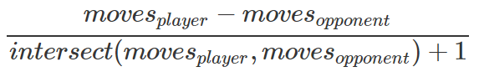

The idea here is to consider that in the situation when both players are locked away from each other, the player with the more moves left win. So, we use the number of squares that are in intersect between the player’s moves as a divider of the improved scorer. Players would then seek to have less and less intersect, locking out the other player from contact.

It worked reasonably well, but still not better than the improved scorer alone.