Term Project 1

20130501 이철민

1. Data description

Data is iris data which is famous data in machine learning. It has 5 basic attributes that is sepal length, sepal width, petal length, petal width, and species. And I add new attribute tid(tuple id) as identifier. Data exists in ‘iris.csv’ file, and it has 150 tuples.

2. Tree order, key

Order of tree is 3, so it can have 3 children and 2 keys as maximum. And, tree has at least 2 children and 1 keys. Key pairs consist of (sepal length, sepal width) as tuple.

3. Program

1. load 2. print

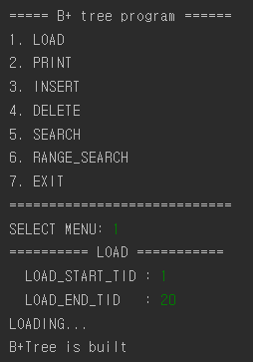 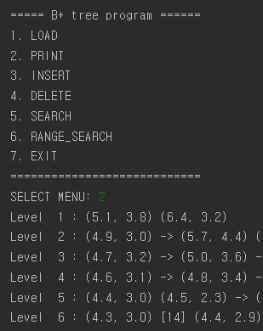

3. insert 4. delete

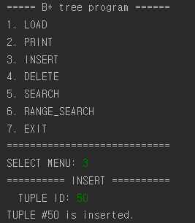 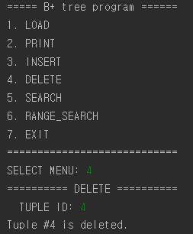

5. search 6. range search

