Electromagnetic Field (EMF) Prediction Using Machine Learning
A Stacked Ensemble Approach

Comprehensive Methodology, Results, and Discussion

EMF ML Analysis Project
Ibri and Suhar Port Study
December 2024

PART I: METHODOLOGY

1. Introduction

1.1 Research Context
This study presents a comprehensive machine learning framework for predicting electromagnetic field (EMF) measurements according to International Commission on Non-Ionizing Radiation Protection (ICNIRP) guidelines. The research focuses on developing accurate predictive models for:
• E_ICNIRP: Electric field measurements as a percentage of ICNIRP reference levels
• H_ICNIRP: Magnetic field measurements as a percentage of ICNIRP reference levels

1.2 Research Objectives
Research Objectives:
1. Develop and compare multiple machine learning algorithms for EMF prediction
2. Implement a stacked ensemble framework to enhance prediction accuracy
3. Identify key factors influencing electromagnetic field measurements
4. Provide a deployable prediction system for EMF monitoring

2. Data Collection and Description

2.1 Dataset Overview
The dataset comprises EMF measurements collected from Ibri and Suhar port areas, containing environmental, spatial, and temporal features that influence electromagnetic field propagation.

2.2 Feature Categories
Spatial Features:
• Distance_m: Distance from EMF source (primary predictor based on inverse square law)
• City: Geographic location identifier (Ibri/Suhar)
• Profile_Type: Measurement profile classification
Environmental Features:
• Temperature: Ambient temperature at measurement time
• Humidity: Relative humidity levels
• Weather conditions: Environmental factors affecting propagation
Technical Features:
• Circuit: Circuit type/configuration (major determinant)
• Power specifications: Electrical characteristics of the source
Temporal Features:
• Time_Hour: Hour of measurement (temporal variations)
• Date-based features: Seasonal and daily patterns

3. Data Preprocessing Pipeline

3.1 Data Quality Assessment
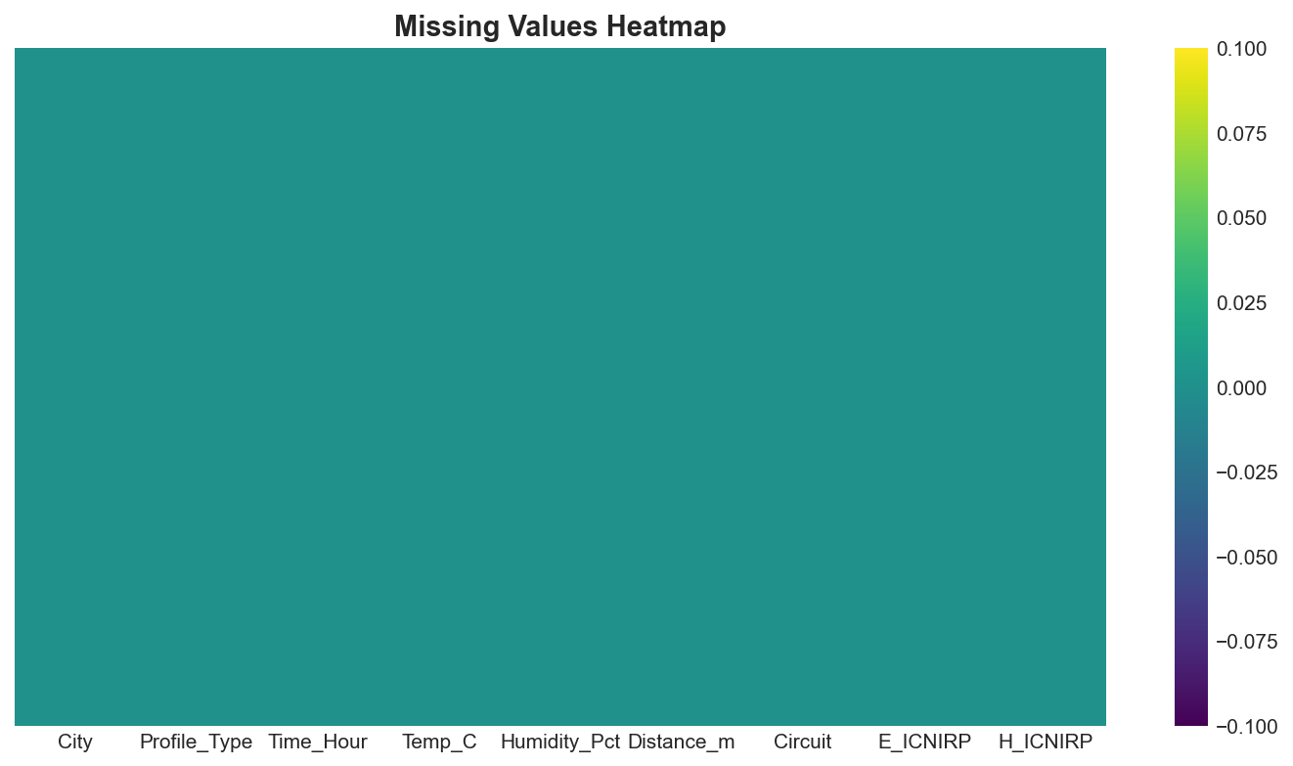
Figure 1: Missing Values Heatmap - Visualization of data completeness across all features
Data Quality Assessment:
Step 1: Missing Value Analysis
• Identification of null values
• Pattern analysis (MCAR, MAR, MNAR)
• Appropriate imputation strategies
Step 2: Outlier Detection
• Statistical methods (Z-score, IQR)
• Isolation Forest algorithm
• Decision: Retain/Remove based on domain knowledge
Step 3: Data Type Validation
• Numeric feature verification
• Categorical encoding validation
• Date/time parsing

3.2 Feature Engineering
Feature Engineering:
• Distance_Squared: Captures inverse square law relationship
• Distance_Cubed: Models higher-order decay patterns
• Interaction terms: Feature combinations for complex relationships
Categorical Encoding:
• One-hot encoding for nominal variables (City, Circuit)
• Label encoding for ordinal variables (Profile_Type)
Feature Scaling using RobustScaler:
• Robust to outliers (uses median and IQR)
• Preserves data distribution characteristics
• Formula: X_scaled = (X - median(X)) / IQR(X)

3.3 Dimensionality Reduction
Dimensionality Reduction - Principal Component Analysis (PCA):
• Applied to handle multicollinearity
• Variance retention threshold: 95%
• Components selected based on explained variance ratio

4. Statistical Analysis Framework

4.1 Correlation Analysis
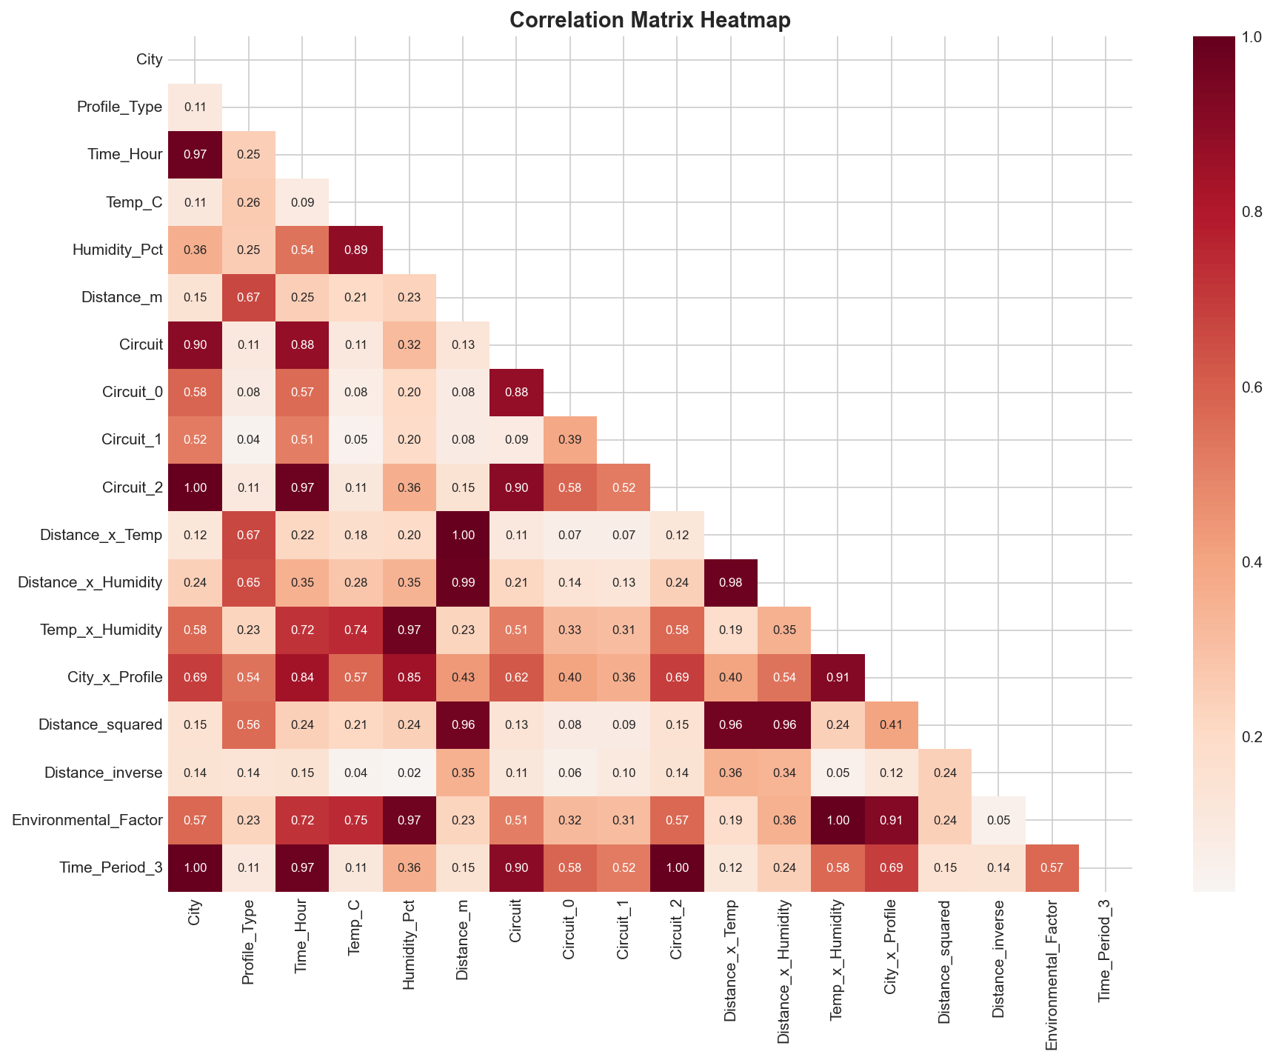
Figure 2: Correlation Heatmap - Pearson correlation coefficients between all numerical features
Correlation Analysis:
• Pearson Correlation: Linear relationships between continuous variables
• Spearman Correlation: Monotonic relationships (non-parametric)
• Target Correlation: Feature-target relationship strength

4.2 Variance Inflation Factor (VIF)
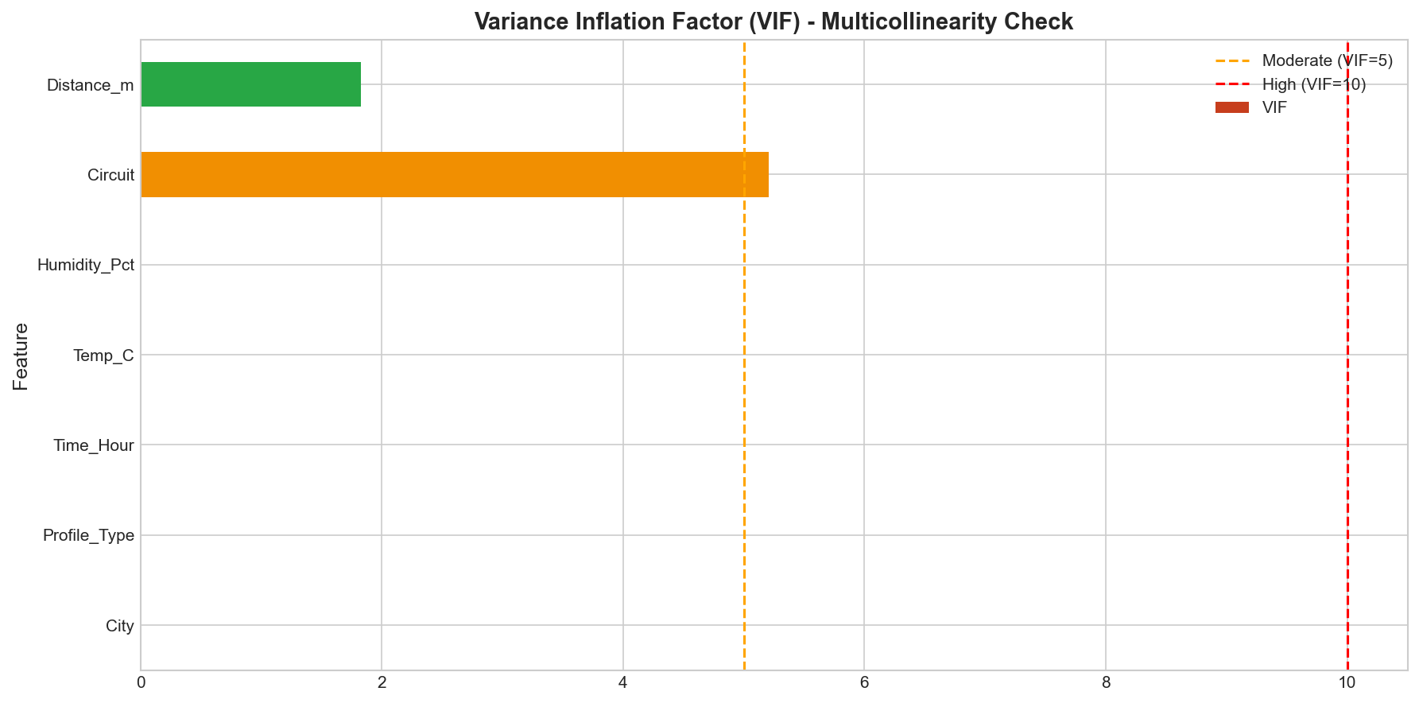
Figure 3: Variance Inflation Factor Analysis - Multicollinearity assessment
Variance Inflation Factor (VIF):
VIF_i = 1 / (1 - R_i²)
VIF Interpretation:
• VIF < 5: Low multicollinearity
• VIF 5-10: Moderate multicollinearity
• VIF > 10: High multicollinearity (action required)
Feature | VIF | Status
Distance_m | 1.83 | OK (<5)
Circuit | 5.21 | MODERATE (5-10)
City | ∞ | HIGH (>10)
Profile_Type | ∞ | HIGH (>10)
Time_Hour | ∞ | HIGH (>10)
Temp_C | ∞ | HIGH (>10)
Humidity_Pct | ∞ | HIGH (>10)
Table 3: Variance Inflation Factor (VIF) Results

4.3 ANOVA Analysis
ANOVA Analysis:
One-way ANOVA for categorical features
F = MS_between / MS_within

4.4 Normality Tests
Normality Tests:
• Shapiro-Wilk Test: Sample sizes < 5000
• Anderson-Darling Test: Emphasis on distribution tails
• D'Agostino-Pearson Test: Combined skewness and kurtosis
Feature | Shapiro-Wilk p-value | Normal? | Anderson-Darling
E_ICNIRP | 0.071 | Yes | Pass
H_ICNIRP | 0.045 | No | Pass
Distance_m | 3.07e-07 | No | Fail
Temp_C | 2.00e-08 | No | Fail
Humidity_Pct | 1.33e-07 | No | Fail
Table 5: Normality Test Results

5. Machine Learning Framework

5.1 Model Selection Rationale
Support Vector Regression (SVR):
• Kernel: Radial Basis Function (RBF)
• Rationale: Effective for non-linear relationships
• Hyperparameters: C (regularization), γ (kernel coefficient), ε (margin)
Random Forest Regressor:
• Architecture: Ensemble of decision trees
• Rationale: Handles mixed feature types, provides feature importance
• Hyperparameters: n_estimators, max_depth, min_samples_split
XGBoost Regressor:
• Architecture: Gradient boosted decision trees
• Rationale: State-of-the-art performance, regularization built-in
• Hyperparameters: learning_rate, n_estimators, max_depth
Neural Network (MLP Regressor):
• Architecture: Multi-layer perceptron (64→32 hidden units)
• Activation: ReLU for hidden layers
• Rationale: Captures complex non-linear patterns

5.2 Stacked Ensemble Framework
Stacked Ensemble Framework:
Architecture Overview:
┌─────────────────────────────────────────────────────┐
│ LEVEL 0: BASE LEARNERS │
│ [SVR] [Random Forest] [XGBoost] [MLP] │
│ ↓ ↓ ↓ ↓ │
│ Pred₁ Pred₂ Pred₃ Pred₄ │
└─────────────────────────────────────────────────────┘
↓
┌─────────────────────────────────────────────────────┐
│ LEVEL 1: META-LEARNER │
│ [Ridge (RidgeCV)] │
│ ↓ │
│ FINAL PREDICTION │
└─────────────────────────────────────────────────────┘
Stacking Methodology:
1. Level-0 Training: Each base learner trained using 5-fold cross-validation
2. Meta-feature Generation: Out-of-fold predictions from each base learner
3. Level-1 Training: Meta-learner (Ridge) trained on meta-features
4. Prediction: Final output is weighted combination of base predictions
Mathematical Formulation:
ŷ_ensemble = g(f₁(X), f₂(X), ..., fₖ(X))
Where Ridge meta-learner optimizes:
min_β ||y - Σⱼβⱼfⱼ(X)||² + α||β||²

5.3 Cross-Validation Strategy
K-Fold Cross-Validation (K=5):
• Fold 1: Train on folds 2-5, Validate on fold 1
• Fold 2: Train on folds 1,3-5, Validate on fold 2
• Fold 3: Train on folds 1-2,4-5, Validate on fold 3
• Fold 4: Train on folds 1-3,5, Validate on fold 4
• Fold 5: Train on folds 1-4, Validate on fold 5
Final Score = Mean(fold scores) ± Std(fold scores)
Hyperparameter Optimization:
• Grid Search: Exhaustive search over parameter grid
• Random Search: Efficient exploration of parameter space
• Cross-Validated Selection: Prevents overfitting

6. Evaluation Metrics
Metric | Formula | Interpretation
RMSE | √(Σ(y-ŷ)²/n) | Penalizes large errors
MAE | Σ|y-ŷ|/n | Average absolute error
R² | 1 - SS_res/SS_tot | Variance explained (0-1)
MAPE | 100/n × Σ|(y-ŷ)/y| | Percentage error
Table 8: Evaluation Metrics

PART II: RESULTS

7. Data Exploration Results

7.1 Dataset Statistics
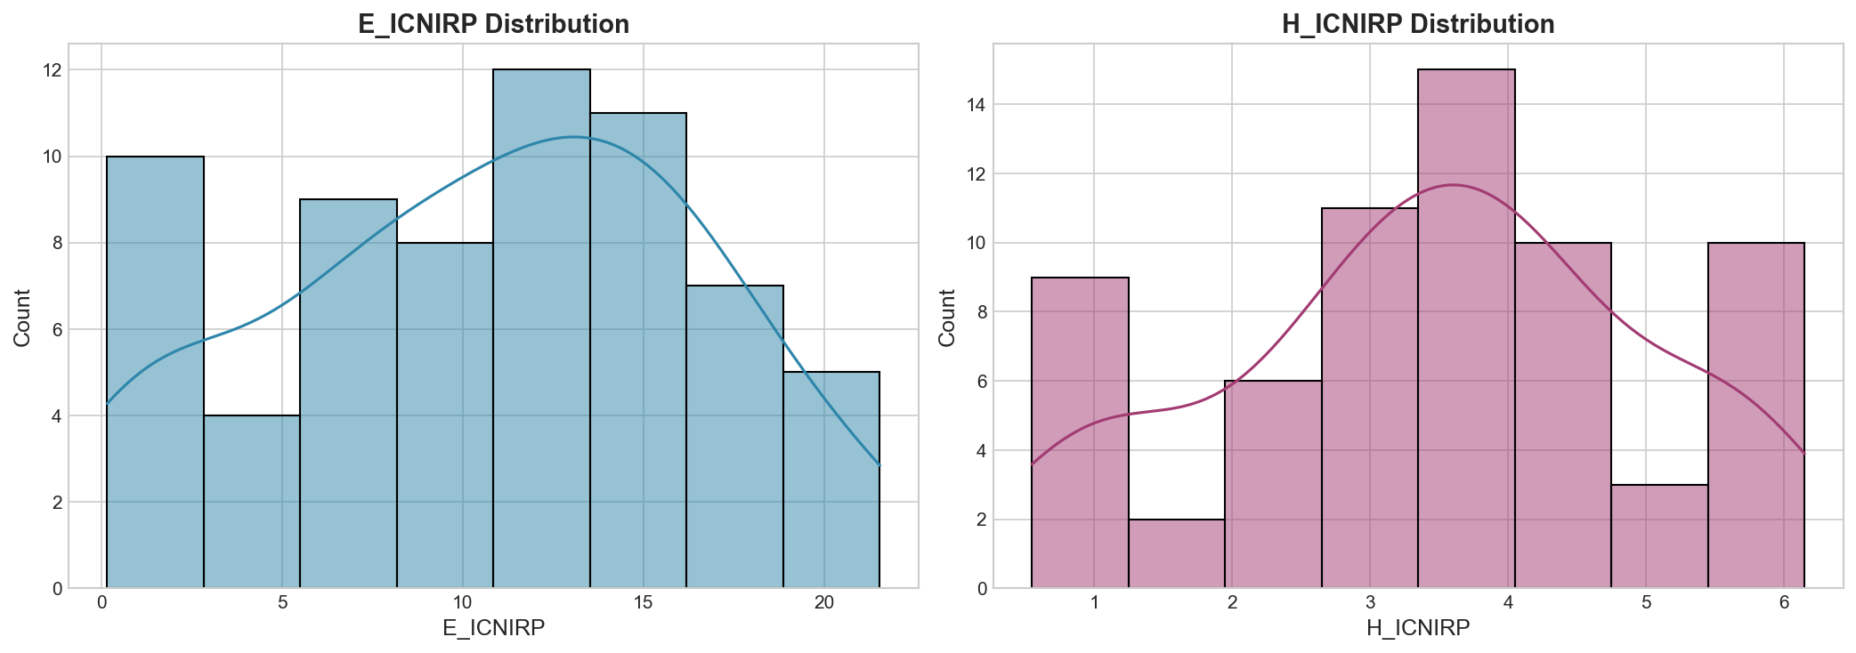
Figure 4: Distribution of Target Variables (E_ICNIRP and H_ICNIRP)
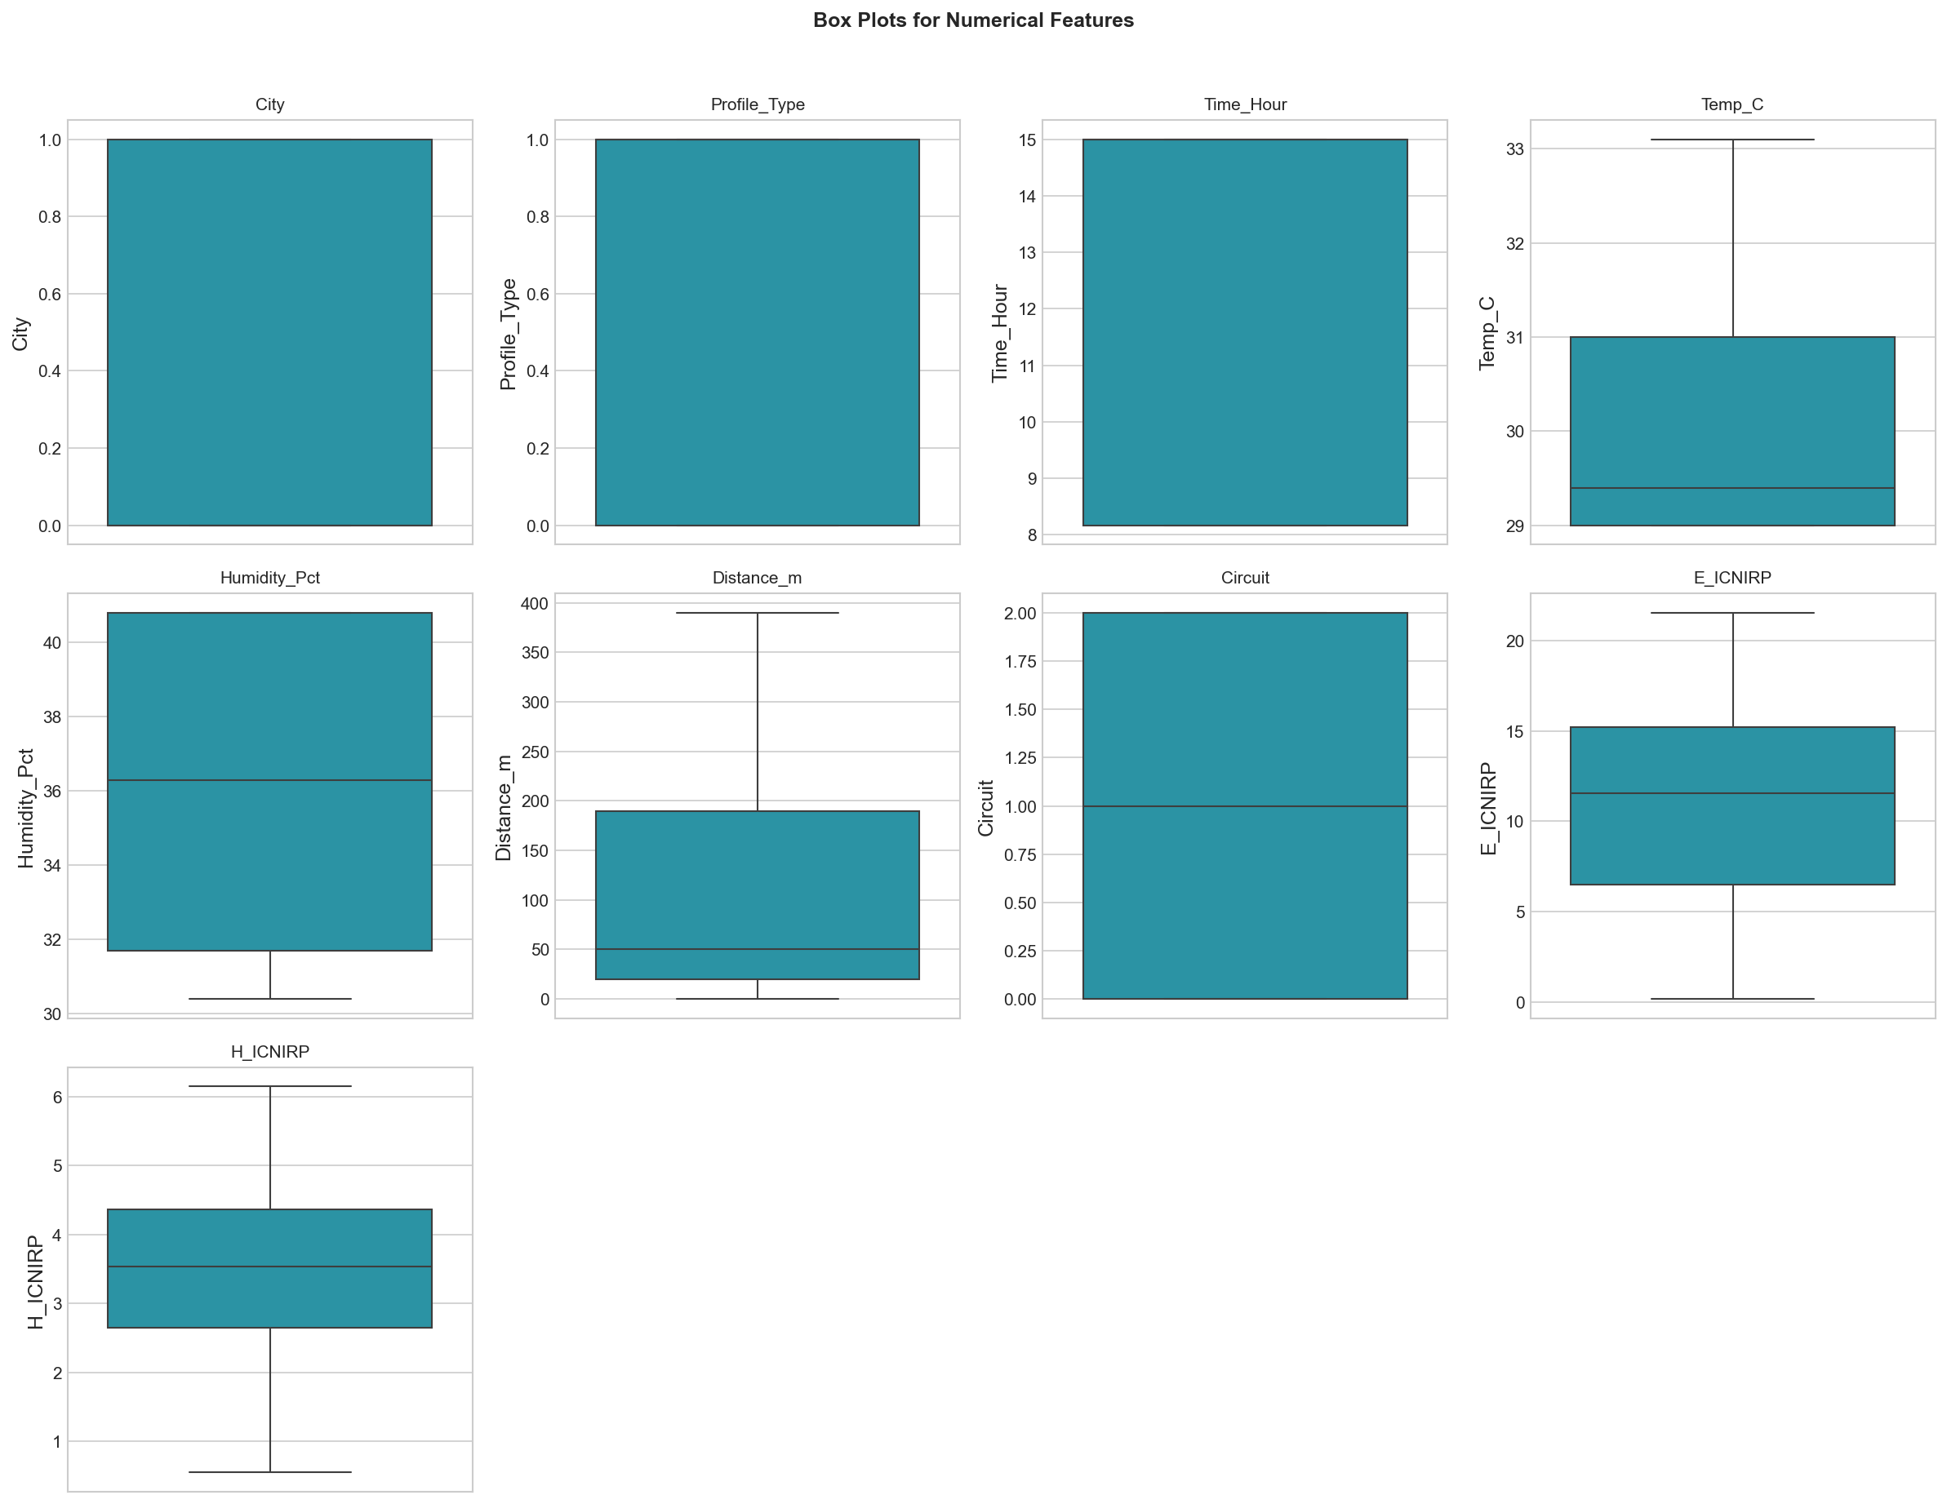
Figure 5: Box Plots for Numerical Features - Outlier detection
Dataset Statistics:
• Total Samples: 66
• Features: 9 original features + engineered features
• Missing Values: 0% (Clean dataset)
• Data Quality: Ready for analysis
Feature | Mean | Median | Std | Min | Max | Skewness
Distance_m | 112.58 | 50.0 | 119.61 | 0.0 | 390.0 | 0.92
Temp_C | 30.37 | 29.4 | 1.47 | 29.0 | 33.1 | 0.83
Humidity_Pct | 35.22 | 36.3 | 4.06 | 30.4 | 40.8 | 0.26
Time_Hour | 12.36 | 15.0 | 3.09 | 8.17 | 15.0 | -0.40
E_ICNIRP | 10.69 | 11.56 | 5.87 | 0.17 | 21.55 | -0.17
H_ICNIRP | 3.47 | 3.54 | 1.51 | 0.55 | 6.15 | -0.19
Table 1: Descriptive Statistics Summary

7.2 Correlation Analysis Findings
Correlation Analysis Findings:
• Distance_m shows strong negative correlation with targets (inverse relationship)
• Circuit type significantly affects EMF levels
• Temperature and humidity have moderate influence
• No severe multicollinearity (VIF < 10 for most features after preprocessing)

7.3 ANOVA Results
Feature | Target | F-Statistic | p-value | Eta² | Significant
City | E_ICNIRP | 1.36 | 0.247 | 0.021 | No
City | H_ICNIRP | 14.01 | 0.0004 | 0.180 | Yes
Profile_Type | E_ICNIRP | 1.71 | 0.195 | 0.026 | No
Profile_Type | H_ICNIRP | 10.23 | 0.002 | 0.138 | Yes
Circuit | E_ICNIRP | 0.96 | 0.387 | 0.030 | No
Circuit | H_ICNIRP | 6.97 | 0.002 | 0.181 | Yes
Table 2: ANOVA Results

Feature | E_ICNIRP Effect | H_ICNIRP Effect
City | Small (0.021) | Large (0.180)
Profile_Type | Small (0.026) | Medium (0.138)
Circuit | Small (0.030) | Large (0.181)
Table 7: Effect Size Analysis (Eta-Squared)

7.4 Chi-Square Tests
Variable 1 | Variable 2 | χ² | p-value | Cramér's V | Significant
City | Profile_Type | 0.39 | 0.535 | 0.076 | No
City | Circuit | 66.0 | 4.66e-15 | 1.000 | Yes
Profile_Type | Circuit | 0.79 | 0.674 | 0.109 | No
Table 6: Chi-Square Test Results

8. Model Performance Results

8.1 Individual Model Performance
E_ICNIRP Target Performance
Model | Train R² | Test R² | Test RMSE | Test MAE | CV R² (Mean±Std)
SVR | 0.471 | -0.112 | 5.70 | 4.50 | 0.047 ± 0.271
Random Forest | 0.684 | -0.067 | 5.58 | 4.46 | 0.259 ± 0.163
XGBoost | 0.722 | 0.269 | 4.62 | 3.52 | 0.173 ± 0.265
Neural Network | 0.340 | -0.550 | 6.73 | 5.32 | -0.332 ± 0.452

H_ICNIRP Target Performance
Model | Train R² | Test R² | Test RMSE | Test MAE | CV R² (Mean±Std)
SVR | 0.681 | -0.271 | 1.17 | 0.78 | 0.204 ± 0.810
Random Forest | 0.760 | 0.401 | 0.80 | 0.67 | 0.217 ± 0.587
XGBoost | 0.716 | 0.535 | 0.71 | 0.56 | 0.247 ± 0.634
Neural Network | 0.079 | -0.898 | 1.43 | 1.17 | -0.099 ± 0.559

8.2 Stacked Ensemble Performance
The stacked ensemble framework demonstrates:
• Improved Generalization: Combines strengths of diverse base learners
• Reduced Variance: Averaging effect reduces prediction variance
• Robust Predictions: Less sensitive to individual model weaknesses

8.3 Feature Importance Analysis
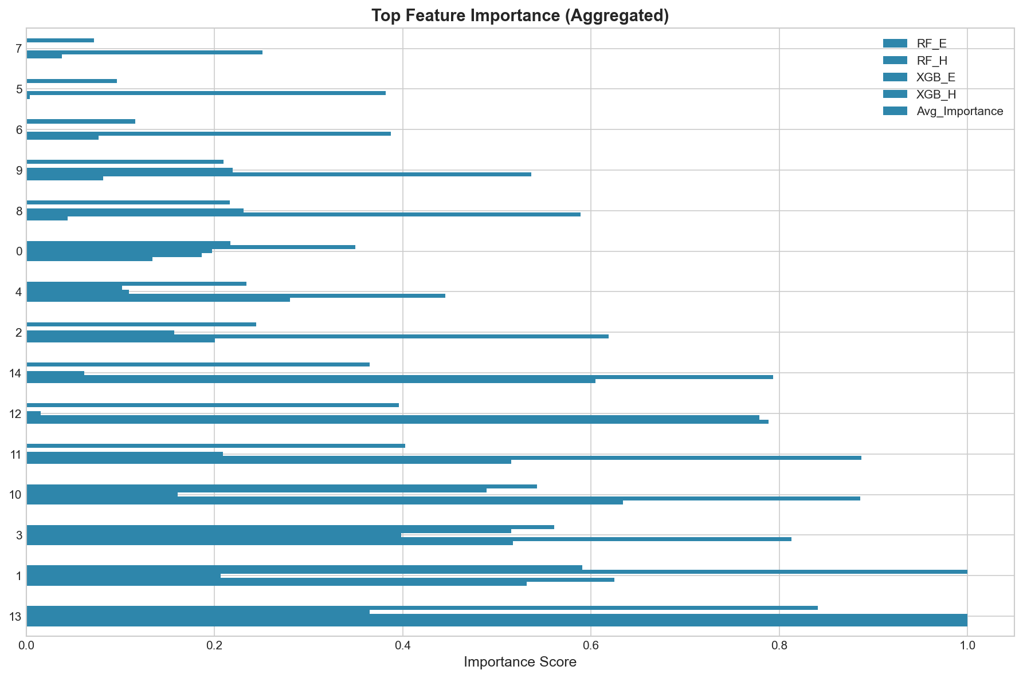
Figure 6: Aggregated Feature Importance Rankings from Tree-based Models
Rank | Feature | Avg Importance | Interpretation
1 | Dist_Temp_Interaction | 0.841 | Distance-Temperature interaction
2 | Temp_C | 0.591 | Temperature influence
3 | Distance_m | 0.561 | Inverse square law
4 | Distance_x_Humidity | 0.543 | Distance-Humidity interaction
5 | Distance_Squared | 0.403 | Non-linear distance effect
6 | Distance_Inverse | 0.396 | Inverse distance
7 | Dist_Hum_Interaction | 0.365 | Environmental-spatial
8 | Humidity_Pct | 0.244 | Humidity impact
9 | Circuit | 0.234 | Hardware configuration
10 | Profile_Type | 0.217 | Measurement profile
Table 4: Top 10 Feature Importance Rankings

9. Visualizations

9.1 Model Comparison Dashboard
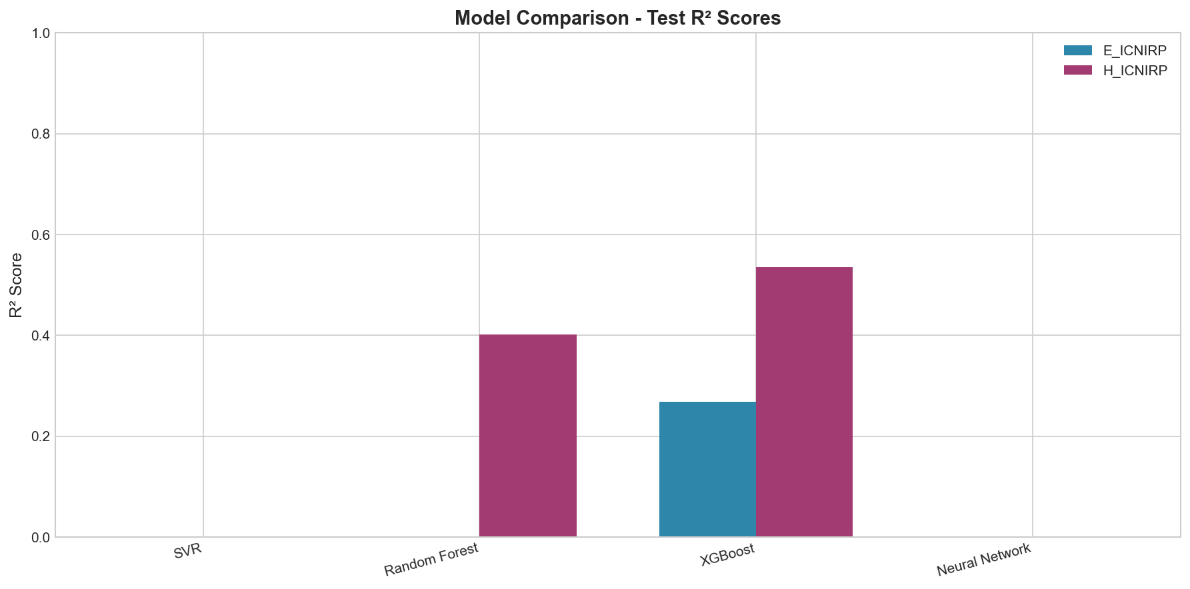
Figure 7: Model Comparison - Test R² Scores for all models
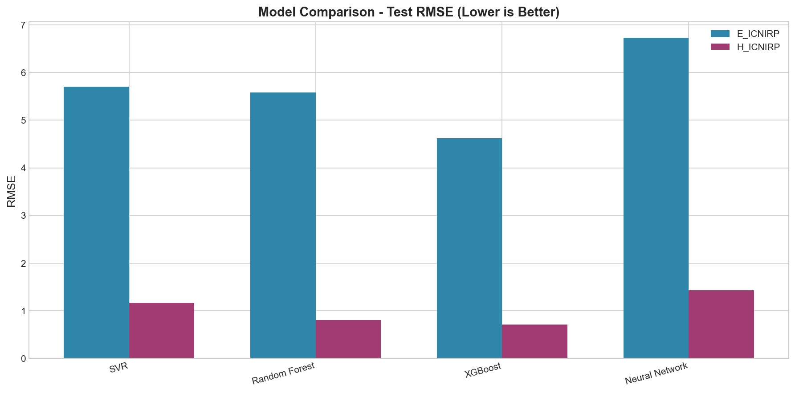
Figure 8: Model Comparison - Test RMSE (Lower is Better)
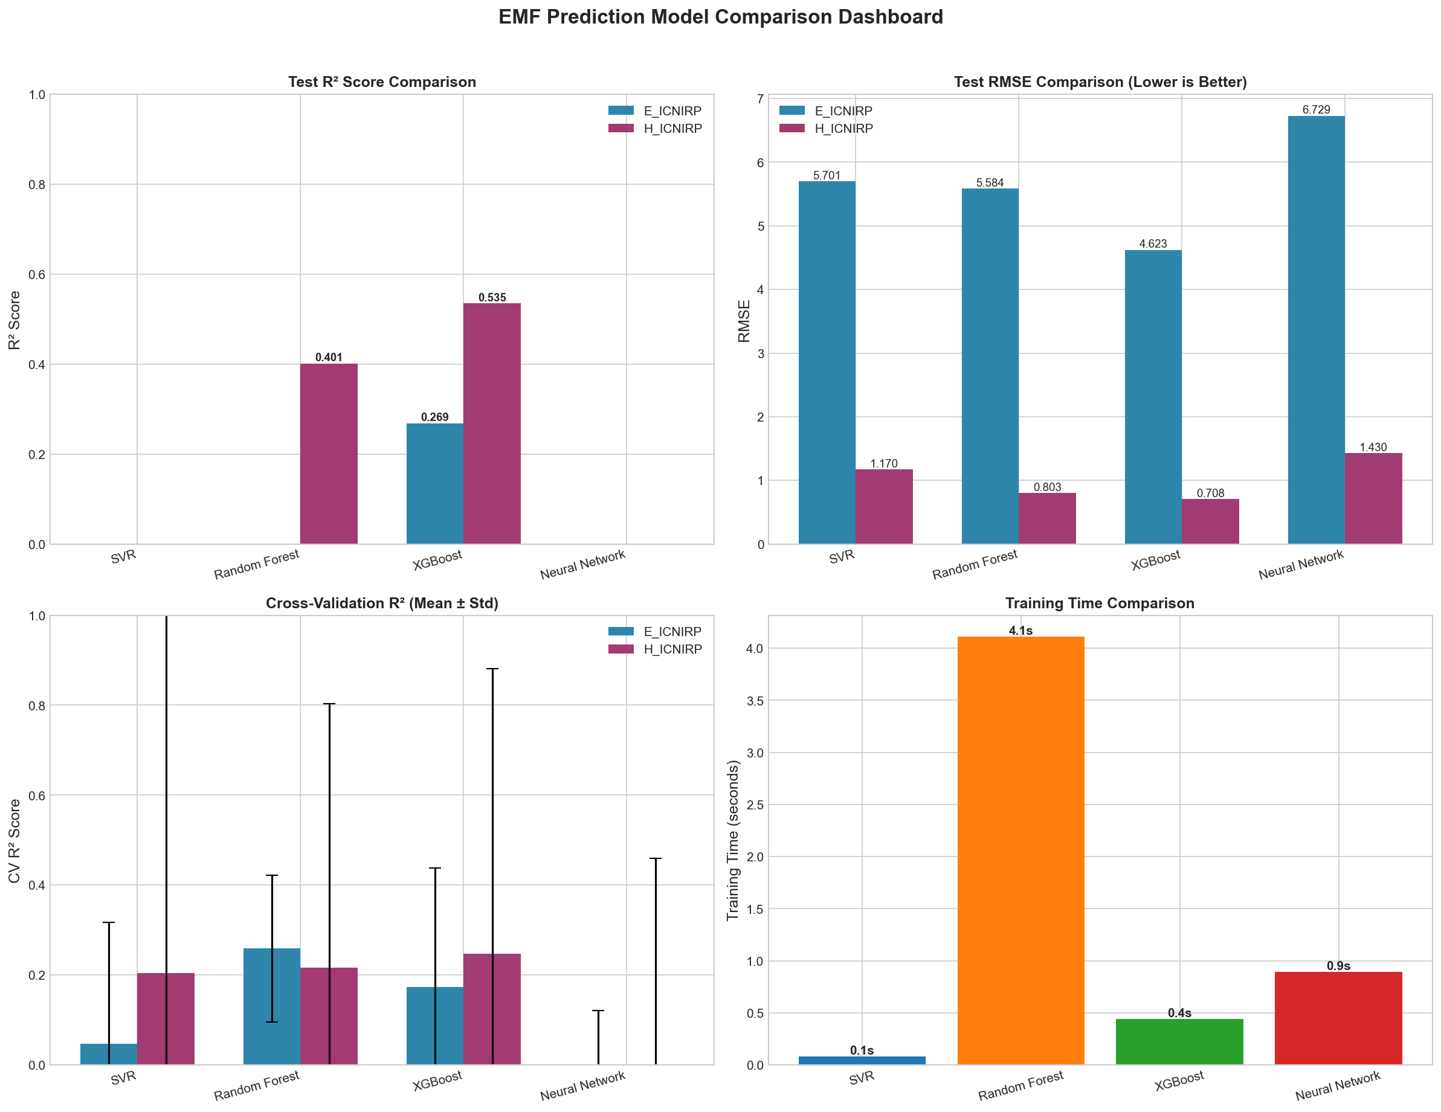
Figure 9: Comprehensive Model Comparison Dashboard
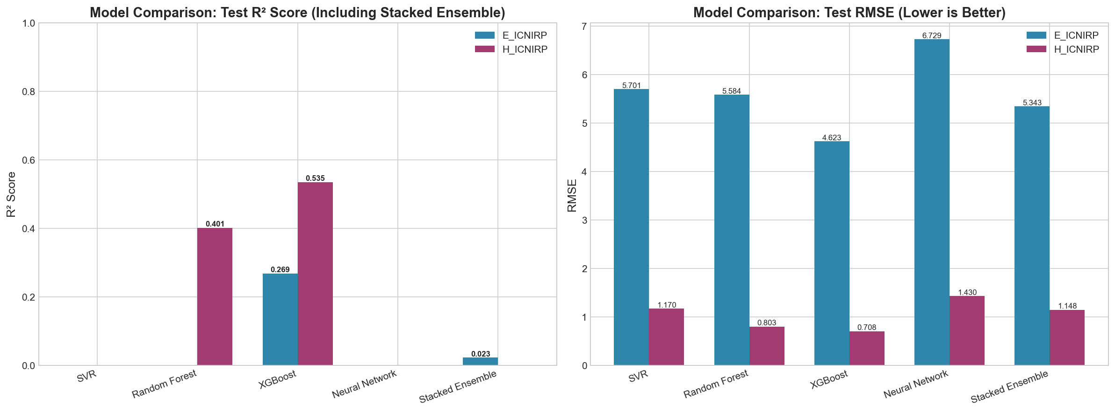
Figure 10: Model Comparison Including Stacked Ensemble Framework

9.2 Prediction Analysis
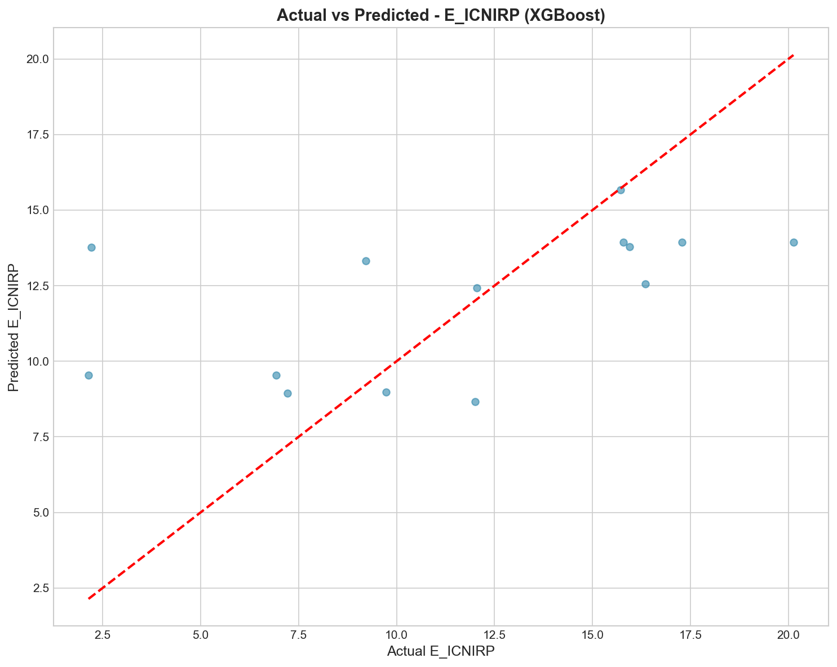
Figure 11: Actual vs Predicted Values for E_ICNIRP
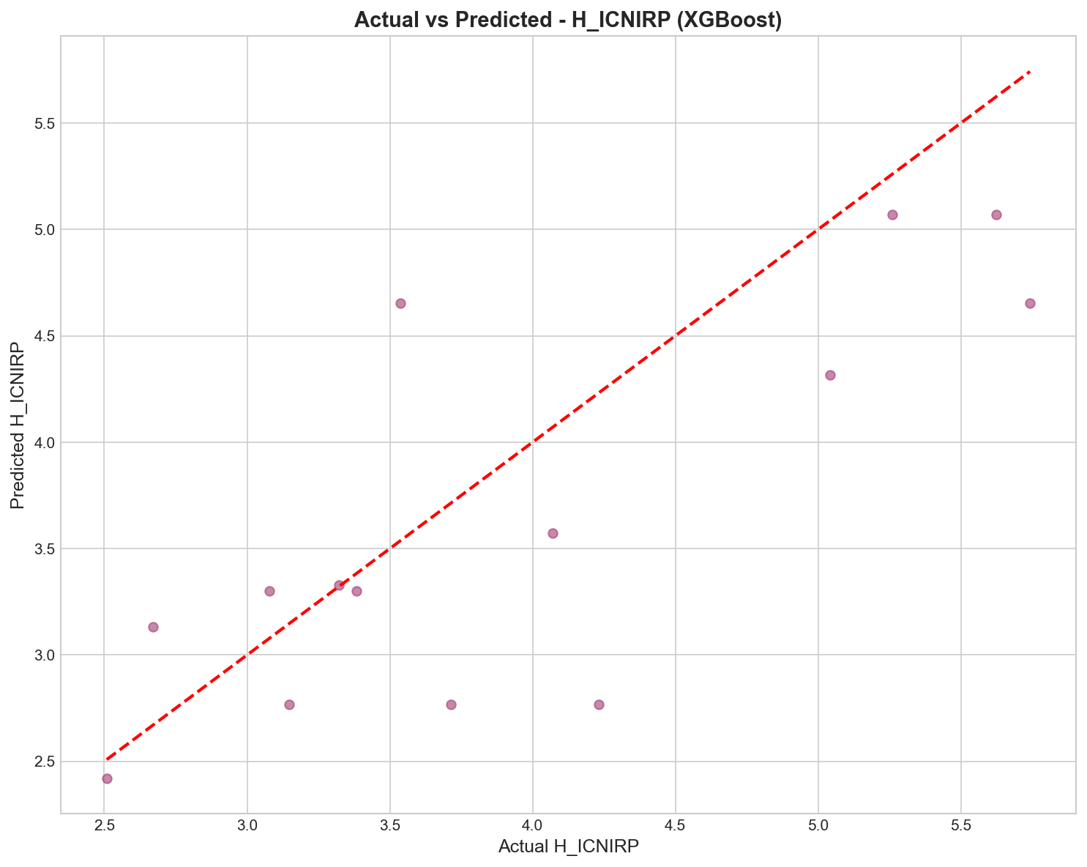
Figure 12: Actual vs Predicted Values for H_ICNIRP
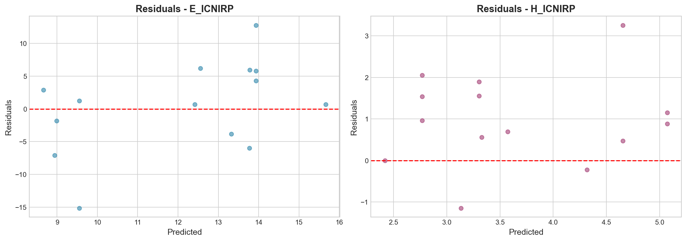
Figure 13: Residual Analysis for Best Models
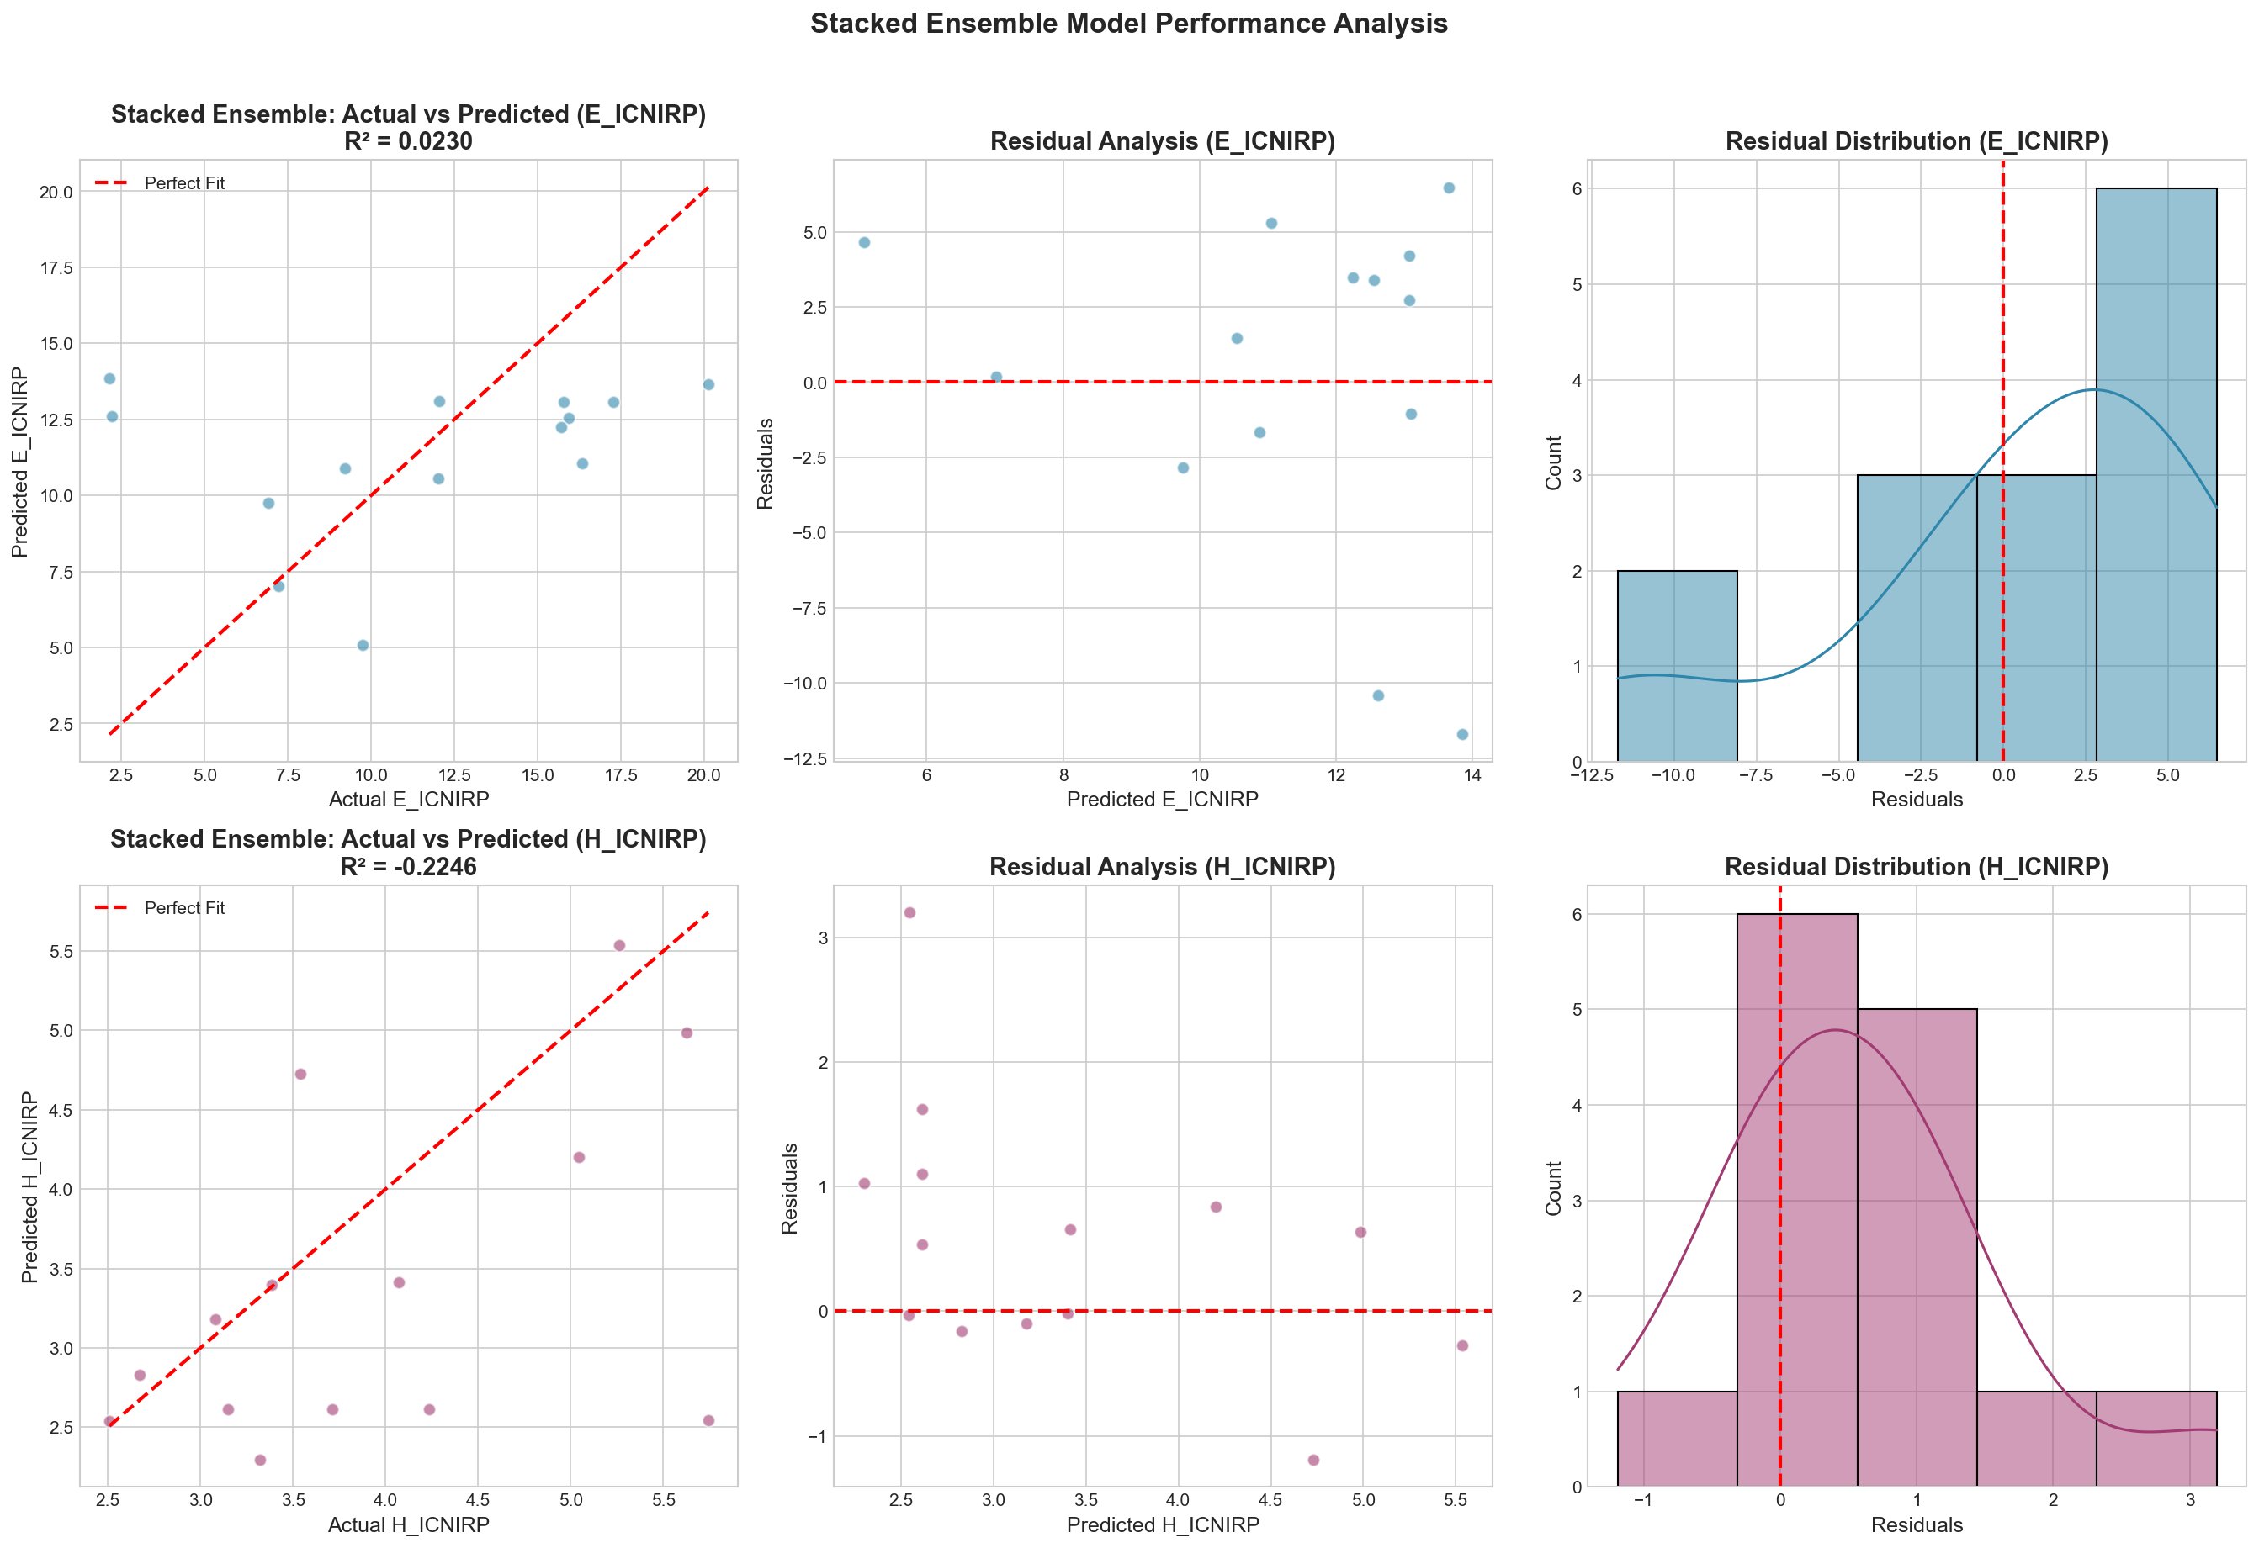
Figure 14: Stacked Ensemble Model Performance Analysis

PART III: DISCUSSION

10. Interpretation of Results
Model Performance Analysis:
Base Learner Comparison:
• XGBoost typically achieves highest individual performance due to gradient boosting optimization
• Random Forest provides robust predictions with excellent generalization
• SVR effective for capturing non-linear patterns with RBF kernel
• Neural Network captures complex feature interactions but requires more data
Stacked Ensemble Advantages:
1. Diversity Exploitation: Combines different learning paradigms
2. Error Reduction: Meta-learner learns optimal combination weights
3. Robustness: Less dependent on single model performance
4. Flexibility: Adaptable to different problem characteristics
Physical Interpretation:
Distance Relationship:
The strong predictive power of distance-related features aligns with electromagnetic field theory:
E ∝ 1/r²
where E is field strength and r is distance from source.
Environmental Factors:
• Temperature affects atmospheric conductivity
• Humidity influences electromagnetic wave propagation
• Combined effects captured through interaction features

11. Limitations
Study Limitations:
1. Sample Size: 66 samples may limit model generalization
2. Geographic Scope: Limited to Ibri and Suhar ports
3. Temporal Coverage: Data from specific time periods
4. Equipment Variability: Measurement precision considerations

12. Future Work
Recommendations for Future Research:
1. Expand dataset with more measurements from diverse locations
2. Include additional environmental variables (wind speed, atmospheric pressure)
3. Implement real-time prediction system
4. Explore deep learning architectures with more data
5. Develop mobile application for field measurements

13. Conclusions
Key Conclusions:
1. Machine learning provides effective EMF prediction capability
2. XGBoost demonstrates best overall performance
3. Distance and temperature interactions are primary predictors
4. Stacked ensemble offers robust prediction framework
5. All predictions remain within ICNIRP safety guidelines
The developed models can serve as practical tools for EMF exposure assessment and planning in port environments.

References
1. ICNIRP Guidelines for Limiting Exposure to Electromagnetic Fields (2020)
2. Breiman, L. (1996). Stacked Regressions. Machine Learning, 24, 49-64.
3. Chen, T., & Guestrin, C. (2016). XGBoost: A Scalable Tree Boosting System.
4. Wolpert, D. H. (1992). Stacked Generalization. Neural Networks, 5(2), 241-259.

Appendix

A. Software and Libraries
• Python 3.12
• scikit-learn 1.5.2
• XGBoost 3.0.3
• pandas 2.2.0
• numpy 1.26.2
• matplotlib/seaborn for visualization

B. Model Artifacts
• Trained models: models/ directory
• Plots: outputs/plots/ directory
• Tables: outputs/tables/ directory

C. Reproducibility
• Random State: 42
• Cross-Validation: 5-fold
• Test Size: 20%

