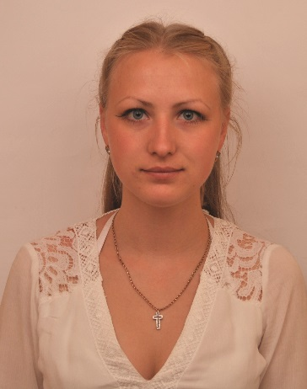**Sokol Olena**

Lomonosova street 47, 526

Kiev, Ukraine

**E-mail:** [sokololena21@ukr.net](mailto:sokololena21@ukr.net)

**Website**: <https://www.linkedin.com/in/>

olena-sokol-000765176/ , https://github.com/Sokolheavy

**Phone:** +380985268727

# Streamline March 2018 — May 2018

**WORK EXPERIENCE**

Python Chatbot Developer (freelance)

# 'AVON Cosmetics Ukraine' SE

# Taras Shevchenko

# National University of Kyiv

* Math Tutor

# Apr 2014 — May 2017

# Apr 2014 — May 2017

**EDUCATION Taras Shevchenko National University of Kyiv**  **Sep 2017 — Present**

Faculty of Information Technology

**Information analytics and impacts** specialty

Group leader

# Taras Shevchenko National University of Kyiv Sep 2013 — July2017

* Faculty of Mechanics and Mathematics
* **Mathematic** specialty
* Group leader

**Tools & Technologies**:

**TECHNICAL SKILLS**

**C, Python**

**PL-SQL,** Oracle HTML/PHP/CSS (Basic) Unix, shell, git, emacs

**Agile**-Development Methodologies (Scrum, XP, FDD, DSDM)

## Math Knowledge:

**Analytical Skills, Optimization Methods, Algorithms**

Mathematical and Complex Analysis, Operations Research

**SOFT SKILLS Languages:**

## English - b1/b2

Ukrainian - native speaker

**Interpersonal Skills: Critical Thinking Teamworking** Public Speaking Responsiblity Passionate Learner