WinControl component
Overview
A WinControl is designed for effective and comfortable operating in multiple-window applications using tab pages. Design and behavior of a WinControl has realized in a similar of Microsoft Visual Studio.

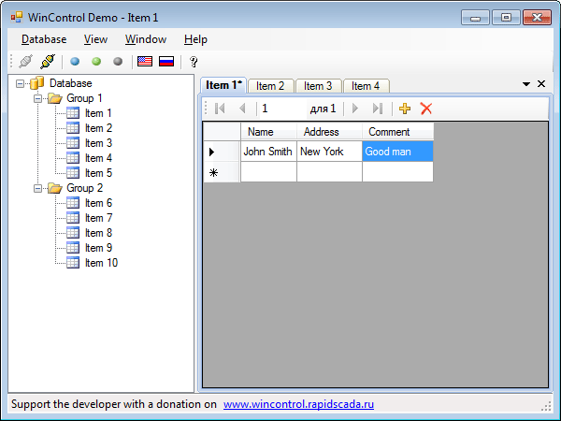

Benefits of a WinControl:
- allows organize effective and comfortable operating in multiple-window applications using tab pages;
- displays an image (such as program logo) and text when pages doesn't exists;
- tabs dragging;
- data modification control and save request on close;
- raises event when the active form has changed;
- three color schemes: blue, green and gray.

Requirements:
- Microsoft Visual Studio 2005 / 2008 / 2010 development environment;
- Windows.Forms projects for .NET 2.0 or higher.

Using
In your projects a WinControl should be used in the following order:
- Start Visual Studio and then create new Windows Forms Application project.
- Right-click on the Toolbox and select Choose Items.
- Click Browse button on .NET Framework Components page, select WinControl.dll file and then click OK.
- Drag a WinControl component from the Toolbox to your form.
- Properties and events specific for a WinControl are located in WinControl and WinControl Strings categories of the Properties window.

WinControl properties:
ActiveForm | Gets the active form
Forms | Gets the list of forms contained within the control
FormCount | Gets the number of forms in the tab strip
AllowToOrderTabs | Gets or sets a value indicating whether manual tab repositioning is enabled
ButtonsVisible | Gets or sets a value indicating whether the buttons are displayed
ControlColorScheme | Gets or sets the color scheme of the control
Image | Gets or sets the image displayed by the control when pages doesn't exists
MessageText | Gets or sets the message text displayed by the control when pages doesn't exists
MessageFont | Gets or sets the font of the message displayed by the control
MessageColor | Gets or sets the color of the message
SaveReqCaption | Gets or sets the text to display in the title bar of the save request form
SaveReqQuestion | Gets or sets the question text to display in the save request form
SaveReqYes | Gets or sets the 'Yes' button text to display in the save request form
SaveReqNo | Gets or sets the 'No' button text to display in the save request form
SaveReqCancel | Gets or sets the 'Cancel' button text to display in the save request form

WinControl methods:
AddForm | Adds a form to the control
CloseForm | Closes a form
CloseAllForms | Closes all the forms
CloseAllButActive | Closes all the forms except the active form
ActivateForm | Activates a form
ActivateNext | Activates the next form
ActivatePrevious | Activates the previous form

WinControl events:
ActiveFormChanged | Occurs when the active form has changed

If data modification control needed, your forms should implement the IWinControllable interface. Example:

#region IWinControllable Members

public WinInfo WinInfo { get; set; }

public void Save()
{
if (WinInfo != null && WinInfo.Modified)
{
WinInfo.Modified = false;
MessageBox.Show("Data of '" + Text + "', as it were, saved.",
"Information", MessageBoxButtons.OK,
MessageBoxIcon.Information);
}
}

#endregion

Contacts
Developer: Mikhail Shiryaev, m_shir@mail.ru
Web site: wincontrol.rapidscada.ru
Bug reports and wishes you can send by e-mail. A WinControl is free and can be used in any projects including commercial projects.
If you found a WinControl useful and nice you can donate the developer for some money.
Donate by SMS: see instruction on wincontrol.rapidscada.ru
Donate by Yandex.Money: 41001585792381
Donate by WebMoney: Z140739224373, R241047306940

