( 두더지게임 ) 주간진행보고서
2학년 YB반 이나연 2025. 06. 02

1 |  | 주간 진행 내용 (5/19~5/25)
구현 내용, H/W 사진, S/W 스케치 등
H/W 변경사항
- 두더지를 3개->4개로 변경하여 그에 맞는 센서들도 4개로 변경
- H/W 전체 구현 완료

------------------------------------------------------------
S/W
#include <Wire.h>
#include <LiquidCrystal_I2C.h>
#include <Servo.h>

LiquidCrystal_I2C lcd(0x27, 16, 2);

const int NUM_MOLES = 4;
const int ledPins[NUM_MOLES] = {11, 12, 13, 10};
const int btnPins[NUM_MOLES] = {7, 8, 9, 6};
const int servoPins[NUM_MOLES] = {3, 4, 5, 2};
const int buzzer = A1;

Servo servos[NUM_MOLES];
int score = 0;

void setup() {
for (int i = 0; i < NUM_MOLES; i++) {
pinMode(ledPins[i], OUTPUT);
pinMode(btnPins[i], INPUT_PULLUP);
servos[i].attach(servoPins[i]);
servos[i].write(0);
}

pinMode(buzzer, OUTPUT);

lcd.init();
lcd.backlight();
lcd.setCursor(0, 0);
lcd.print("Ready to play!");

Serial.begin(9600);
randomSeed(analogRead(0));

for (int i = 3; i > 0; i--) {
lcd.setCursor(0, 1);
lcd.print("Start in ");
lcd.print(i);
lcd.print("... ");
delay(1000);
}

lcd.clear();
lcd.setCursor(0, 0);
lcd.print("Game Start!");
delay(1500);
lcd.clear();
}

void playStage(int duration, int limitTimeMs, bool randomLED) {
unsigned long startStage = millis();

while (millis() - startStage < duration) {
int moleIndex = random(0, NUM_MOLES);
int ledIndex = moleIndex;

if (randomLED) {
ledIndex = random(0, NUM_MOLES);
digitalWrite(ledPins[ledIndex], HIGH);
}

servos[moleIndex].write(90);

lcd.setCursor(0, 0);
lcd.print("Score: ");
lcd.print(score);
lcd.setCursor(0, 1);
lcd.print("Hit the mole! ");

Serial.print("두더지 ");
Serial.print(moleIndex + 1);
if (randomLED) {
Serial.print(" (LED 방해: ");
Serial.print(ledIndex + 1);
Serial.print(")");
}
Serial.println();

unsigned long appearTime = millis();
bool answered = false;

while (millis() - appearTime < limitTimeMs && !answered) {
for (int i = 0; i < NUM_MOLES; i++) {
if (digitalRead(btnPins[i]) == LOW) {
if (i == moleIndex) {
tone(buzzer, 1000, 300);
score += 10;
Serial.println("정답! +10점");
} else {
tone(buzzer, 500, 200);
score -= 5;
Serial.print("오답! 버튼 ");
Serial.print(i + 1);
Serial.println(" -5점");
}
answered = true;
break;
}
}
}

servos[moleIndex].write(0);

if (randomLED) {
digitalWrite(ledPins[ledIndex], LOW);
}

delay(500);
lcd.clear();
}
}

void loop() {
// Stage 1
lcd.setCursor(0, 0);
lcd.print("Stage 1");
delay(1000);
lcd.clear();
playStage(20000, 3000, false);

if (score < 20) {
lcd.clear();
lcd.setCursor(0, 0);
lcd.print("Need 20 points");
lcd.setCursor(0, 1);
lcd.print("Try again!");
Serial.println("스테이지 1 실패. 20점 미만.");
while (true);
}

// Stage 2
lcd.setCursor(0, 0);
lcd.print("Stage 2");
delay(1000);
lcd.clear();
playStage(20000, 1500, false);

if (score < 50) {
lcd.clear();
lcd.setCursor(0, 0);
lcd.print("Need 50 points");
lcd.setCursor(0, 1);
lcd.print("Try again!");
Serial.println("스테이지 3 잠금. 50점 미만.");
while (true);
}

// Stage 3
lcd.setCursor(0, 0);
lcd.print("Stage 3");
delay(1000);
lcd.clear();
playStage(20000, 1500, true);

lcd.clear();
lcd.setCursor(0, 0);
lcd.print("Game Over!");
lcd.setCursor(0, 1);
lcd.print("Final: ");
lcd.print(score);
Serial.print("게임 종료! 최종 점수: ");
Serial.println(score);

while (true);
}

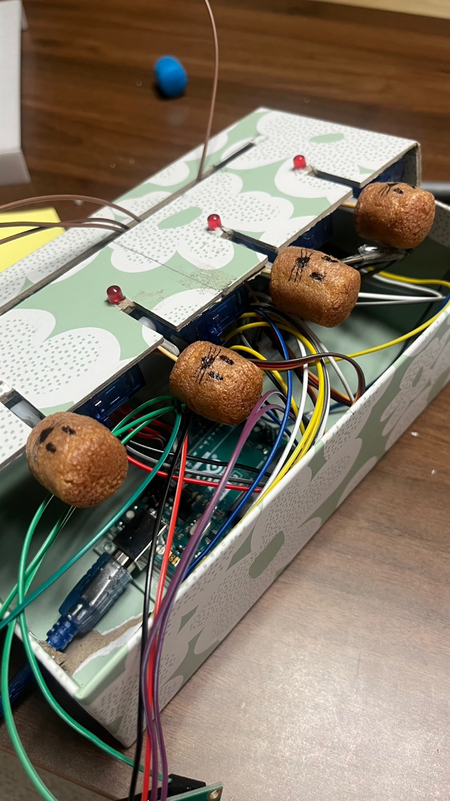

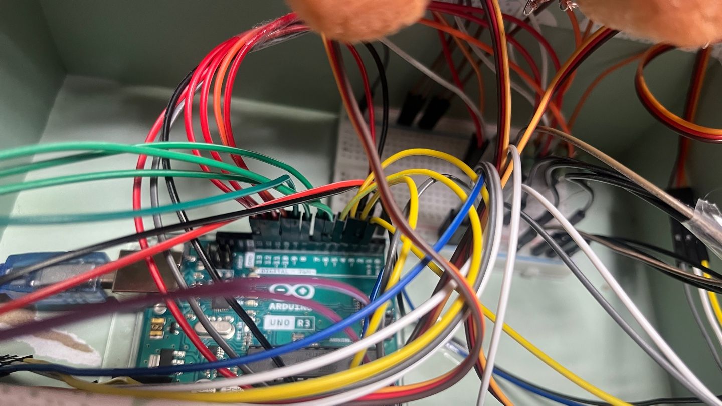

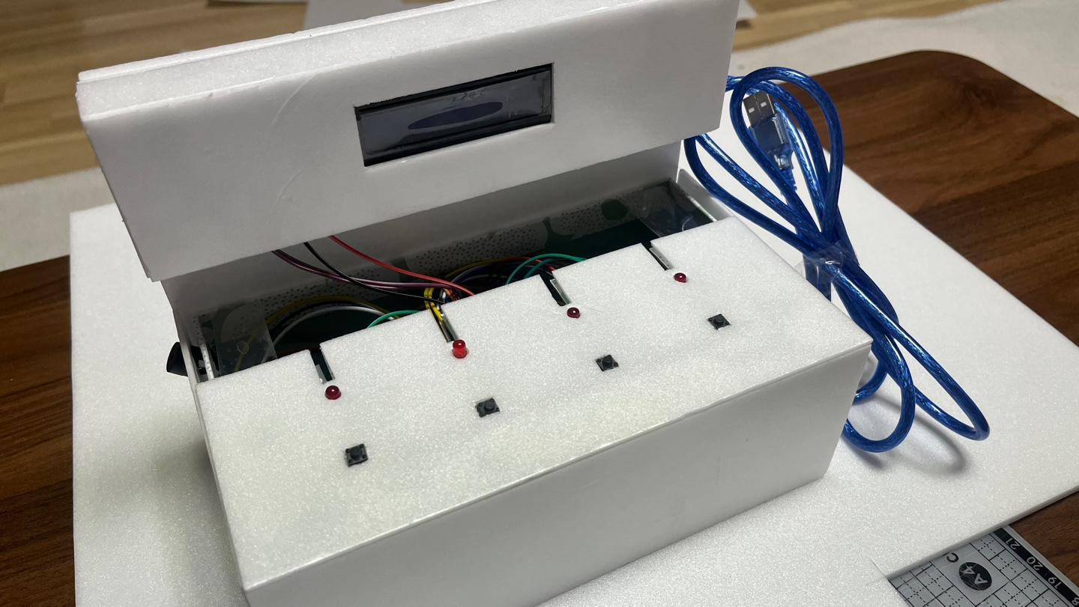

2 |  | 진행 중 어려운 점, 문의 사항

3 |  | 다음주 계획 (5/26~6/1)

- S/W스케치에서 두더지게임 룰 수정 예정

