Diagnostic Feature Leakage Behind Near-Perfect CKD Prediction: A Feature-Tier Ablation with a Pre-Laboratory Screening Check
Antonio B. Garcia Jr.
National University, Philippines
Course and section: COM241

Abstract - Many machine learning studies report close to 100% accuracy for predicting chronic kidney disease (CKD) on the UCI CKD dataset. I asked where that accuracy comes from. Before modeling, I sorted the 24 UCI features into pre-registered tiers by when they become known: features that define CKD (such as serum creatinine and urine albumin), features caused by CKD (such as low hemoglobin), and features available before any laboratory test. Logistic Regression, Random Forest and Gradient Boosting reached about 99% accuracy with all features, and single diagnostic features almost separated the classes on their own (hemoglobin ROC-AUC 0.98). Removing the tiers step by step showed that the accuracy depends on diagnostic features: with pre-laboratory features only, accuracy fell to 0.69 to 0.76 and F2 was no better than referring everyone, while the all-feature model still scored 98.8% on unseen data, which points to leakage rather than overfitting. As a practical check, I trained the same three algorithms on 13 pre-laboratory features for 7,363 US adults from NHANES 2017-March 2020 (16.5% with CKD), with F2 as the primary metric. The models tied (cross-validated F2 0.578 to 0.580). Random Forest, selected by a pre-registered rule, referred 86% of the test participants with CKD for testing (F2 0.586), close to a simple risk-factor rule (F2 0.583), and ranked patients better when testing capacity was limited. Near-perfect CKD prediction reflects diagnostic leakage; pre-laboratory data supports screening, but only modestly.
Index Terms - chronic kidney disease, data leakage, feature ablation, screening, machine learning
I. INTRODUCTION
Chronic kidney disease affected an estimated 697.5 million people worldwide in 2017 and is a growing cause of death [1]. It is defined by a reduced glomerular filtration rate (GFR below 60 mL/min/1.73m2) or markers of kidney damage such as albuminuria, present for more than three months [2]. Early CKD has no symptoms, so it is only found if someone is tested. In the Philippines, as in many low- and middle-income settings, many patients are first diagnosed when they already need dialysis. A screening tool that a rural health unit could use before any laboratory test would help decide who should be sent for testing.
Many machine learning studies report near-perfect CKD prediction using the UCI Chronic Kidney Disease dataset [3]. For example, Qin et al. reported 99.75% accuracy with Random Forest and 99.83% with a combined model [4]. However, the UCI features include serum creatinine, blood urea, urine albumin and specific gravity. These are the measurements used to diagnose CKD, so a model that uses them may be largely re-deriving the diagnosis. This is a form of data leakage, in which information about the outcome enters the inputs. Kapoor and Narayanan found leakage in hundreds of published machine learning studies across 17 fields, where it produced overly optimistic results [5]. Before starting this project, I ran the UCI dataset through a free no-code browser tool that trains a neural network, and it reached about 99% accuracy in under a minute. That experience, which is not part of the model comparison in this paper, led to the main question of this study.
Pre-laboratory risk scores already exist. SCORED, developed on NHANES data with logistic regression, uses age, sex, hypertension, diabetes, cardiovascular disease, anemia and proteinuria [6]. Anemia and proteinuria still require a test, however. This study asks two questions. The main question is: (1) How much of the accuracy reported on the UCI dataset comes from features that are part of the diagnosis itself? The secondary, practical question is: (2) Once those features are removed, can a model that uses only information available before any laboratory test flag adults for kidney testing better than a simple rule? The scope is limited to adults aged 20 and over who have never been told they have kidney disease, and to traditional machine learning algorithms.
The contributions are: (1) a pre-registered framework that sorts features by when they become available; (2) a feature-tier ablation showing that near-perfect accuracy on the UCI dataset depends on diagnostic features; (3) a check on NHANES of what pre-laboratory features can do, using the same three algorithms and an F2 metric that reflects the cost of a missed case; and (4) an open screening application and code.
II. METHODS
A. Datasets and ethics
The main dataset is the National Health and Nutrition Examination Survey (NHANES) 2017-March 2020 pre-pandemic release [7], a public, de-identified survey of the US population run by the National Center for Health Statistics, whose protocols are approved by its research ethics review board. I used 10 files (demographics, body measures, blood pressure, five questionnaires, serum biochemistry and urine albumin). The second dataset is UCI CKD [3]: 400 hospital patients with 24 features, released under CC BY 4.0. Both are public, and no identifiable information was used. All analysis rules (label, tiers, metric, split, models and selection rule) were written in a pre-registration document and committed to the project repository before any data were downloaded.
B. Cohort and label
From 15,560 NHANES participants, I kept adults aged 20 or older who were examined at the mobile examination center, not pregnant, had both serum creatinine and urine albumin-to-creatinine ratio (ACR), and had not been told they had weak or failing kidneys. This left 7,363 adults. CKD was defined as eGFR below 60 mL/min/1.73m2, calculated with the race-free CKD-EPI 2021 equation [8], or ACR of 30 mg/g or more. These laboratory values were used only to build the label and were never model inputs. The label is not circular: creatinine defines the answer, and the model learns which pre-laboratory characteristics predict that answer.
C. Feature tiers
Each feature was assigned to a tier before modeling. Tier 1 (definitional) features are KDIGO criteria or direct measures of kidney function. Tier 2 (consequential) features change because CKD is already present. Tier 3 (antecedent) features can be collected without a laboratory. Laboratory values that are neither were grouped as other laboratory. Table I lists the UCI assignment. The NHANES model uses 13 Tier 3 features: age, sex, BMI, waist, systolic and diastolic blood pressure, told of hypertension, blood pressure medication, told of high cholesterol, any cardiovascular disease, family history of diabetes, diabetes (no, borderline, yes) and smoking (never, former, current).
TABLE I
PRE-REGISTERED FEATURE TIERS FOR THE UCI DATASET
Tier | UCI features
1 Definitional | serum creatinine, blood urea, urine albumin, specific gravity, urine red cells
2 Consequential | hemoglobin, packed cell volume, red cell count, anemia, potassium, sodium, pedal edema, appetite
Other laboratory | urine sugar, blood glucose, white cell count, pus cells, pus cell clumps, bacteria
3 Antecedent | age, blood pressure, hypertension, diabetes, coronary artery disease

D. Exploratory data analysis and preprocessing
The EDA checked file sizes and duplicate IDs, answer codes for refused and don't know (set to missing), questionnaire skip patterns, impossible values, missing values, distributions, relationships with the label, correlations, outliers and subgroups. Data quality checks used fixed rules on the whole cohort; everything that looked at the label used the training set only. Preprocessing was the same for all models and was fitted inside a scikit-learn pipeline [9] on training data only: median imputation and standardization for numeric features, most-frequent imputation for yes/no features, and most-frequent imputation with one-hot encoding for categorical features.
E. Split, algorithms and tuning
Each dataset was split 80/20, stratified on the label, with random_state 42. The NHANES training set had 5,890 people and the test set 1,473. I compared Logistic Regression, Random Forest [10] and Histogram Gradient Boosting [11], all with balanced class weights to account for the 16.5% prevalence. Hyperparameters were tuned by grid search with the same 5 stratified folds for every model: C for Logistic Regression; maximum depth and minimum leaf size for Random Forest (300 trees); and learning rate, maximum depth and number of iterations for Gradient Boosting. Inside every fit, the decision threshold was tuned to maximize F2 with a separate inner cross-validation, so it was never chosen on the data used to score it.
F. Metrics and model selection
A false negative leaves CKD undetected, while a false positive costs one confirmatory blood and urine test. The primary metric was therefore F2, which weights recall more than precision but, unlike recall alone, still penalizes referring everyone. Supporting metrics were recall, precision, specificity, F1, accuracy, ROC-AUC, PR-AUC and the Brier score, reported as mean and standard deviation over the 5 folds. The selected model was the one with the highest mean F2; if the top two differed by less than one standard deviation, the simpler one was chosen (Logistic Regression, then Random Forest, then Gradient Boosting). Two baselines were scored on the same folds: referring everyone, and a risk-factor rule (refer if diabetes, told of hypertension, cardiovascular disease, or age 60 or older). The test set was used once, after selection. After peer review, I added post-hoc analyses on the test set: a comparison at the same number of referrals, the cases found at each testing capacity against a points rule (the number of the four risk factors a person has), bootstrap 95% confidence intervals with 2,000 resamples, and recall by age. They are reported separately and did not change the selected model.
G. Application
The selected pipeline, including preprocessing and the tuned threshold, was saved with joblib and loaded by a Streamlit [12] application. The deployed application is available online [13]. The application accepts one patient through a validated form or several through a CSV upload, and it rejects missing, invalid or out-of-range inputs with a readable message. For a CSV upload, the user can also enter the number of available tests, and only that many patients are referred, highest scores first. It was tested with automated tests covering valid, invalid and boundary inputs.
III. RESULTS
A. UCI feature-tier ablation
Table II and Fig. 1 show the ablation. With all 24 features, every model reached about 99% cross-validated accuracy and a ROC-AUC of 1.00, reproducing the literature. Single diagnostic features almost separated the classes on their own: hemoglobin had a ROC-AUC of 0.98, packed cell volume 0.96 and serum creatinine 0.92, against 0.79 for the best Tier 3 feature (hypertension). Removing Tier 1 therefore changed almost nothing, because Tier 2 features carried the same signal. Removing Tier 1 and Tier 2 lowered accuracy to 0.74 to 0.94. With Tier 3 only, accuracy was 0.69 to 0.76, specificity 0.21 to 0.44, and F2 0.89 to 0.90, equal to referring everyone (0.893) at the UCI prevalence of 62.5%. On the UCI test set, the selected all-feature model reached 98.8% accuracy and the Tier 3 model 68.8%. Because the all-feature model performed as well on unseen data as in cross-validation, the high accuracy is not overfitting; it comes from inputs that contain the diagnosis.
TABLE II
UCI ABLATION, 5-FOLD CROSS-VALIDATION MEANS
Feature set | Model | F2 | ROC-AUC | Accuracy | Spec.
All features | LR | 0.997 | 1.000 | 0.991 | 0.975
All features | RF | 0.995 | 0.999 | 0.984 | 0.958
All features | GB | 0.995 | 1.000 | 0.994 | 0.992
Without Tier 1 | LR | 0.984 | 0.995 | 0.969 | 0.933
Without Tier 1 | RF | 0.979 | 0.994 | 0.972 | 0.958
Without Tier 1 | GB | 0.981 | 0.992 | 0.969 | 0.942
Without Tier 1 and 2 | LR | 0.907 | 0.929 | 0.744 | 0.367
Without Tier 1 and 2 | RF | 0.950 | 0.980 | 0.906 | 0.808
Without Tier 1 and 2 | GB | 0.953 | 0.975 | 0.938 | 0.908
Tier 3 only | LR | 0.898 | 0.897 | 0.691 | 0.208
Tier 3 only | RF | 0.894 | 0.936 | 0.756 | 0.442
Tier 3 only | GB | 0.902 | 0.922 | 0.738 | 0.358

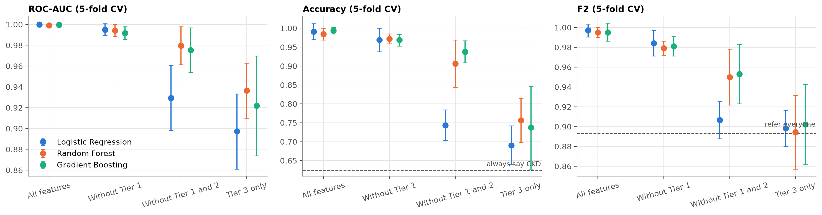
Fig. 1. UCI ablation: cross-validated ROC-AUC, accuracy and F2 (mean and one standard deviation) for each feature set and model.

B. NHANES exploratory data analysis
Of the 7,363 adults, 1,217 (16.5%) had CKD: 766 by albuminuria only, 302 by low eGFR only and 149 by both. So most cases were early disease found in the urine. CKD rose from 7% in adults in their 20s to 38% at 70 and over (Fig. 2). Diabetes was the strongest yes/no feature (CKD in 40% of people with diabetes against 12% without). No feature had a Spearman correlation with CKD above 0.28 (age), which is consistent with no feature leaking the label. BMI and waist were highly correlated (0.91). Outliers flagged by the interquartile rule were all within plausible ranges and had higher CKD rates, so they were kept. People with a missing waist measurement had twice the CKD rate (31.6% against 16.0%), most likely because they could not be measured. I did not add missing-value indicators, because in the application a missing waist would only mean it was not measured. Fig. 3 shows that part of the age effect comes from the eGFR equation itself: a man with creatinine 1.3 mg/dL is labeled CKD from about age 67.
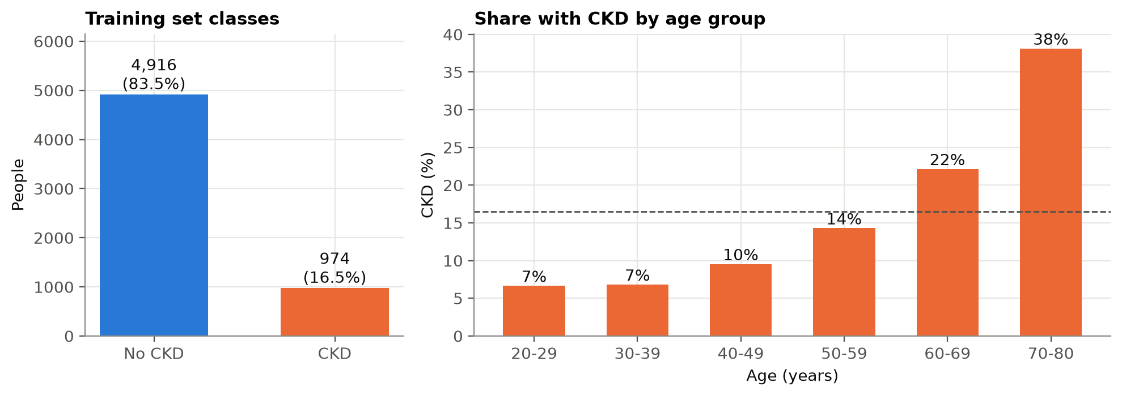
Fig. 2. Class balance in the NHANES training set (left) and CKD prevalence by age group (right). Dashed line: overall prevalence.
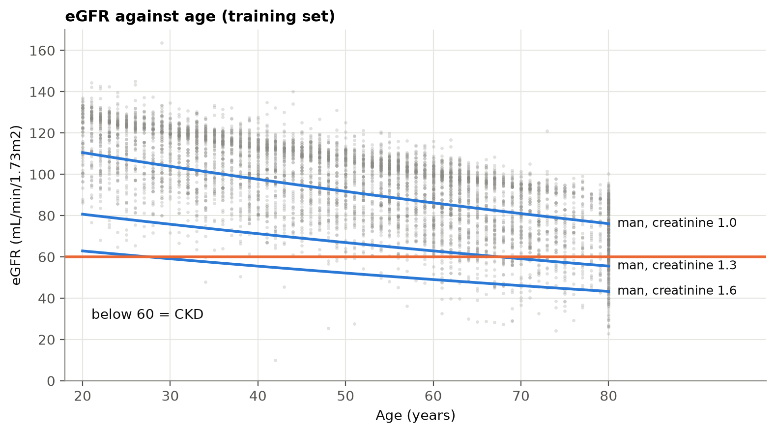
Fig. 3. eGFR against age in the training set. Curves show eGFR from the CKD-EPI 2021 equation for a man with fixed creatinine; the same creatinine crosses the CKD threshold at an older age.
C. NHANES model comparison
Table III and Fig. 4 show the cross-validation results; accuracy and per-class precision, recall and F1 for all three models are in Table IV (Appendix C). The three models were almost identical: mean F2 0.578 to 0.580 and ROC-AUC 0.758 to 0.770, with differences much smaller than the fold-to-fold spread. All beat referring everyone (0.498), but none clearly beat the risk-factor rule (0.576). Gradient Boosting had the highest mean F2 by 0.0001 over Random Forest, which was within one standard deviation, so the pre-registered rule selected Random Forest (maximum depth unlimited, minimum leaf size 20). Random Forest also had the highest ROC-AUC and PR-AUC, the lowest Brier score and the smallest spread across folds. All models were poorly calibrated because of the balanced class weights: a score of about 0.8 corresponded to an observed CKD rate of about 0.5 (Fig. 5).
TABLE III
NHANES CROSS-VALIDATION, MEAN (SD) OVER 5 FOLDS
Model | F2 | Recall | Specificity | ROC-AUC
Logistic Regression | 0.578 (0.027) | 0.793 (0.033) | 0.591 (0.024) | 0.758 (0.014)
Random Forest | 0.580 (0.014) | 0.819 (0.025) | 0.554 (0.059) | 0.770 (0.012)
Gradient Boosting | 0.580 (0.023) | 0.791 (0.053) | 0.599 (0.036) | 0.760 (0.014)
Risk-factor rule | 0.576 (0.019) | 0.841 (0.029) | 0.514 (0.023) | -
Refer everyone | 0.498 (0.001) | 1.000 (0.000) | 0.000 (0.000) | -

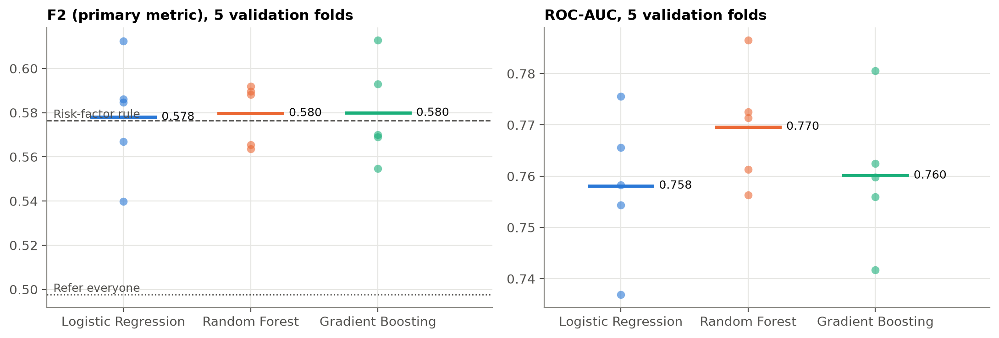
Fig. 4. F2 and ROC-AUC on each of the 5 validation folds. Lines show the means; dashed lines show the two baselines.

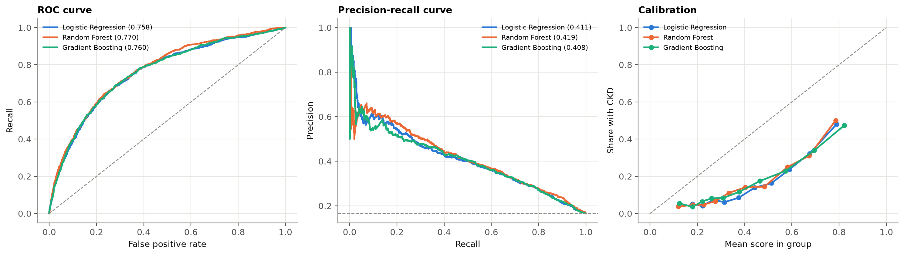
Fig. 5. Out-of-fold ROC, precision-recall and calibration curves for the three models.

D. Final test
On the 1,473 test participants, the Random Forest reached F2 0.586, recall 0.864, specificity 0.504, precision 0.256 and ROC-AUC 0.773, close to its cross-validation results. It referred 210 of the 243 participants with CKD for testing, and 820 participants in total, 610 of whom did not have CKD (Fig. 6). The risk-factor rule reached F2 0.583 on the same people. In the 175 Non-Hispanic Asian test participants (26 cases), recall was 0.808 and ROC-AUC 0.795.
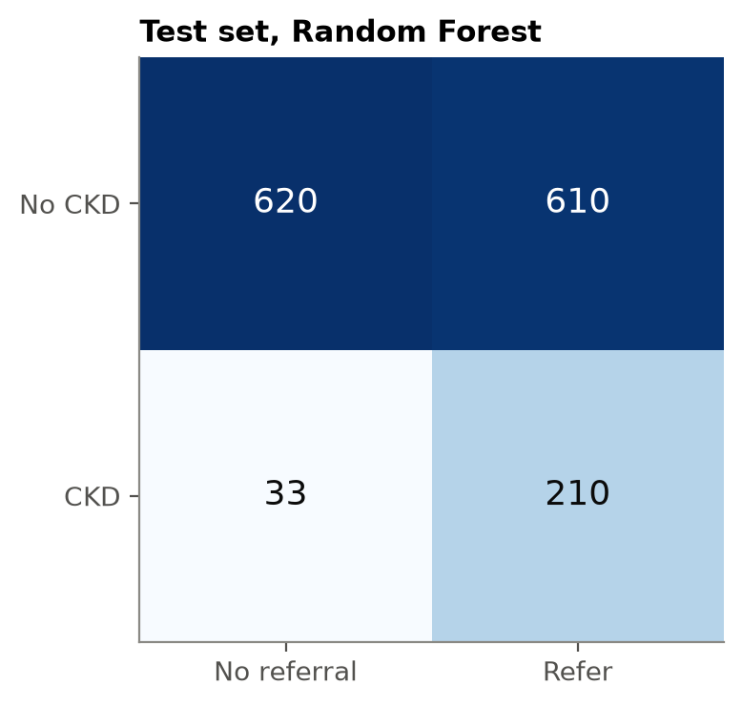
Fig. 6. Confusion matrix of the selected Random Forest on the test set at its tuned threshold (0.320).
E. Error analysis
In out-of-fold training predictions, recall was 0.95 for CKD defined by low eGFR only and 0.98 for both criteria, but 0.74 for albuminuria only. Recall was 0.97 at ages 60 to 80, 0.69 at 40 to 59 and 0.31 at 20 to 39. Permutation importance showed that the model relied most on age, then diabetes and systolic blood pressure (Fig. 7).
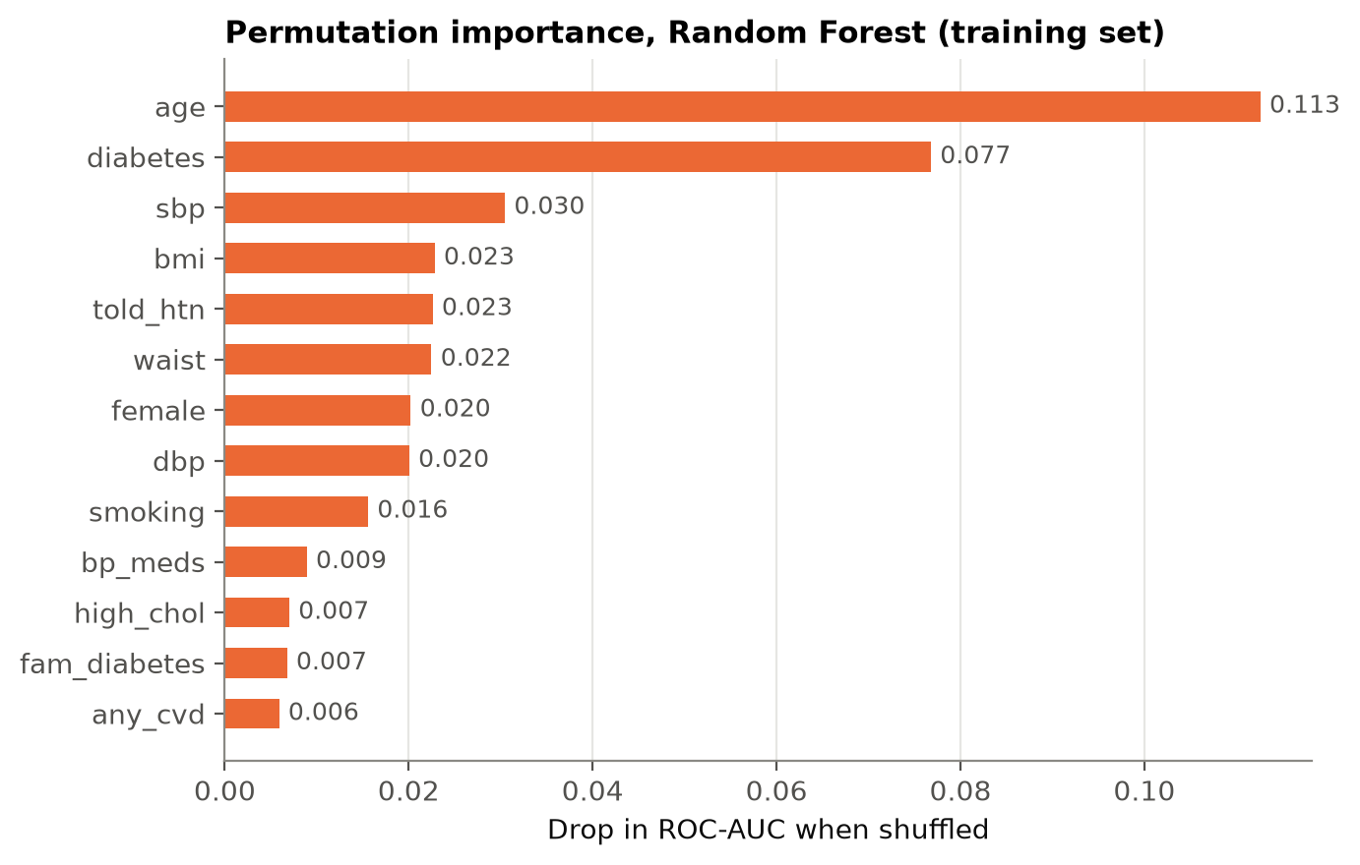
Fig. 7. Permutation importance of the Random Forest: drop in ROC-AUC when each feature is shuffled.
F. Post-hoc analysis: testing capacity
After the final test, a peer reviewer asked whether the model adds value over the risk-factor rule. I added post-hoc analyses that do not change the model or its threshold. When the model was given the same number of referrals as the rule (804), the two found almost the same cases (208 against 207 of 243). Fig. 8 shows the cases found at every testing capacity when people are tested in order of score. With 300 tests the model found 122 cases, a points rule counting the four risk factors 107, and the yes/no rule in random order 77. Bootstrap 95% confidence intervals put the model's gain over the points rule at 15.2 cases (3.9 to 25.3) with 300 tests and 13.0 (2.4 to 22.6) with 500, but not clearly above zero with 150 (3.6, -5.9 to 13.1). On F2 the model and the yes/no rule were tied (difference 0.003, 95% CI -0.017 to 0.024). Recall among test participants aged 20 to 49 was 0.47 (51 cases), against 0.97 from age 50.
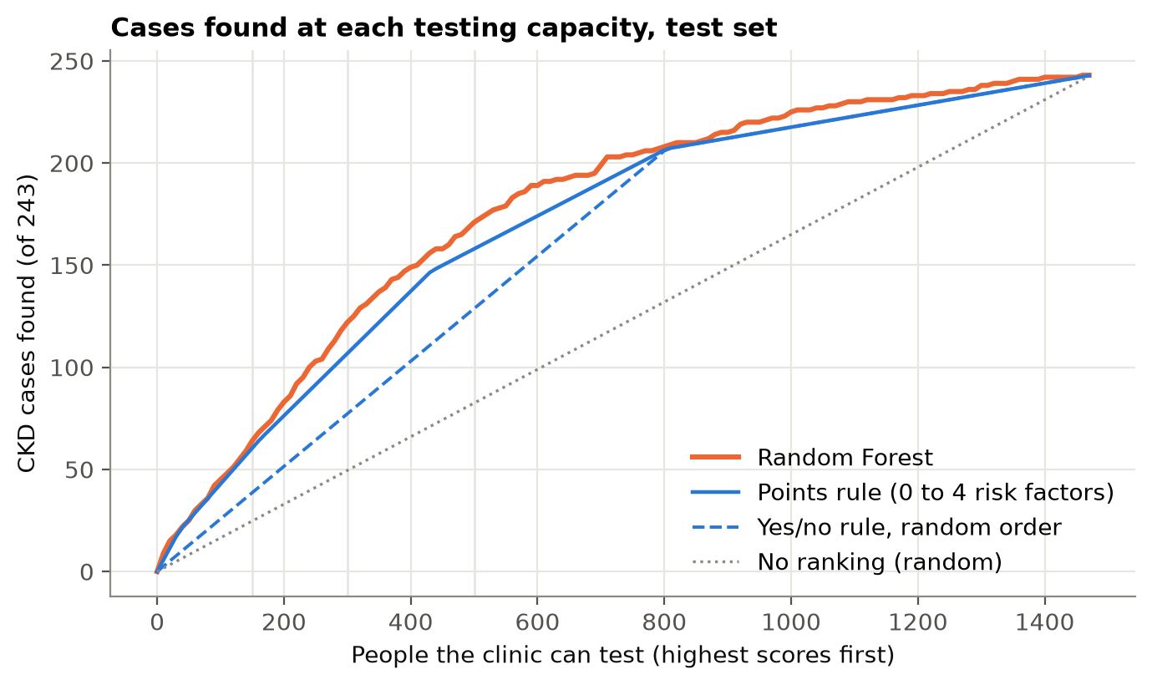
Fig. 8. Post-hoc: CKD cases found on the test set when people are tested in order of score, for every testing capacity, compared with a points rule and with the yes/no rule in random order.
G. Application
The deployed application loads the saved pipeline and model card. Sample inputs and outputs, and screenshots of the application, are in Appendix B. The automated tests confirmed that the application loads, gives a recommendation for valid input, and shows an error instead of crashing for an out-of-range age or an empty form.
IV. DISCUSSION
The main finding is that near-perfect CKD prediction on the UCI dataset depends on diagnostic leakage. The accuracy comes from Tier 1 and Tier 2 features, which are measured after a patient is already suspected of kidney disease, and single features such as hemoglobin almost reproduce the label on their own. A model built on them re-derives a diagnosis that has already been made, so its accuracy says little about its value for finding undiagnosed patients. This matches the wider pattern of leakage in machine learning research [5]. For future CKD prediction studies, I recommend reporting when each feature becomes available and running a tier ablation like this one before claiming high accuracy. Even the Tier 3 UCI models had ROC-AUC 0.90 to 0.94, much higher than on NHANES, because UCI compares hospital patients with clearly abnormal results against people without CKD, at a prevalence of 62.5%. A screening population is different: most people are healthy, and most CKD is early.
On NHANES, the three algorithms reached the same ceiling. When the features are a handful of risk factors, there is little non-linear structure for Random Forest or Gradient Boosting to exploit, and Logistic Regression already captures most of the signal. Random Forest was selected by the tie-break rule rather than because it was clearly better, and Logistic Regression would have been an equally defensible choice. I kept Random Forest because changing the choice after seeing the results would break the pre-registration, and because it ranked patients slightly better (cross-validated ROC-AUC 0.770 against 0.758, with the best PR-AUC and Brier score), which is where its value turned out to be. The model did not beat the risk-factor rule on F2: the test-set difference was 0.003 (95% CI -0.017 to 0.024). Its practical advantage is ranking. When both refer 804 people they find almost the same cases, but when a health unit can test only 300 or 500 of 1,473 people, the model finds 15.2 and 13.0 more cases than a points rule. The tenth of training patients with the highest scores had CKD 50% of the time, against 3.7% in the lowest tenth. This gain is modest, post-hoc and limited to that range of capacity, so I present the model as a ranking aid, not a better classifier.
On the other selection criteria the models were also close. Grid search with threshold tuning took 46 s for Logistic Regression, 135 s for Random Forest and 165 s for Gradient Boosting on my computer, and each model scores a patient instantly, so speed did not separate them. Logistic Regression is the easiest to interpret, because each coefficient shows the direction and size of a feature's effect. Random Forest needs permutation importance to be explained (Fig. 7), and it gave a clinically sensible order: age, then diabetes and systolic blood pressure. For practical use, the saved Random Forest pipeline is 5.4 MB and runs in the Streamlit app without delay. I accept the small loss in interpretability for the slightly better ranking.
The errors follow the label. Low-eGFR CKD is concentrated in older adults, partly because the eGFR equation contains age, so age dominates the model. The model therefore misses most young adults with CKD and many people whose only sign is albuminuria. The tradeoff chosen by F2 is to refer about half of the people without CKD in order to refer 86% of the people with CKD for testing. Since the confirmatory test is cheap and a missed case can progress silently, I consider this acceptable for screening, but a negative result does not rule out CKD.
V. CONCLUSION AND RECOMMENDATIONS
The near-perfect accuracy reported for CKD prediction on the UCI dataset comes from diagnostic leakage. In a pre-registered feature-tier ablation, the same three algorithms reached about 99% accuracy only while features that define or follow from the diagnosis were included; with pre-laboratory features alone they were no better than referring everyone. As a practical check on NHANES, a Random Forest using 13 features that need no laboratory referred 86% of the test participants with CKD for testing, with ROC-AUC 0.77, and was deployed as a working Streamlit application. It performs about as well as a simple risk-factor rule, with a modest advantage in ranking patients when testing capacity is limited. Limitations: the model is trained on US adults and not validated on Filipino patients; the label is based on a single measurement instead of the three-month requirement; survey weights were not used; and the model misses many young and albuminuria-only cases. Realistic improvements are external validation on Philippine data, adding a urine dipstick (cheap and available at many health units) as a low-cost laboratory step, recalibrating the scores, and using repeated measurements to define the label. Before any local use, I set these stop rules for a validation study in a Philippine health unit: if the model does not find more cases than the points rule at the unit's real testing capacity, use the simpler points rule instead; if recall at the 0.32 threshold is below 0.75, stop and recalibrate or retrain; and if the top tenth of scores does not have at least twice the local CKD prevalence, the ranking has not transferred and the model should not be used. Adults under 50 are a known gap (test-set recall 0.47), so for them the model should not be used alone, and a urine dipstick for anyone with a risk factor should be tested instead.
REFERENCES
[1] GBD Chronic Kidney Disease Collaboration, "Global, regional, and national burden of chronic kidney disease, 1990-2017: a systematic analysis for the Global Burden of Disease Study 2017," Lancet, vol. 395, no. 10225, pp. 709-733, 2020.
[2] Kidney Disease: Improving Global Outcomes (KDIGO) CKD Work Group, "KDIGO 2024 clinical practice guideline for the evaluation and management of chronic kidney disease," Kidney Int., vol. 105, no. 4S, pp. S117-S314, 2024.
[3] L. Rubini, P. Soundarapandian, and P. Eswaran, "Chronic Kidney Disease," UCI Machine Learning Repository, 2015, doi: 10.24432/C5G020.
[4] J. Qin, L. Chen, Y. Liu, C. Liu, C. Feng, and B. Chen, "A machine learning methodology for diagnosing chronic kidney disease," IEEE Access, vol. 8, pp. 20991-21002, 2020.
[5] S. Kapoor and A. Narayanan, "Leakage and the reproducibility crisis in machine-learning-based science," Patterns, vol. 4, no. 9, p. 100804, 2023, doi: 10.1016/j.patter.2023.100804.
[6] H. Bang et al., "SCreening for Occult REnal Disease (SCORED): a simple prediction model for chronic kidney disease," Arch. Intern. Med., vol. 167, no. 4, pp. 374-381, 2007.
[7] National Center for Health Statistics, "National Health and Nutrition Examination Survey 2017-March 2020 Pre-Pandemic Data," Centers for Disease Control and Prevention, Hyattsville, MD, USA. [Online]. Available: https://wwwn.cdc.gov/nchs/nhanes/
[8] L. A. Inker et al., "New creatinine- and cystatin C-based equations to estimate GFR without race," N. Engl. J. Med., vol. 385, no. 19, pp. 1737-1749, 2021.
[9] F. Pedregosa et al., "Scikit-learn: Machine learning in Python," J. Mach. Learn. Res., vol. 12, pp. 2825-2830, 2011.
[10] L. Breiman, "Random forests," Mach. Learn., vol. 45, no. 1, pp. 5-32, 2001.
[11] J. H. Friedman, "Greedy function approximation: A gradient boosting machine," Ann. Statist., vol. 29, no. 5, pp. 1189-1232, 2001.
[12] Streamlit Inc., "Streamlit." [Online]. Available: https://streamlit.io
[13] A. B. Garcia Jr., "Pre-lab CKD risk screening," web application, 2026. [Online]. Available: https://intro-ml-final-k5xt73im3xwcggoc8x3mws.streamlit.app/

Appendix A. Data dictionary (NHANES model features)
Feature | Source | Unit or coding | Meaning
age | RIDAGEYR | years | Age at screening. 80 means 80 or older.
bmi | BMXBMI | kg/m2 | Body mass index
waist | BMXWAIST | cm | Waist circumference
sbp | BPXOSY1-3 | mmHg | Systolic blood pressure, mean of up to 3 readings
dbp | BPXODI1-3 | mmHg | Diastolic blood pressure, mean of up to 3 readings
female | RIAGENDR | 1 = female, 0 = male | Sex
told_htn | BPQ020 | 1 = yes, 0 = no | Ever told by a doctor they have high blood pressure
bp_meds | BPQ040A, BPQ050A | 1 = yes, 0 = no | Currently taking prescribed blood pressure medicine
high_chol | BPQ080 | 1 = yes, 0 = no | Ever told by a doctor they have high cholesterol
any_cvd | MCQ160B-F | 1 = yes, 0 = no | Ever told they had heart failure, coronary heart disease, angina, heart attack or stroke
fam_diabetes | MCQ300C | 1 = yes, 0 = no | A close relative has diabetes
diabetes | DIQ010 | no / borderline / yes | Ever told by a doctor they have diabetes
smoking | SMQ020, SMQ040 | never / former / current | Never = under 100 cigarettes in their life
Full data dictionary and processing notes: documentation/data_dictionary.md.

Appendix B. Sample inputs and outputs
Input | Output
age 68, male, 82 kg, 168 cm, waist 104, BP 152/84, told high BP yes, BP medicine yes, high cholesterol yes, heart disease no, family diabetes yes, diabetes yes, smoking former | Refer for kidney testing; score 0.79 (threshold 0.32); similar patients with CKD 50%
age 45, female, 70 kg, 155 cm, waist 92, BP 132/82, told high BP no, BP medicine no, high cholesterol no, heart disease no, family diabetes dont_know, diabetes borderline, smoking never | Refer for kidney testing; score 0.49 (threshold 0.32); similar patients with CKD 14%
age 28, male, 65 kg, 172 cm, waist not entered, BP 116/72, told high BP no, BP medicine no, high cholesterol no, heart disease no, family diabetes no, diabetes no, smoking current | No referral indicated; score 0.13 (threshold 0.32); similar patients with CKD 4%. Note: Waist was not entered, so the typical value from the training data is used.
age 91, female, 50 kg, 150 cm, waist 80, BP 160/70, told high BP yes, BP medicine yes, high cholesterol no, heart disease yes, family diabetes no, diabetes no, smoking never | Refer for kidney testing; score 0.79 (threshold 0.32); similar patients with CKD 50%. Note: Age 91 is treated as 80, the oldest age in the training data.
age 15, female, 50 kg, 150 cm, waist 70, BP 110/120, told high BP no, BP medicine no, high cholesterol no, heart disease no, family diabetes no, diabetes no, smoking never | Rejected: Age must be between 20 and 120 years, got 15. Diastolic blood pressure must be lower than systolic blood pressure.
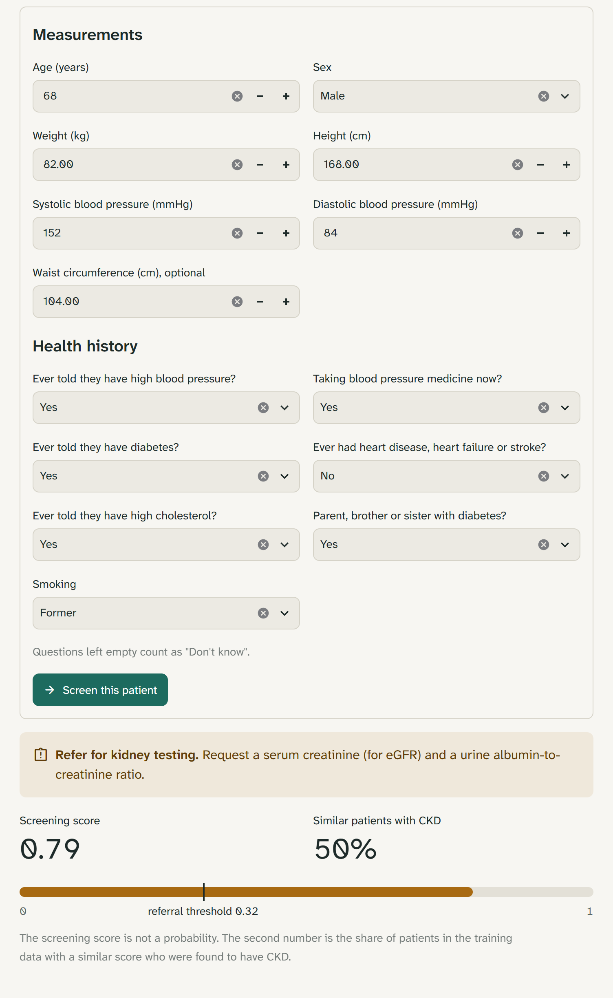
Screenshot of the application for the first sample patient: the form, the referral recommendation, the screening score against the threshold, and the share of similar training patients with CKD.
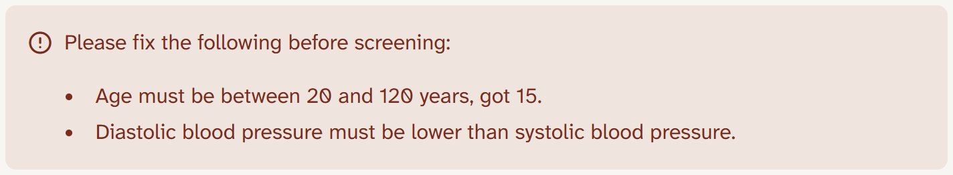
The fifth sample patient entered in the form. The inputs are rejected with a readable message instead of a prediction.
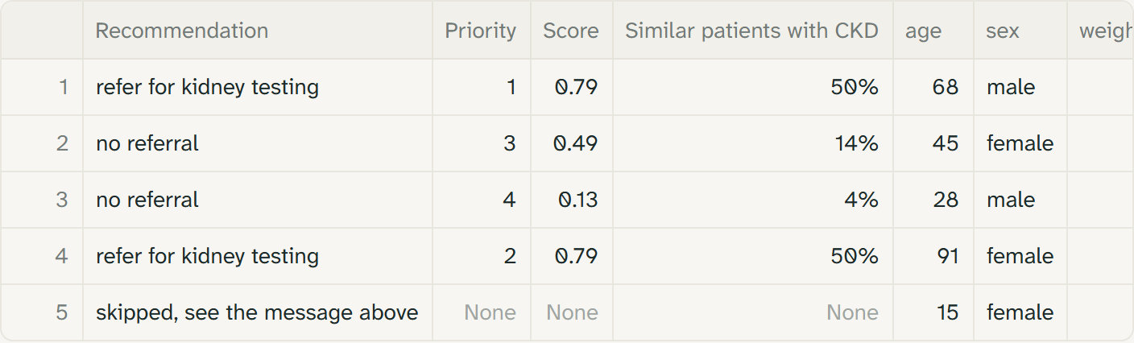
Result columns after uploading the five sample patients as a CSV file with 2 tests available. The two highest scores are referred, the other two valid rows are not, each row has a priority, and row 5 is skipped with the same message.

Appendix C. Additional figures and tables
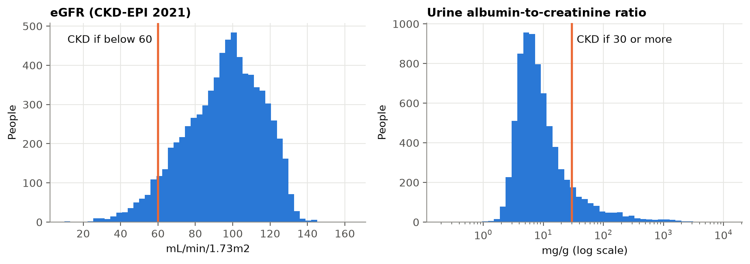
Distributions of eGFR and urine ACR in the cohort, with CKD thresholds.
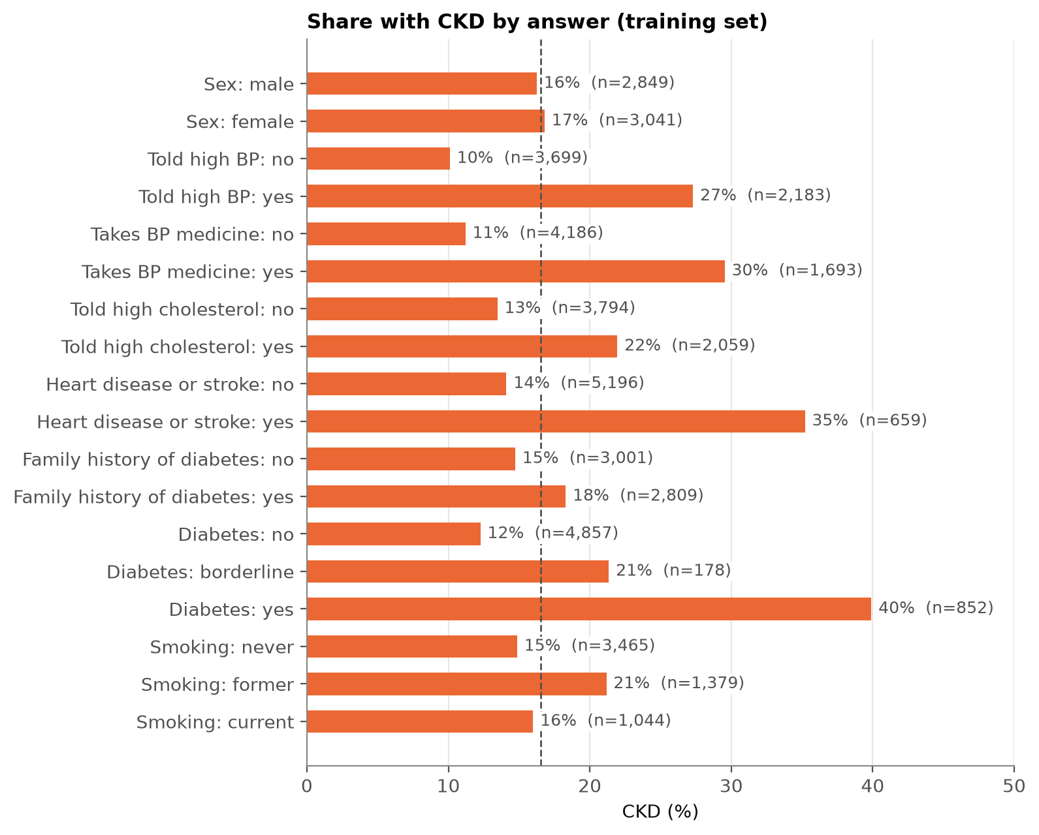
Share with CKD by answer to each yes/no and categorical feature (training set).
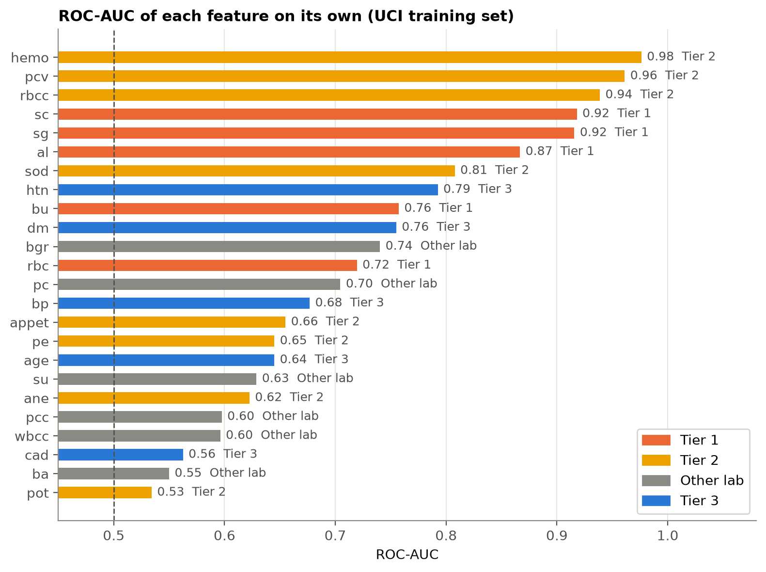
ROC-AUC of each UCI feature on its own, colored by tier.
TABLE IV
ACCURACY AND PER-CLASS METRICS FOR ALL THREE MODELS
Model | Accuracy | CKD precision | CKD recall | CKD F1 | No-CKD precision | No-CKD recall | No-CKD F1
Logistic Regression (CV) | 0.624 | 0.277 | 0.793 | 0.411 | 0.935 | 0.591 | 0.724
Random Forest (CV) | 0.598 | 0.267 | 0.819 | 0.403 | 0.939 | 0.554 | 0.697
Gradient Boosting (CV) | 0.631 | 0.281 | 0.791 | 0.415 | 0.935 | 0.599 | 0.731
Random Forest (test) | 0.563 | 0.256 | 0.864 | 0.395 | 0.949 | 0.504 | 0.659
CV rows use the pooled out-of-fold predictions on the 5,890 training adults at each model's tuned threshold; the last row is the selected model on the 1,473 test adults. No-CKD recall is the specificity.

Appendix D. Contribution record
Member | Assigned responsibilities | Actual contributions | Confirmation
Antonio B. Garcia Jr. | All project work (sole member) | Problem definition and pre-registration; data acquisition; EDA; preprocessing; model training, comparison and selection; final evaluation; Streamlit application; tests; technical documentation; paper | Signature: ____________

Ownership and Authorship Declaration
Project Information | Details
Project title | Beyond 99%: Diagnostic Leakage in CKD Prediction and a Pre-lab Screening Check
Course and section | COM241
Group name or number | ____________________________________________
Date submitted | 10/15/2026

Declaration Statement
We, Dr. Armida P. Salazar as the course instructor and the undersigned student group members, jointly declare that we are the owners and authors of the submitted project output identified above. The project output includes the application, source code, trained model and saved pipeline, exploratory data analysis, visualizations, technical documentation, research paper, and original materials produced specifically for this course project.
We affirm that the submitted work accurately represents our documented contributions and that all external datasets, software libraries, code, models, frameworks, images, publications, and other third party materials have been properly cited, licensed, or acknowledged using IEEE citation format where applicable. This declaration does not transfer or claim ownership of pre-existing third party or institutional materials and remains subject to applicable National University policies, intellectual property rules, licenses, and Philippine law.

Signatories
Name and Role | Signature | Date
Dr. Armida P. Salazar
Course Instructor
Antonio B. Garcia Jr.
Student Group Member

