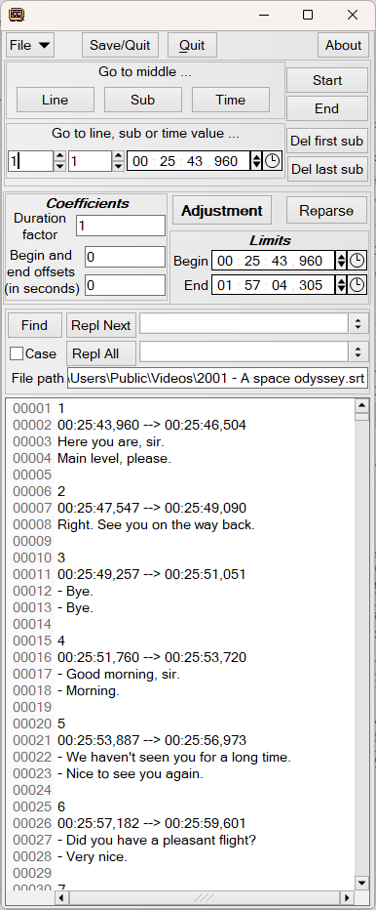
Save your file and exit from the app.
Go to start or end of the subtitle text

Delete the first or last line of the subtitle text
Undo/redo with Ctrl-Z/Ctrl-Y

Go to closest timestamp

The “Reparse” button will analyse the subtitle text and modify the parameters accordingly.
Counterpart of the “Adjustment” button

Search and replace all pattern occurrences
More details about ECMAScript regex here
https://en.cppreference.com/w/cpp/regex/ecmascript.html

The subtitle text can be modified directly or via the settings or the find/replace feature.

File menu (Ctrl-O, Ctrl-S ...)
Go to desired text line or subtitle number

The “Adjustment” button will modify the subtitle timeline according to the parameters
Counterpart of the “Reparse” button

The settings can be used to modify, or conversely be modified by, the subtitle chronology.

Search next or search and replace next or all
In case or not case sensitive way

