**Summary: Git and GitHub**

**Git**

Git is a distributed version control system created by Linus Torvalds in 2005. It tracks changes to files and coordinates work on those files among multiple people.

**GitHub**

GitHub is a web-based platform for version control and collaboration. It provides a graphical interface and additional features like issue tracking, project management, and social coding. It hosts repositories in the cloud, making them accessible from anywhere.

**Practice Screenshots**

For practice I preferred GUI because it is easy to use.

**Created New Repo**  
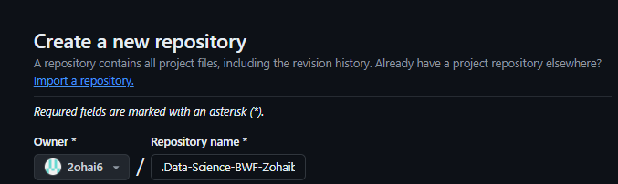

**Added New File**

**Deleted Practice File**

