**Working with Remote Repositories**

**Remote Repository**

Remote repositories on GitHub are used to host and manage codebases online, allowing collaboration and version control.

**Created a Repo**

**Cloned the repo**

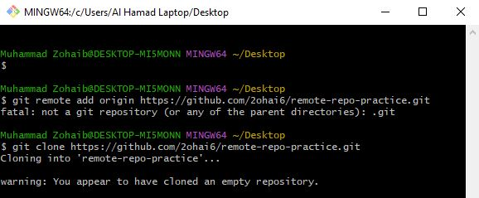

**Pushed a.txt after commit**

