ESP8266 : Temperature Humidity Battery and Wifi Automatic connect

Small application for temperature, humidity and battery measuring - results sending to IOT – cloud, for graphical data and alerts.
Written with natif NodeMcu(Lua) language and firmware modules compiled here: …..(to complete).
ESP8266 card: huzzah.

Purpose: - have a small battery powered card (so small power consumption), easy Wi-fi initial configuration (without additional programs or serial console connection for setting SSID and password).

- DHT22 sensor (temperature and humidity).
- internal ESP voltage measuring or small resistors divider on ADC pin.
- enduser_setup() module for initializing WIFI (SSID and password) via Web browser.
- dsleep() for low power consumption.
- http data sending to IOT cloud.

How it works?

First time the user have to connect the wireless network:
- fire up the huzzah card (power button) – the huzzah card sets itself in a WI-FI Access Point with an SSID like this: Gadget8266...
- the user connect his laptop or smartphone to this WI-FI Access Point, then he open the browser on the laptop or smartphone and point it to this address: http://192.168.4.1
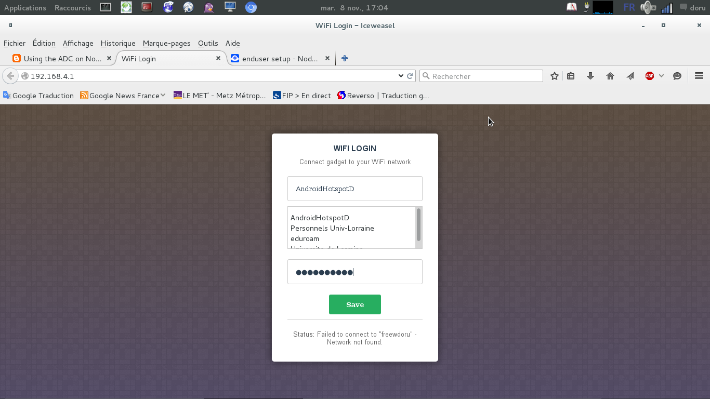
- the webpage, there, asks the SSID and password of his box WI-FI (home connection):
- once this done, these parameters will be stored on the EEPROM memory and will be keeped even after card power is down.
- at this point, the program will start:
- measuring temperature, humidity and battery voltage
- sending data to IOT cloud (http://io.adafruit.com)
- start hardware sleeping to economize battery power -1 minute (dsleep (1minute))
- after 1 minute Reboot.

Quite simple, here the 2 program files:
----------------------------------------------
init.lua

function startup()
if file.open("init.lua") == nil then
print("init.lua deleted")
else
print("Running")
file.close("init.lua")
-- dofile("test-wifi-th-init.lua")
-- dofile("wifi_dht_tcp.lua")
-- dofile("test_adc.lua")
dofile("wifi_dht_volt_tcp.lua")
--node.dsleep(60*1000*1000)
end
end

--init.lua
print("You have 5 seconds to abort Startup")
print("Waiting...")
tmr.alarm(0,5000,0,startup)

wifi_dht_volt_tcp.lua

HOST = "io.adafruit.com"
ADAFRUIT_KEY = "28f74649c7f44508a5ca529b1b9e2eec"

function dweet(temperature,humidity,voltage)
conn=net.createConnection(net.TCP,0)
conn:on("receive", function(conn, pl) print("response: ",pl) end)
conn:on("connection", function(conn, payload)
print("connected")
conn:send("GET /api/groups/66368/send.json?"
.. "x-aio-key=28f74649c7f44508a5ca529b1b9e2eec"
.. "&temperature=" .. temperature
.. "&humidity=" .. humidity
.. "&voltage=" .. voltage
.. " HTTP/1.1\r\n"
.. "Host: " .. HOST .. "\r\n"
.. "Connection: close\r\n"
.. "Accept: */*\r\n\r\n") end)
conn:on("disconnection", function(conn, payload)
print("disconnected")
node.dsleep(60*1000*1000) end)
conn:connect(80, HOST)
end

function check_wifi()
local ip = wifi.sta.getip()

if(ip==nil) then
print("Connecting...")
else
tmr.stop(0)
print("Connected to AP!")
print(ip)
tmr.alarm(1,20,tmr.ALARM_SINGLE,read_temp_hum_voltage)
end

end

function read_temp_hum_voltage()
pin = 1
-- DHT module: read temp and humidity
status, temp, humi, temp_dec, humi_dec = dht.readxx(pin)
if status == dht.OK then
-- Integer firmware using this example
print(string.format("DHT Temperature:%d.%03d;Humidity:%d.%03d\r\n",
math.floor(temp),
temp_dec,
math.floor(humi),
humi_dec
))
-- ADC module: read internal power
if adc.force_init_mode(adc.INIT_VDD33)
then node.restart()
return
end
volt = adc.readvdd33(0)
print ("System voltage (mV):", volt)

-- send data to adafruit dashboard site
dweet(math.floor(temp),math.floor(humi),volt)
elseif status == dht.ERROR_CHECKSUM then
print( "DHT Checksum error." )
elseif status == dht.ERROR_TIMEOUT then
print( "DHT timed out." )
end
end

-- This section should be in init.lua
-- If wifi not in station mode, execute enduser_setup.start() and wait the user for SSID and PASSWD
-- if (wifi.getmode() ~=wifi.STATIONAP) then
if (wifi.getmode() ~= wifi.STATION) then
enduser_setup.start(
function()
print("Connected to wifi as:" .. wifi.sta.getip())
end,
function(err, str)
print("enduser_setup: Err #" .. err .. ": " .. str)
end
)
-- elseif (not wifi.sta.getip()) then
elseif (wifi.sta.getip() == nil) then
-- tmr.alarm(0,2000,1,check_wifi)
tmr.alarm(0,100,1,check_wifi)
-- End section init.lua
else
tmr.alarm(1,2000,tmr.ALARM_SINGLE,read_temp_hum_voltage)
end

And the results here:

https://io.adafruit.com/dmesp/temp-humidity#

