CAR SALES SQL QUERIES

1. Cleaning data

-- Setting all makes, models and trims uppercase

UPDATE [CarSalesDB].[dbo].[car_prices]

SET make = UPPER(make), model = UPPER(model), trim = UPPER(trim)

-- Fix models with invalid data (invalid VIN, state, condition)

SELECT *

FROM [CarSalesDB].[dbo].[car_prices]

WHERE state LIKE '3%'

DELETE

FROM [CarSalesDB].[dbo].[car_prices]

WHERE state LIKE '3%'

SELECT *

FROM [CarSalesDB].[dbo].[car_prices]

WHERE year = 2015 and make = 'AUDI' and model = ''

-- Found a lot of Audi cars but with empty model column so I copied and pasted vin number into the browser to find out it is Audi A3

UPDATE [CarSalesDB].[dbo].[car_prices]

SET model = 'A3'

WHERE year = 2015 and make = 'AUDI' and model = ''

-- Ford F-150 (which is one of best selling cars) is also noticed as 'F150' so I've also fixed that

SELECT make, model

FROM [CarSalesDB].[dbo].[car_prices]

WHERE model = 'F150'

UPDATE [CarSalesDB].[dbo].[car_prices]

SET model = 'F-150'

WHERE make = 'FORD' and model = 'F150'

1. KPI’s
   1. Top 10 best-selling car models

-- What car model was best-seller

SELECT make, model, COUNT(model) AS SoldUnits

FROM [CarSalesDB].[dbo].[car_prices]

GROUP BY make, model

ORDER BY COUNT(model) DESC

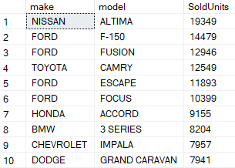

-- What car model was best-seller including year of car manufacture

SELECT make, model, year, COUNT(model) AS SoldUnits

FROM [CarSalesDB].[dbo].[car_prices]

GROUP BY make, model, year

ORDER BY COUNT(model) DESC

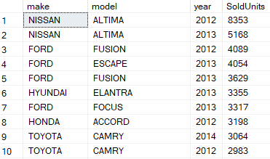

1. Top 10 best-selling car brands

-- What car brand was best-seller

SELECT make, COUNT(make) AS SoldUnits

FROM [CarSalesDB].[dbo].[car_prices]

GROUP BY make

ORDER BY SoldUnits DESC

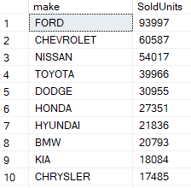

1. Which car dealer made highest revenue

-- Which car dealer made highest revenue

SELECT seller, SUM(CAST(sellingprice AS INT)) AS TotalRevenue

FROM [CarSalesDB].[dbo].[car_prices]

GROUP BY seller

ORDER BY TotalRevenue DESC

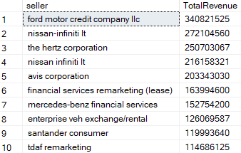

1. What was the best average revenue per car for every car dealer

-- Avg revenue per car by car dealers

SELECT seller, COUNT(*) AS NumberOfSoldUnits

FROM [CarSalesDB].[dbo].[car_prices]

GROUP BY seller

ORDER BY NumberOfSoldUnits DESC

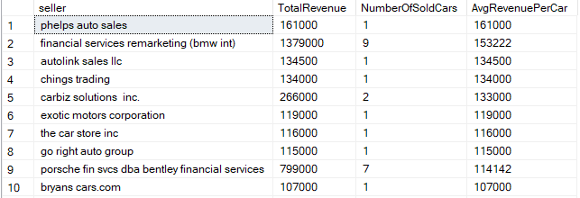

1. What car model made the highest total revenue

-- What car model made highest total revenue

SELECT make, model, SUM(CAST(sellingprice AS INT)) AS TotalRevenue

FROM [CarSalesDB].[dbo].[car_prices]

GROUP BY make, model

ORDER BY TotalRevenue DESC

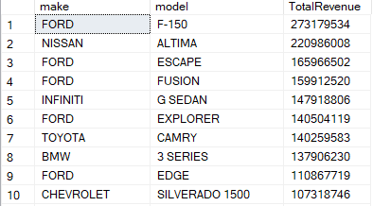

1. Difference between MMR (Manheim Market Report) and average selling price. Which car model was the most overpriced?

-- Difference between MMR (Manheim Market Report) and selling price (which car was the most overpriced)

SELECT make, model, AVG(CAST(sellingprice AS INT)) AS AvgSalePrice, AVG(CAST(mmr AS INT)) AS AvgMmr,

AVG(CAST(sellingprice AS INT))-AVG(CAST(mmr AS INT)) AS DifferenceMmr

FROM [CarSalesDB].[dbo].[car_prices]

GROUP BY make, model

ORDER BY DifferenceMmr DESC

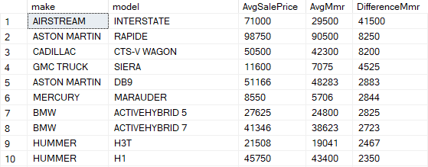

1. Best-selling cars in every noticed state

WITH CarSalesCount AS

(

-- This CTE counts the sales for each car model within each state

SELECT make, model, state, COUNT(*) AS CarSales

FROM [CarSalesDB].[dbo].[car_prices]

GROUP BY state, make, model

),

MaxSalesByState AS

(

-- This CTE finds the maximum sales for each state

SELECT state, MAX(CarSales) AS MaxSales

FROM CarSalesCount

GROUP BY state

)

-- This final query joins the CarSalesCount with the MaxSalesByState to get the best-selling car(s) for each state

SELECT

CarSalesCount.make,

CarSalesCount.model,

CarSalesCount.state,

CarSalesCount.CarSales

FROM CarSalesCount

JOIN MaxSalesByState

ON CarSalesCount.state = MaxSalesByState.state AND CarSalesCount.CarSales = MaxSalesByState.MaxSales

