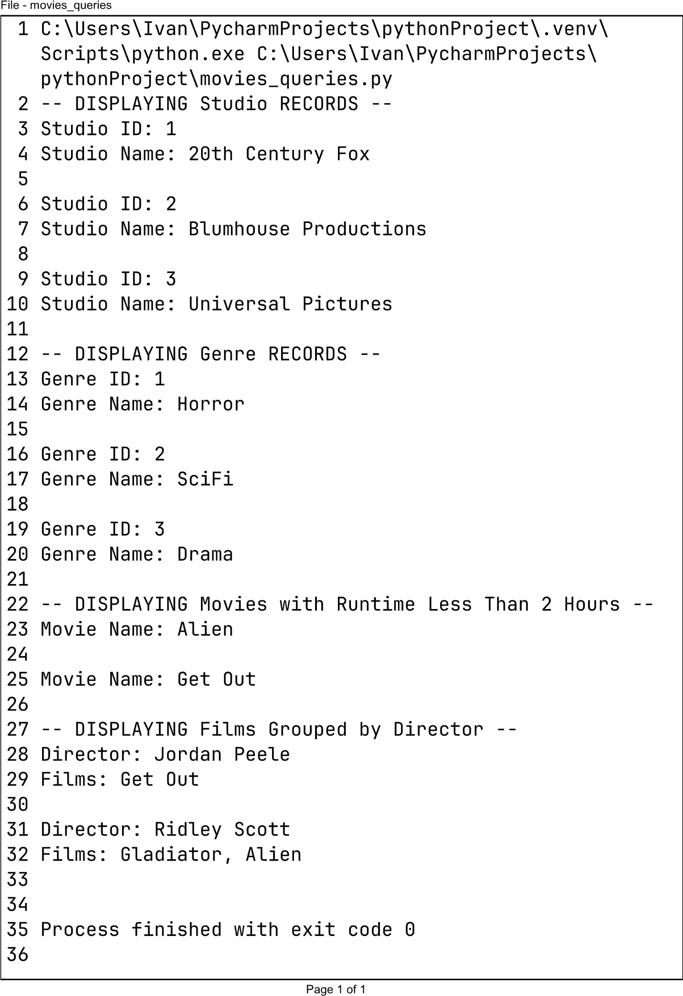
https://github.com/2pointO/csd-310

