Assumptions made:

Each Publisher has a unique ID, each book has a unique isbn, an author can write multiple books.

First Normal Form:

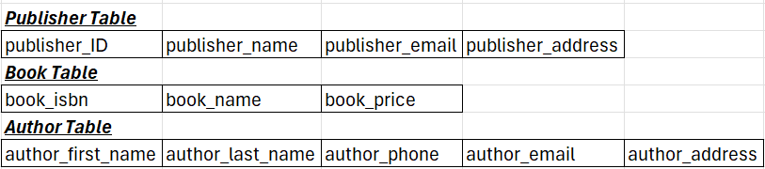

Third Normal Form:

