[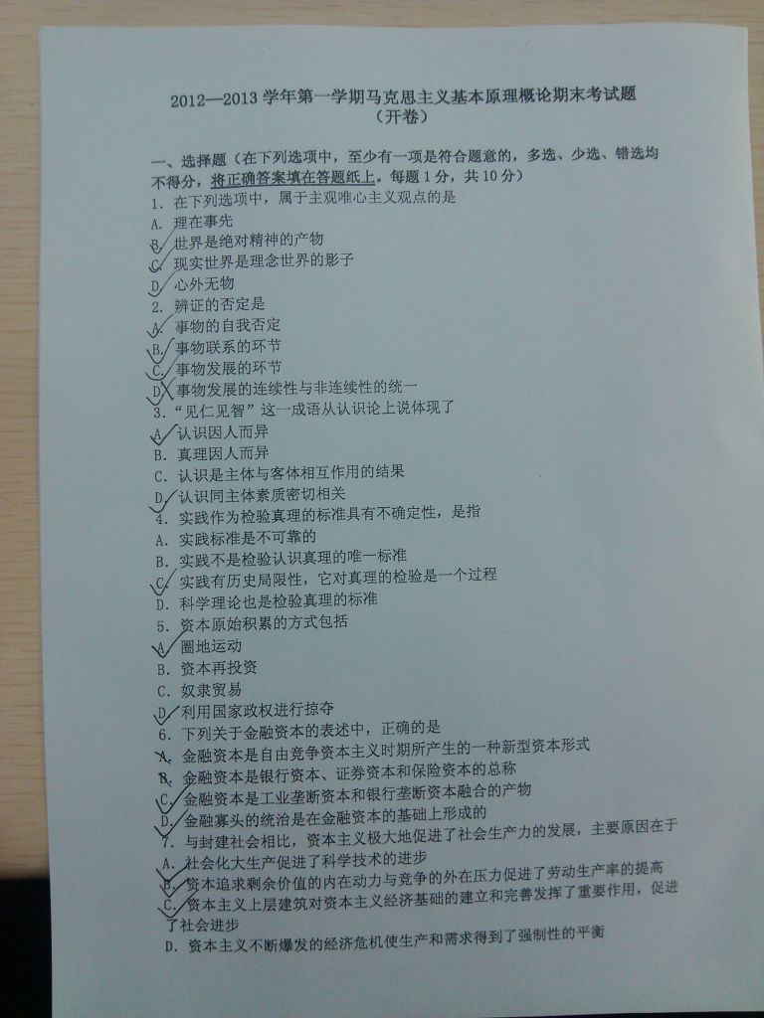](http://attach3.bdwm.net/attach/boards/Courses/M.1357892939.A/img_20130111_160227.jpg)

[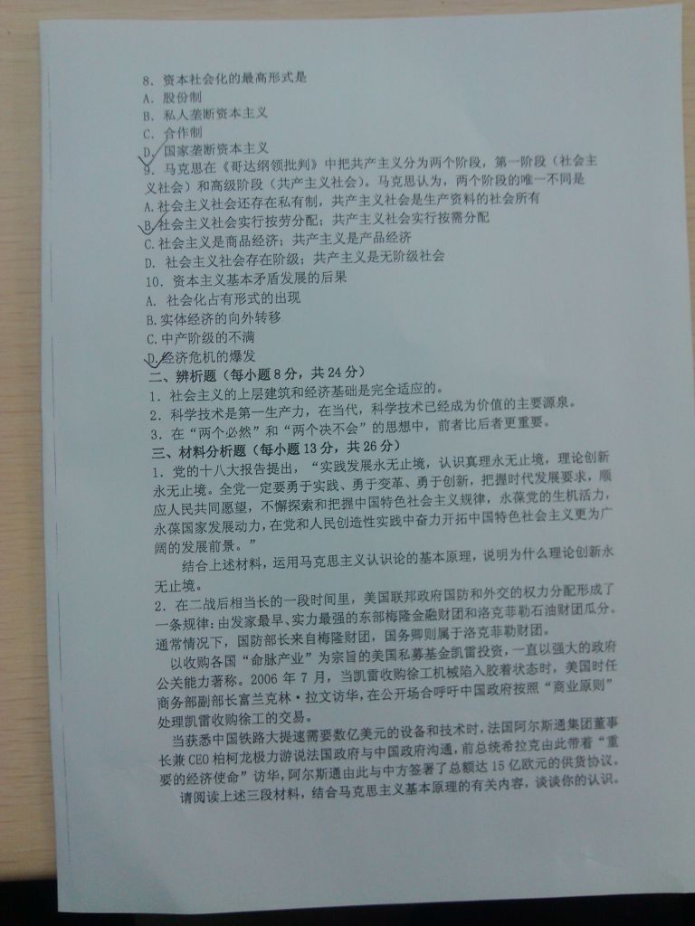](http://attach3.bdwm.net/attach/boards/Courses/M.1357892939.A/img_20130111_160234.jpg)