[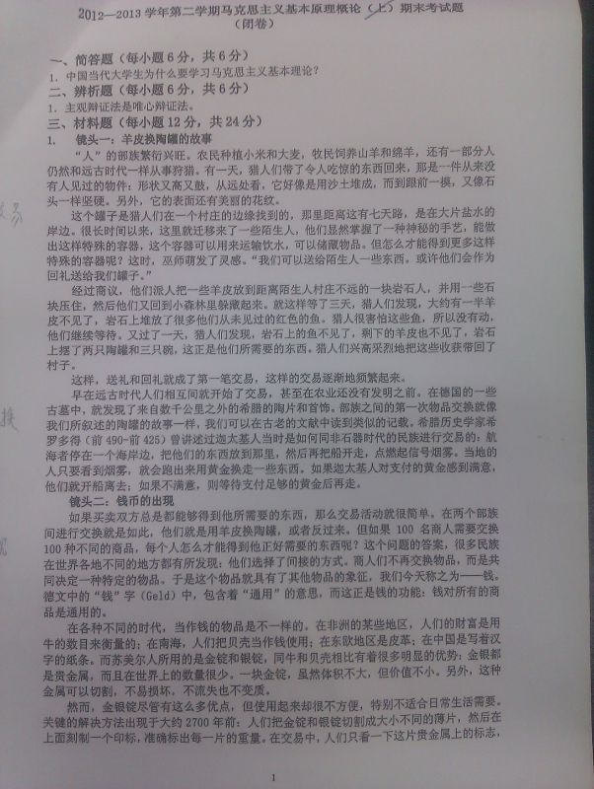](http://attach3.bdwm.net/attach/boards/Courses/M.1371810771.A/imag0223.jpg)

[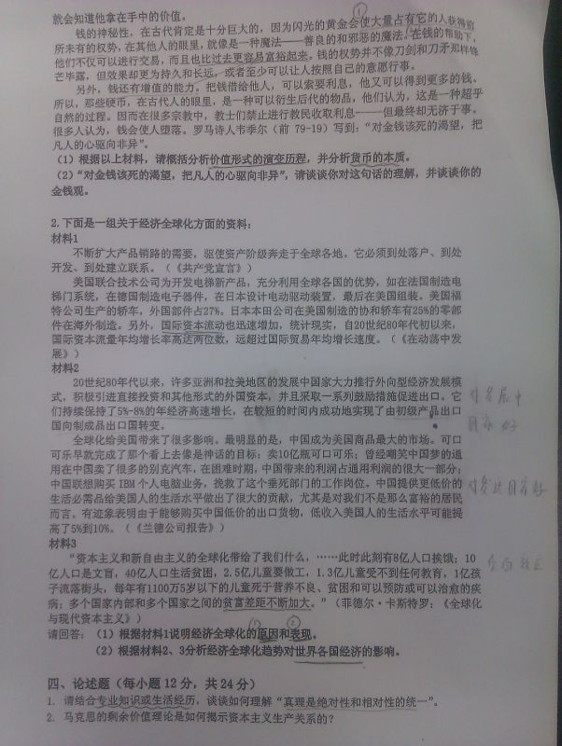](http://attach3.bdwm.net/attach/boards/Courses/M.1371810771.A/imag0224.jpg)