INTERESTING PEOPLE · READING & FACTS · LEVEL A2
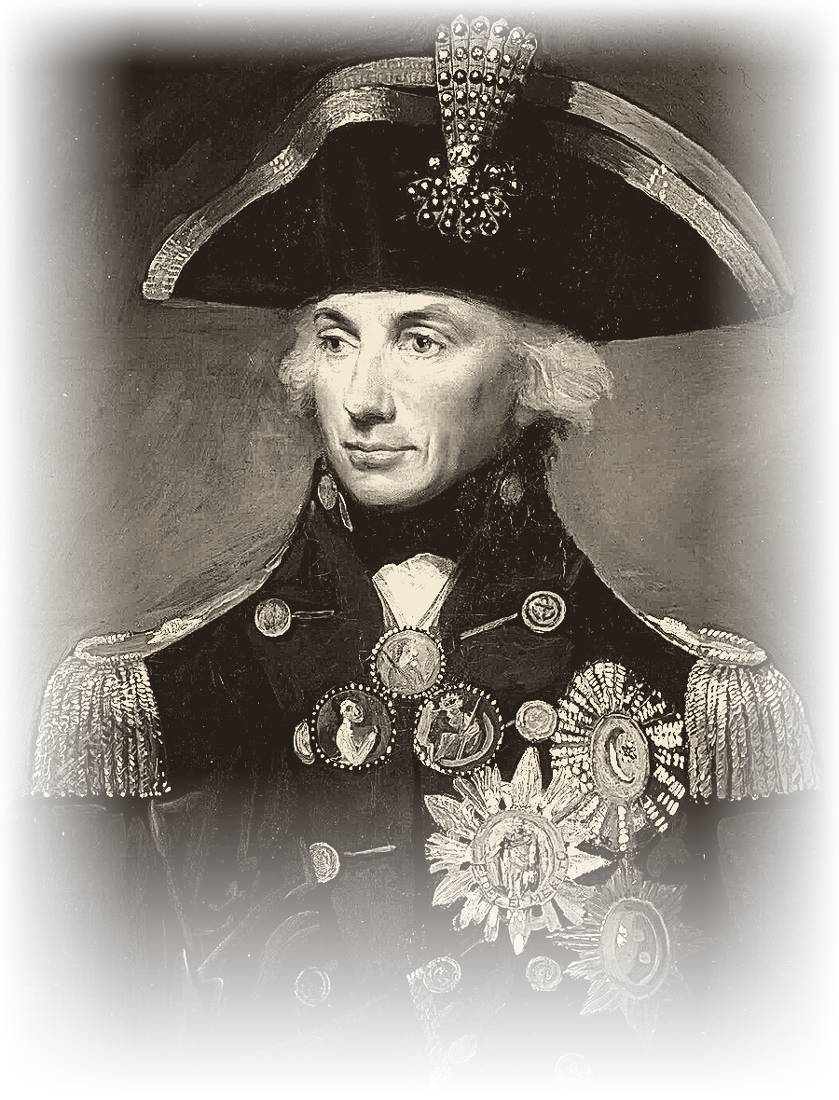 | HORATIO NELSON  1758 – 1805  Naval officer · Vice-Admiral · National hero  A national hero at sea
READ THE TEXT
Paragraph numbers help you find the answers.
1 Horatio Nelson was a famous British naval officer who lived from 1758 to 1805. He was born on 29 September 1758 in a small village called Burnham Thorpe in England.
2 Nelson joined the Royal Navy when he was only 12 years old. He loved the sea and wanted to become a brave and successful sailor. Nelson was not very tall, but he was a strong leader with great courage.
3 During his career, he fought in many important battles at sea. He lost the sight in his right eye during a battle in 1794. In 1797, he lost his right arm during the Battle of Santa Cruz de Tenerife. Even after these injuries, Nelson returned to the sea and continued his career. He became famous for his clever plans and unusual ideas in naval battles.
4 One of his greatest victories came at the Battle of the Nile in 1798. In this battle, Nelson defeated a large French fleet in Egypt. His most famous battle was the Battle of Trafalgar on 21 October 1805. Nelson led the British fleet against the French and Spanish fleets near the coast of Spain. The British won the battle, but Nelson was badly wounded by an enemy bullet. He died on his ship, HMS Victory, on the same day at the age of 47.
5 Nelson became a national hero, and people still remember him for his courage and leadership. Today, Nelson’s Column in Trafalgar Square, London, is a famous monument to this remarkable sailor.
"He lost an eye and an arm, and went back to sea."
WORDS TO KNOW
navy – the ships and people that protect a country at sea | sailor – a person who works on a ship
battle – a fight between armies or ships | fleet – a large group of ships
courage – being brave when something is dangerous | wounded – badly hurt in a battle
hero – someone people admire for brave actions | monument – something built to remember a person

TASK 1 TRUE, FALSE OR NOT GIVEN Circle T, F or NG.
1. | Nelson was born in a big city. | T F NG
2. | Nelson joined the Royal Navy when he was 12. | T F NG
3. | Nelson was a very tall man. | T F NG
4. | Nelson’s father was also a sailor. | T F NG
5. | Nelson lost his right arm in 1797. | T F NG
6. | Nelson stopped working after his injuries. | T F NG
7. | The Battle of Trafalgar took place in 1805. | T F NG
8. | Nelson died on his ship. | T F NG
TASK 2 FILL IN THE GAPS Use the words in the box.
arm · courage · eye · fleet · monument · Navy · Trafalgar · Victory
1. Nelson joined the Royal ________________ when he was 12.
2. He lost the sight in his right ________________ during a battle in 1794.
3. In 1797 he lost his right ________________ .
4. At the Battle of the Nile he defeated a large French ________________ .
5. His most famous battle was the Battle of ________________ .
6. Nelson died on his ship, HMS ________________ .
7. People remember him for his ________________ and leadership.
8. Nelson’s Column is a famous ________________ in London.

TASK 3 ANSWER THE QUESTIONS Write full sentences.
1. Where was Nelson born?
................................................................................................
................................................................................................
2. How old was Nelson when he joined the Royal Navy?
................................................................................................
................................................................................................
3. What happened to Nelson in 1794 and in 1797?
................................................................................................
................................................................................................
4. Which fleet did Nelson defeat at the Battle of the Nile?
................................................................................................
................................................................................................
5. What was the name of Nelson’s ship?
................................................................................................
................................................................................................
6. Which monument in London remembers Nelson?
................................................................................................
................................................................................................
TASK 4 MATCH THE TWO HALVES Write a, b, c, d or e.
1. |  | Nelson joined the Royal Navy | a) during a battle in 1794.
2. |  | He lost the sight in his right eye | b) defeated a large French fleet in Egypt.
3. |  | At the Battle of the Nile Nelson | c) when he was only 12 years old.
4. |  | At Trafalgar the British won, but Nelson | d) is a famous monument to this sailor.
5. |  | Nelson’s Column in Trafalgar Square | e) was badly wounded by an enemy bullet.
TASK 5 BACK TO THE BOARD From the game – texts face down!
100 | What was Nelson’s job?
200 | Who was born in England on 29 September 1758?
300 | Who became a national hero in Britain?

