INTERESTING PEOPLE · READING & FACTS · LEVEL A2
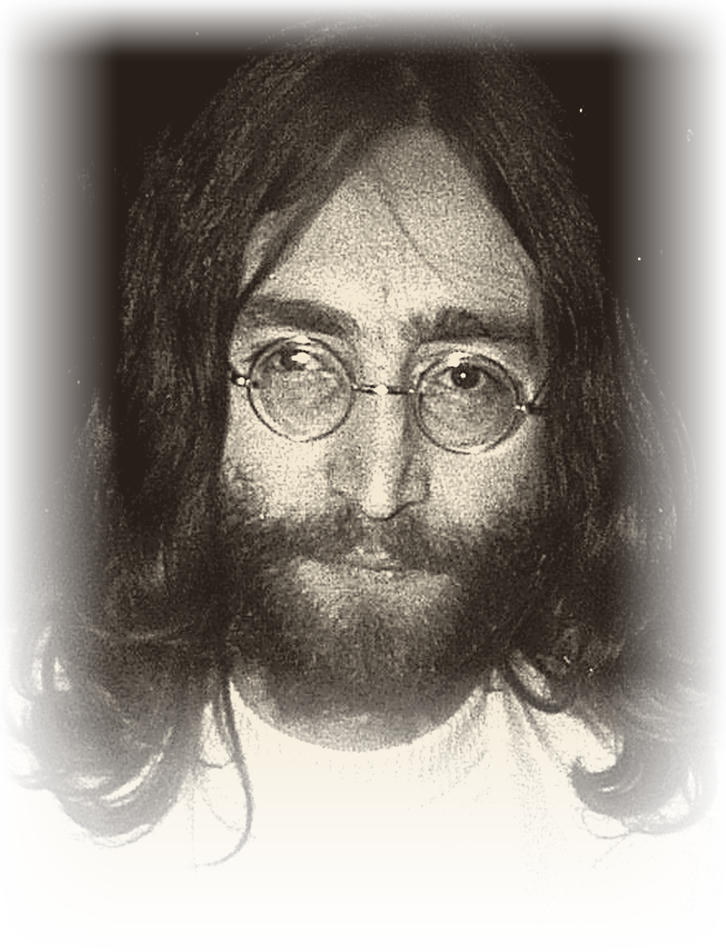 | JOHN LENNON  1940 – 1980  Musician · Songwriter · Peace activist  A voice for peace
READ THE TEXT
Paragraph numbers help you find the answers.
1 John Lennon was born on October 9, 1940, in Liverpool, England. It happened during the war. He was named John Winston after his grandfather and Prime Minister Churchill. John’s parents separated, and his strict aunt Mimi raised him.
2 When John was 15, his mother bought him his first guitar. Before that, he learned to play the banjo and harmonica. In 1956, he formed his first band, The Quarrymen. Later, this band became The Beatles. In 1957, John met Paul McCartney at a church party. They became great friends and wrote songs together.
3 In the 1960s, The Beatles became very famous all over the world. John sang and played guitar. In 1962, he married Cynthia Powell. They had a son, Julian.
4 In 1966, John said that The Beatles were more popular than Jesus. This caused a big scandal. In 1969, he returned his MBE medal to the Queen. He protested against the Vietnam War.
5 In 1969, John married for the second time. His wife was artist Yoko Ono. Together, they did peace actions – “bed-ins” in Amsterdam and Montreal.
6 In 1970, The Beatles broke up. John started a solo career. His first solo album came out in 1970. In 1971, he recorded his famous song “Imagine” about peace.
7 In the 1970s, John had problems with the American government. President Nixon wanted to send him out of the USA because of his anti-war views. From 1973 to 1975, John lived apart from Yoko. This period is called his “lost weekend.”
8 On October 9, 1975, John and Yoko had a son, Sean. It was John’s birthday on the same day! After that, John did not work as a musician for five years. He stayed at home and raised his son.
9 In 1980, John came back to music with a new album, Double Fantasy. Sadly, on December 8, 1980, a crazy fan killed him outside his home in New York City. But John Lennon will always stay in people’s memory as a great musician and a fighter for peace.
"A great musician and a fighter for peace."
WORDS TO KNOW
band – a group of musicians who play together | solo career – working alone, not in a group
to protest – to say publicly that something is wrong | scandal – something that shocks a lot of people
album – a collection of songs | to break up – to stop working together
views – the things a person believes | memory – something that people remember

1. TRUE, FALSE OR NOT GIVEN Circle T, F or NG.
1. | John Lennon was born in London. | T F NG
2. | John was raised by his strict aunt Mimi. | T F NG
3. | The guitar was the first instrument John learned to play. | T F NG
4. | John met Paul McCartney at school. | T F NG
5. | Cynthia Powell sang in The Quarrymen. | T F NG
6. | John returned his MBE medal to the Queen in 1969. | T F NG
7. | John and Yoko did “bed-ins” in Amsterdam and Montreal. | T F NG
8. | Sean Lennon was born on his father’s birthday. | T F NG
2. FILL IN THE GAPS Use the words in the box.
Beatles · guitar · Imagine · Liverpool · peace · Quarrymen · Sean · solo
1. John Lennon was born in ________________ in 1940.
2. When John was 15, his mother bought him his first ________________ .
3. In 1956 he formed his first band, The ________________ .
4. Later this band became The ________________ .
5. After 1970 John started a ________________ career.
6. In 1971 he recorded his famous song “________________” .
7. John and Yoko did “bed-ins” for ________________ .
8. In 1975 John and Yoko had a son, ________________ .

3. ANSWER THE QUESTIONS Write full sentences.
1. Why was John given the name “Winston”?
................................................................................................
................................................................................................
2. Who raised John when his parents separated?
................................................................................................
................................................................................................
3. Where and when did John meet Paul McCartney?
................................................................................................
................................................................................................
4. What did John say in 1966 that caused a big scandal?
................................................................................................
................................................................................................
5. Why did President Nixon want to send John out of the USA?
................................................................................................
................................................................................................
6. What was special about Sean’s date of birth?
................................................................................................
................................................................................................
4. MATCH THE TWO HALVES Write a, b, c, d or e.
1. |  | Before the guitar, John learned to play | a) this period is called his “lost weekend.”
2. |  | In 1969 John returned his MBE medal | b) with a new album, Double Fantasy.
3. |  | From 1973 to 1975 John lived apart from Yoko – | c) to the Queen.
4. |  | After Sean was born, John stayed at home | d) the banjo and the harmonica.
5. |  | In 1980 John came back to music | e) and did not work as a musician for five years.
5. BACK TO THE BOARD From the game – texts face down!
100 | Who was born in Liverpool in 1940?
200 | What band did John Lennon help create?
500 | What did John Lennon do after The Beatles broke up?

