INTERESTING PEOPLE · READING & FACTS · LEVEL A2
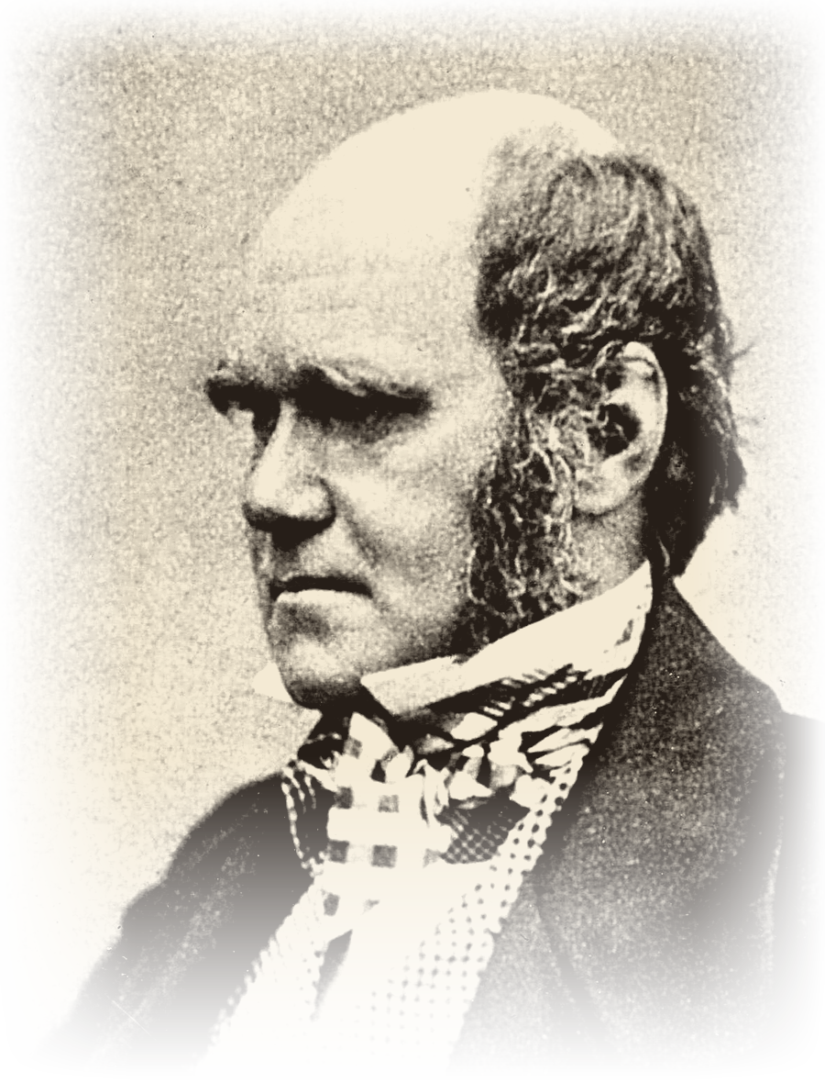 | CHARLES DARWIN  1809 – 1882  Naturalist · Geologist · Author  Ask questions. Discover the truth.
READ THE TEXT
Paragraph numbers help you find the answers.
1 Charles Darwin (1809–1882) was a British scientist who studied nature and animals during the Victorian era. He was born in Shrewsbury, England, and died in Kent.
2 Darwin grew up in a wealthy family. His father, a doctor, hoped Charles would follow the same path, but Charles was far more drawn to nature than to his studies. At university he showed little interest in his lessons, preferring instead to explore the natural world and collect beetles and birds. Much of what he learned came not from textbooks but from his own observations and curiosity.
3 Adventurous by nature, Darwin loved exploring rainforests and climbing mountains in search of new plants and animals. At the age of 22, he joined a voyage around the world that lasted five years — a journey that would go on to change the course of science.
4 Through his observations during and after the voyage, Darwin developed the theory of evolution, proposing that all living things, including humans, share common ancestors. It was a radical idea for its time, offering an answer to a question that had long puzzled naturalists: how do species change over time? His theory reshaped the way people understood the natural world.
5 Later in life, Darwin married his cousin Emma, and together they had children.
6 Today, Darwin’s theory remains a cornerstone of modern science and is taught in schools around the world, having fundamentally changed how we understand nature.
"Much of what he learned came from his own observations and curiosity."
WORDS TO KNOW
nature – plants, animals and everything in the natural world | wealthy – having a lot of money
beetle – a small insect with hard wings | voyage – a long journey by ship
observation – watching something carefully to learn about it | evolution – the slow change of plants and animals over a very long time
ancestor – someone who lived a long time before you | species – a group of animals or plants of the same kind

TASK 1 TRUE, FALSE OR NOT GIVEN Circle T, F or NG.
1. | Charles Darwin was born in England. | T F NG
2. | Darwin’s father wanted him to become a doctor too. | T F NG
3. | Darwin was a very good student at university. | T F NG
4. | At university Darwin collected beetles and birds. | T F NG
5. | Darwin’s brother travelled with him on the voyage. | T F NG
6. | The voyage around the world lasted five years. | T F NG
7. | Darwin was 22 years old when he joined the voyage. | T F NG
8. | Darwin married a woman he had never met before. | T F NG
TASK 2 FILL IN THE GAPS Use the words in the box.
ancestors · beetles · cousin · doctor · evolution · mountains · nature · voyage
1. Charles Darwin studied ________________ and animals.
2. His father was a ________________ .
3. At university Darwin collected ________________ and birds.
4. He loved exploring rainforests and climbing ________________ .
5. At the age of 22 he joined a ________________ around the world.
6. Darwin developed the theory of ________________ .
7. He proposed that all living things share common ________________ .
8. Later in life Darwin married his ________________ Emma.

TASK 3 ANSWER THE QUESTIONS Write full sentences.
1. Where was Charles Darwin born?
................................................................................................
................................................................................................
2. What did Darwin’s father hope his son would become?
................................................................................................
................................................................................................
3. What did Darwin collect instead of studying his lessons?
................................................................................................
................................................................................................
4. How old was Darwin when he joined the voyage around the world?
................................................................................................
................................................................................................
5. What did Darwin’s theory say about all living things?
................................................................................................
................................................................................................
6. Who did Darwin marry?
................................................................................................
................................................................................................
TASK 4 MATCH THE TWO HALVES Write a, b, c, d or e.
1. |  | Darwin’s father was a doctor and hoped | a) lasted five years.
2. |  | At university Darwin was more interested in nature | b) that Charles would follow the same path.
3. |  | The voyage around the world | c) is taught in schools around the world.
4. |  | Darwin’s theory says that humans and animals | d) than in his lessons.
5. |  | Today Darwin’s theory | e) share common ancestors.
TASK 5 BACK TO THE BOARD From the game – texts face down!
400 | Who joined a voyage around the world at the age of 22?
600 | What is the name of Darwin’s famous theory?
800 | Who did Charles Darwin marry?

