INTERESTING PEOPLE · READING & FACTS · LEVEL A2
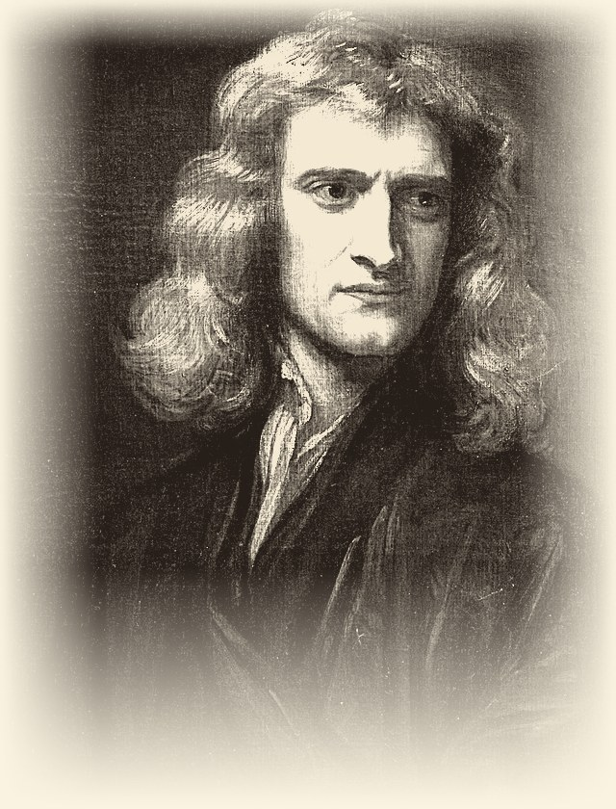 | ISAAC NEWTON  1642 – 1727  Scientist · Mathematician · Astronomer  The man who never stopped looking
READ THE TEXT
Paragraph numbers help you find the answers.
1 Isaac Newton was born on December 25, 1642, in England. His childhood was difficult. His father died shortly after he was born. His mother remarried and left him with his grandmother, Marjorie. Newton lived on a boring farm and spent most of his time alone.
2 His grandmother wanted him to be a farmer and take care of pigs. But Newton was not interested in farming. He preferred to watch the rain, the wind, and the grass. His grandmother did not like his “observation.” When he was 12, his mother and grandmother sent him to school. He stayed at the house of a pharmacist, Mr. Clark. There he discovered a library with books on chemistry, mathematics, and astronomy. He read many of them and learned a lot.
3 After a few years, his mother took him away from school to work on the farm again. One day, he had to guard the pigs, but he was not paying attention. He was thinking about nature and the books he had read. The pigs escaped and destroyed the crops. After this failure, his uncle William convinced his mother to send Newton to Cambridge University.
4 At Cambridge, Newton had to work as a servant to pay for his studies. He cleaned rooms and swept stairs, but he did not care. He read all the important science books of that time.
5 In 1665, something terrible happened. The plague arrived in London from ships. Thousands of people died every day. Newton left Cambridge and returned to his family’s farm. The village was safer and cleaner. There, he had time to think and observe nature again. During this time, he made his most important discoveries.
6 First, he experimented with light and colors. He bought a glass pyramid called a prism. He let a single ray of sunlight pass through it. The white light became a rainbow of many colors. He proved that white light is a combination of all colors. He also built the best telescope of his time, and the King of England congratulated him.
7 Then came his most famous idea. One day, in the garden, he saw an apple fall from a tree. He asked himself: “Why do objects fall to the ground? Is there a force that pulls them?” After many calculations and experiments, he discovered the force of gravity. He understood that the Earth attracts all objects. The apple falls because of gravity. But gravity does not work only on Earth. All bodies in the universe attract each other. The planets stay in orbit around the Sun because of gravity. The Moon attracts water in our oceans and creates tides. Gravity is like a string that holds the planets in their places.
8 Newton created three important laws of motion. With these laws and the law of gravity, he could explain how any object moves. He became the most famous scientist in the world, admired by kings and queens. He continued to observe nature and kept a telescope on his roof.
9 Today, his formulas help us build cars, bridges, and rockets for space travel. Newton said: “Remember me and my apple.” His story is the story of a man who never stopped looking and thinking.
"Remember me and my apple."
WORDS TO KNOW
observation – watching something very carefully | servant – a person who works in someone else’s house
plague – a very dangerous illness that spreads quickly | prism – a piece of glass that breaks light into colours
gravity – the force that pulls objects down to the ground | orbit – the path of a planet around the Sun
tide – the rise and fall of the sea | crops – plants that farmers grow for food

TASK 1 TRUE, FALSE OR NOT GIVEN Circle T, F or NG.
1. | Newton’s father died before Newton was born. | T F NG
2. | Newton’s grandmother wanted him to become a farmer. | T F NG
3. | Newton enjoyed taking care of the pigs. | T F NG
4. | At Mr. Clark’s house Newton found a library with science books. | T F NG
5. | Newton’s uncle William was a teacher at Cambridge University. | T F NG
6. | Newton worked as a servant to pay for his studies. | T F NG
7. | Newton left Cambridge in 1665 because of the plague. | T F NG
8. | Newton proved that white light is made of only three colors. | T F NG
TASK 2 FILL IN THE GAPS Use the words in the box.
apple · gravity · motion · plague · prism · pigs · servant · telescope
1. Newton’s grandmother wanted him to take care of ________________ .
2. At Cambridge, Newton worked as a ________________ to pay for his studies.
3. In 1665 the ________________ arrived in London from ships.
4. He used a glass ________________ to turn white light into a rainbow.
5. Newton built the best ________________ of his time.
6. In the garden he saw an ________________ fall from a tree.
7. After many experiments he discovered the force of ________________ .
8. Newton created three important laws of ________________ .

TASK 3 ANSWER THE QUESTIONS Write full sentences.
1. Where did Newton live when he was 12?
................................................................................................
................................................................................................
2. What happened to the pigs when Newton was not paying attention?
................................................................................................
................................................................................................
3. Who convinced Newton’s mother to send him to Cambridge?
................................................................................................
................................................................................................
4. What did Newton prove about white light?
................................................................................................
................................................................................................
5. Why do the planets stay in orbit around the Sun?
................................................................................................
................................................................................................
6. What did Newton keep on the roof of his house?
................................................................................................
................................................................................................
TASK 4 MATCH THE TWO HALVES Write a, b, c, d or e.
1. |  | Newton’s mother took him away from school | a) so they escaped and destroyed the crops.
2. |  | Newton was thinking about nature instead of watching the pigs, | b) and became a rainbow of many colors.
3. |  | A single ray of sunlight passed through the prism | c) and creates the tides.
4. |  | The Moon attracts the water in our oceans | d) build cars, bridges and rockets.
5. |  | Today Newton’s formulas help engineers | e) to work on the family farm again.
TASK 5 BACK TO THE BOARD From the game – texts face down!
400 | Who was left with a grandmother as a small child?
600 | What did Newton create to explain how objects move?
700 | What did Newton do at Cambridge to pay for his studies?

