INTERESTING PEOPLE · READING & FACTS · LEVEL A2
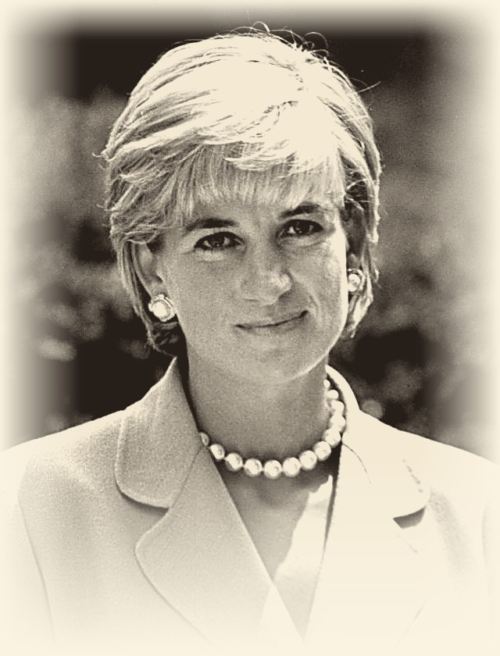 | PRINCESS DIANA  1961 – 1997  Princess of Wales · Charity worker  The People’s Princess
READ THE TEXT
Paragraph numbers help you find the answers.
1 Diana Frances Spencer was born on 1 July 1961 in England. She grew up in a large family with two older sisters and a younger brother. Her parents divorced when she was young.
2 Diana was a quiet and shy child. She liked music, dancing and working with children. She studied in England and Switzerland but did not go to university. Before becoming a princess, she worked with children in London.
3 In 1981, Diana married Prince Charles and became the Princess of Wales. They had two sons, William and Harry. Diana became very popular because she was kind, friendly and open with ordinary people.
4 Diana did a lot of charity work. She visited hospitals and helped sick children, homeless people and people with HIV/AIDS. She also worked to stop the use of landmines. She used her fame to talk about important problems and help people in need.
5 Diana died in a car accident in Paris on 31 August 1997. She was 36 years old. People still remember her for her kindness, courage and charity work. She was often called the “People’s Princess”. One of her famous quotes is: “Only do what your heart tells you.”
"Only do what your heart tells you."
WORDS TO KNOW
shy – not comfortable with new people | charity work – helping people without being paid
homeless – having nowhere to live | landmine – a bomb hidden under the ground
fame – being known by very many people | kindness – being good and friendly to other people
courage – being brave when something is difficult | ordinary people – normal people, not rich or famous

TASK 1 TRUE, FALSE OR NOT GIVEN Circle T, F or NG.
1. | Diana was born in 1961. | T F NG
2. | Diana was the youngest child in her family. | T F NG
3. | Diana studied at a university in Switzerland. | T F NG
4. | Diana’s favourite subject at school was history. | T F NG
5. | Before she married, Diana worked with children in London. | T F NG
6. | Diana and Prince Charles had two sons. | T F NG
7. | Diana worked to stop the use of landmines. | T F NG
8. | Diana was 40 years old when she died. | T F NG
TASK 2 FILL IN THE GAPS Use the words in the box.
charity · children · hospitals · landmines · Paris · People’s · shy · Wales
1. Diana was a quiet and ________________ child.
2. In 1981 she married Prince Charles and became the Princess of ________________ .
3. Before becoming a princess, she worked with ________________ in London.
4. Diana did a lot of ________________ work.
5. She visited ________________ and helped sick children.
6. She also worked to stop the use of ________________ .
7. Diana died in a car accident in ________________ in 1997.
8. People often called her the “________________ Princess”.

TASK 3 ANSWER THE QUESTIONS Write full sentences.
1. How many brothers and sisters did Diana have?
................................................................................................
................................................................................................
2. What happened to Diana’s parents when she was young?
................................................................................................
................................................................................................
3. What are the names of Diana’s two sons?
................................................................................................
................................................................................................
4. Name two groups of people that Diana helped.
................................................................................................
................................................................................................
5. Why did Diana become very popular?
................................................................................................
................................................................................................
6. How old was Diana when she died?
................................................................................................
................................................................................................
TASK 4 MATCH THE TWO HALVES Write a, b, c, d or e.
1. |  | Diana grew up in a large family | a) died in a car accident in Paris.
2. |  | She studied in England and Switzerland, | b) to talk about important problems and help people in need.
3. |  | Diana used her fame | c) with two older sisters and a younger brother.
4. |  | On 31 August 1997 Diana | d) “Only do what your heart tells you.”
5. |  | One of her famous quotes is: | e) but she did not go to university.
TASK 5 BACK TO THE BOARD From the game – texts face down!
300 | What did Diana do before becoming a princess?
500 | Who was a quiet and shy child and liked dancing and music?
700 | What important work did Diana do for people with serious problems?

