INTERESTING PEOPLE · READING & FACTS · LEVEL A2
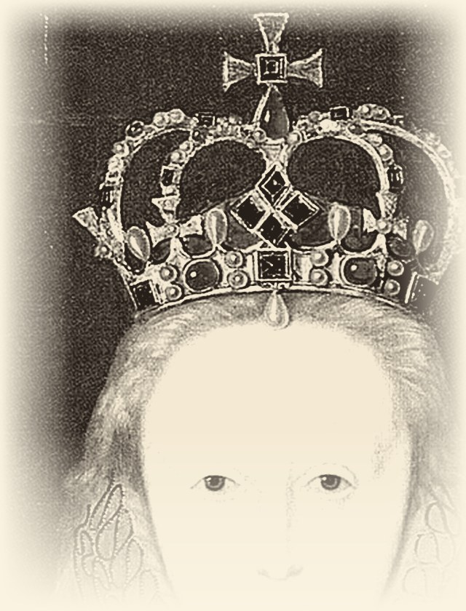 | ELIZABETH I  1533 – 1603  Queen of England · The Virgin Queen  She kept the power herself
READ THE TEXT
Paragraph numbers help you find the answers.
1 Elizabeth was born in 1533. Her parents were King Henry VIII and Anne Boleyn. Her father was not happy because he wanted a son. When Elizabeth was two years old, her mother was killed. The young girl went to live at Hatfield Palace, where she got a very good education. By the age of thirteen, she spoke several languages and was a good writer.
2 She became queen in 1558. Many men from different countries wanted to marry her, but she said no to all of them. She never married because she wanted to keep all the power herself. During her reign, she had a big conflict with Spain. Spain was a big, rich, and Catholic country, but England was smaller and Protestant. In the 1580s, the two countries fought at sea. English sailors were fast and clever, so Spain never won.
3 The Queen had time for other things and loved the theatre very much. Her favourite writer was William Shakespeare, and his actors often performed plays at her palace. As a young woman, Elizabeth was ill with smallpox, and the illness left marks on her face. To hide them, she covered her face with thick white make-up and wore a big orange wig.
4 Elizabeth died on 24 March 1603. She was queen for 44 years. Nobody knows exactly why she died, but the white make-up was a poison, and it perhaps killed her slowly. Today, she is buried in Westminster Abbey.
"She said no to all of them, and kept the power herself."
WORDS TO KNOW
education – learning at school or with teachers | power – being able to decide and to give orders
reign – the years when a king or a queen rules | conflict – a serious quarrel or fight between two sides
sailor – a person who works on a ship | smallpox – a dangerous illness that leaves marks on the skin
make-up – colour that people put on the face | wig – false hair that a person wears on the head

TASK 1 TRUE, FALSE OR NOT GIVEN Circle T, F or NG.
1. | Elizabeth’s father wanted a daughter. | T F NG
2. | Elizabeth’s mother was killed when Elizabeth was two years old. | T F NG
3. | Elizabeth got a very good education at Hatfield Palace. | T F NG
4. | Elizabeth spoke only one language. | T F NG
5. | Elizabeth’s teachers came from other countries. | T F NG
6. | Elizabeth married a king from another country. | T F NG
7. | Spain never won the war at sea. | T F NG
8. | Elizabeth was queen for more than forty years. | T F NG
TASK 2 FILL IN THE GAPS Use the words in the box.
Abbey · education · languages · make-up · power · Spain · theatre · wig
1. At Hatfield Palace Elizabeth got a very good ________________ .
2. By the age of thirteen she spoke several ________________ .
3. She wanted to keep all the ________________ herself.
4. During her reign she had a big conflict with ________________ .
5. The Queen loved the ________________ very much.
6. She covered her face with thick white ________________ .
7. She also wore a big orange ________________ .
8. Today she is buried in Westminster ________________ .

TASK 3 ANSWER THE QUESTIONS Write full sentences.
1. Who were Elizabeth’s parents?
................................................................................................
................................................................................................
2. Why was her father not happy?
................................................................................................
................................................................................................
3. Why did Elizabeth never marry?
................................................................................................
................................................................................................
4. Why did Spain never win at sea?
................................................................................................
................................................................................................
5. Why did Elizabeth wear thick white make-up?
................................................................................................
................................................................................................
6. How long was Elizabeth queen?
................................................................................................
................................................................................................
TASK 4 MATCH THE TWO HALVES Write a, b, c, d or e.
1. |  | Elizabeth’s father was not happy | a) but she said no to all of them.
2. |  | At Hatfield Palace Elizabeth | b) so Spain never won.
3. |  | Many men wanted to marry her, | c) so she covered it with white make-up.
4. |  | English sailors were fast and clever, | d) got a very good education.
5. |  | Smallpox left marks on her face, | e) because he wanted a son.
TASK 5 BACK TO THE BOARD From the game – texts face down!
100 | Which person was a queen?
200 | Who wore a big orange wig?
600 | What did Queen Elizabeth love very much?

