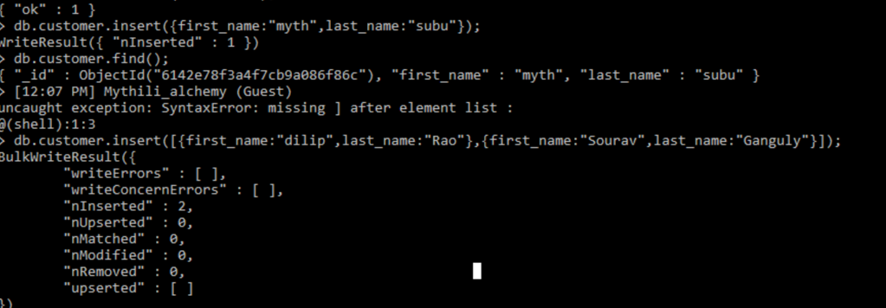
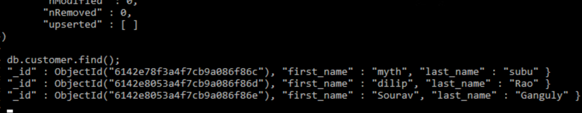

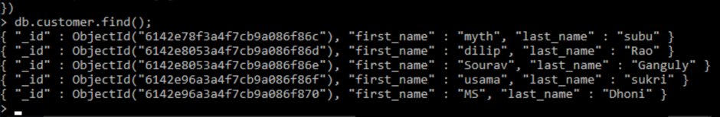

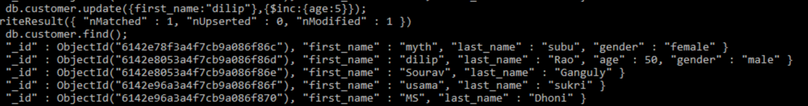

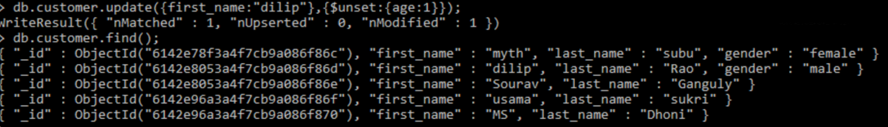
Numeric Functions are used to perform operations on numbers and return numbers.
Following are the numeric functions defined in SQL:

ABS(): It returns the absolute value of a number.
Syntax: SELECT ABS(-243.5);
Output: 243.5

SQL> SELECT ABS(-10);
+--------------------------------------+
| ABS(10)
+--------------------------------------+
| 10
+--------------------------------------+
ACOS(): It returns the cosine of a number.
Syntax: SELECT ACOS(0.25);
Output: 1.318116071652818

ASIN(): It returns the arc sine of a number.
Syntax: SELECT ASIN(0.25);
Output: 0.25268025514207865

ATAN(): It returns the arc tangent of a number.
Syntax: SELECT ATAN(2.5);
Output: 1.1902899496825317

CEIL(): It returns the smallest integer value that is greater than or equal to a number.
Syntax: SELECT CEIL(25.75);
Output: 26

CEILING(): It returns the smallest integer value that is greater than or equal to a number.
Syntax: SELECT CEILING(25.75);
Output: 26

COS(): It returns the cosine of a number.
Syntax: SELECT COS(30);
Output: 0.15425144988758405

COT(): It returns the cotangent of a number.
Syntax: SELECT COT(6);
Output: -3.436353004180128

DEGREES(): It converts a radian value into degrees.
Syntax: SELECT DEGREES(1.5);
Output: 85.94366926962348

SQL>SELECT DEGREES(PI());
+------------------------------------------+
| DEGREES(PI())
+------------------------------------------+
| 180.000000
+------------------------------------------+
DIV(): It is used for integer division.
Syntax: SELECT 10 DIV 5;
Output: 2

EXP(): It returns e raised to the power of number.
Syntax: SELECT EXP(1);
Output: 2.718281828459045

FLOOR(): It returns the largest integer value that is less than or equal to a number.
Syntax: SELECT FLOOR(25.75);
Output: 25

GREATEST(): It returns the greatest value in a list of expressions.
Syntax: SELECT GREATEST(30, 2, 36, 81, 125);
Output: 125

LEAST(): It returns the smallest value in a list of expressions.
Syntax: SELECT LEAST(30, 2, 36, 81, 125);
Output: 2

LN(): It returns the natural logarithm of a number.
Syntax: SELECT LN(2);
Output: 0.6931471805599453

LOG10(): It returns the base-10 logarithm of a number.
Syntax: SELECT LOG(2);
Output: 0.6931471805599453

LOG2(): It returns the base-2 logarithm of a number.
Syntax: SELECT LOG2(6);
Output: 2.584962500721156

MOD(): It returns the remainder of n divided by m.
Syntax: SELECT MOD(18, 4);
Output: 2

PI(): It returns the value of PI displayed with 6 decimal places.
Syntax: SELECT PI();
Output: 3.141593

POW(): It returns m raised to the nth power.
Syntax: SELECT POW(4, 2);
Output: 16

RADIANS(): It converts a value in degrees to radians.
Syntax: SELECT RADIANS(180);
Output: 3.141592653589793

RAND(): It returns a random number.
Syntax: SELECT RAND();
Output: 0.33623238684258644

ROUND(): It returns a number rounded to a certain number of decimal places.
Syntax: SELECT ROUND(5.553);
Output: 6

SIGN(): It returns a value indicating the sign of a number.
Syntax: SELECT SIGN(255.5);
Output: 1

SIN(): It returns the sine of a number.
Syntax: SELECT SIN(2);
Output: 0.9092974268256817

SQRT(): It returns the square root of a number.
Syntax: SELECT SQRT(25);
Output: 5

TAN(): It returns the tangent of a number.
Syntax: SELECT TAN(1.75);
Output: -5.52037992250933

ATAN2(): It returns the arctangent of the x and y coordinates, as an angle and expressed in radians.
Syntax: SELECT ATAN2(7);
Output: 1.42889927219073

TRUNCATE(): This doesn’t work for SQL Server. It returns 7.53635 truncated to 2 places right of the decimal point.
Syntax: SELECT TRUNCATE(7.53635, 2);
Output: 7.53

=========================================================================
