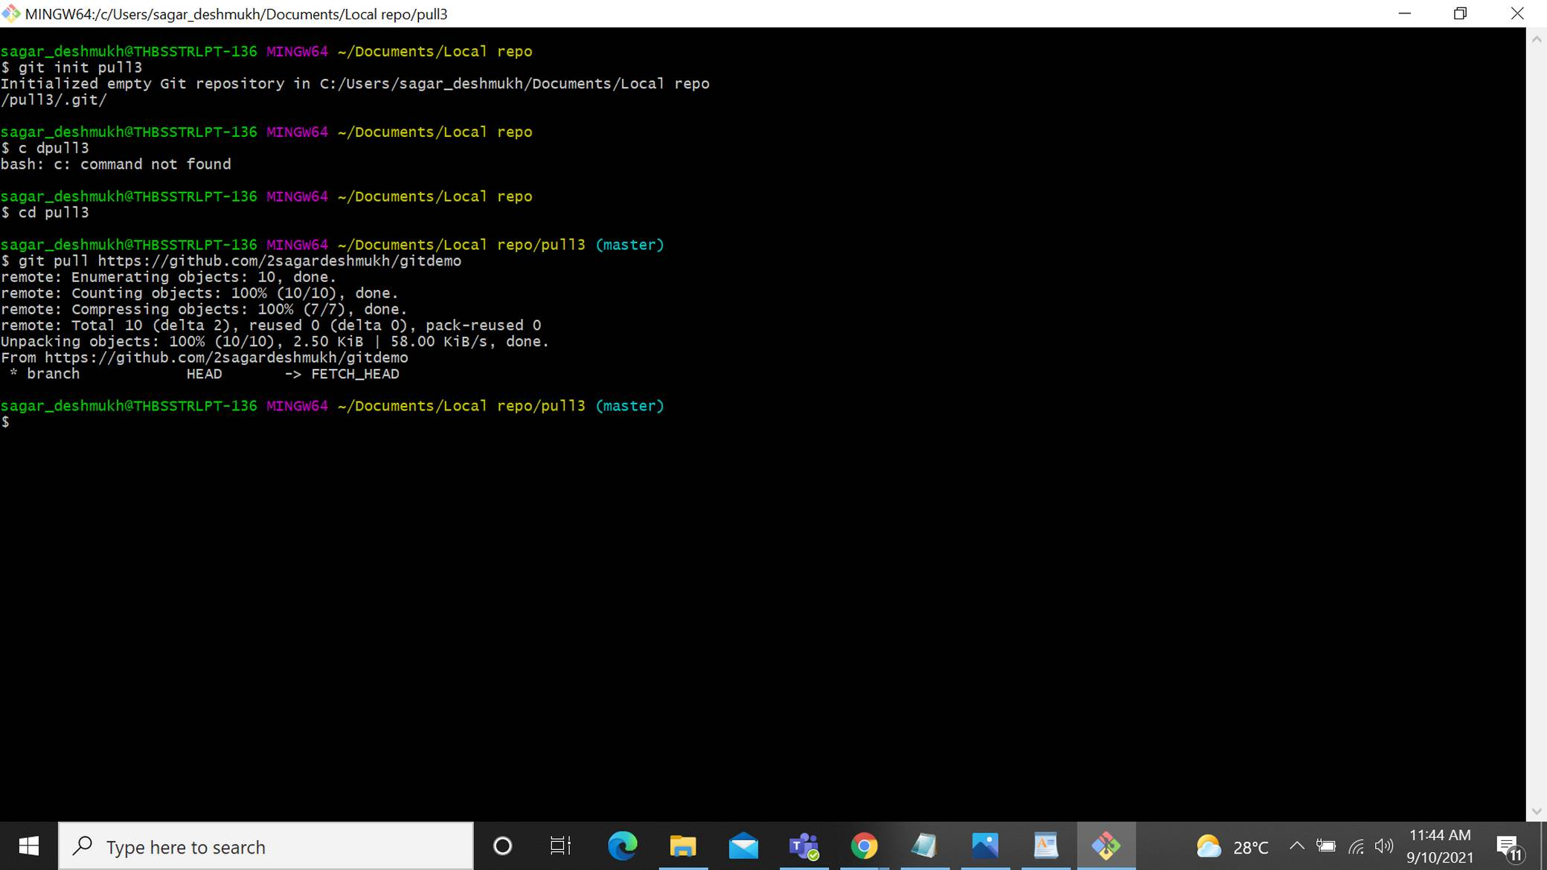
Git pull:

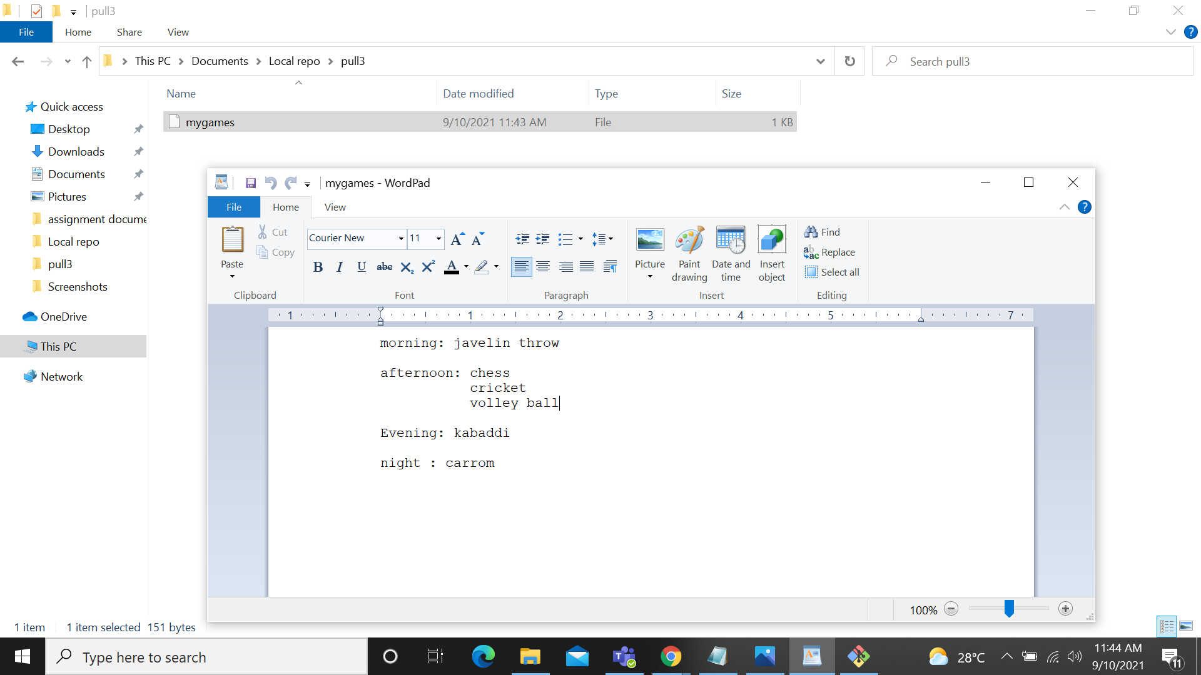

git push:
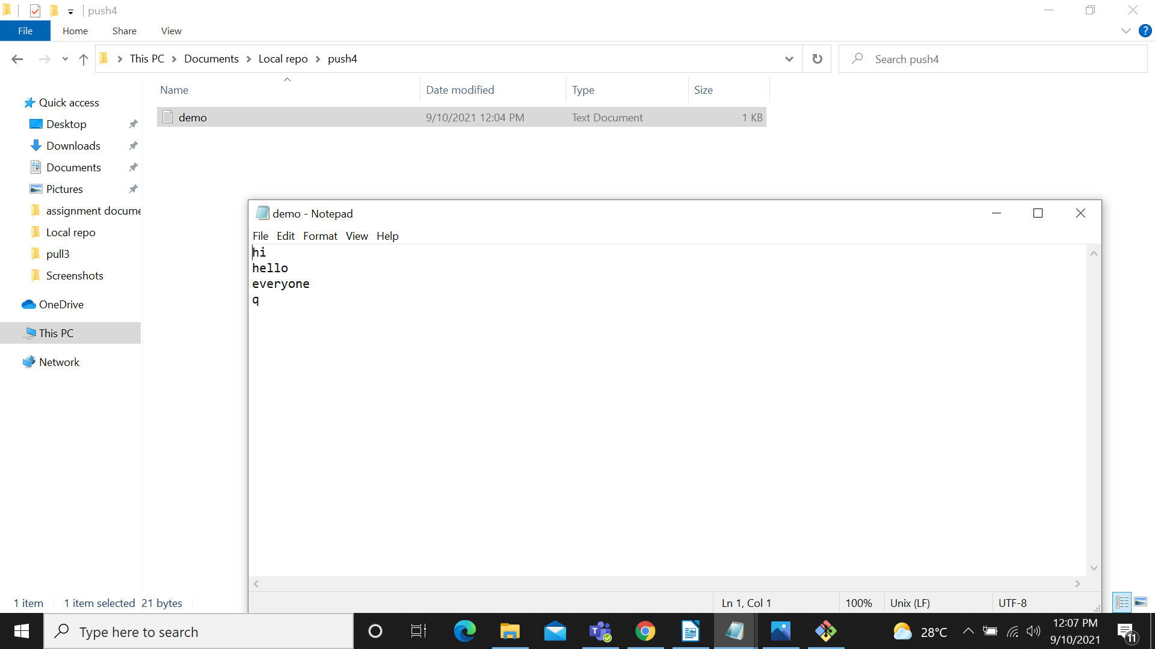
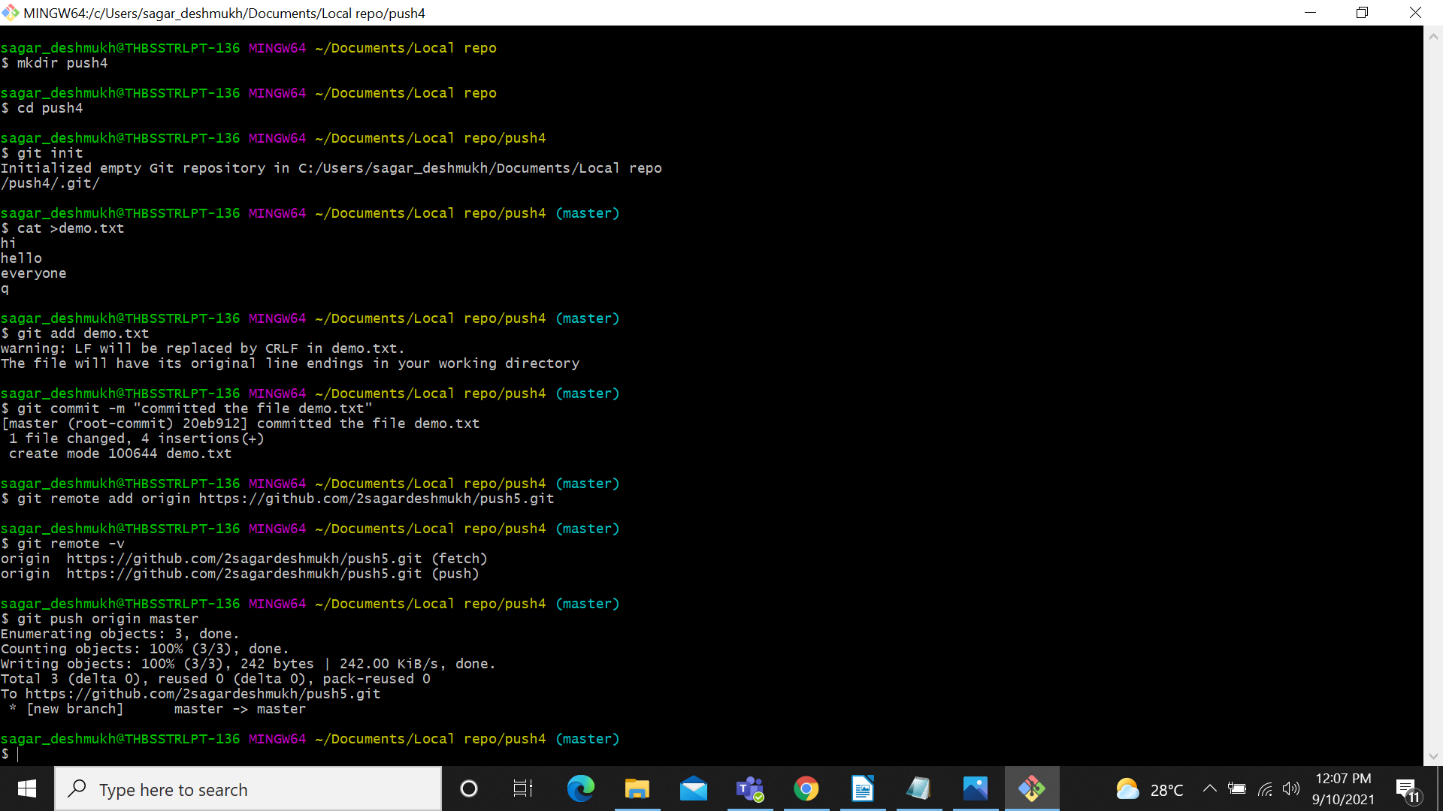
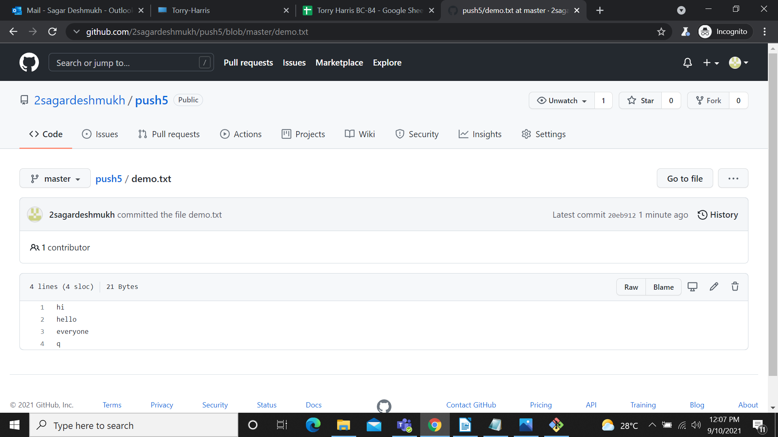

Linux Commands:

1)grep: The grep command will search for line that matches the specified pattern.
grep [0-9] file1.txt //selects the digits.
grep “[^0-9]” file1.txt //does not selects the digits.

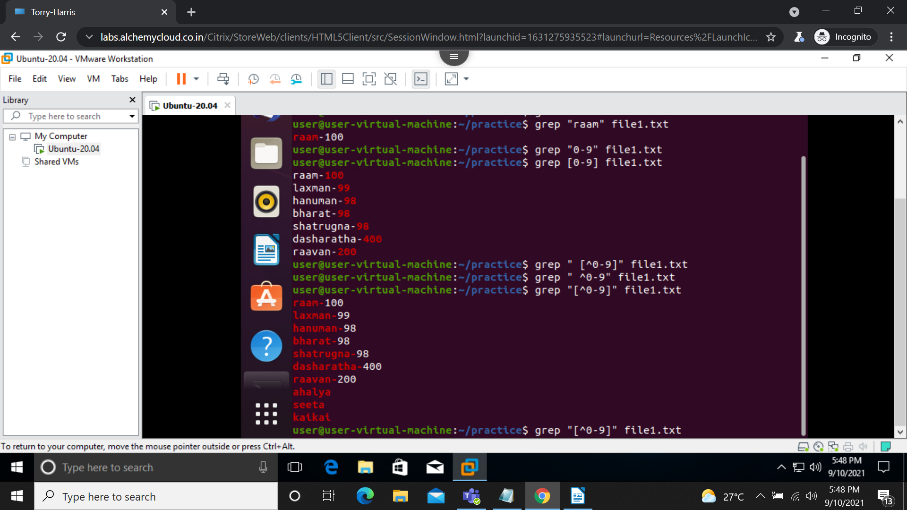

2) tr: The tr command in UNIX is a command line utility for translating or deleting characters.
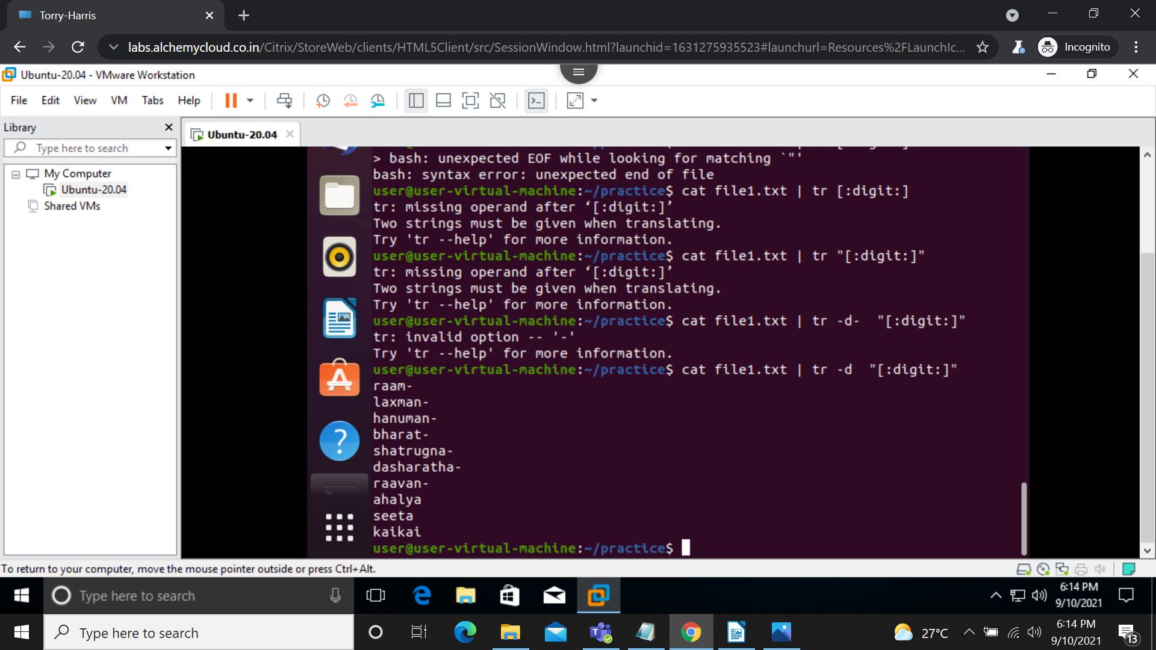
tr -d “[:digits:]” //it deletes the digits from the lines.
head : By default it will select top 10 lines.
head -n 12 places.txt //it will select the top 12 lines from the file places.txt
head -v -n 12 places.txt age.txt //it will select the top 12 lines from the file places.txt and age.txt along with file names
head -c -6 places.txt // it will start selecting from top after 6 charaters.

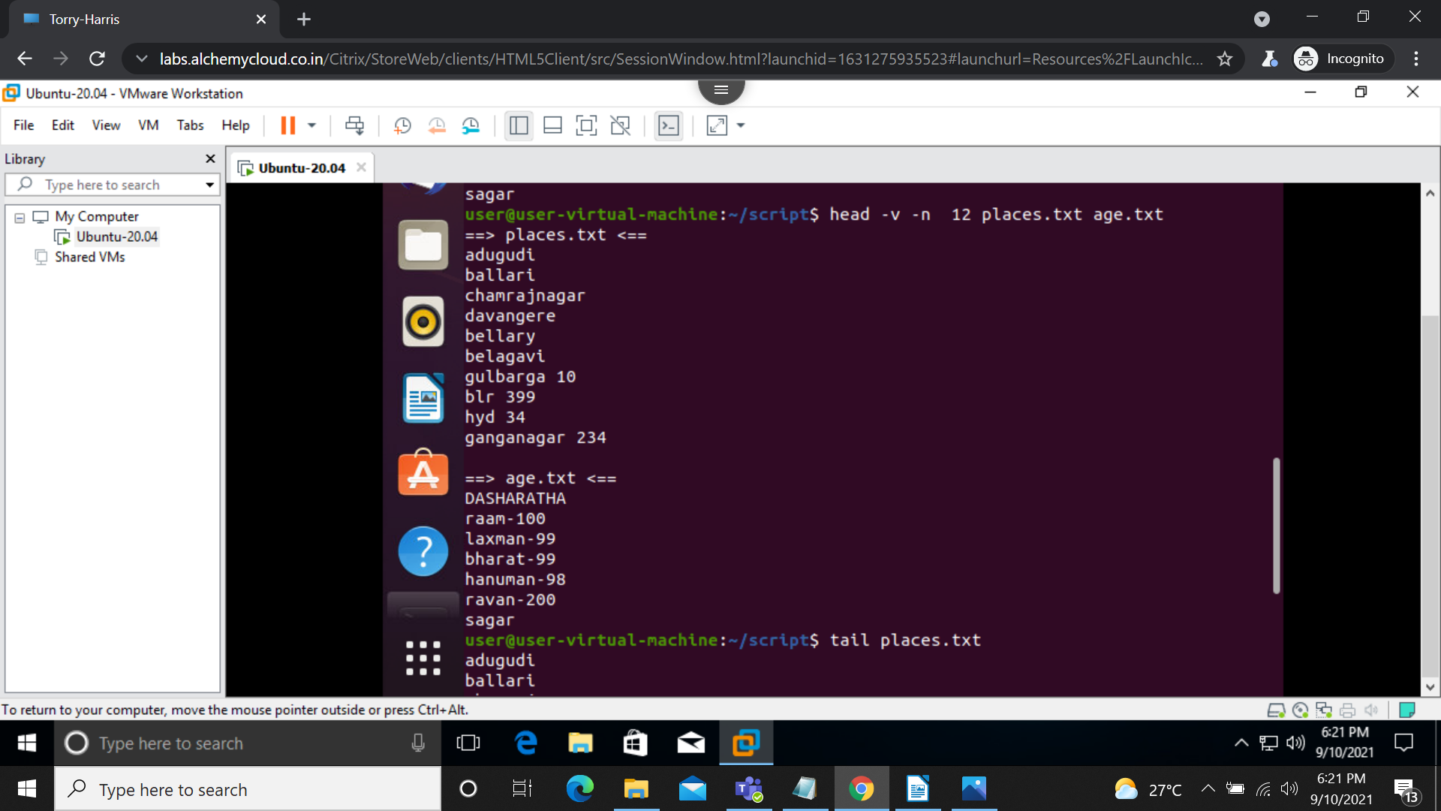

tail : it will selects last 10 lines by default. We can say that tail is a compliment of head command.
tail -n 12 places.txt //it will select the last 12 lines from the file places.txt
tail -v -n 12 places.txt age.txt //it will select the last 12 lines from the file places.txt and age.txt along with file names
head -c -6 places.txt // it will start selecting from after 6 charaters.

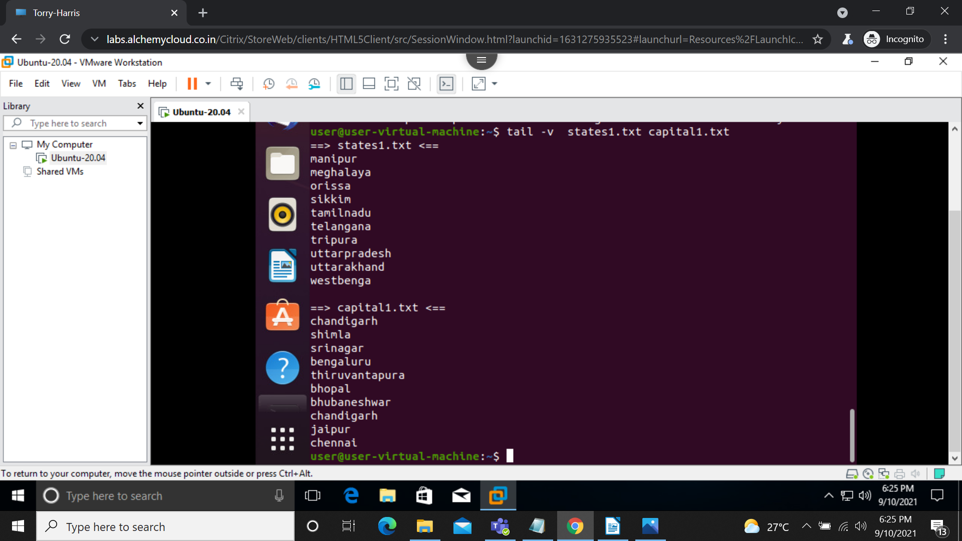

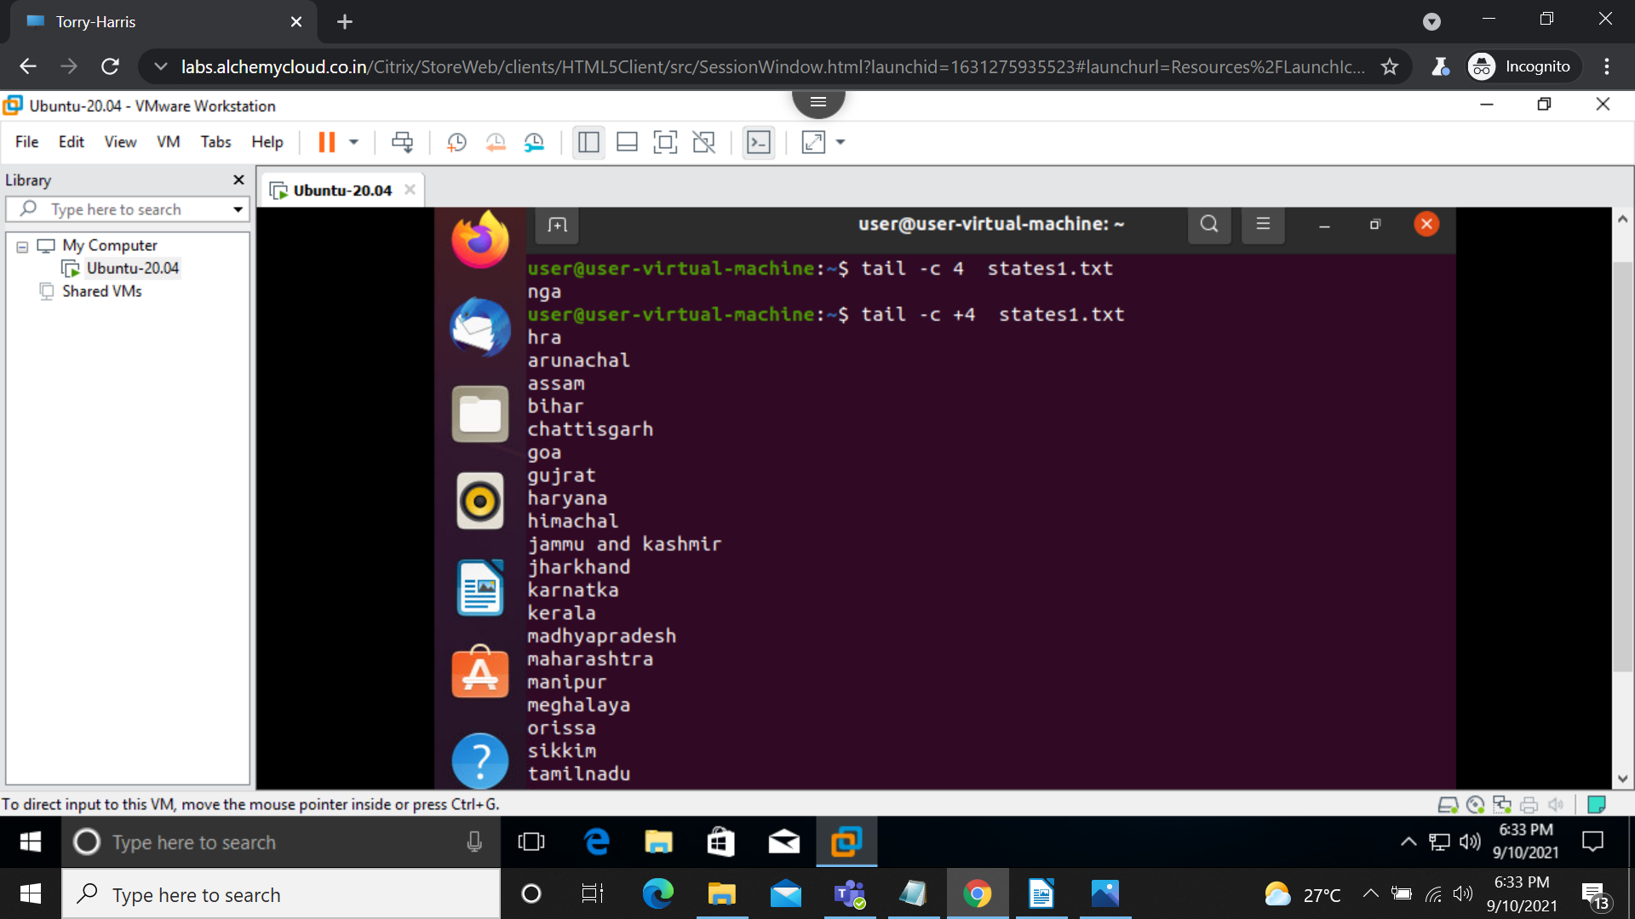

ls : list command
ls -l shows the permissions of the file.
ls -r reverses the files.
Ls -R gives the subdirectory
ls -i gives the index number
ls -Q double quotes the filename
ls -s arranges the file according to file size
ls -v arranges the file in natural sort according to numbers

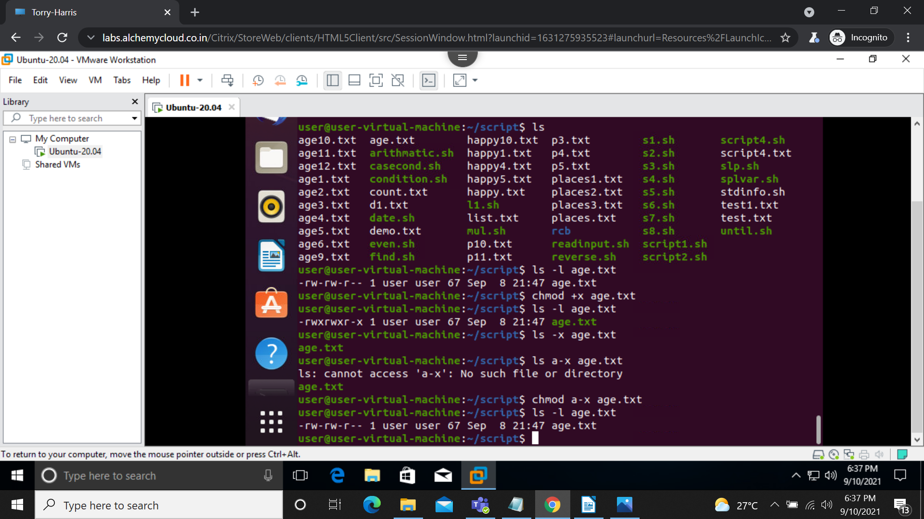
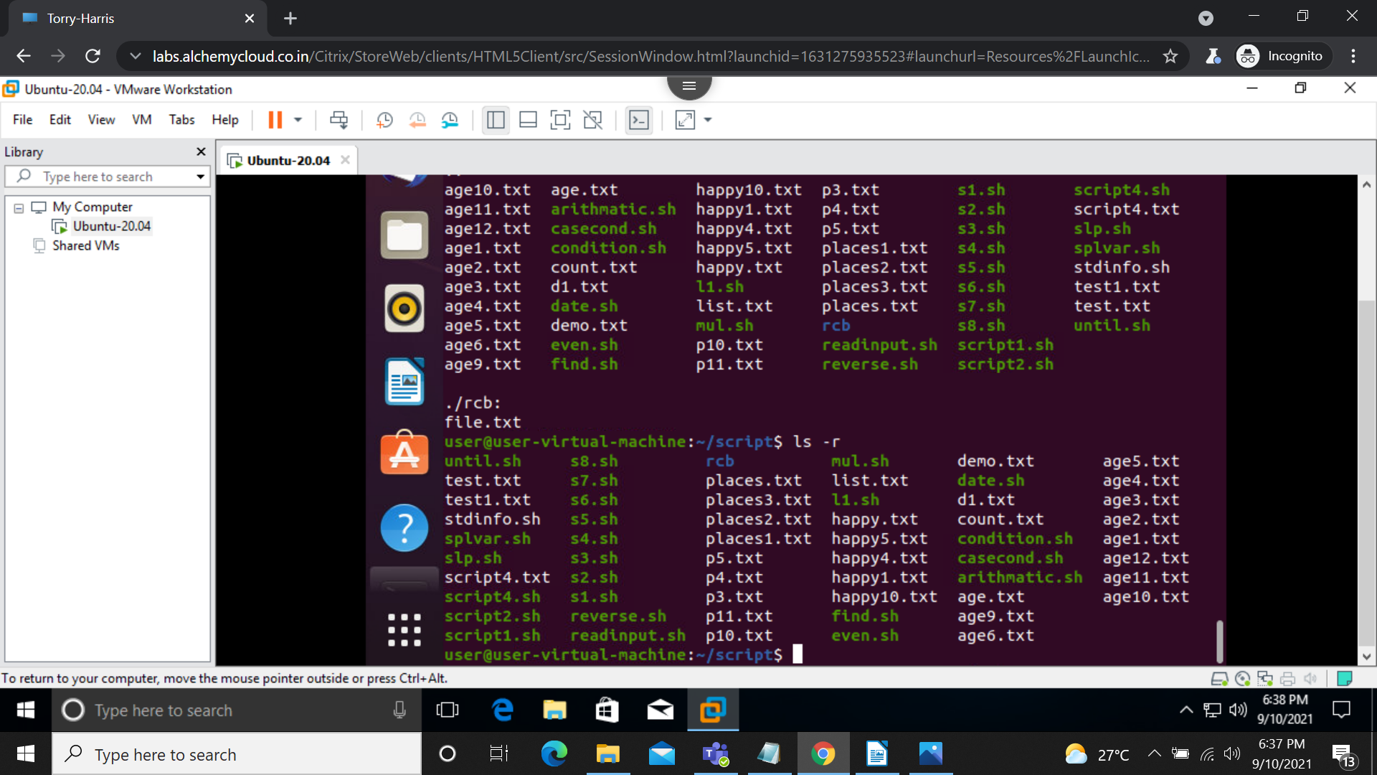

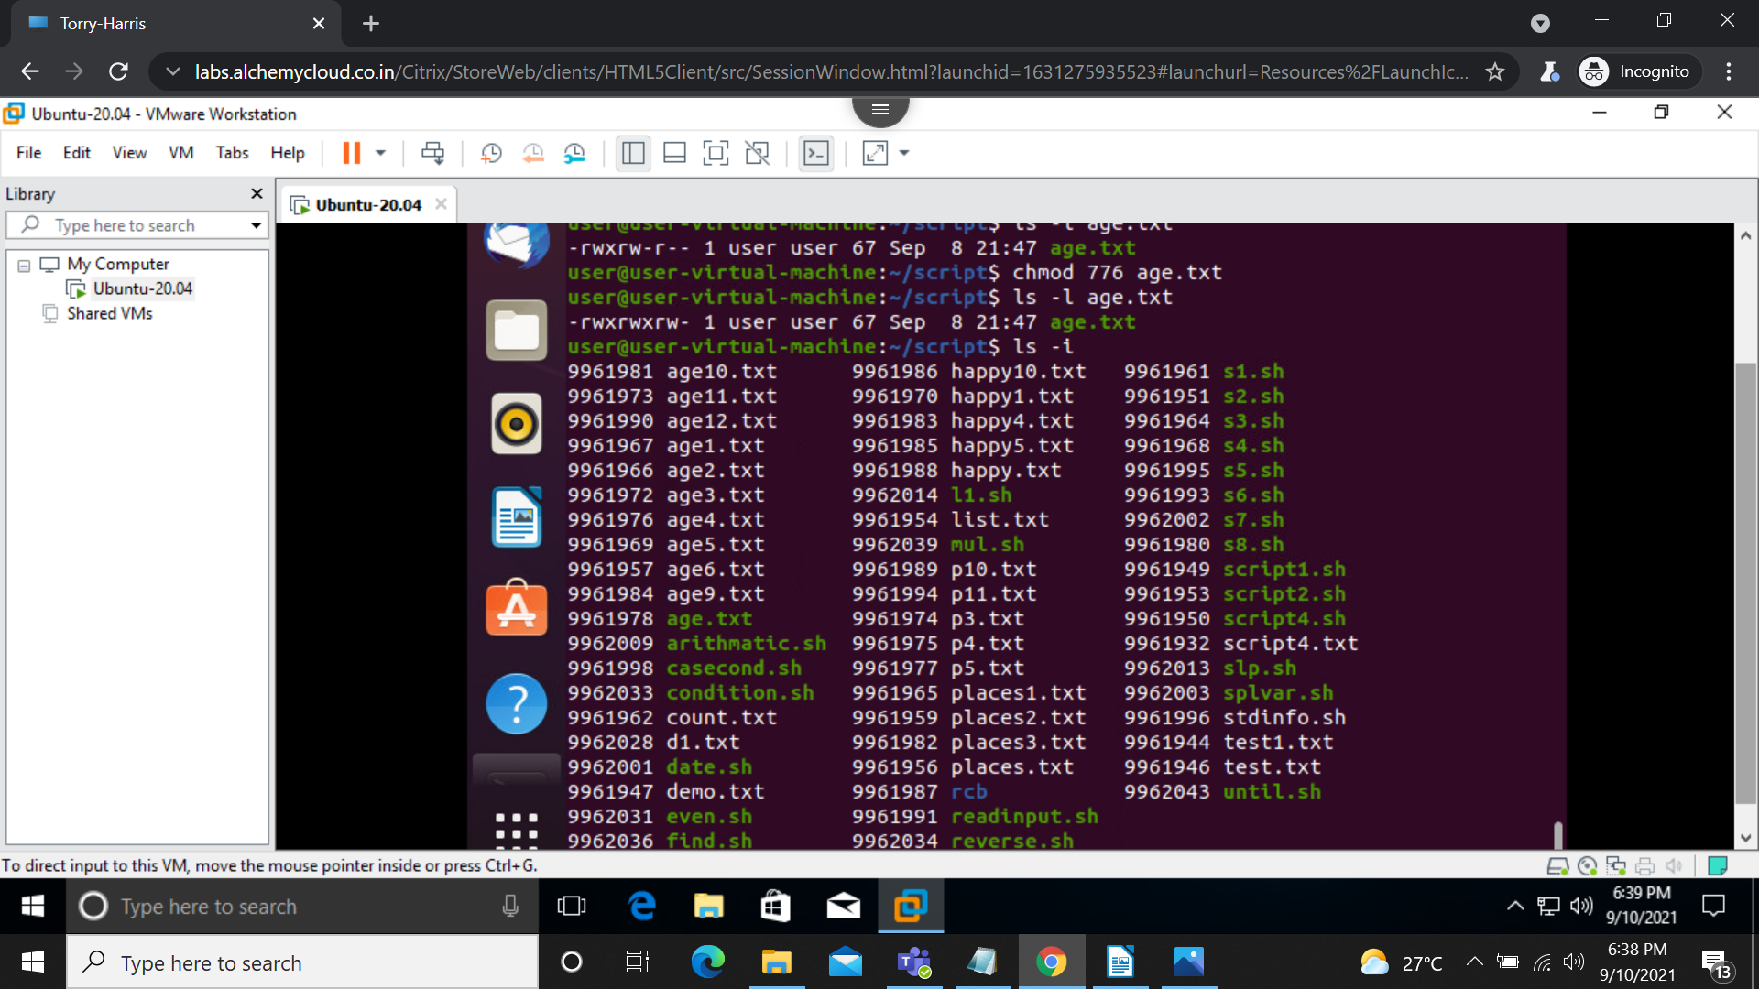

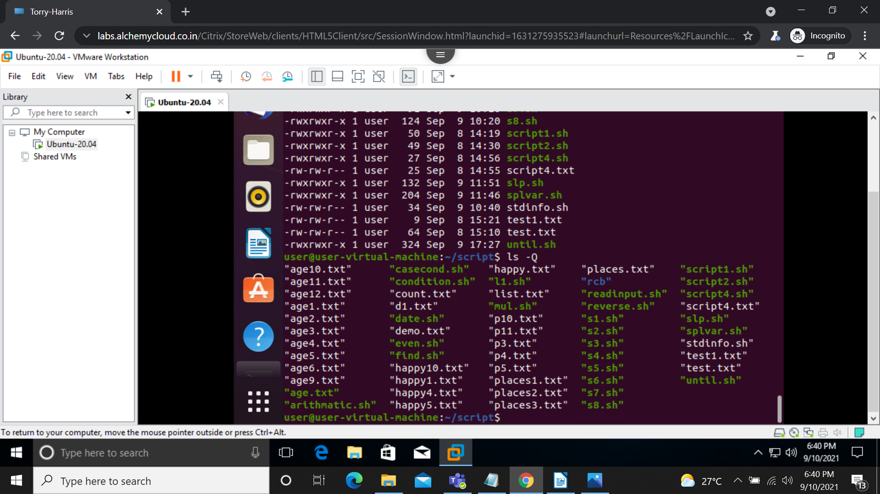
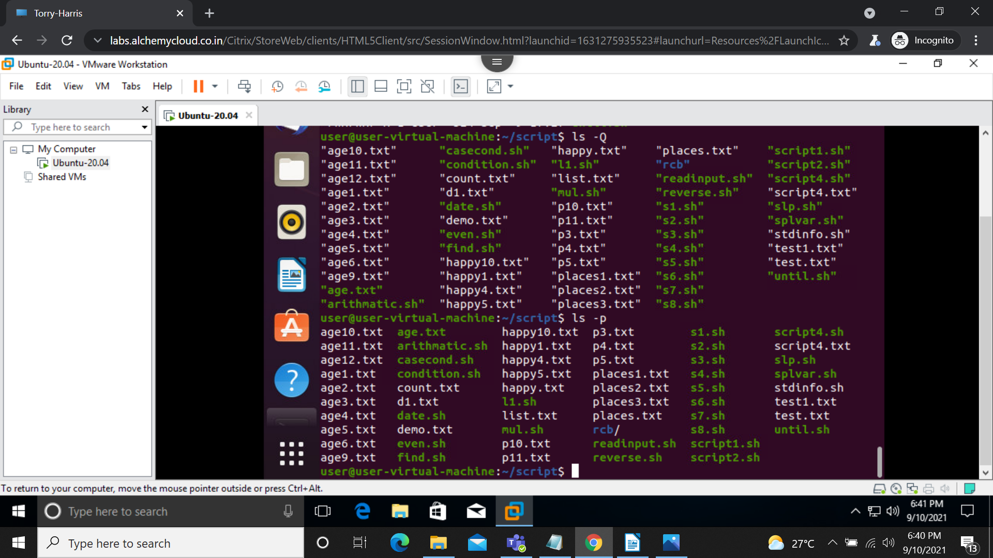

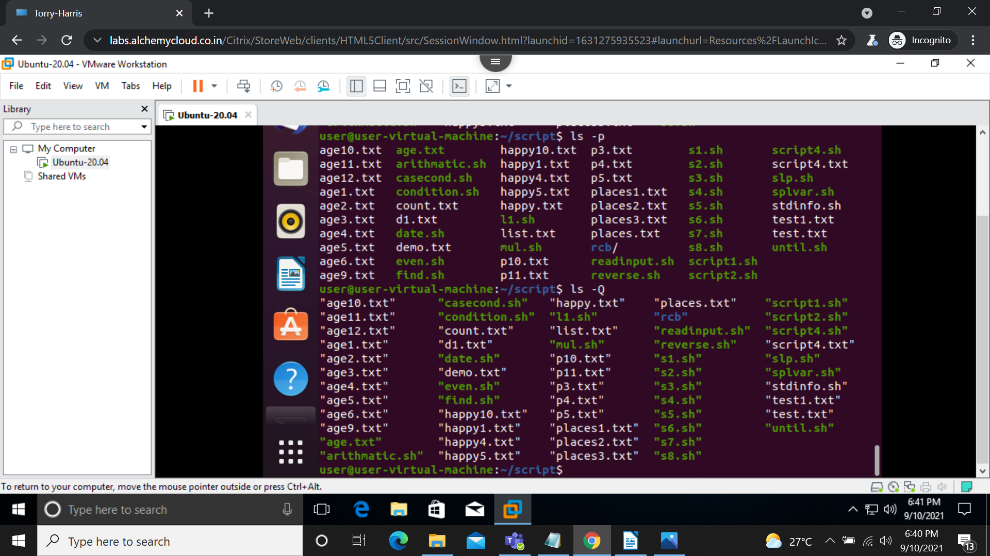
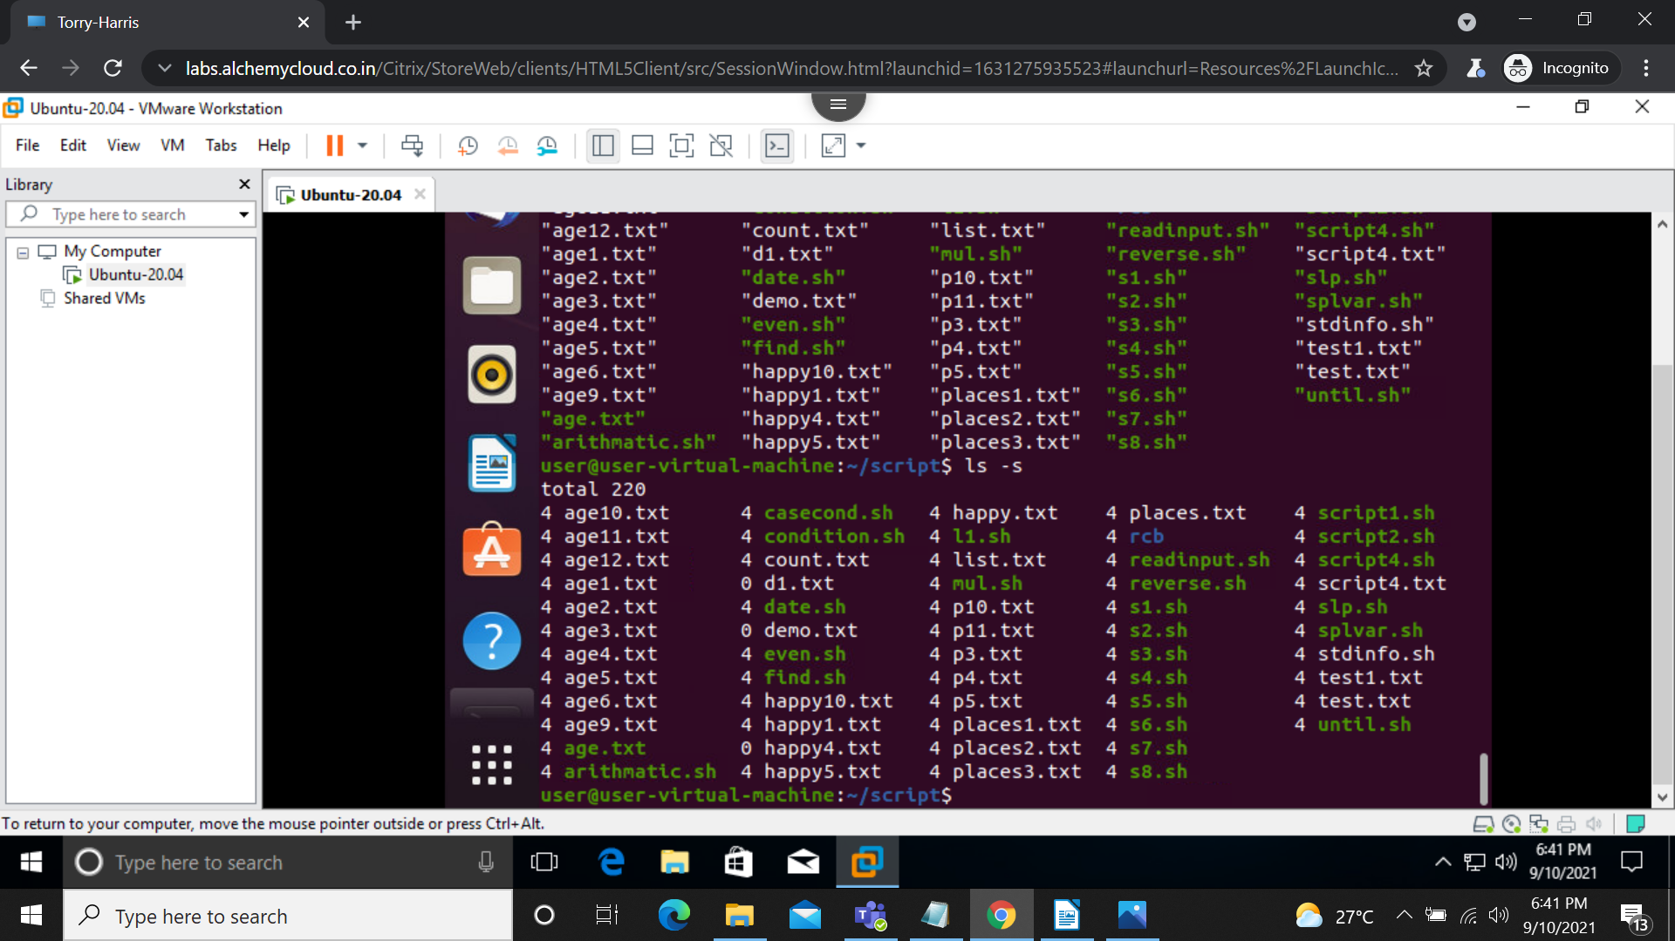

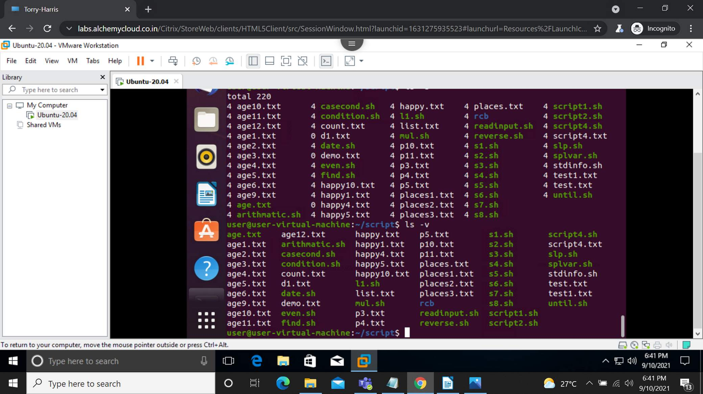
cut: The cut command in UNIX is a command for cutting out the sections from each line of files and writing the result to standard output. It can be used to cut parts of a line by byte position, character and field.
cut -b num //selects specific position in a line
cut -c -num // selects specific characters.
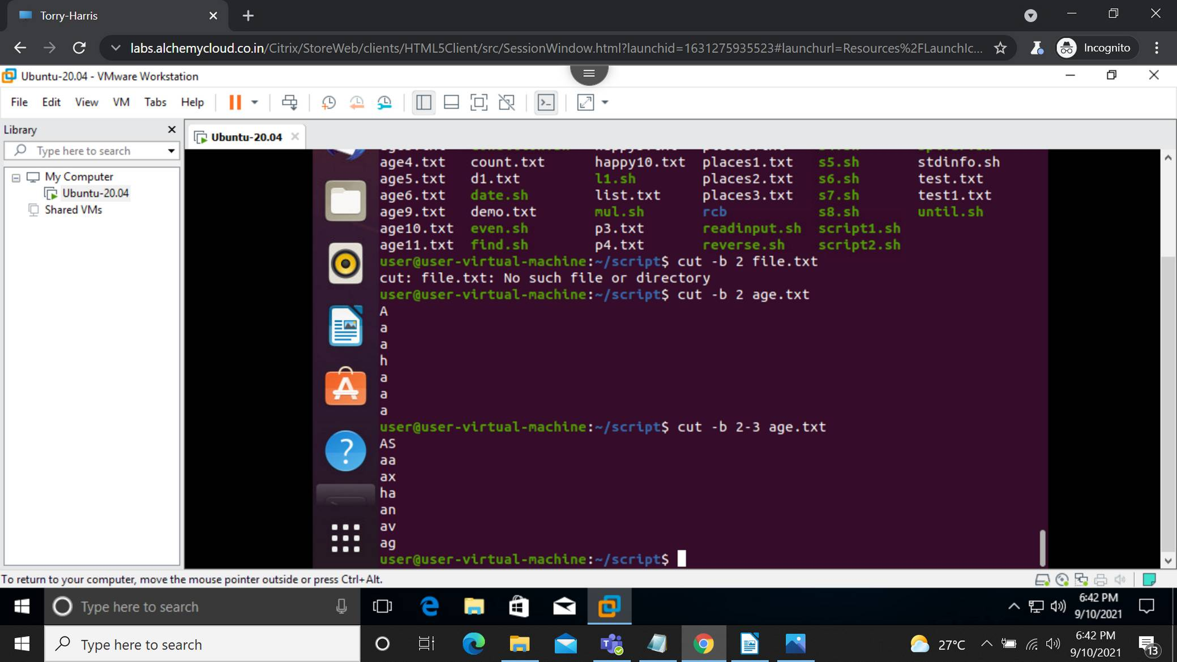

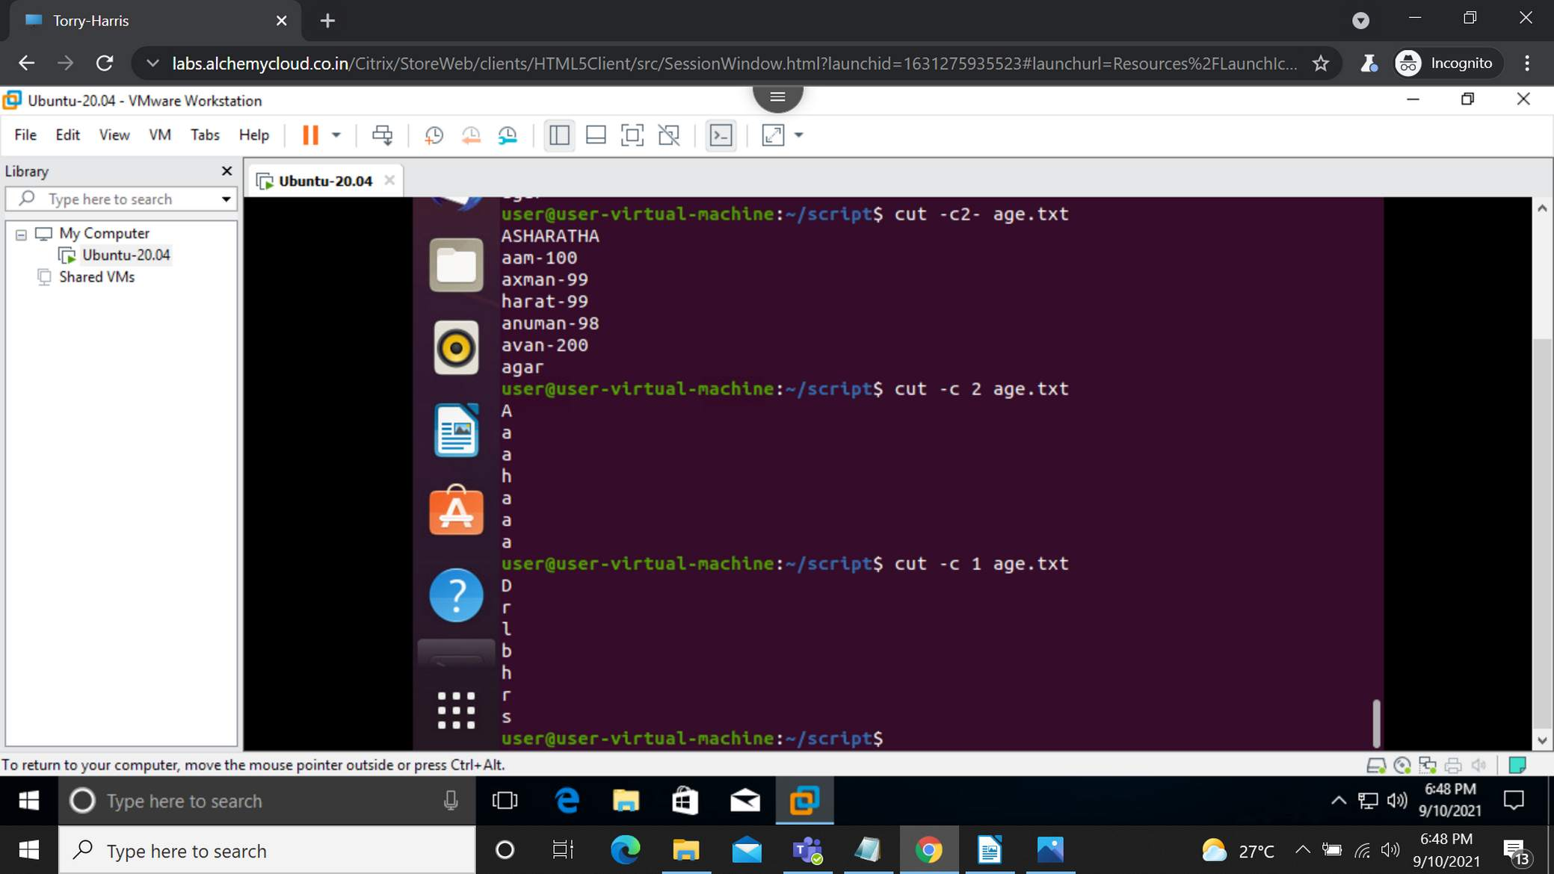

sort : SORT command is used to sort a file, arranging the records in a particular order
sort filename // natural sort
sort -r //sort in reverse order
sort -c // checks the file is sorted or not
sort -nu // sort in numeric order
sort -o // sorted ouput will be stored in destination file.
Sort -m // sort the months in natural order.

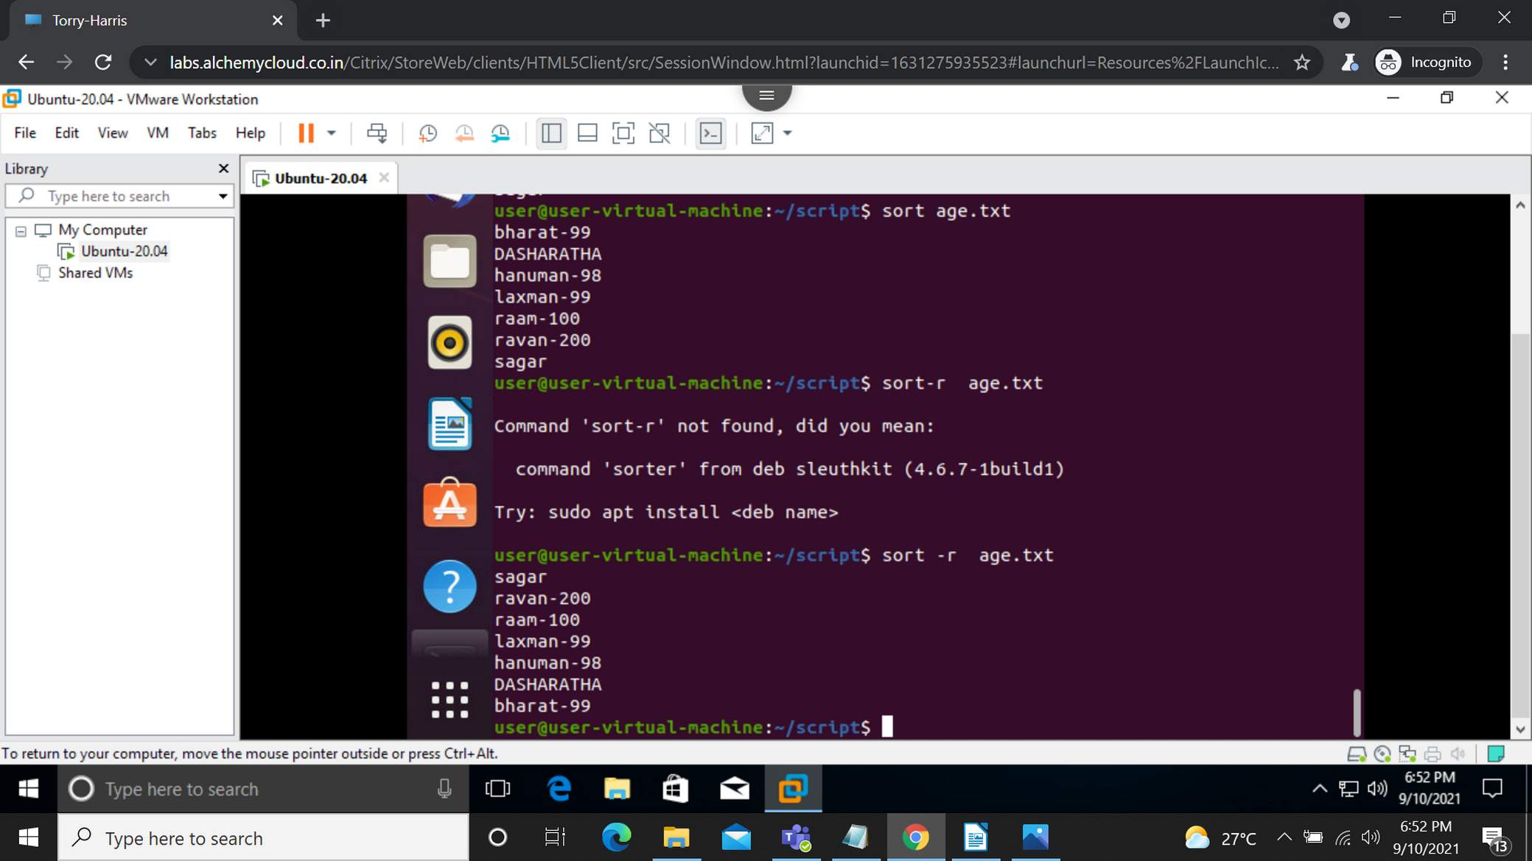

cp : copy command which copies the file.
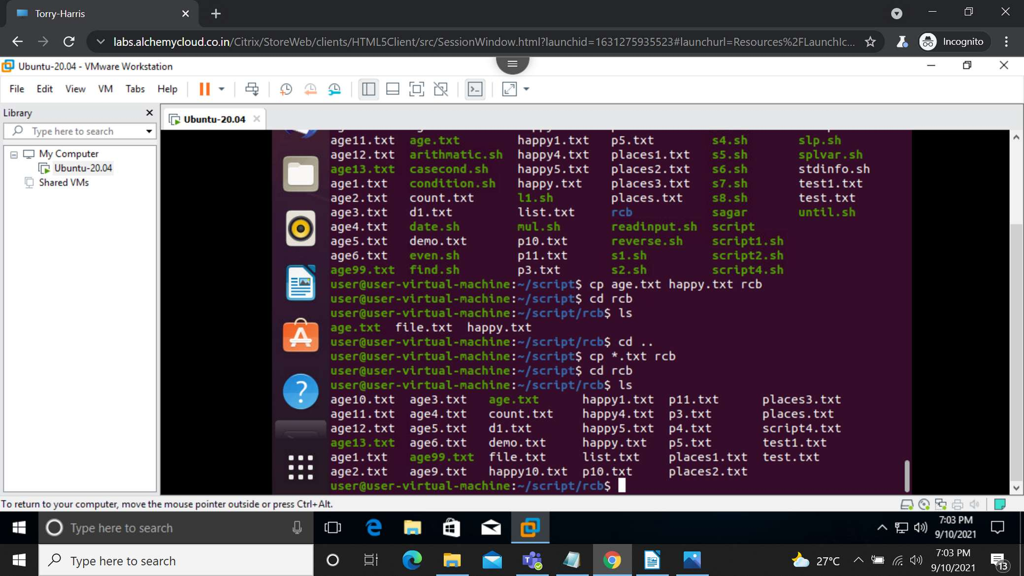
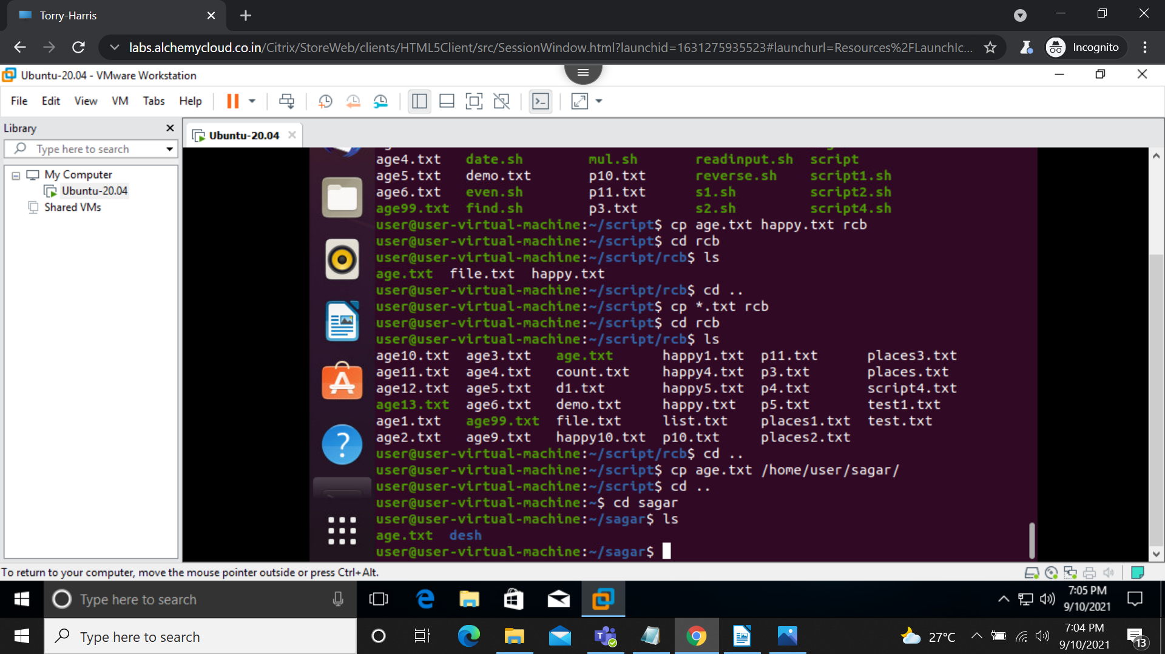

mv : move command.
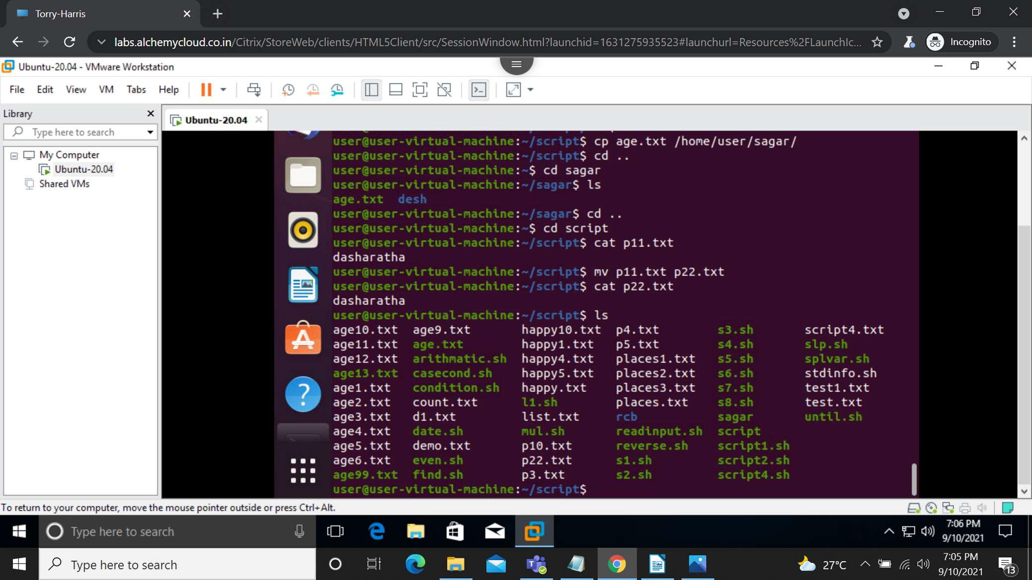
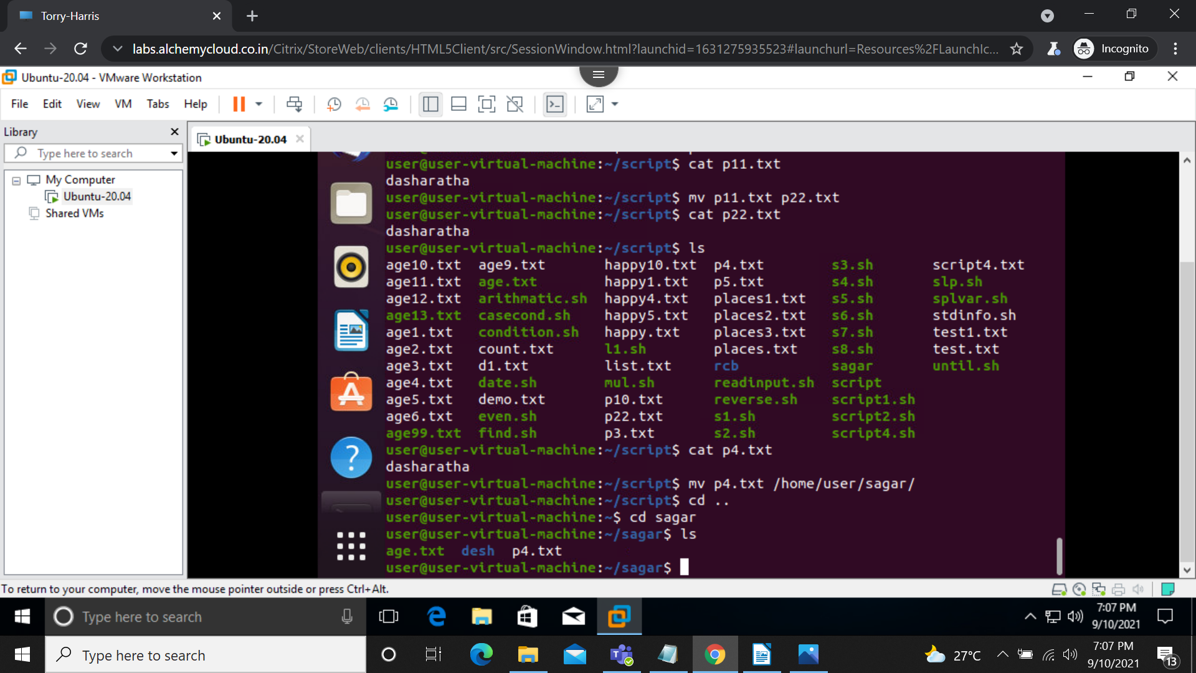

-s : squeeze command, which removes the repeated characters.
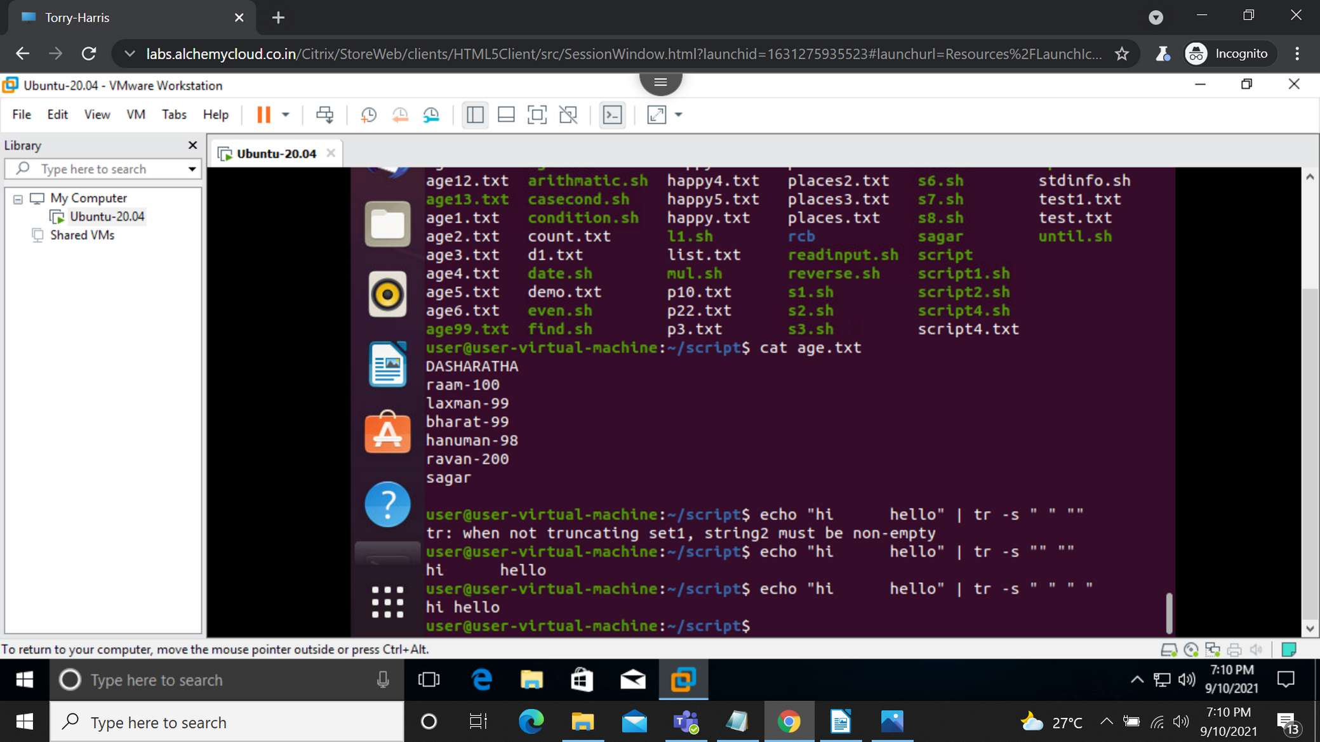

tree: this command will give subdirectories and file information in a directory.
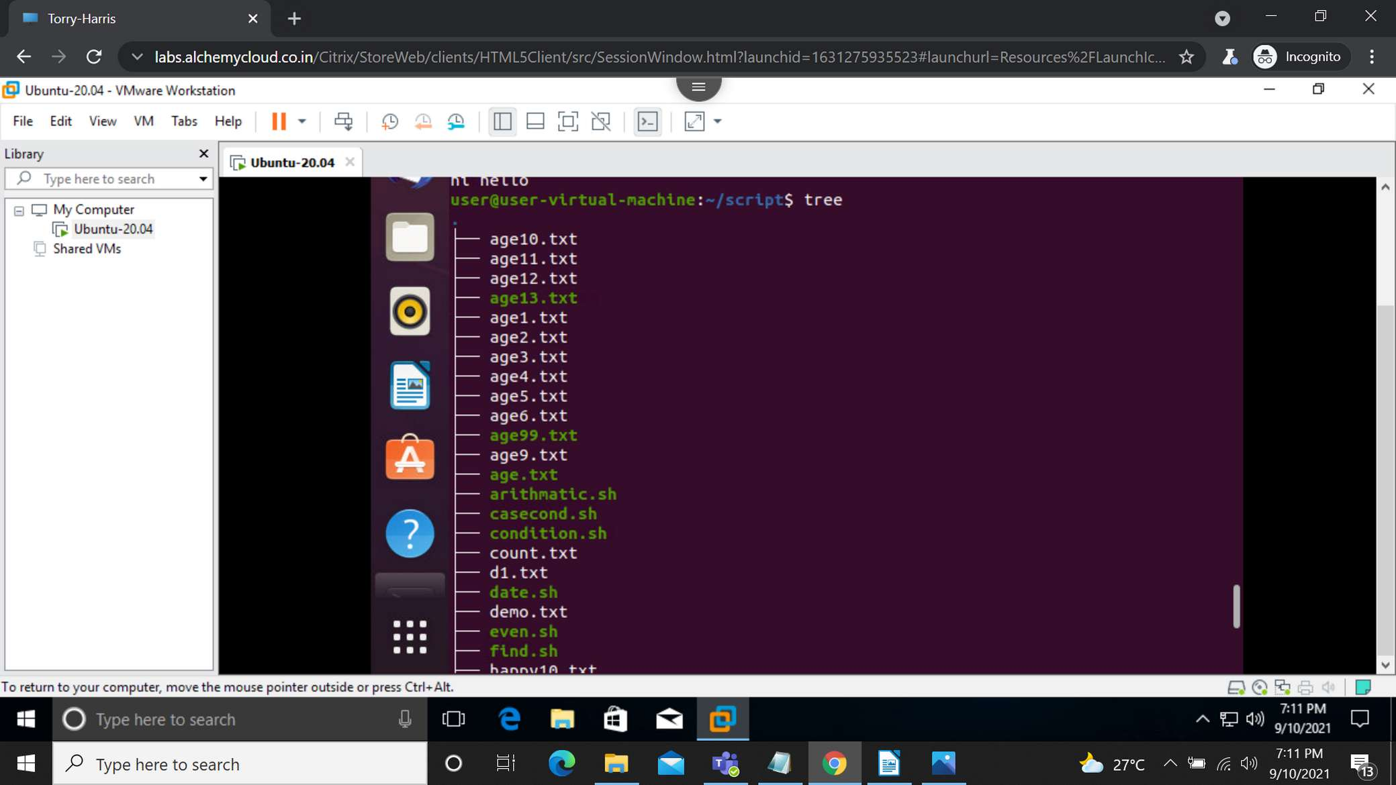
Continued….
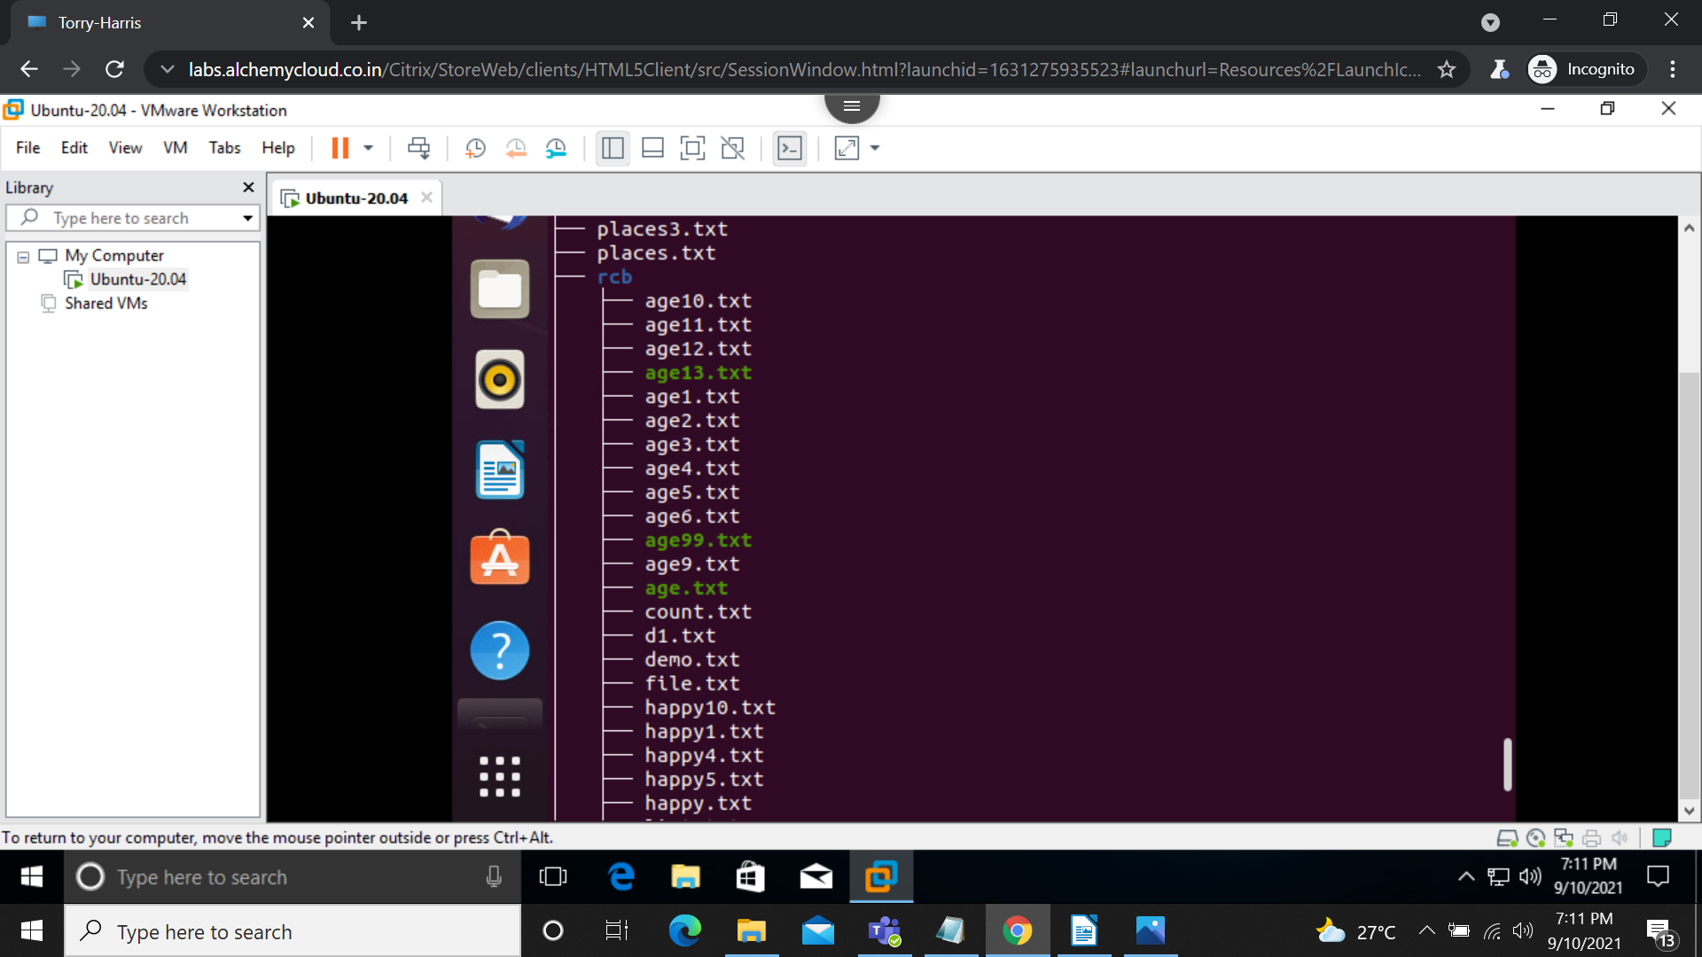

find : find the specified file from a directory.
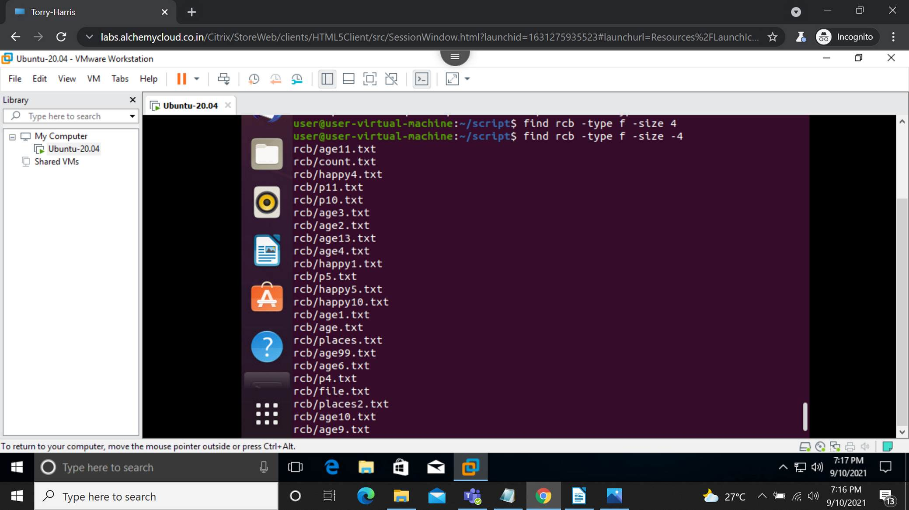
File permission: we can give or take permissions from users, groups and others. There are 3 types of permissions read(r), write(w) and execute(x). with the help of chmod command we can give permissions in characters, digits or in octal way.
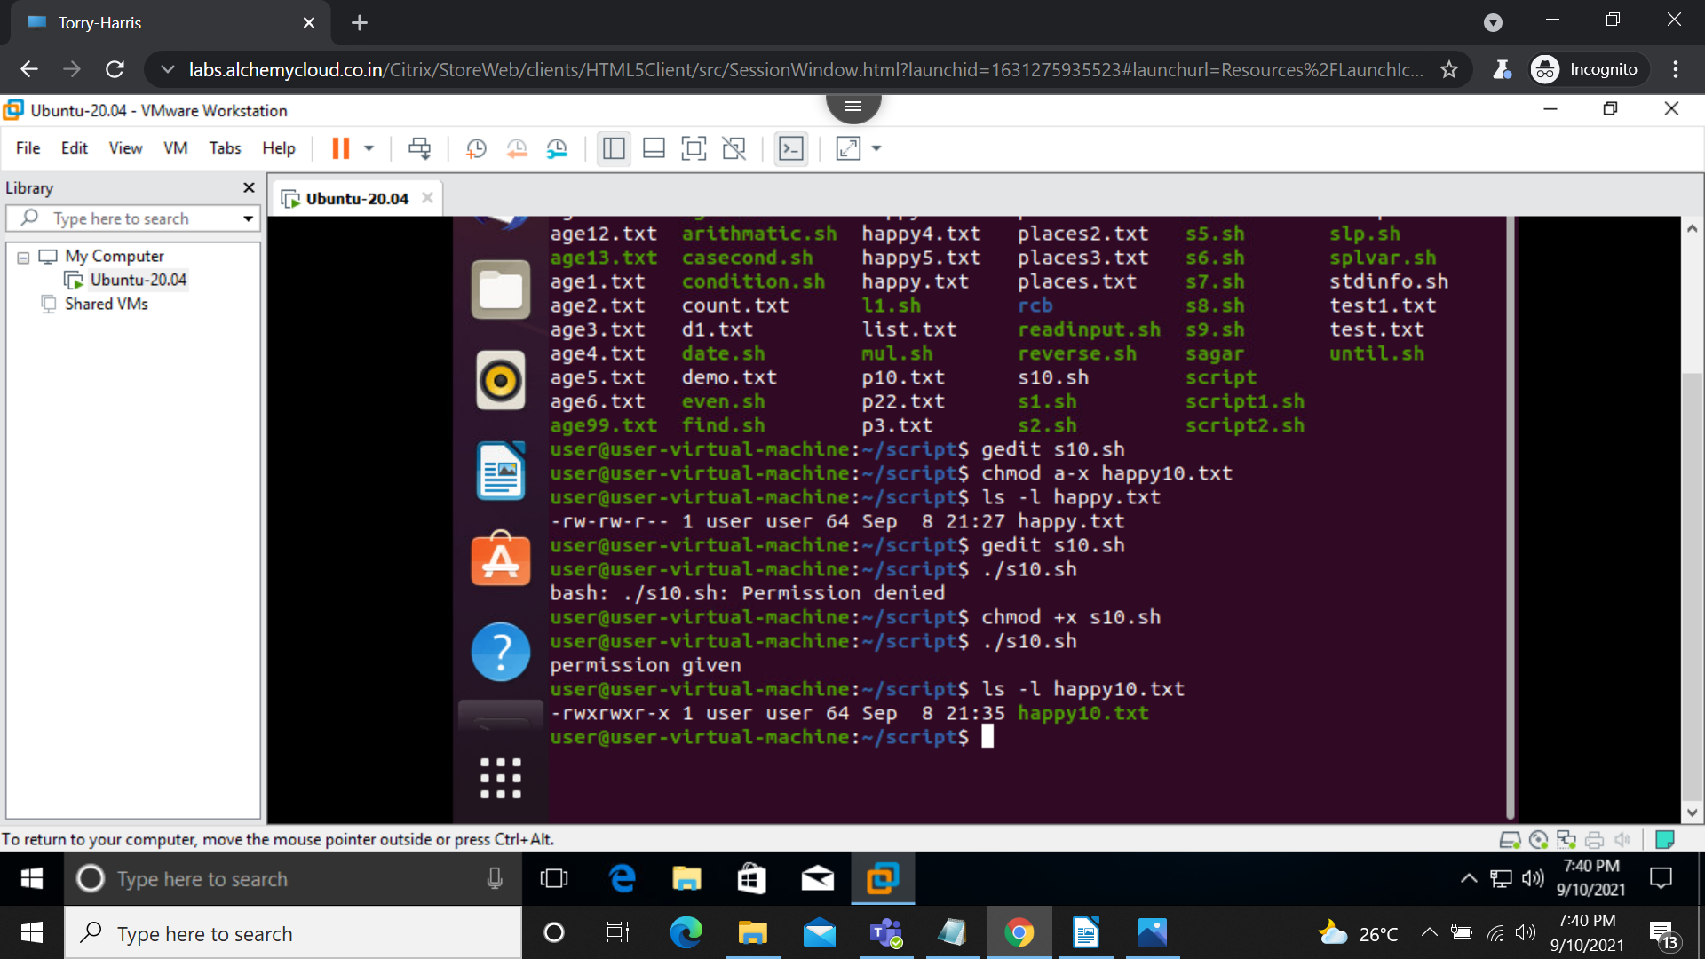

shell script:
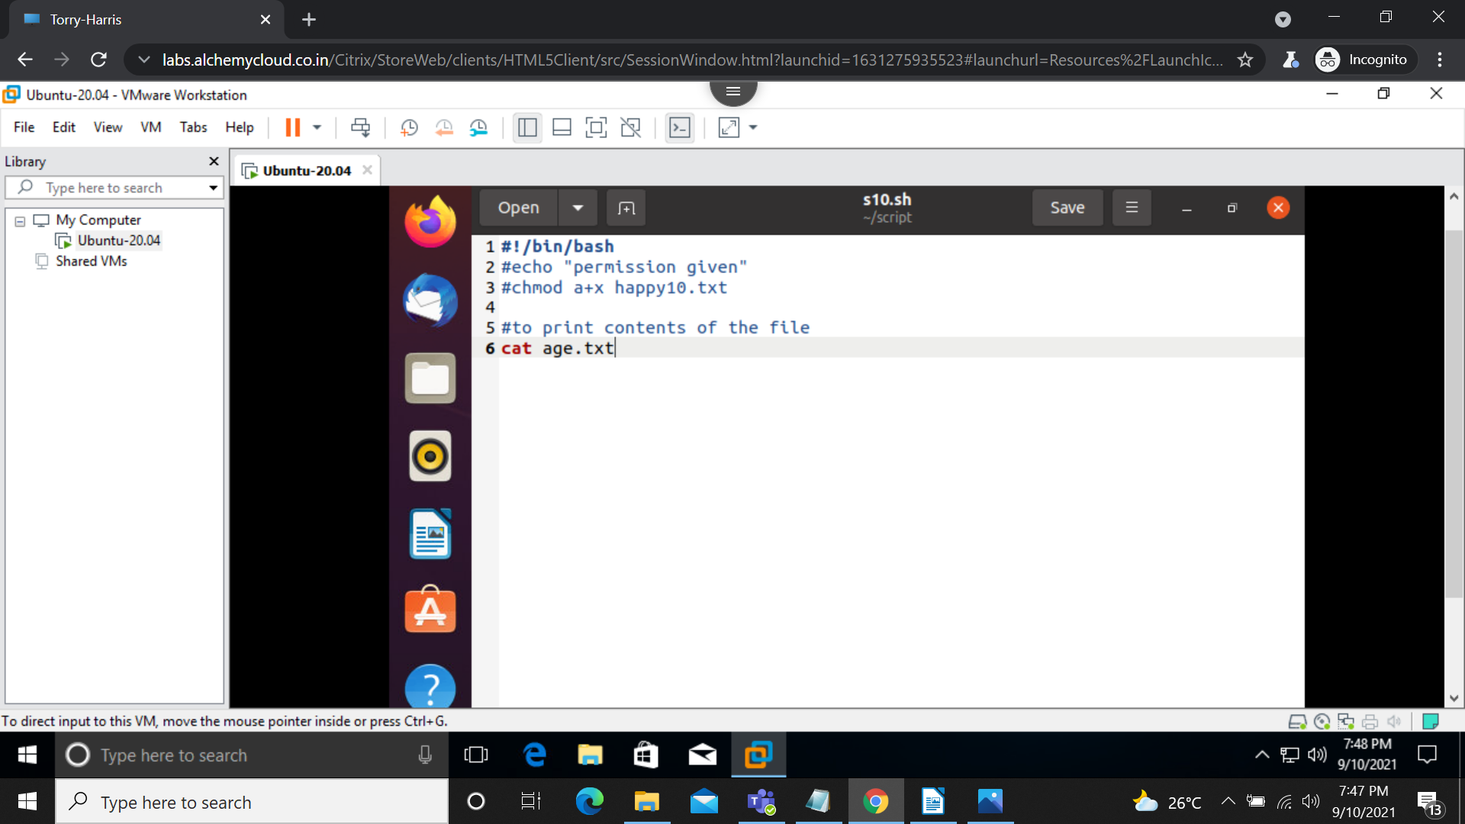
1) program to print contents of the given file.
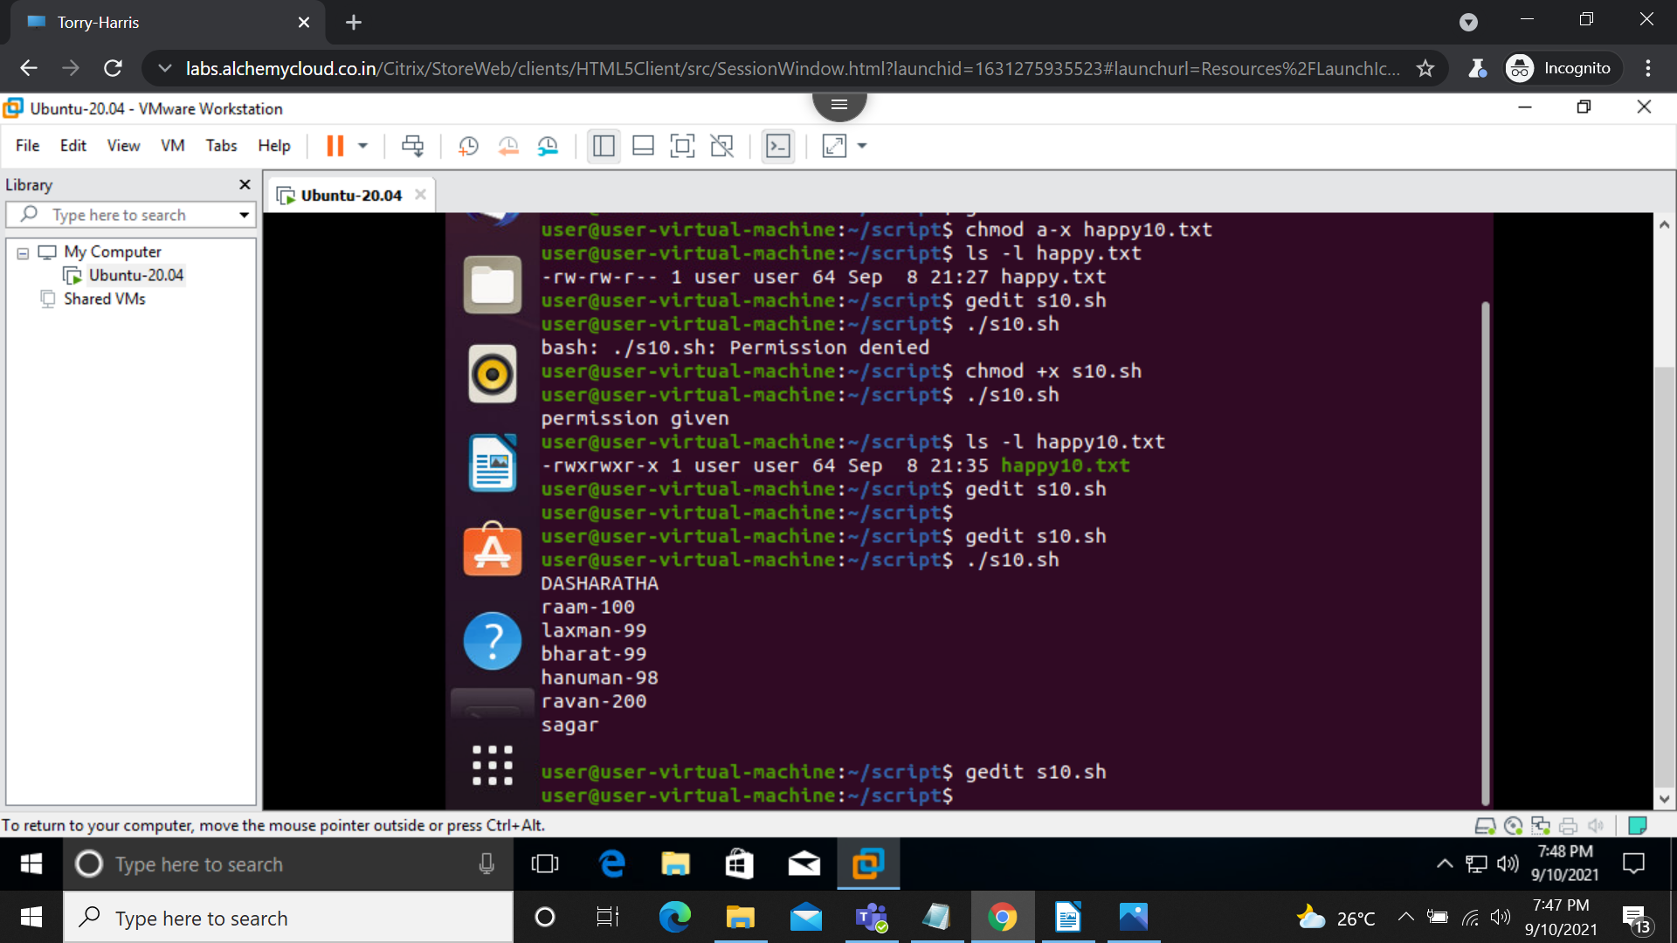
Output:

2)sort in natural order in shell script.
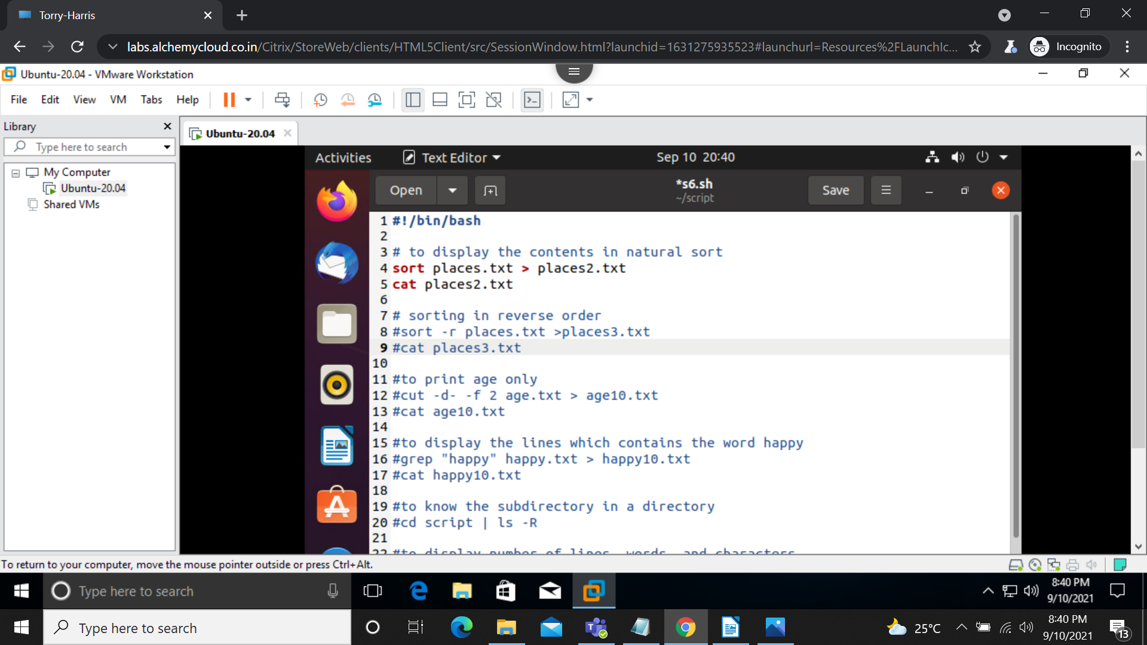
output:
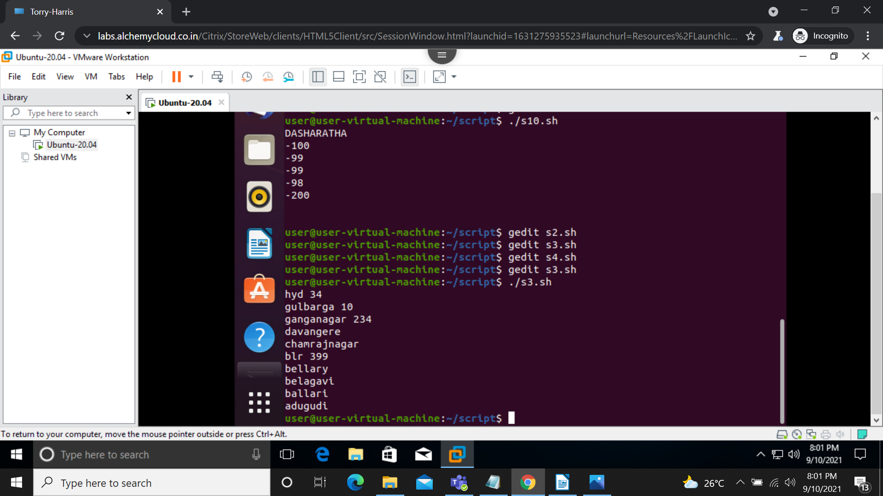

3) sort in reverse order in shell script.
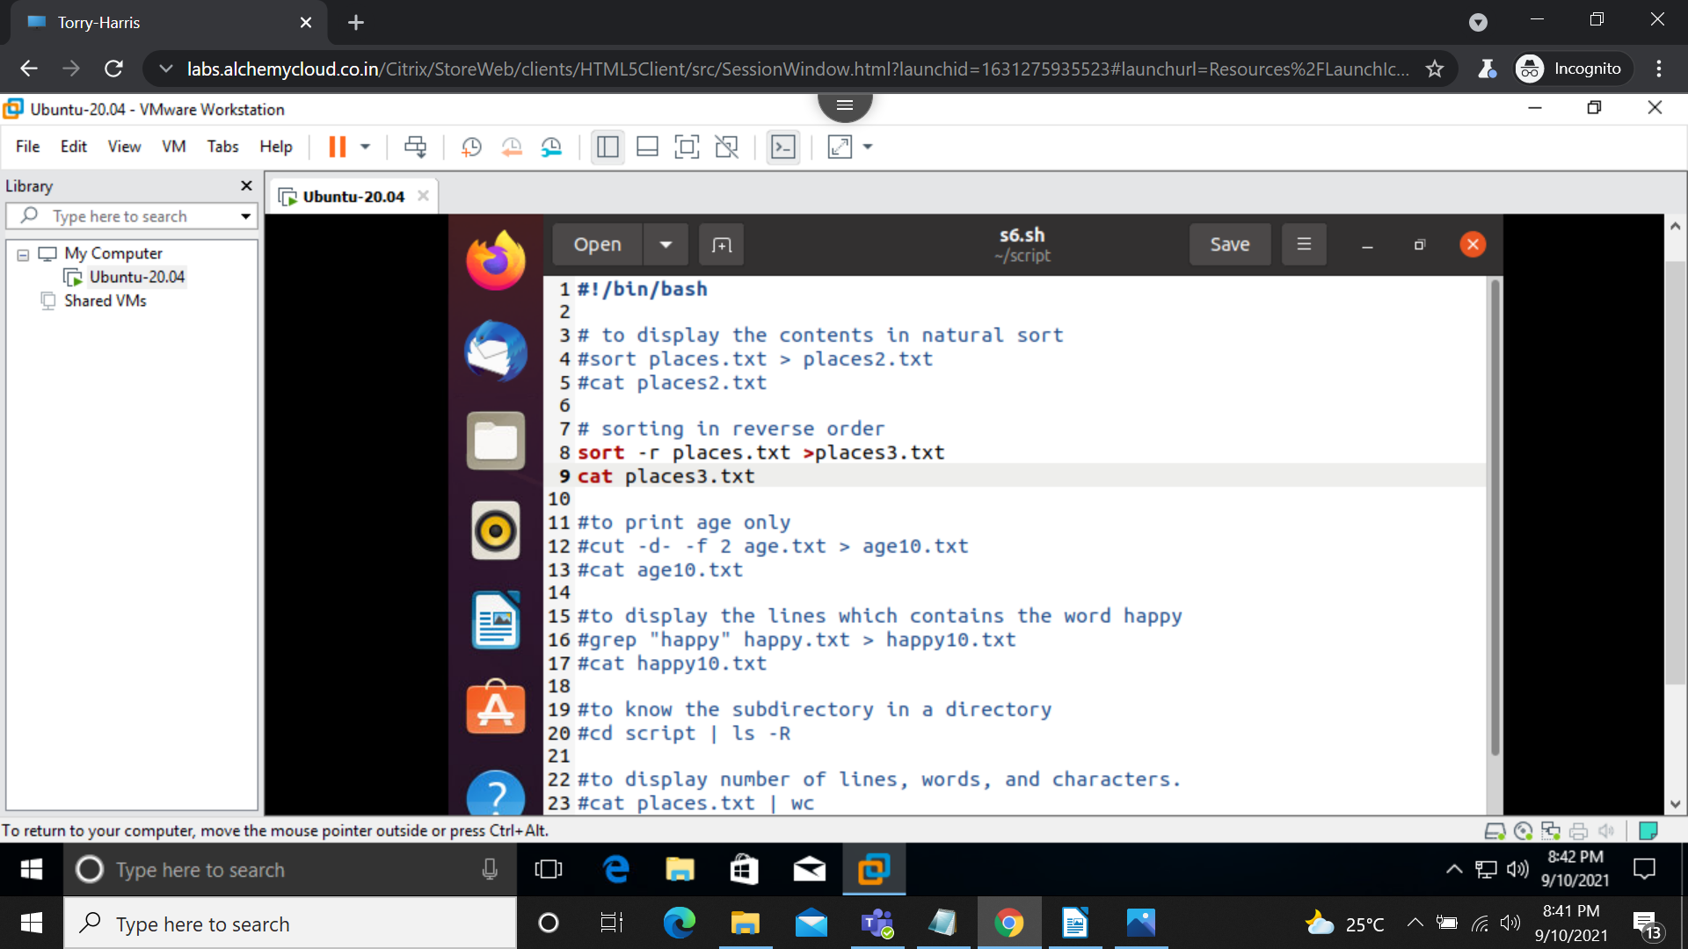
Output:
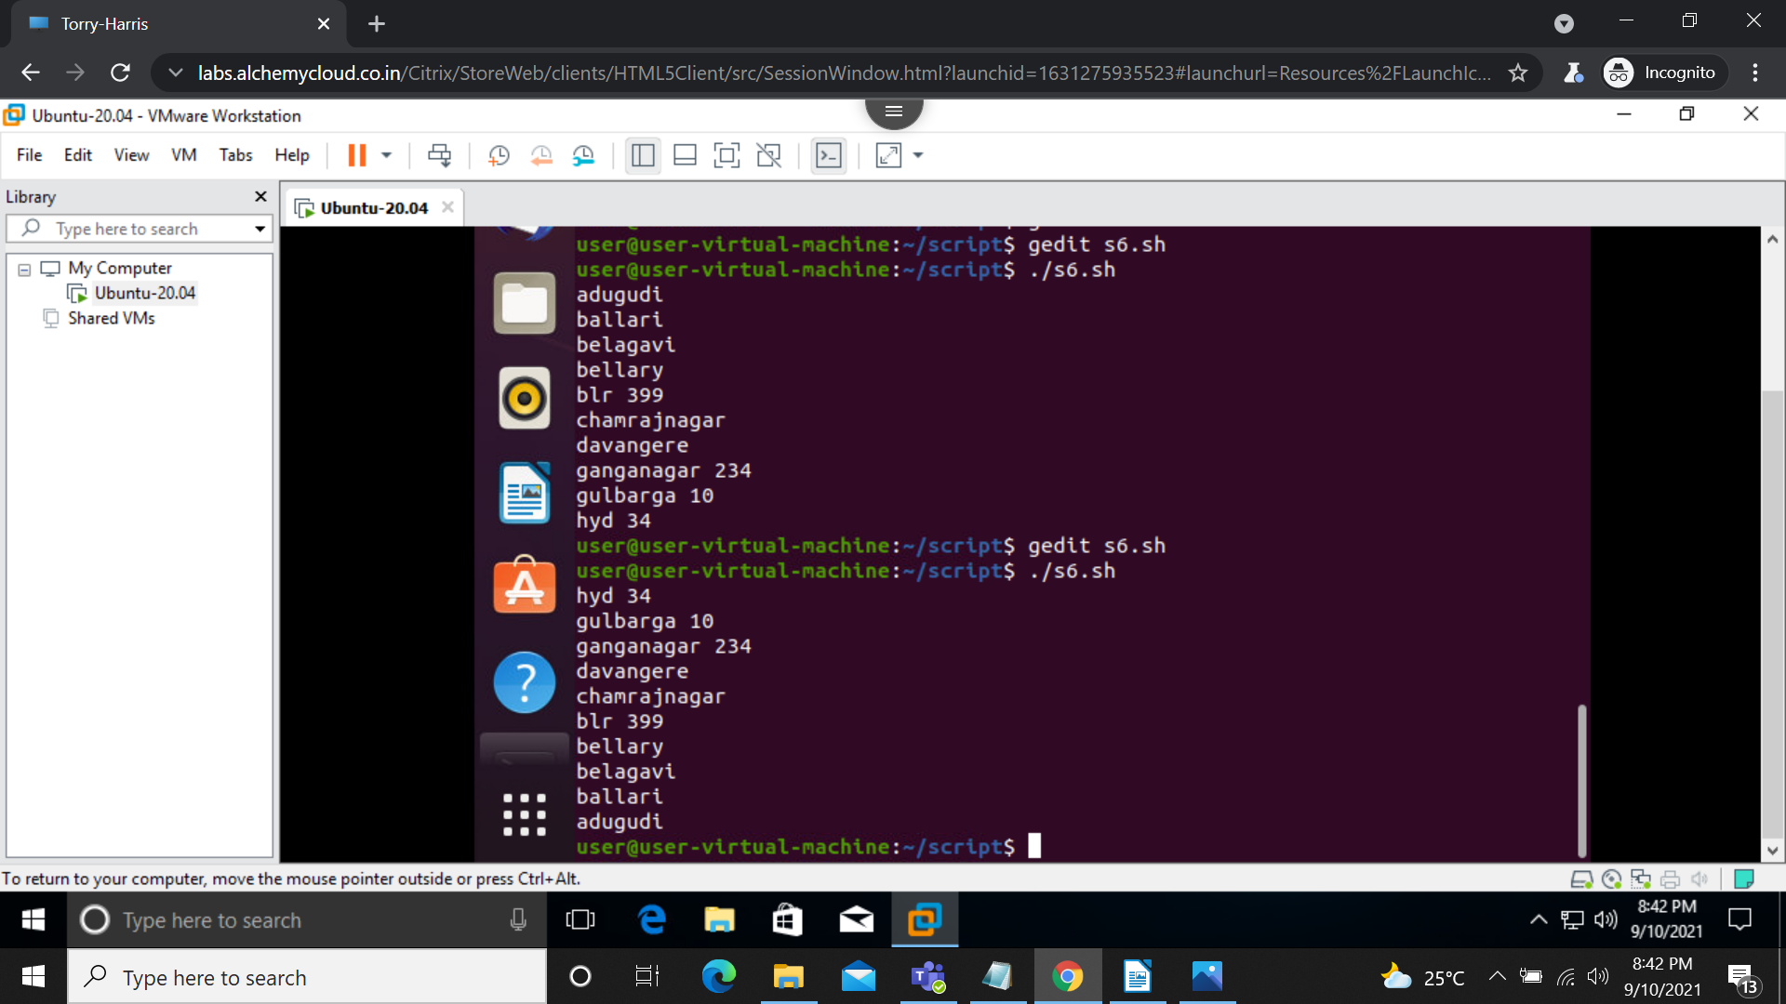

4)case condition:
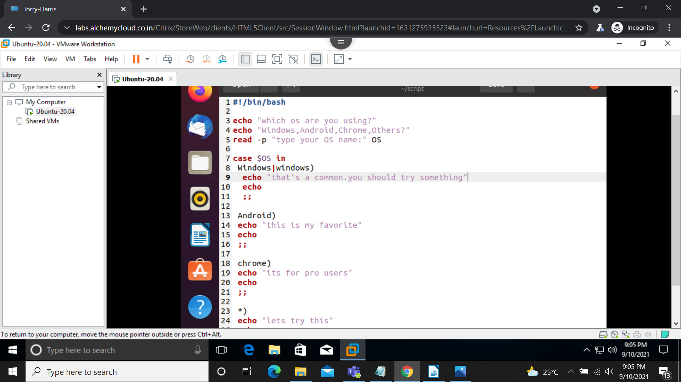
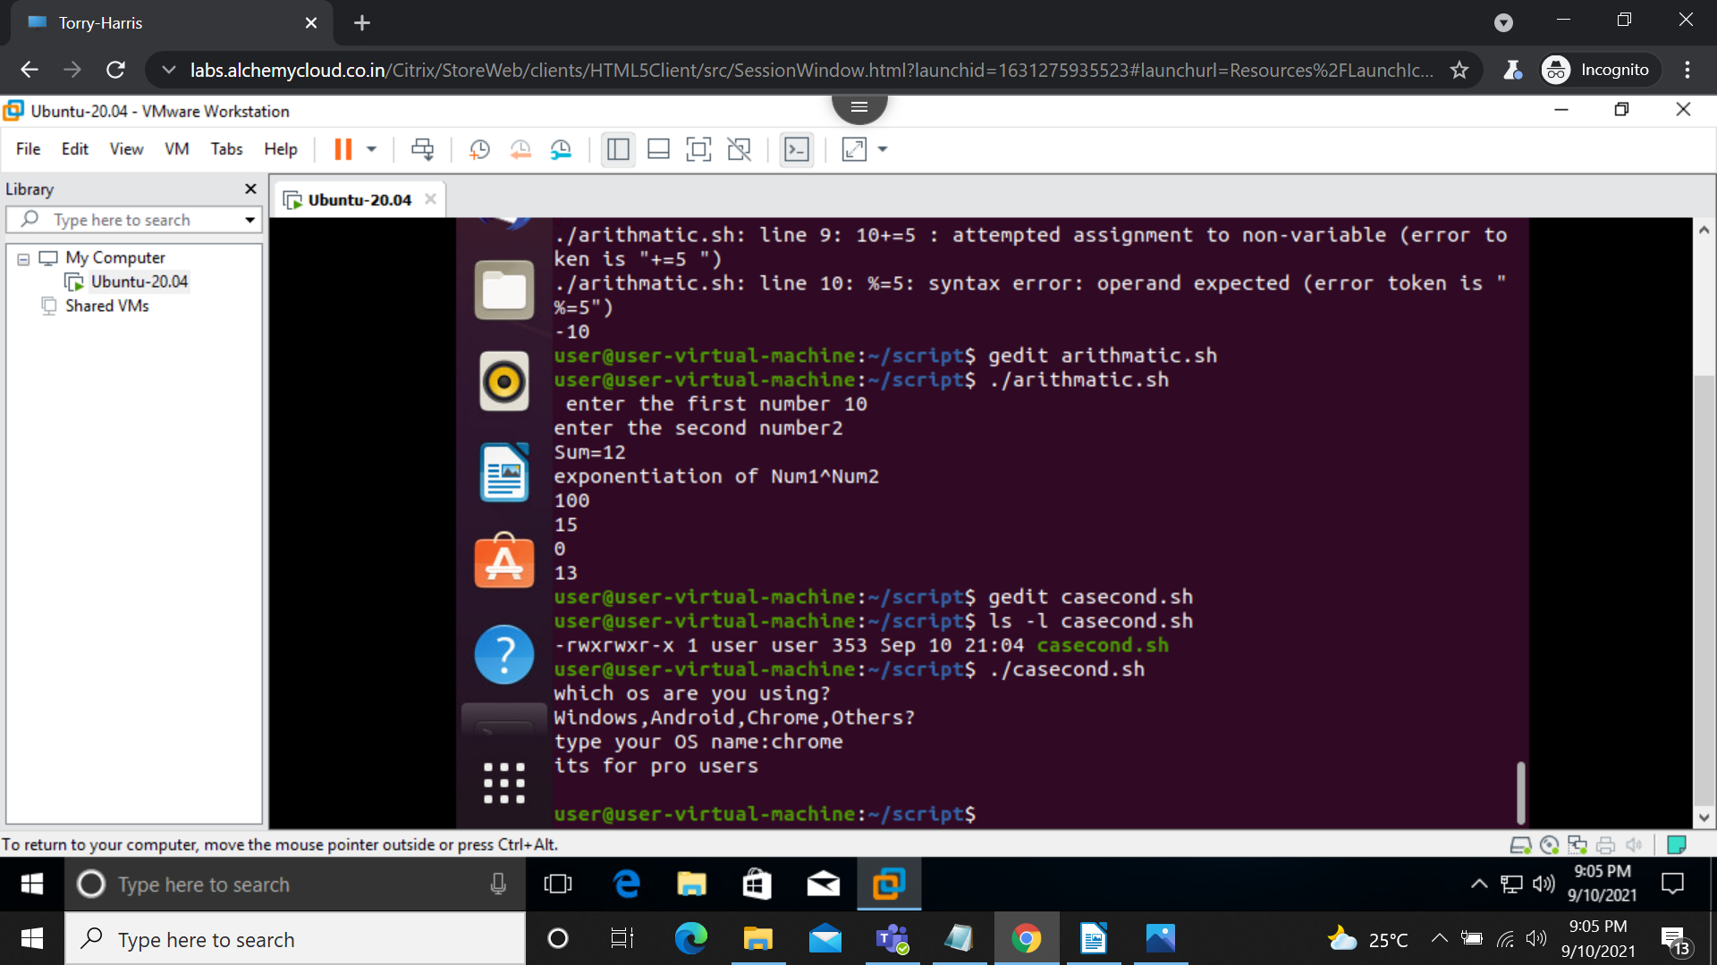
output:
5) largest among 3 numbers using if else in shell script:
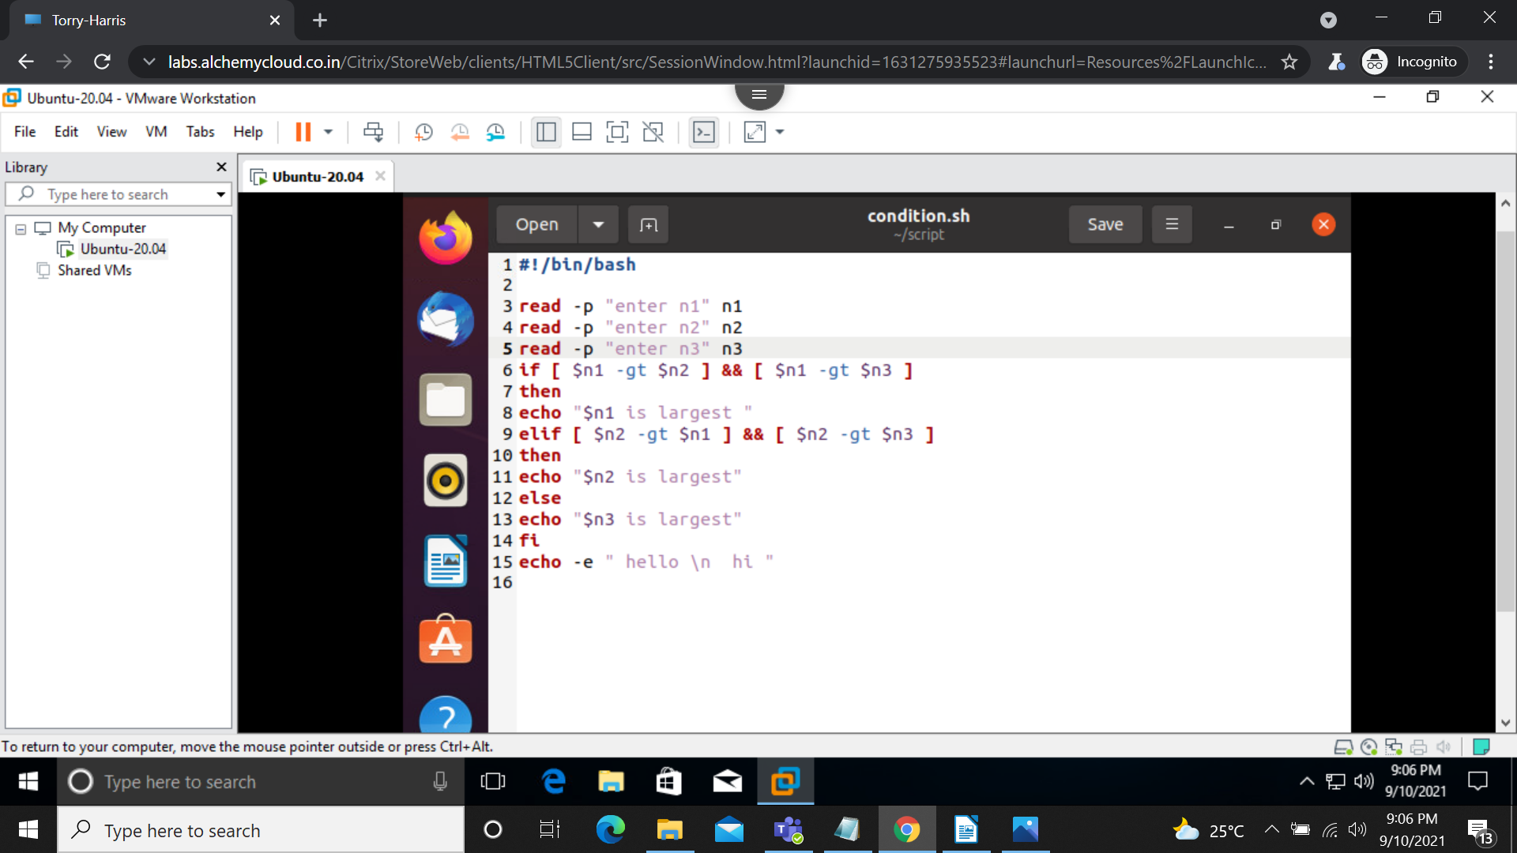
output:
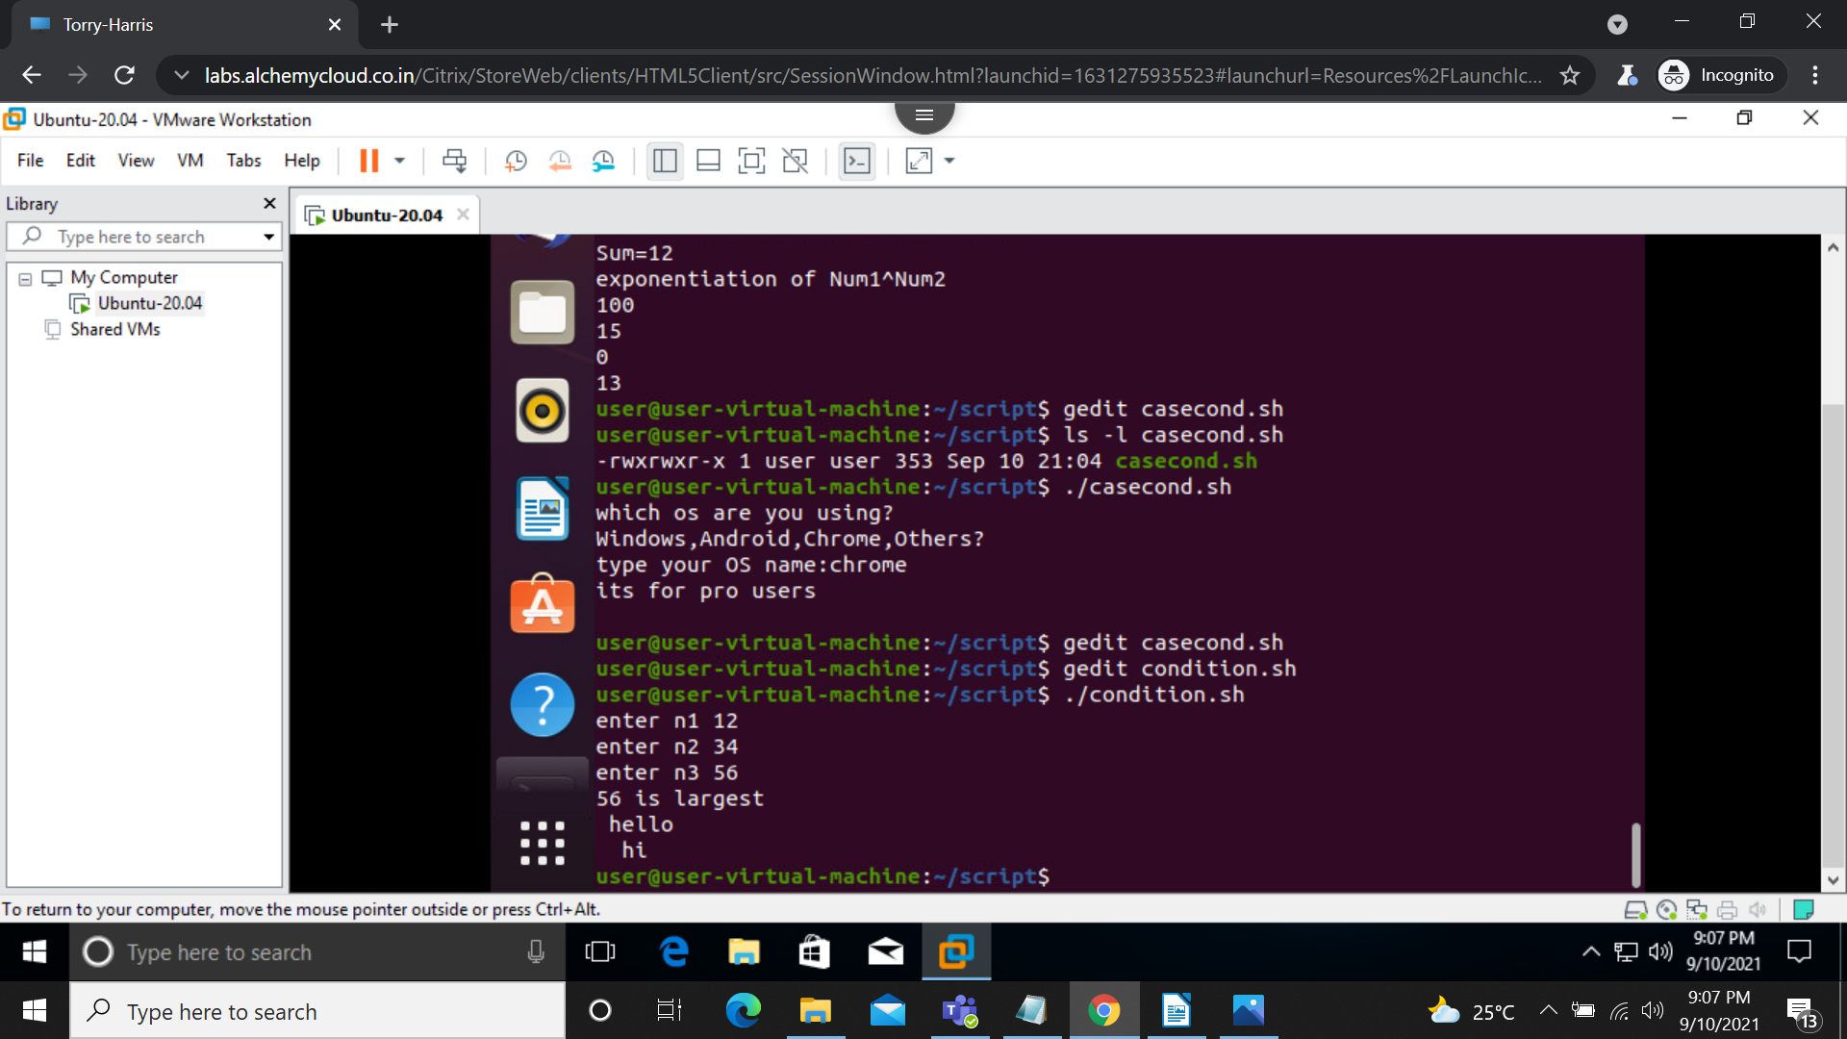

6) Date format in shell script:
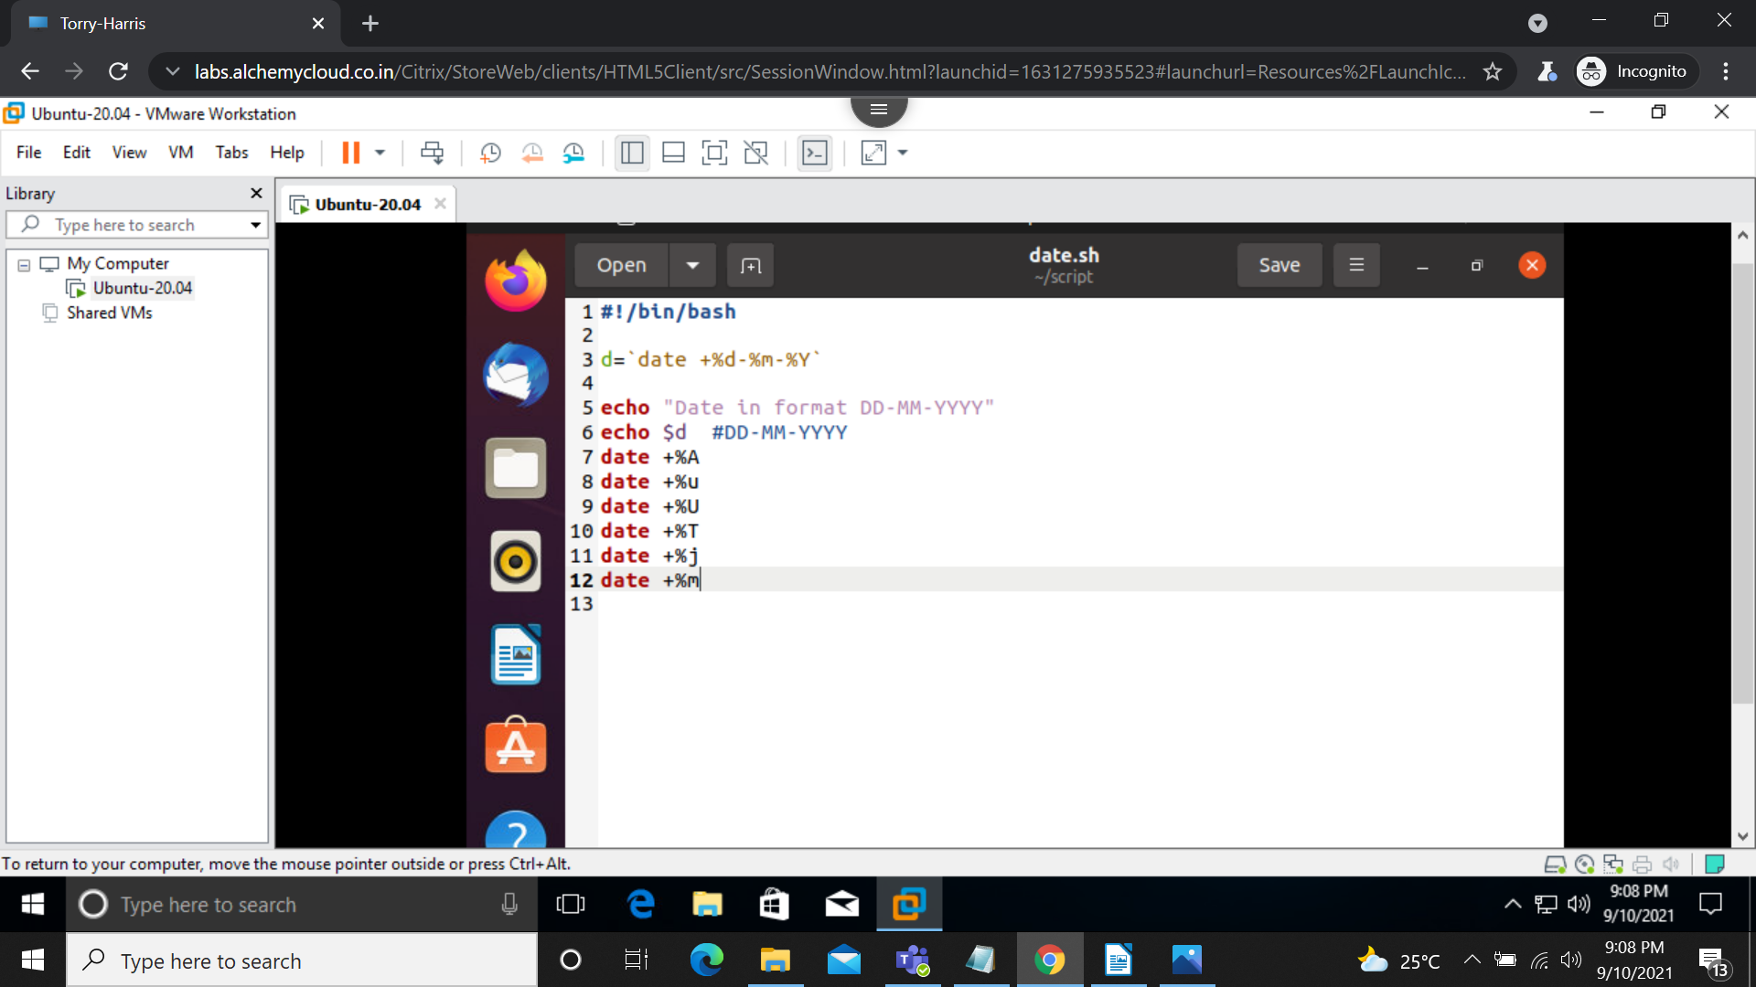
output:
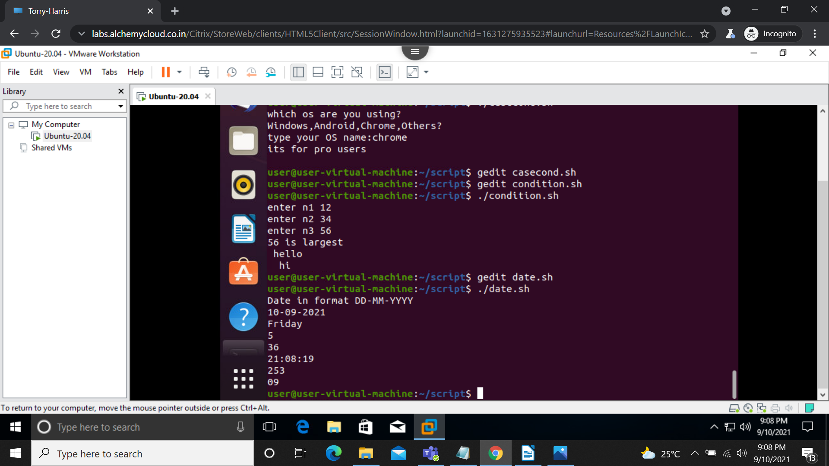

7)given number is even or odd:
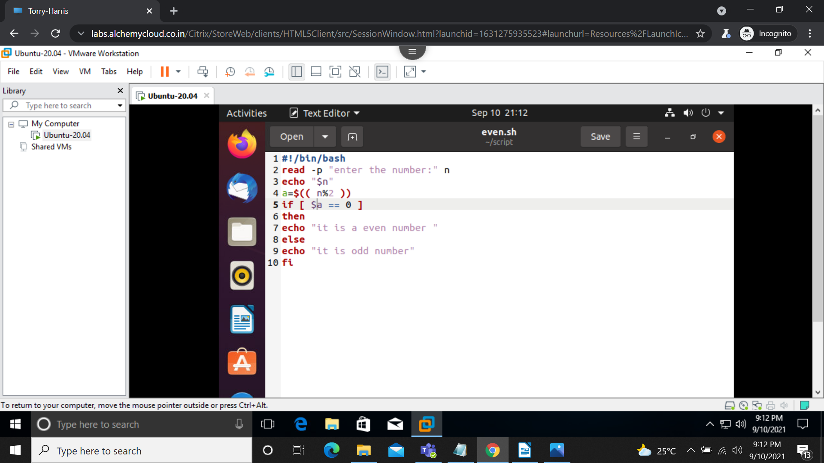
output:
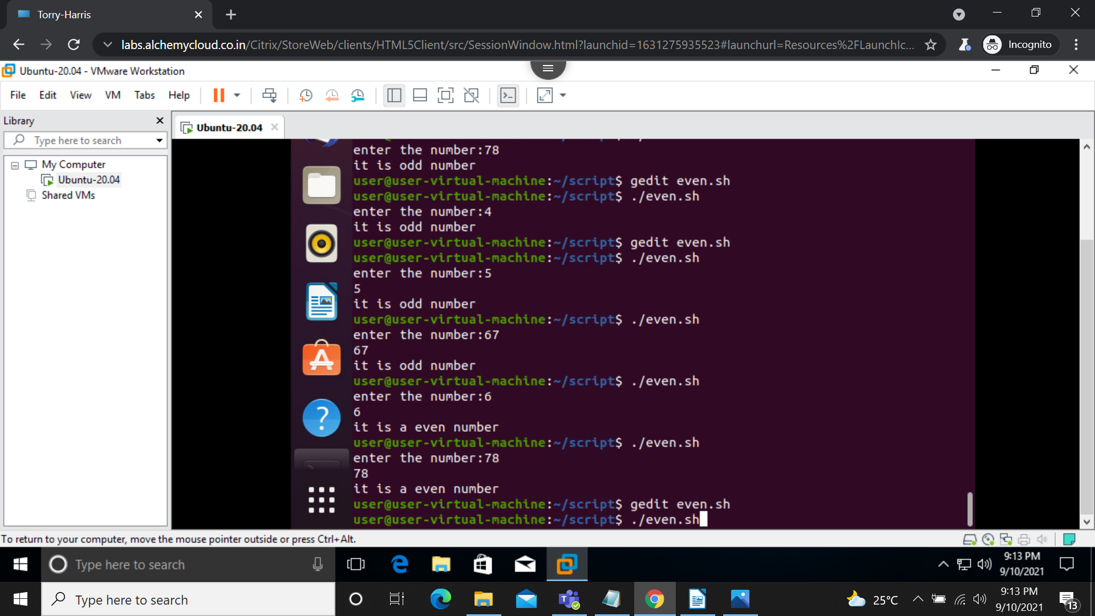

8)factorail of 5:
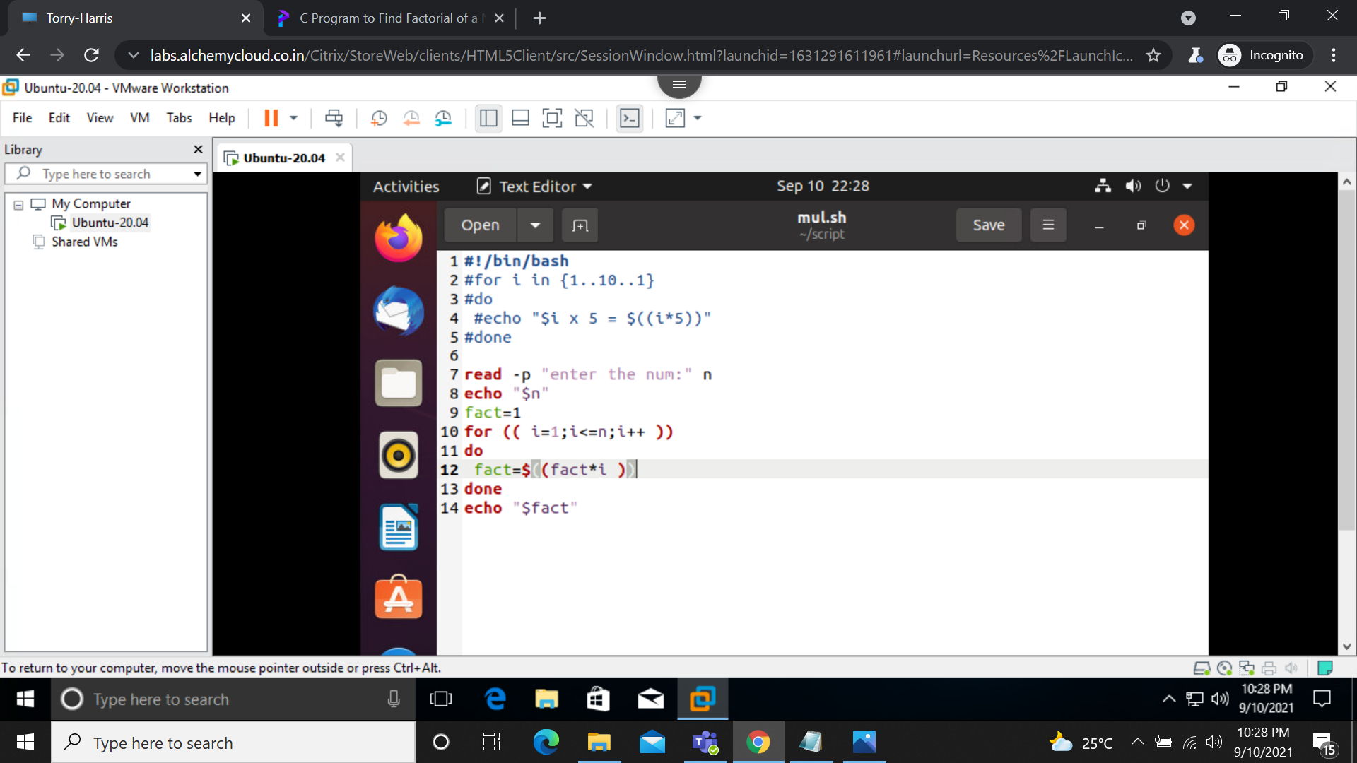
output:
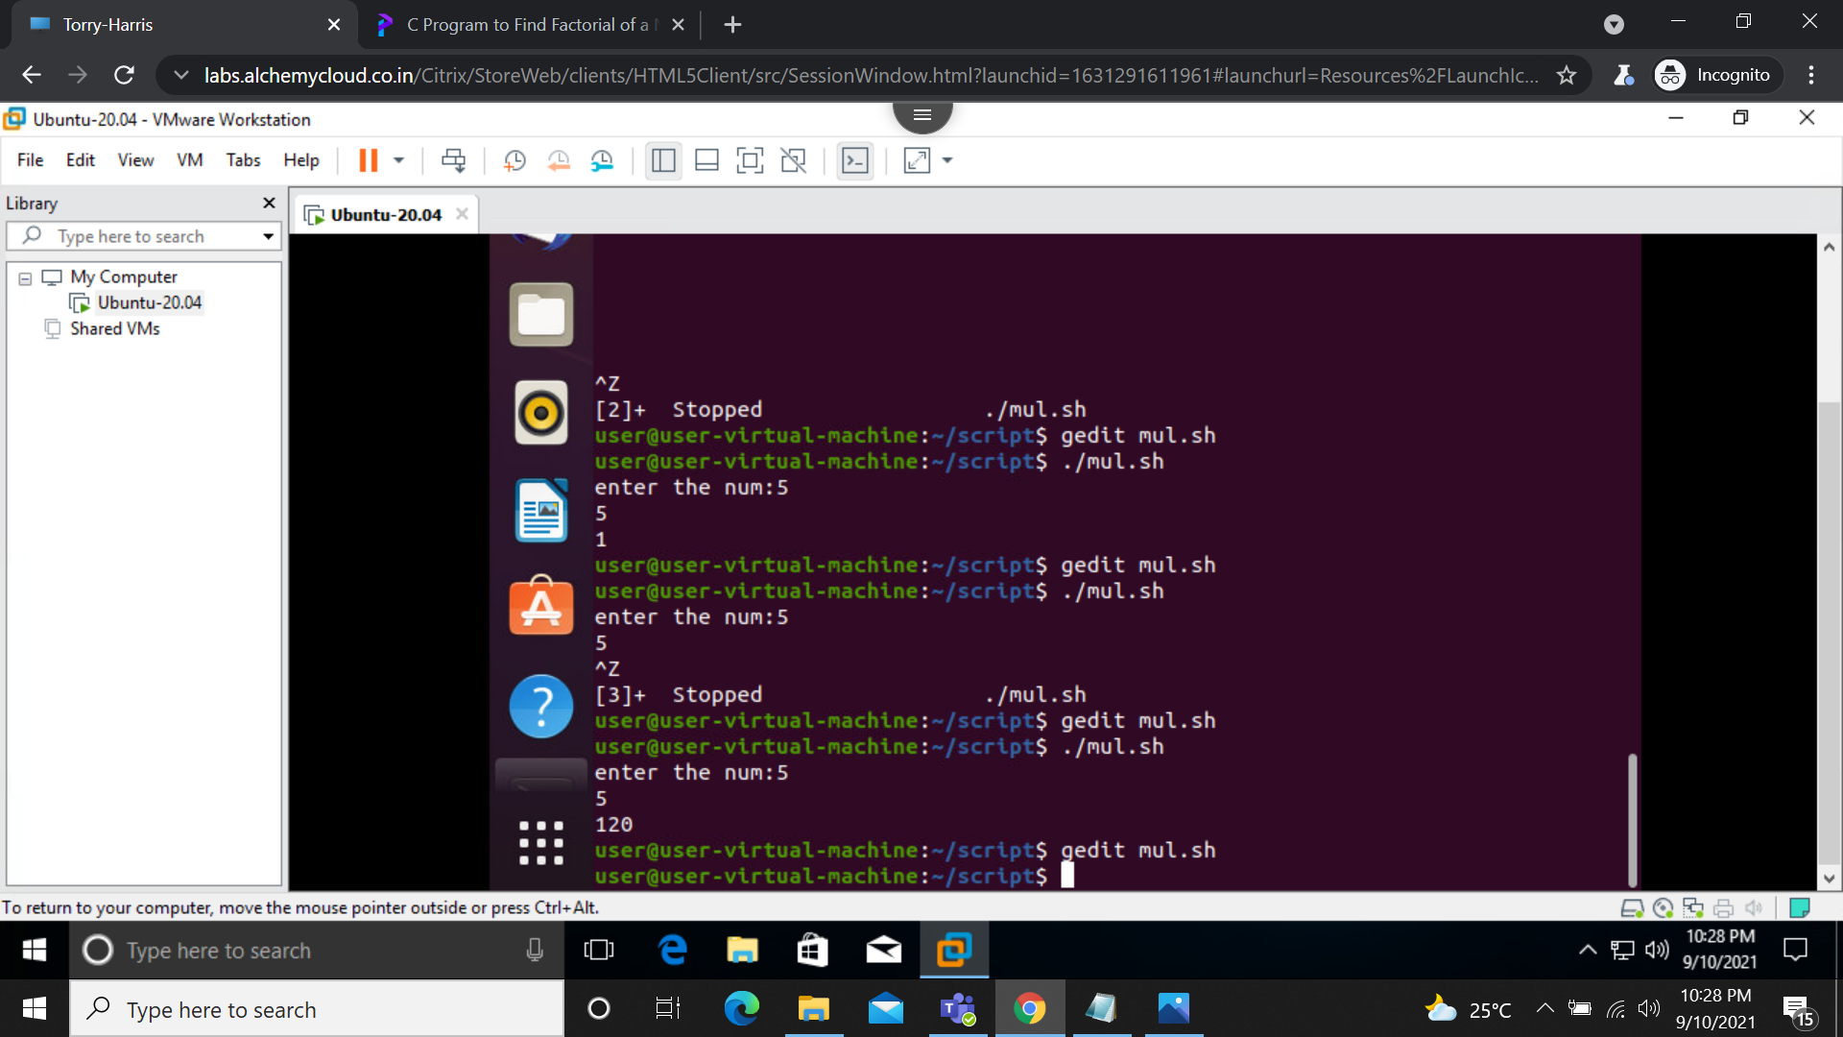

9)reverse of a given number:
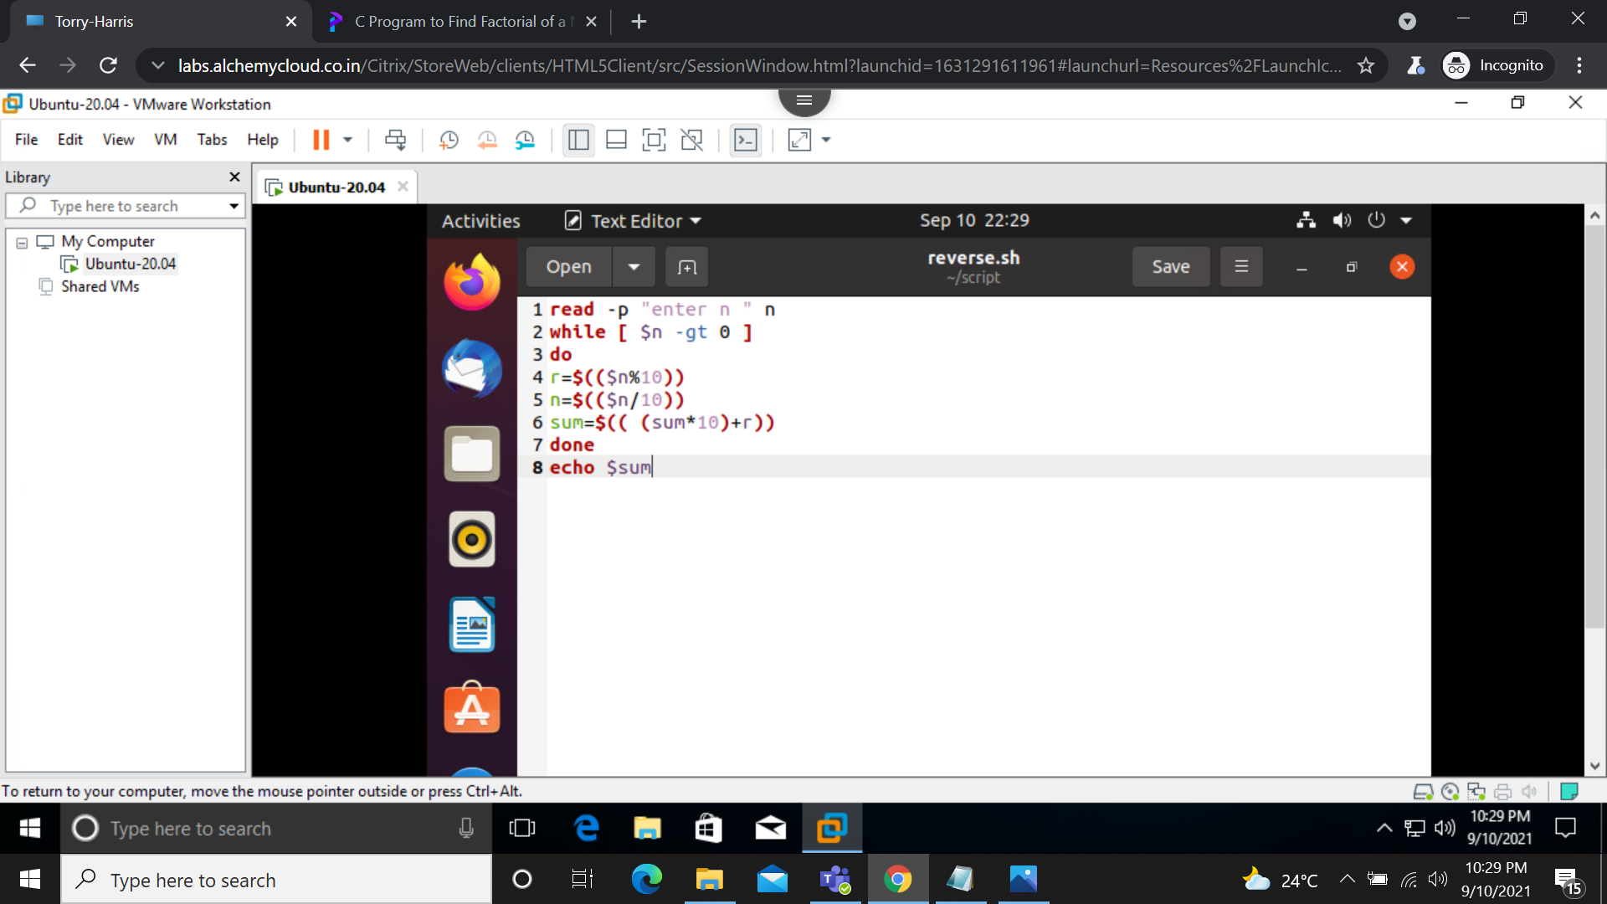
output:
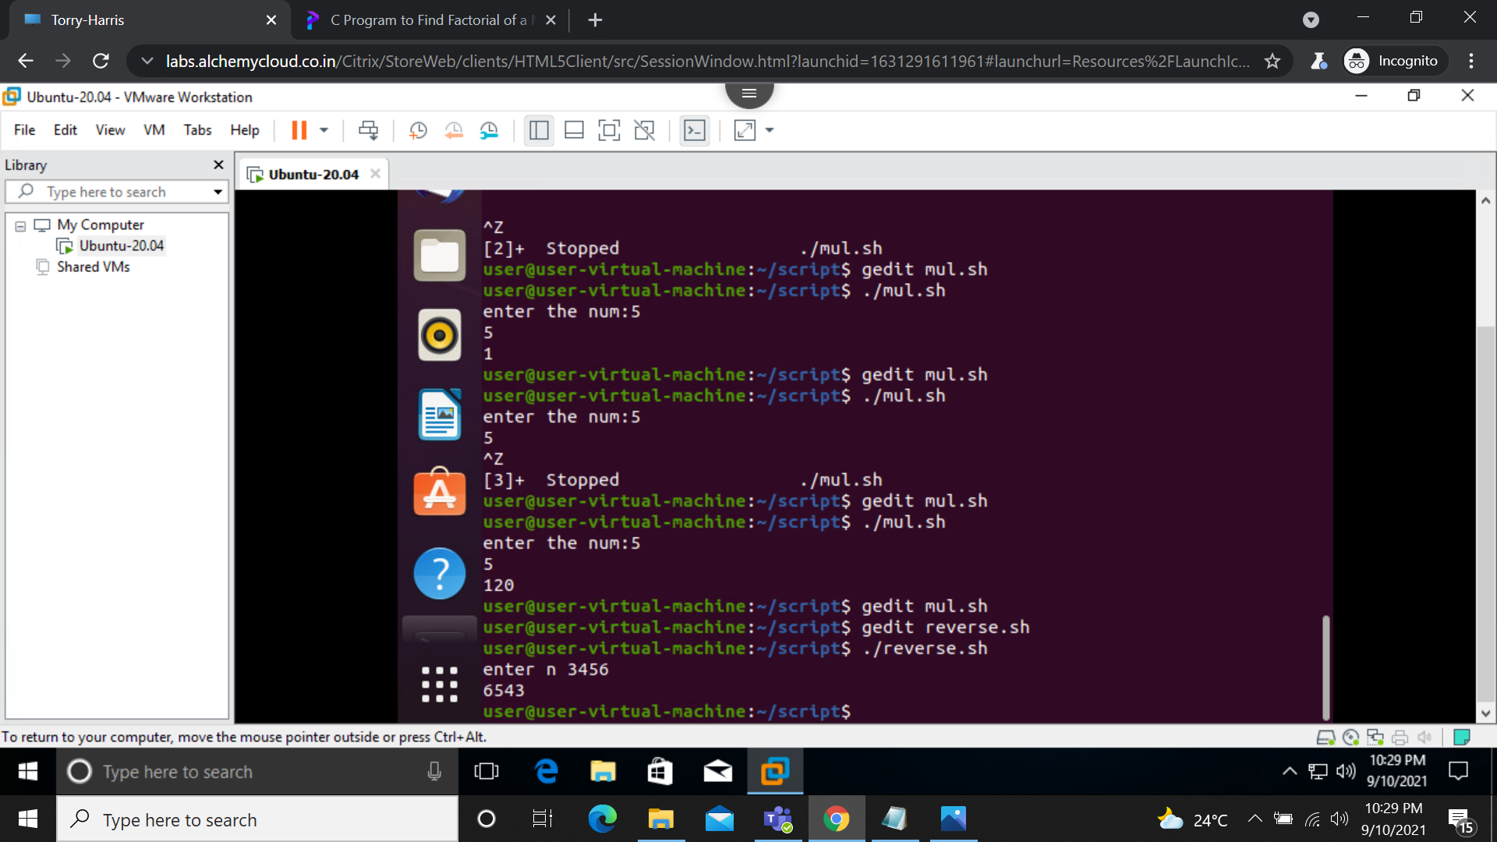

10)sleep command:
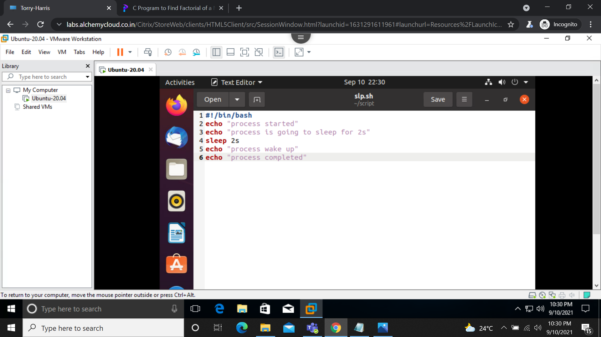
output:
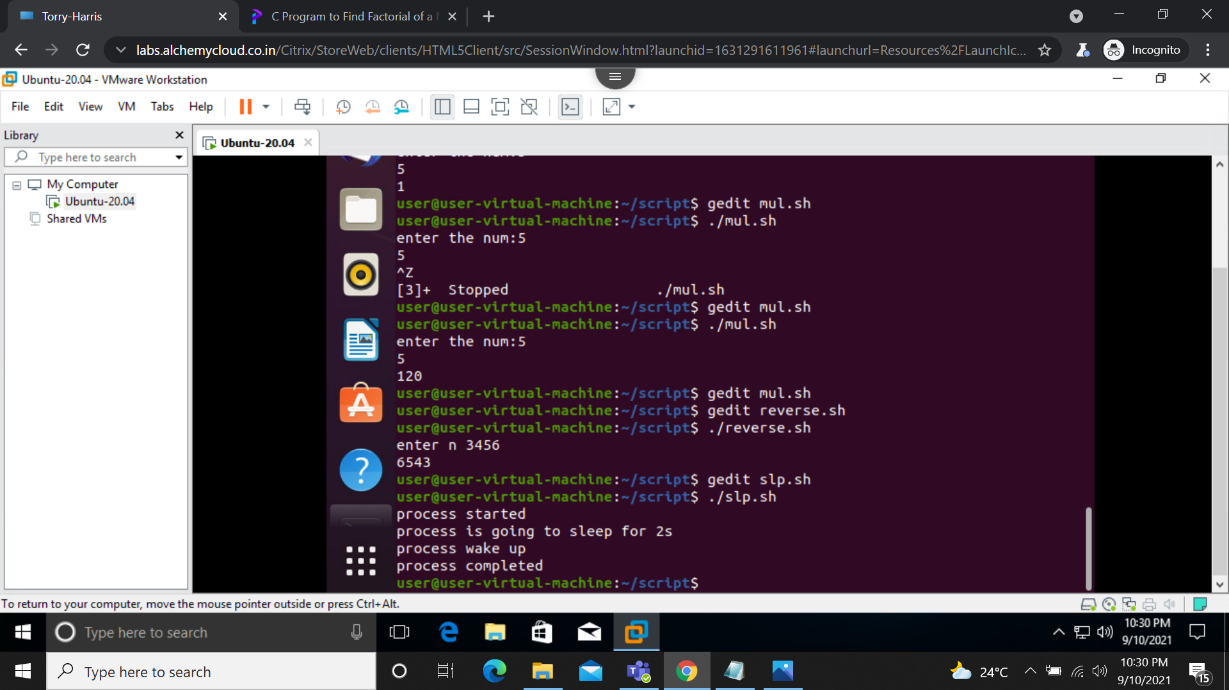

11)calculating factorail of 5 using until:
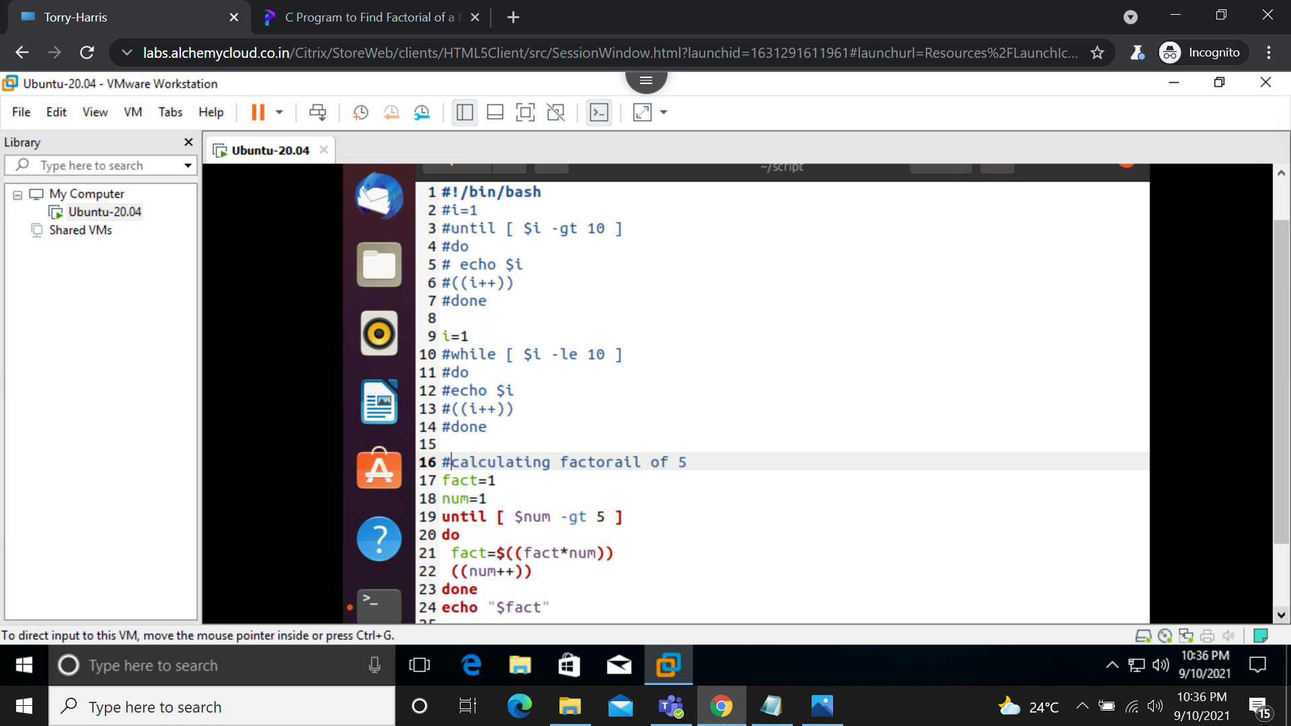
output:


