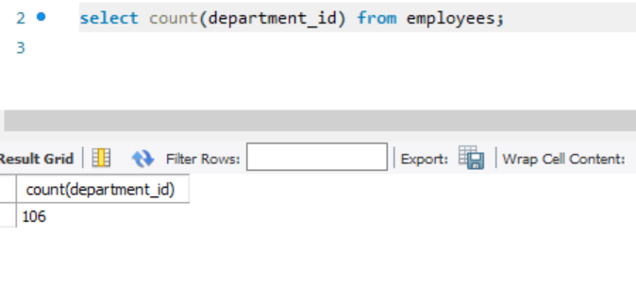

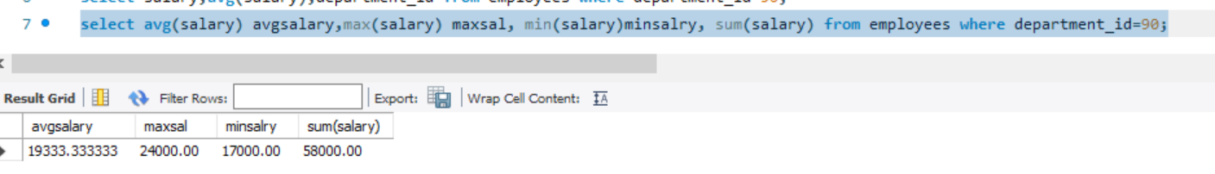

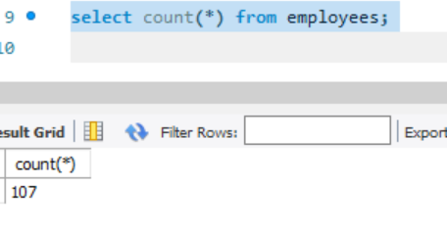

below query will total number of rows from employees table.

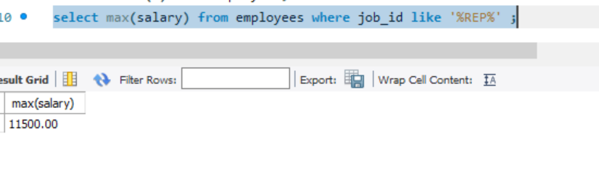
Below command will give highest salary among representatives.

The below statement will give total number of rows which has commssion_pct.
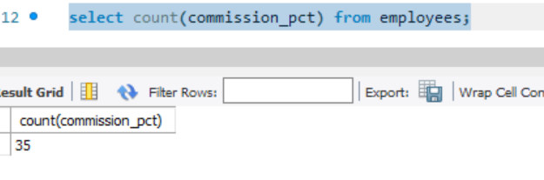

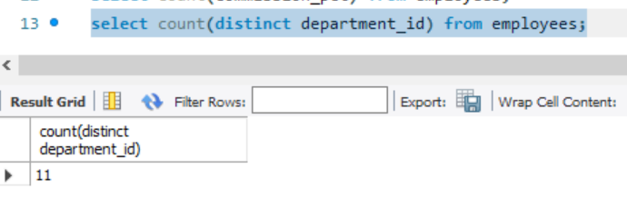
The below statement will give total number of departments.

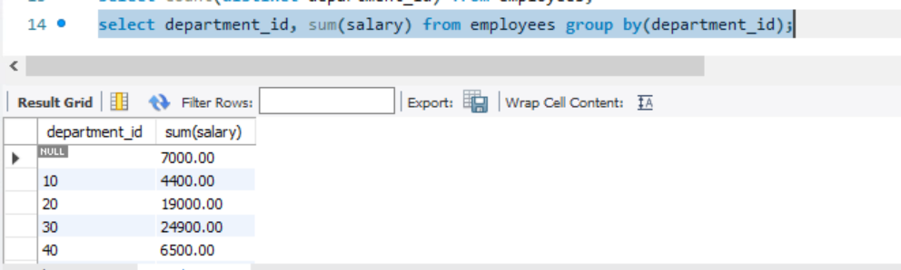
The below statement will give total salary of each department.
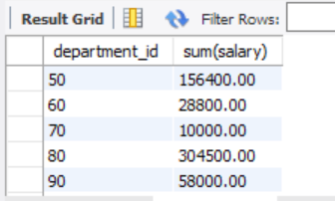

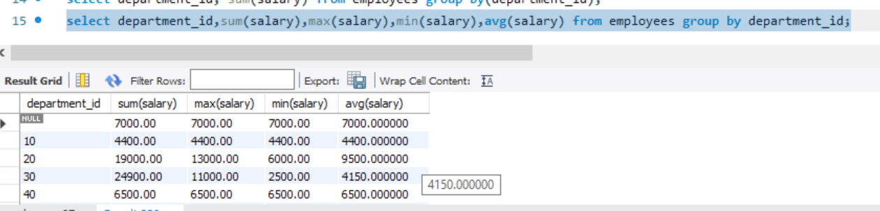
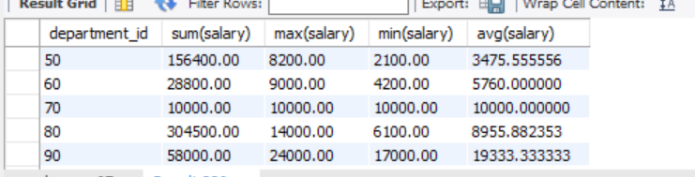

The below statement gives the total salary of each department having department id>40
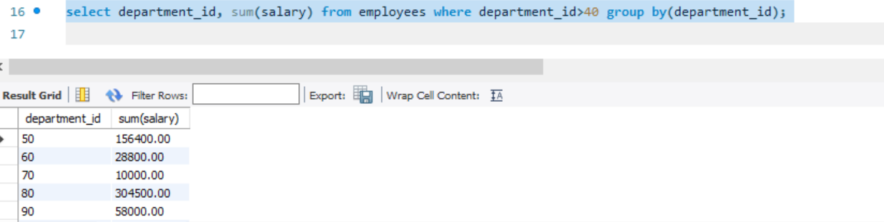
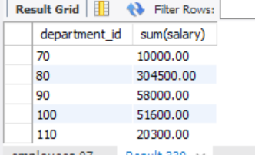

the below statement is same as above but ordered in descending order of department id.
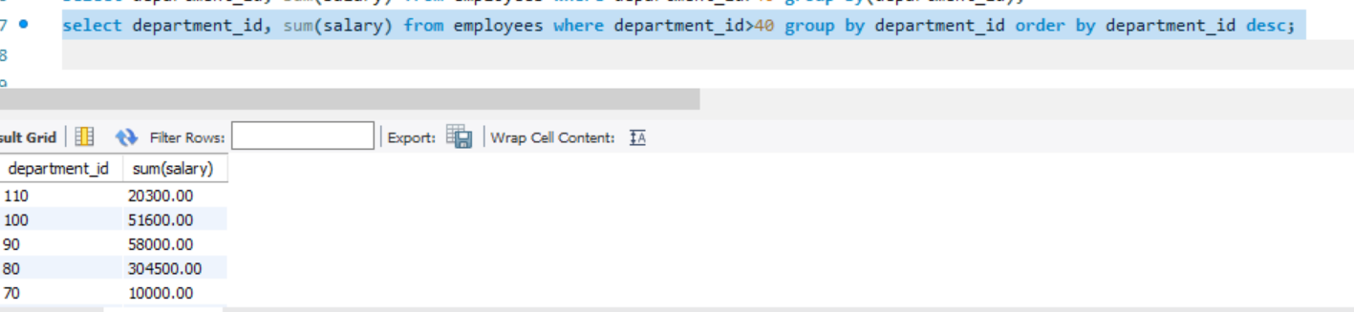
========================================================================
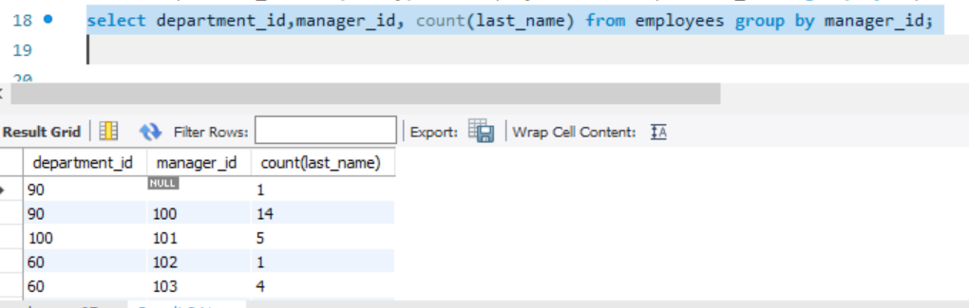
=========================================================================

the below statement gives department_id in which whose average salary is >5000.
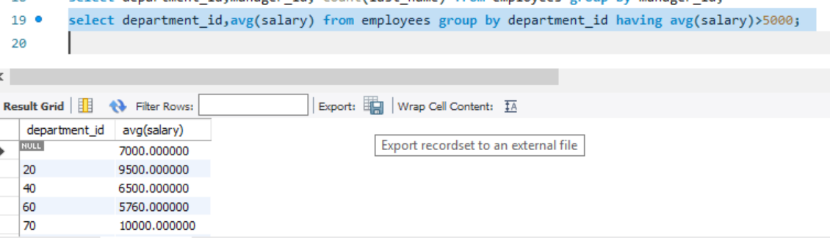
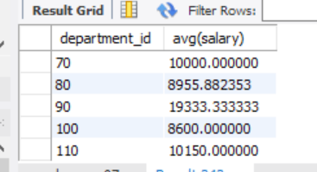

the below statement gives total salary paid for all the employees except for the representatives.
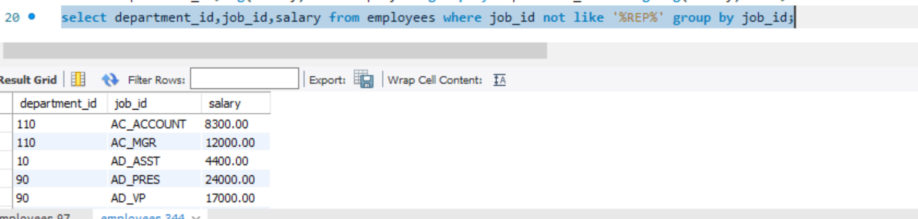
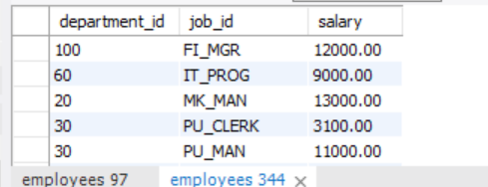
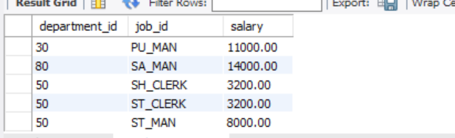

=========================================================================

Query: Find all the employees whose salary is greater than ernst salary.
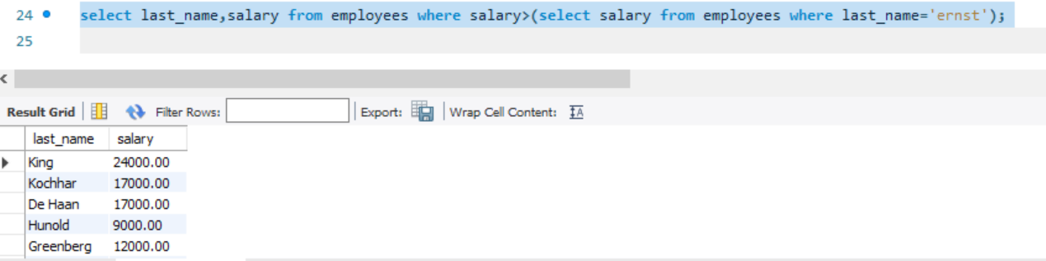
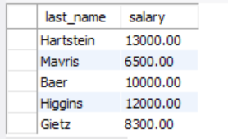
and many more whose salary is greater than ernst salary.

Query: Find all the employees who has same job id as ernst and salary greater than austin.
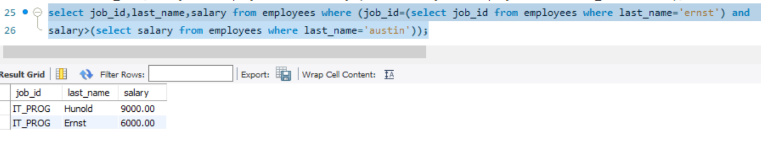
=========================================================================

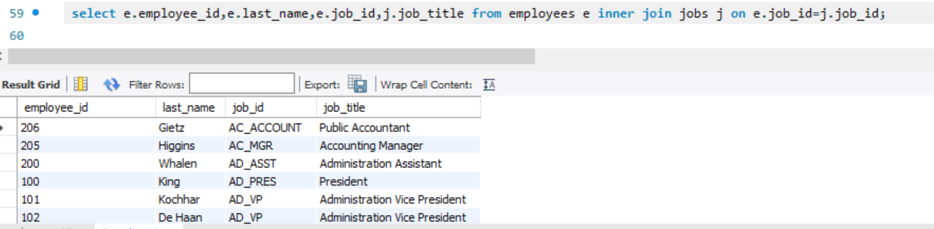
query: give employee_id,last_name,job_id,job_title by joining jobs and employee table.
=========================================================================
query:left_join

