STEM Center Judge

Training Website

Scott Johnson

Justin Anderson

Matt Pryor

**I. Introduction:**

Our team is working with Sean Herberts and Georgia Bracey from the SIUe Center for Science Technology Engineering and Mathematics (STEM). Every year the STEM Center holds a science fair known as the Science and Engineering Research Challenge. This is a competition for 5th through 12th grade students from the area to work on challenging scientific and engineering projects while utilizing the steps of the scientific method. Every year there are close to 250 children that participate. To run competitions the STEM Center has to have many volunteers to work as judges. This means that every year STEM has to train about 100 volunteers how to judge the competition. The day before the competition everyone who wants to volunteer has to come to SIUe to sit through a short training session and then take an examination before they are allowed to judge. We are working with STEM to develop a website that would take the place of the training. This would allow the volunteers to get certified for judging at the competition without having to come in the day before.

**II. Executive Summary:**

Our team’s goal is to simplify the training of science fair judges for both STEM and the volunteers who participate in the science fair. To do so, we are developing a website for STEM that will automate this training process. This website will be hosted on a web server through 1anddone.com provided by STEM. This web server will support all our programming requirements: PHP, MySQL, JavaScript, and HTML5. The website will have three main purposes such as training the volunteer judges, testing the judges, and providing STEM with a tool to update the site. Also, we will setup a MySql database that will contain information for each user. This information is stored in the **User** table. The user information is described in Figure 1 below. The database also has two other tables: one **Presentation** table (figure 2) which stores training slides, and another **Test** table (figure 3) which stores the testing questions and answers.

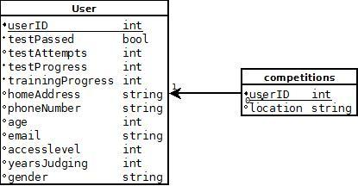

*Figure 1: This is a UML description of the User table.*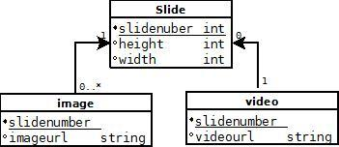

*Figure 2: This image is a UML description of the Presentation table.*

The site features five main pages to accomplish these tasks: test.php(the testing portion), home.php(home page), account.php (user account display/modification), admin.php (STEM admin tool), and presentation.php(the training portion).

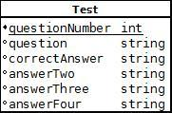

*Figure 3: This image is a UML description of the Test table.*

When first connecting to the site, the user is brought to the “home.php” page. The first thing the user sees when connecting to this page is an option to “log in” to the website located at the center of the screen. To connect website users via their google account we use an application called Janrain. This could have also been done using the OAuth2.0 protocol directly. We chose the Janrain implementation rather than using OAuth2.0 ourselves because of the simplicity of the setup along with Janrain supporting other various log-in systems such as facebook, twitter, etc. After connecting with google, a JSON packet is returned back to our website containing basic profile data retrieved from google.

The packet returned looks like this :

{  
 "stat": "ok",  
 "profile": {  
 "providerName": "Google",  
 "identifier": "https://www.google.com/profiles/107600078531407802300",  
 "verifiedEmail": "mpryor@siue.edu",  
 "preferredUsername": "mpryor",  
 "displayName": "Matt Pryor",  
 "name": {  
 "formatted": "Matt Pryor",  
 "givenName": "Matt",  
 "familyName": "Pryor"  
 },  
 "email": "mpryor@siue.edu",  
 "url": "https://www.google.com/profiles/107600078531407802300",  
 "googleUserId": "107600078531407802300"  
 }  
}

The information we use from this is “email”, “googleUserId”, and “name”. A new user is created in the database upon first login from a google account. “Email”, “googleUserId”, and “name” are all placed into the appropriate fields in the user table. Upon all subsequent logins, the database is searched for an ID field containing their googleUserId. If the googleUserId is already stored in the database, the user is simply logged in without the need to create a new user; if not, a new user is created.

If it is the user’s first time logging in to our site, after the login process they will be presented with a survey. STEM wants to collect demographic information of their judges and also some basic contact information. The survey will include the following questions:

“How many years have you volunteered judging?”

“How old are you?”

“Gender?”

“Home address?”

“Phone number?”

The answer to these questions will be stored in the correct fields in the **User** table: **yearsJudging**, **age**, **gender**, **homeAddress**, **phoneNumber**.

The following question will also be asked:

“What competitions have you previously judged?”

The answer to this question will be stored in the **competitions** table with the same **userID** that correlates to the current user.

After logging in, the user is presented with a navigational bar at the top of the screen, and a widget that displays their current progress among the site in the center of the screen. This widget will display to the user their current progress among the training and testing modules. To display this information, information from the database will be used such as the user’s **trainingProgress**, **testProgress**, and **testScore**. The widget displayed will look something like this:

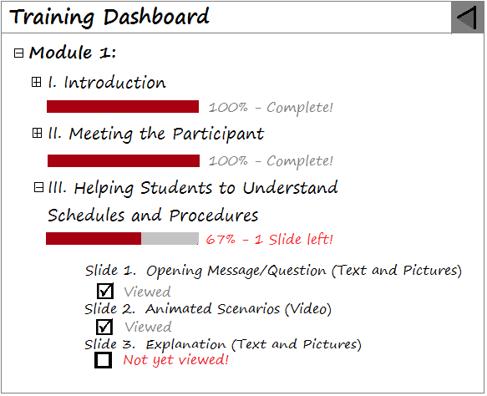

*Figure 4: The image above shows an example mockup of what the “Training Dashboard” could look like.*

The first task, training the judges, will be accomplished through the “presentation.php” page. The top of the page features a navigational bar providing links to the main pages of the site that the user has access to, along with a link to log the user in. In the center of the page, a slideshow widget will be used to display “modules” to the user. A module is a group of slides with a shared theme such as “Module 1: Creating a Positive Experience for Students.” Each slide is a HTML page that contains either a video, or text and/or images. Training videos will be provided by STEM, and are being created by Sean Herberts. The videos are animations created in flash, exported as video files. Each animation may last anywhere between 10 seconds and 1 minute. The videos will be hosted on youtube. Each slide is viewed through the slideshow as a subpage. At the bottom right of “presentation.php” will be a “next” button and a “back” button to navigate between each individual slide. Each module will also be broken into several subsections of related content. To show this, an example is provided. This is the layout for our first module, which will be finished by early August:

**Module 1: Creating a Positive Experience for Students**

I. Introduction

II. Meeting the Participant

Slide 1. Opening Message/Question (Text and Pictures)

Slide 2. Animated Scenarios (Video)

Slide 3. Introductions (Text and Pictures)

III. Helping Students to Understand Schedule and Procedures

Slide 1. Opening Message/Question (Text and Pictures)

Slide 2. Animated Scenarios (Video)

Slide 3. Explanation (Text and Pictures)

IV. Making Students Feel Heard

Slide 1. Opening Message/Question (Text and Pictures)

Slide 2. Animated Scenarios (Video)

Slide 3. Engaging students so that they feel they have been “heard.” (Text and Pictures)

V. Parting Ways with the Student

Slide 1. Opening Message/Question (Text and Pictures)

Slide 2. Animated Scenarios (Video)

Slide 3. Parting Ways (Text and Pictures)

VI. After Judging

Slide 1. Scenario (Video)

Slide 2. Explanation (Text and Pictures)

VII. Test/Quiz

VIII. Thank You!

Slide 1. You make the difference for participants at Science Fair!

Slide 2. You have successfully completed Module 1: Creating a Positive Experience for Students

Each roman numeral above identifies the title of a subsection. Each subsection title is followed by a series of slides relevant to that title. This title will be placed at the top of each slide, followed by the individual slide name.

The next task our website accomplishes is testing the judges. This will be done on the “test.php” page. The layout of the page is similar to the presentation page, but instead of a slide show being presented, the page will display questions to test the judges. The questions are loaded from the database, and displayed in a random order. For each question, 4 answers are stored in the database, one of them being the correct answer. These are also displayed to the user with a radio button to the left side of them. When the user clicks one of the answers, they are brought to the next question. Once the user has selected answers for every question in the database, the test is considered completed and the users answers are checked against the correct answers in the database. The user is considered to pass the test only if they have 100% of the answers correct. In this case, the user’s **testPassed** in the database is set to 1, and also the **testAttempts** is incremented by 1. If the user did not pass the test, only their **testAttempts** is incremented by 1.

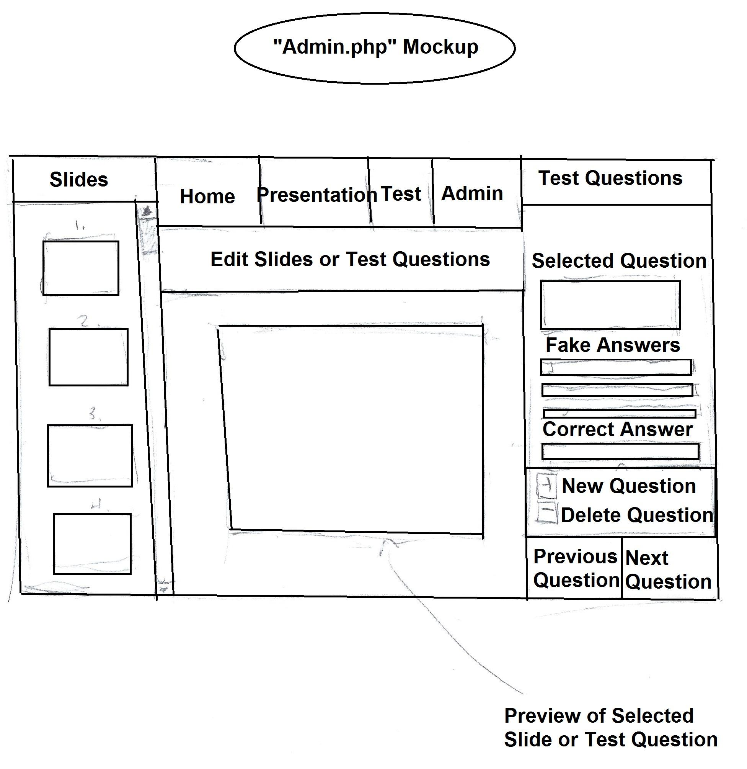

*Figure 5: This is a low fidelity prototype of the admin.php page.*

The final task our website accomplishes is providing an interface for STEM to update the training and testing modules. STEM users may access this interface on the “Admin.php” vpage. To access this page, the user’s account must have the correct access level flag. As shown in figure 5, the left side of this page loads the slides that are currently stored in the database and presents them in an image list. The STEM user has the options to adjust the position of the slides in the list, add a new slide, or remove slides. The right side of the page displays the current test questions stored in the database, and provides a control for the STEM user to edit the selected pair of question and answers, or add a new pair into the database. The center of the page provides a preview of the selected slide or test question. All of this accomplished simply by connecting each control on the page to it’s corresponding element in the database. For example, when new slide is clicked, admin.php contacts the database, and inserts a new row into the presentation table.

**III. Functional Requirements:**

**I. General Site Requirements**

These are requirements that will be part of every web page.

|  |  |  |  |
| --- | --- | --- | --- |
| **Requirement** | **Description** | **Date Finished** | **Complete** |
| Navigation Bar | A navigation bar at the top of every page will allow the user to switch to different areas of the website. The different links in the site are as follows:   * Login/Logout * Home * Presentation * Test | 3/21/2013 | X |
| Dashboard | The dashboard will be an interactive list on the left side of every page. It will show the users progress through the training and test. The titles of the different sections of the dashboard link directly to those pages. | 9/17/2013 |  |

**II. Home Page**

These are requirements that will be specifically included as part of the Home page.

|  |  |  |  |
| --- | --- | --- | --- |
| **Requirement** | **Description** | **Date Finished** | **Complete** |
| Login | From the home screen the users will be require to log in before view the presentation or taking the test. They will be able to log in using the login button on the navigation bar.   * New user login information will be stored into the database | 4/20/2013 | X |
| Slides | In the center of the screen there will be a slideshow of pictures. The pictures will be from previous Science and Engineering Competitions. | 3/21/2013 |  |

**III. Training Interface**

These are requirements that will be specifically included as part of the Training Interface

|  |  |  |  |
| --- | --- | --- | --- |
| **Requirement** | **Description** | **Date Finished** | **Complete** |
| Slideshow | The training interface will be set up as a slideshow. Slides will consist of text and videos that will be used to prepare the volunteers for judging the competition. | 9/6/2013 |  |
| Previous/Next Buttons | The user will be able to navigate through the slides using previous and next button that will be located below the slides. | 3/15/2013 | X |

**IV. Testing Interface**

These are requirements that will be specifically included as part of the Testing Interface

|  |  |  |  |
| --- | --- | --- | --- |
| **Requirement** | **Description** | **Date Finished** | **Complete** |
| Questions | The test will consist of several multiple choice questions that are stored in the database. Each page will have different question. | 8/28/2013 |  |
| Randomized | Whenever the test is started the questions are loaded from the database and will be placed in a random order through which the user will navigate. | 9/10/2013 |  |
| Previous/Next Buttons | The user will be able to navigate through the question pages using previous and next button that will be located below. | 3/15/2013 | X |

**V. STEM Interface**

These are requirements that will be specifically included as part of the STEM Interface

|  |  |  |  |
| --- | --- | --- | --- |
| **Requirement** | **Description** | **Date Finished** | **Complete** |
| Different access levels | Different STEM users will have access to different functionality.  Different levels:   * Volunteer - Can view the training and take the test. * View only - Can view the list of volunteers, view the training, and take the test. * Editor - Can edit questions and training content, view the training, and take the test. * Administrative - Can edit user information and perform the actions of editor and view as well as print the list of volunteers | 10/10/2013 |  |
| Question Editing  Interface | All of the question that are stored in the database will be displayed as a list. The user will be able to select a question to edit it, remove questions, and add questions. | 9/6/2013 |  |
| Training Editing Interface | All of the training slides will be stored in the database. Using the editing interface the user will be able to rearrange the slide, delete slides, and add new slides. | 10/2/2013 |  |
| User Editing | Administrators will be able to access the information for all users of the site. They will be able to make other user into the various types of STEM users. | 4/20/2013 |  |
| Volunteer List | The volunteer list will be a list of all of the volunteers for the current year. From this page the STEM users will be able to print off or download the list. | 4/18/2013 |  |

**IV. Non-functional Requirements:**

* Support for Mac, Windows 7, iOS, and Android operating systems.
* Support for Internet Explorer 10, Firefox, Chrome, Safari browsers.
* The languages used will be Javascript 1.8, HTML5, and PHP 5.4.13 for the website.
* Twitter Bootstrap 2.3.1 will be used as a framework for the design of the website
* The database used will be MySQL 5.6.9.
* The code will be permanently hosted on a server provided by the STEM center.
* The project will be open source.
* To complete the training and test it should take a user between 15-20 min.
* The website should be easy to navigate for experienced and inexperienced computer users. We will verify this doing usability testing.
* Google accounts will be used for the login through Janrain

**V. Team and Process Definition:**

Our team is utilizing a developmental process that is similar to waterfall model. We begin the developmental process by constructing a definitive list of requirements for the entire project. There were additional features that we decided to add after this step which is one reason why we did not use a true waterfall method. Once the initial requirements were established we switch to the design step of of our process. During the design process we create low fidelity prototypes to determine the general layout of the website. We use the paper prototypes to determine how the interfaces of the website should be laid out. Once the general layout of the interfaces has been determined then a high fidelity prototype is made. Our high fidelity is framework for our website that we run local host. Once the design for the website has been determined the next step for our team is the implementation of the website. This is where we use the design of the website and make a fully implemented website. We use the high fidelity prototype and the architecture of our design to make a fully functioning website, that is hosted from the server that it will stay on. Following the completion of the website, we are spending time verifying the product. We are doing usability studies and testing to make sure that our website meets all of its requirements. Once we have determined that the website is completely finished we are turning it over the STEM Center for all future maintenance.

**Team Division**

|  |  |  |  |  |
| --- | --- | --- | --- | --- |
|  | **Database** | **Web Interface** | **Documentation** | **Testing** |
| **Matt Pryor** | 60% | 15% | 25% | 33% |
| **Justin Anderson** | 20% | 50% | 25% | 33% |
| **Scott Johnson** | 20% | 35% | 50% | 33% |

**VI. Architectural Description:**

The user accesses the website with only access to the main page with the login. Users log in, then a php session is created for the user. The user is then granted access to the features that their user level allows. Volunteer users will be granted access to the training and test areas. View only users will be granted access to the training, test, and list of the status of the current volunteers. Editor users will be granted access to the training, test, and editor areas. Administrative users will be granted access to all areas of the website, including the ability to view and edit user information. When a user chooses to do the training, the order and content of the slides is loaded from the database. When a user chooses to take a test, the order of the test questions is randomly generated from the list in the database, and the order of the answers for the questions will be randomly generated for each time they take the test.

UML Description of architecture process on next page.

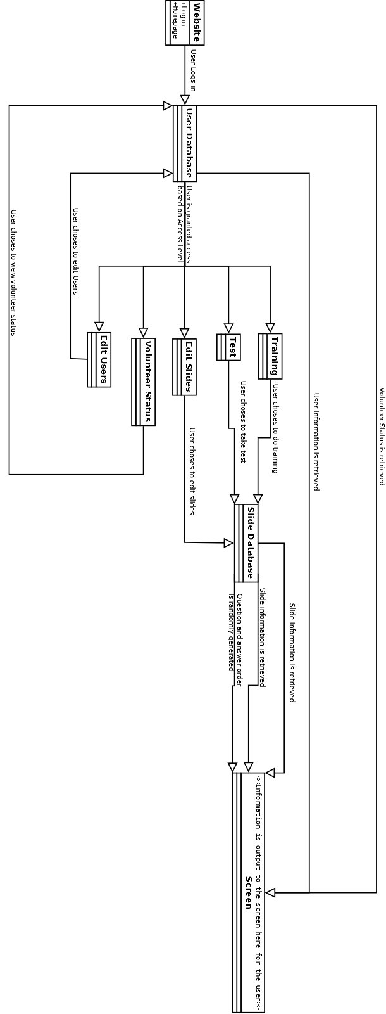

**VII. High Fidelity Prototype:**

1. Home Page

This is the first screen the the users will see when they get to the website. From here the user will be able to log in to the system. If they are already are logged in, then they will be able to go to the presentation and to the test if they have completed the presentation. If the user is already logged in, then “login” will be changed to “logout” which will end the current session for that user. In the center of the screen the is a picture slideshow of pictures from past research competitions.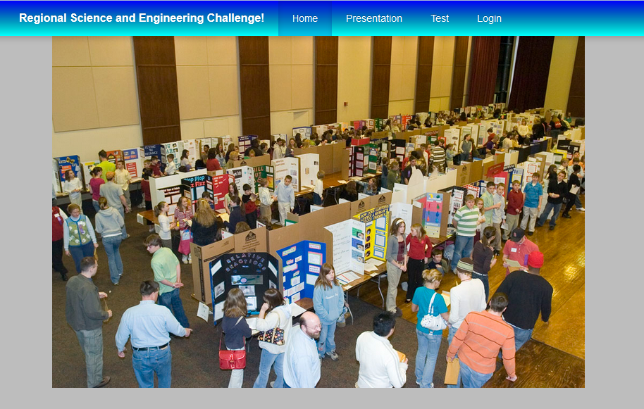

2. Login System

When logging into the website, the users will be using their Gmail accounts. This will be a pop up window when they click the login button. If the user does not currently have a Gmail account, they will be able to click “sign up” that will take them to Google to create an account.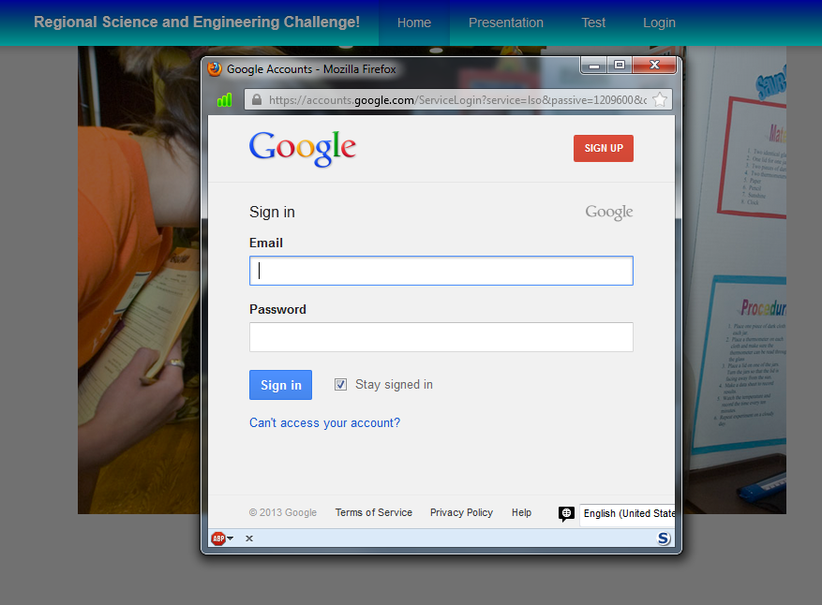

**Judge Interfaces:**

3. Instructional Interface

The instructional interface will be set up as a slideshow that will feature text content and video content that will be used to train volunteers about judging the competition. The judges will start at the first slide and then have to proceed through all of the slides, including watching all of the videos before they have completed the training. They will be able to access the previous and next slides by using the labeled buttons that are located underneath the slides.

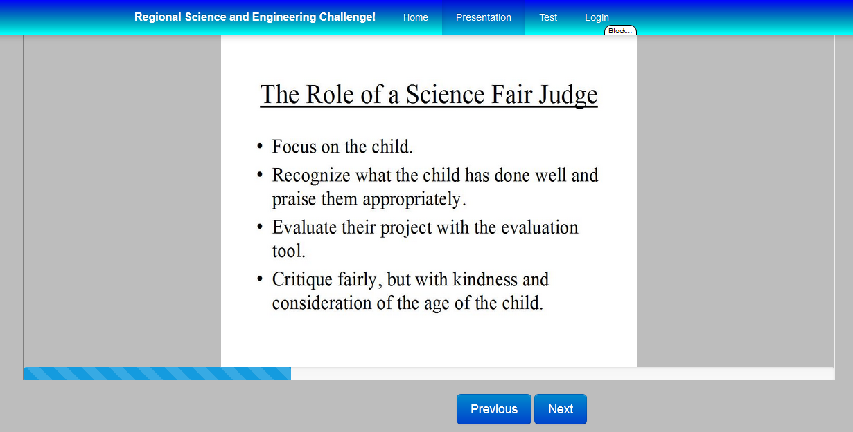

4.Testing Interface

The testing interface will consist of multiple pages that each have a single multiple choice question on each of them. The user will be able to move between the questions with the labeled previous and next buttons. Once every question has been answered, the user will be able to submit their answers.

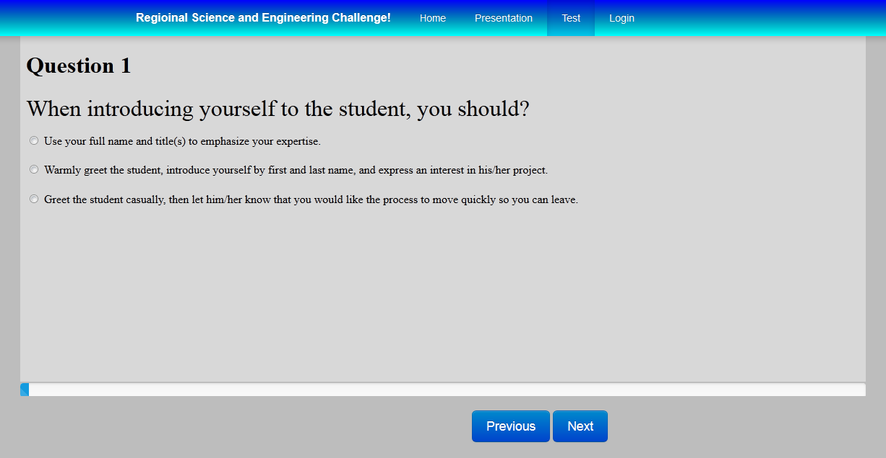

**STEM Interfaces:**

1. Employee Editing Interface

Administrative employee will be able to select different users and edit their information. 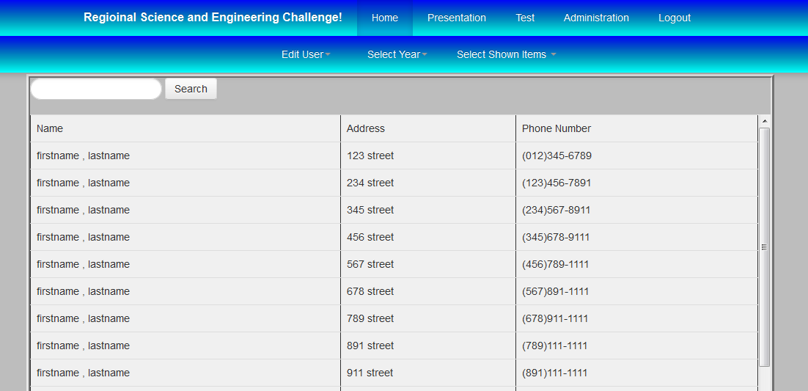

2. Content Editing Interface

This will be an interface through which STEM users are capable of editing the test and presentation content for the website



3. Judge Interface

From here every volunteer that has signed into the website for training will be displayed. The information displayed for each judge will be their name, the number of times that they have taken the test, and whether or not they have passed the test.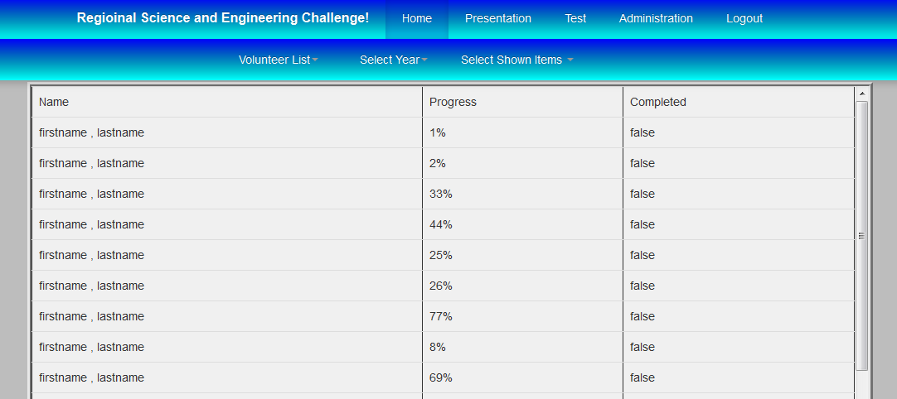

**VIII. Major Milestones:**

* Phase 1 - March 21
  + Preliminary Requirements - completed
    - Login System
    - Administrative Interface
    - Training Interface
    - Testing Interface
    - Test/Training Update Interface
    - Support for Windows, Mac, Android, and iOS browsers.
  + Basic High Fidelity Prototype - completed
    - General layout
    - Training interface
    - Testing interface
    - Login interface
* Phase 2 - April 29th
  + Updated Requirements - completed
    - Initial page is login
    - Dashboard for user
      * List of options for user
      * Progress indicators for training and test
      * Shows what is next for user
    - End of training should have an indicator to complete test
  + Have login implemented for website - completed
    - Store user information in database
    - Google Login
  + Database fully implemented
    - User schema implemented
    - Slide schema implemented
* Phase 3 - October 11th
  + Training interface fully implemented.
    - Supports video
      * mp4
      * webm
      * ogg
    - Supports youtube video
    - Supports images
    - Tracks progress
    - Database functionality
  + Test interface fully implemented.
    - Supports multiple choice
    - Supports matching
    - Tracks progress
    - Randomizes order
    - Database functionality
  + Administrative interface fully implemented.
    - Control selection interface
    - User control interface
    - View current progress of users interface
      * Print functionality
      * database functionality
    - Edit presentation interface
    - Edit test interface
  + Dashboard fully implemented.
    - List of options for user
    - Progress indicators for training and test
    - Shows what is next for user
* Phase 4 - October 31st
  + Access levels working
    - Show different tasks based on access level for user on the dashboard.
    - Blocked access to portions of the site they aren’t supposed to be able to access.
  + Initial testing completed.
    - Windows, Mac, Android, and iOS browsers.
  + Have website working for mobile browsers
    - Resize properly for different size screens
    - Design mobile portion to be friendly for mobile devices.
    - Tested implementation on Android and iOS devices.
* Phase 5 - November 20th
  + Usability testing completed

**IX. Scheduling:**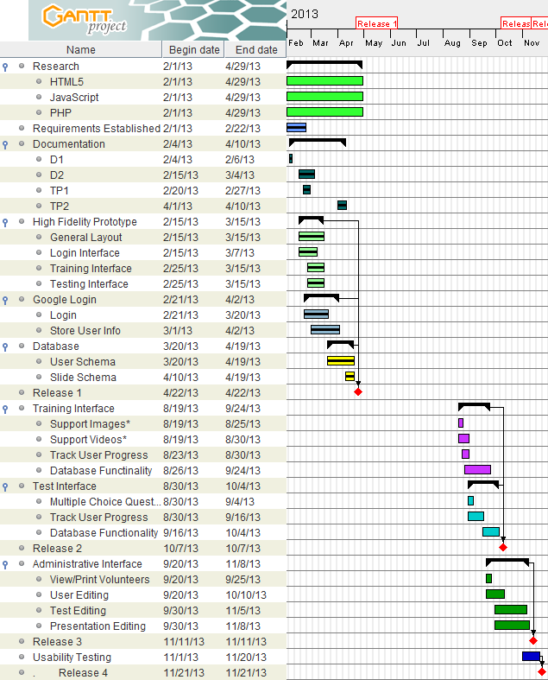

*Supports Images - Images will be able to be loaded into the presentation slides

*Supports Videos - Videos and youtube videos will be able to be loaded into the presentation slides

**X. Client/Team Meetings:**

* Jan 31st STEM Meeting 3:00pm - 4:00pm
  + Discuss requirements with
* Feb 11th Team Meeting 3:00pm - 4:30pm
  + Presentation Slides
  + Requirements
  + Additional features
  + Unnecessary features
* Feb 13th Team Meeting 3:00pm - 5:00pm
  + Presentation Slides
  + Extremely rough prototyping
  + Rehash features/requirements
* Feb 21st Team Meeting 4:00pm - 5:00pm
  + Simple prototype
* Feb 26th Team Meeting 7:00pm - 11:30pm
  + Finish Presentation Slides
* Feb 28th STEM Meeting 3:30pm - 4:20pm
  + Hosting
  + Features
    - additional features
    - remove or change features
* March 14th Team Meeting 5:00pm - 12:00am
  + Constructed basic high-fidelity prototype
* March 16th Team Meeting 12:30pm - 7:00pm
  + High-fidelity prototype
* March 21st STEM Meeting 3:30pm - 4:00pm
  + High-fidelity prototype
* March 21st Team Meeting 5:00pm - 11:00pm
  + Documentation
  + High-fidelity prototype
* April 4th STEM Meeting 3:30pm - 4:30pm
  + High-fidelity prototype
  + Server
  + Design improvement
* April 4th Team Meeting 7:00pm - 12:00am
  + Documentation
  + Presentation slides
* April 5th Team Meeting 12:00pm - 7:00pm
  + Documentation
  + Presentation slides
  + Volunteer List
  + STEM interface
* April 6th Team Meeting 2:00pm - 8:00pm
  + Documentation
  + Presentation slides
  + Volunteer List
  + STEM interface
* April 7th Team Meeting 4:00pm - 12:00am
  + Presentation slides
  + Volunteer List
  + STEM interface
* April 8th Team Meeting 4:45pm - 9:00pm
  + Presentation slides
  + Volunteer List
* April 11th Team Meeting 6:00pm - 12:00am
  + Documentation
  + Interface Change

**XI. Client/Team Meetings:**

Hours worked:

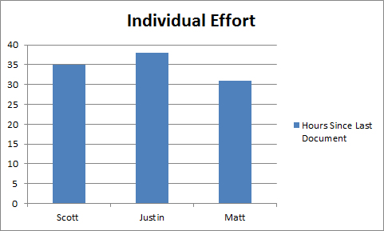

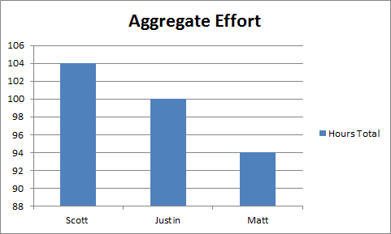

Repository Commits: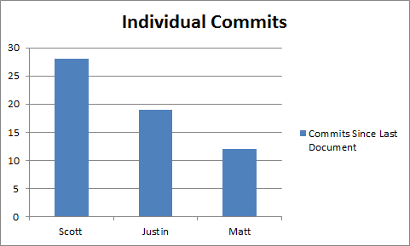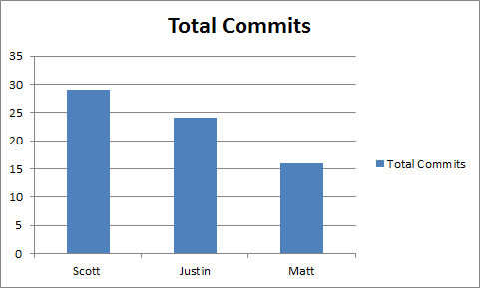

1. Individual Responsibilities:
   1. Matt
      1. Setting up the MySql database on server.
      2. Setting up Janrain so that users may log in to the website using google accounts and other providers if necessary.
      3. Set PHP so that once logged in, creates a unique id in the database for each user based off of their google identifier.
      4. Set up PHP to create a session that remains open until the user logs out or exits the website.
      5. Integrate JanRain / PHP / MySql functionality with the front end prototype provided by Scott and Justin.
      6. Work in the senior project lab on documents along with group.
   2. Scott
      1. Setup front end prototype for website
         1. test interface
         2. training interface
         3. home portion
      2. Work on login
      3. Documentation
      4. Gantt Chart
      5. STEM liaison
   3. Justin
      1. Setup front end prototype for website
         1. test portion
         2. training portion
         3. home portion
      2. Work on login
      3. Documentation
      4. Created volunteer list interface for site